


Mobile Internet
Skills Training
Toolkit
A guide for training people in
basic mobile internet skills
Copyright © 2024 GSM Association
Copyright © 2024 GSM Association
Bitesize Training
TikTok

Mobile Internet
Skills Training

Toolkit

A guide for training people

in basic mobile internet skills

Module 7:
TikTok


What is it?
 | Show TikTok on the phone.  Explain: “TikTok is an app on your phone that lets you watch, create  or share videos. It is like YouTube, Facebook, or even TV, but  normally the videos are quite short.”  “These videos are made by people around the world – some of  them may be people you know, but some you won’t. People like you  and me make these videos.”  “These videos can be about everything. A lot of videos are about the news, famous people, music or sports, but other videos can help you  to learn new things that can help with your business, cooking, looking after your family or taking care of your farm.”

Materials you will need:
Smartphone  handsets | 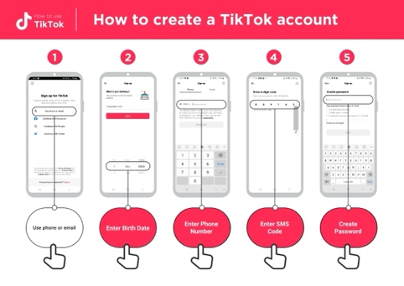  TikTok posters | 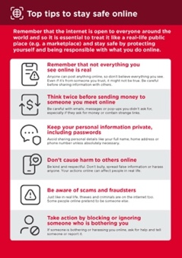  Safety poster

What can you use it for?
Explain “On TikTok you can watch videos about your favourite sport, music or dance, but you will also find a lot more! For example, you can find tips on how to grow a particular crop (e.g. corn), how to cook a particular recipe, or educational videos for your children or videos that can teach you a new skill or share new information.”

“TikTok is not just for watching videos, you can also create your own videos. The people making TikTok videos are just like you and me!”

Share your own examples with the trainee about the benefits of TikTok and how you personally use it.
Make it relevant to the trainee by discussing how it can be beneficial in the trainee’s own life. Consider examples that will be relevant to the following types of trainees:

Older person: Watch videos posted by friends and family who live far away; watch film clips, religious sermons or news.

Mother or homemaker: Learn how to cook a particular recipe for your family; support your children to do better in school and to complete their homework); discover tips and tricks for looking after your home.

Business owner: Learn how to cook a new recipe to grow your business; access information on business management, trends and schemes for business support; access business advice and find inspiration to grow your business.

Farmer or rural person: Learn how to grow a particular crop (e.g. seasonal planting techniques for tomatoes or corn) or tips to treat a certain pest.

Young person: Learn how to do your favourite craft and make money from it (e.g. makeup, woodworking or tailoring); watch videos to help complete schoolwork; watch sports clips, funny videos or tutorials.

How does it work?
Put the phone in the trainee’s hands and help them follow the steps.

Ask: “Do you know what this is? What is it for? Can you find it on your phone?”

Explain how to find and open TikTok on the phone.

Explain: “To find the videos and information that interests you, you can search for things on TikTok. By using search, TikTok will show you things that you might like to see.”
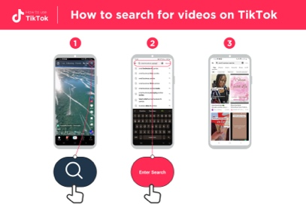 | Using the ‘How to search for videos on TikTok’ poster, explain how to search for videos on TikTok.  1. Click the search icon on the top right of the screen.  2. Enter a search word or phrase into the bar. Allow the trainee to search for something they are interested in. You can give guidance on how they can best find what they want (e.g. using keywords). Examples include how to deal with pests, how to cook their favourite dish, or how to learn to juggle a ball.  3. Choose one of the videos. Remember you may need to scroll down to find the best video.  Ask: “What videos would you like to watch on TikTok?”  Help them search for videos they might not know would be on TikTok. These might include cooking videos, educational videos for children, or videos explaining how to fix something (e.g. bicycle or a leak) or something you (the trainer) are particularly interested in.

Practise!

“Now that you know about TikTok, what are you interested in finding out about?”

Ask the trainee for some keywords to search for, according to their interest. Try to keep the search simple, use only one or two words.
Tip: “Remember, watching TikTok videos can be quite fun, but watching a lot of TikTok videos uses a lot of mobile data/credit so be careful about how much time you spend watching as it could consume a lot of data. Consider limiting the time you spend watching videos on TikTok.”

Tip: “There are other apps like TikTok where you can watch and make videos, for example, Instagram, Snapchat or YouTube. On these apps, like TikTok, many of the people in the videos are just like you.”

Safety
“TikTok is an exciting app and there are many things you can find there. It is important to remember that TikTok and all the internet is open to everyone around the world and so it is essential to treat it like a real-life public place (e.g. a marketplace) and stay safe by protecting yourself and being responsible about what you put on the app.”

“Remember, videos on TikTok are created by people, some may be just like you. Not everything you see on TikTok is true so think twice about acting on or sharing the videos.”
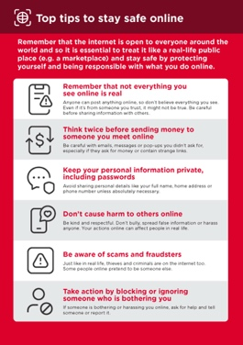
Show the ‘Top tips to stay safe online’ poster.

Discuss with your trainee what these tips mean when using TikTok.
Bring the tips to life by using examples that are relevant for your trainee.
For example, certain people may be worried about some of the content
on TikTok. Some people may be worried about scammers using TikTok
and some women may be more concerned about how to prevent
harassment.

Bitesize Training
TikTok

Mobile Internet
Skills Training

Toolkit

A guide for training people

in basic mobile internet skills

Posters and Cut-Outs

Top tips to stay safe online

 | Remember that not everything you see online is real  Anyone can post anything online, so don’t believe everything you see. Even if it’s from someone you trust, it might not be true. Be careful before sharing information with others
 | Think twice before sending money to someone you meet online  Be careful with emails, messages or pop-ups you didn’t ask for, especially if they ask for money or contain strange links.
 | Keep your personal information private, including passwords  Avoid sharing personal details like your full name, home address or phone number unless absolutely necessary.
 | Don’t cause harm to others online  Be kind and respectful. Don’t bully, spread false information or harass anyone. Your actions online can affect people in real life.
 | Be aware of scams and fraudsters  Just like in real life, thieves and criminals are on the internet too.  Some people online pretend to be someone else.
 | Take action by blocking or ignoring someone who is bothering you  If someone is bothering or harassing you online, ask for help and tell someone or report it.

Remember that the internet is open to everyone around the world and so it is essential to treat it like a real-life public place (e.g. a marketplace) and stay safe by protecting yourself and being responsible with what you do online.

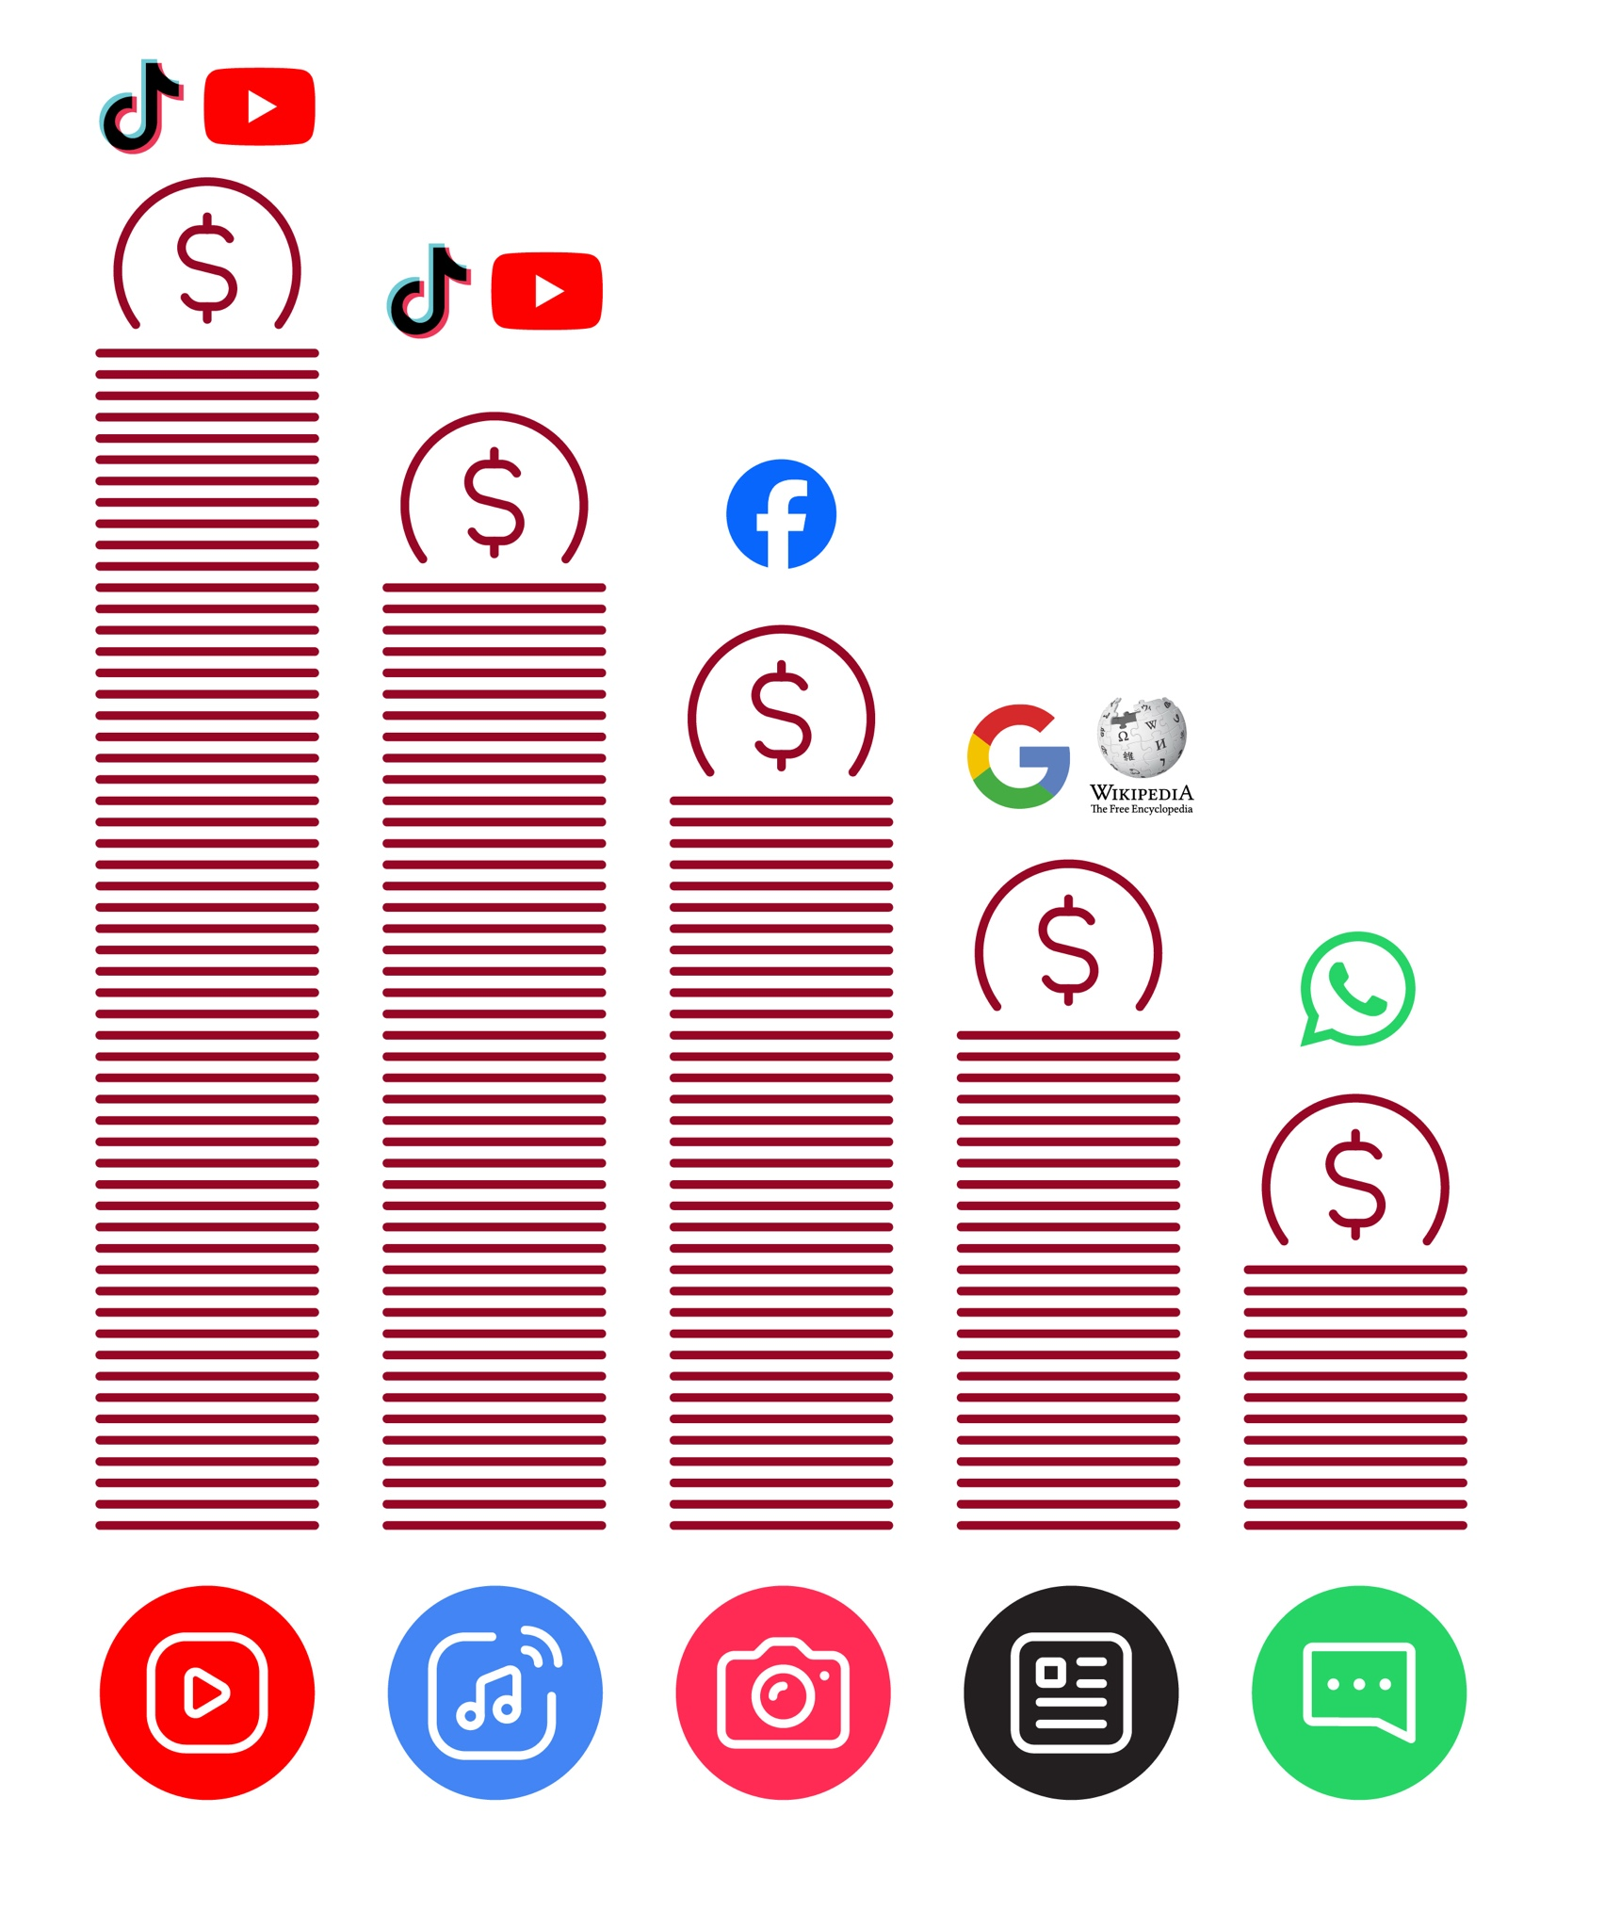
Data Costs

How to create a TikTok account


How to use
TikTok




1 2 3 4 5
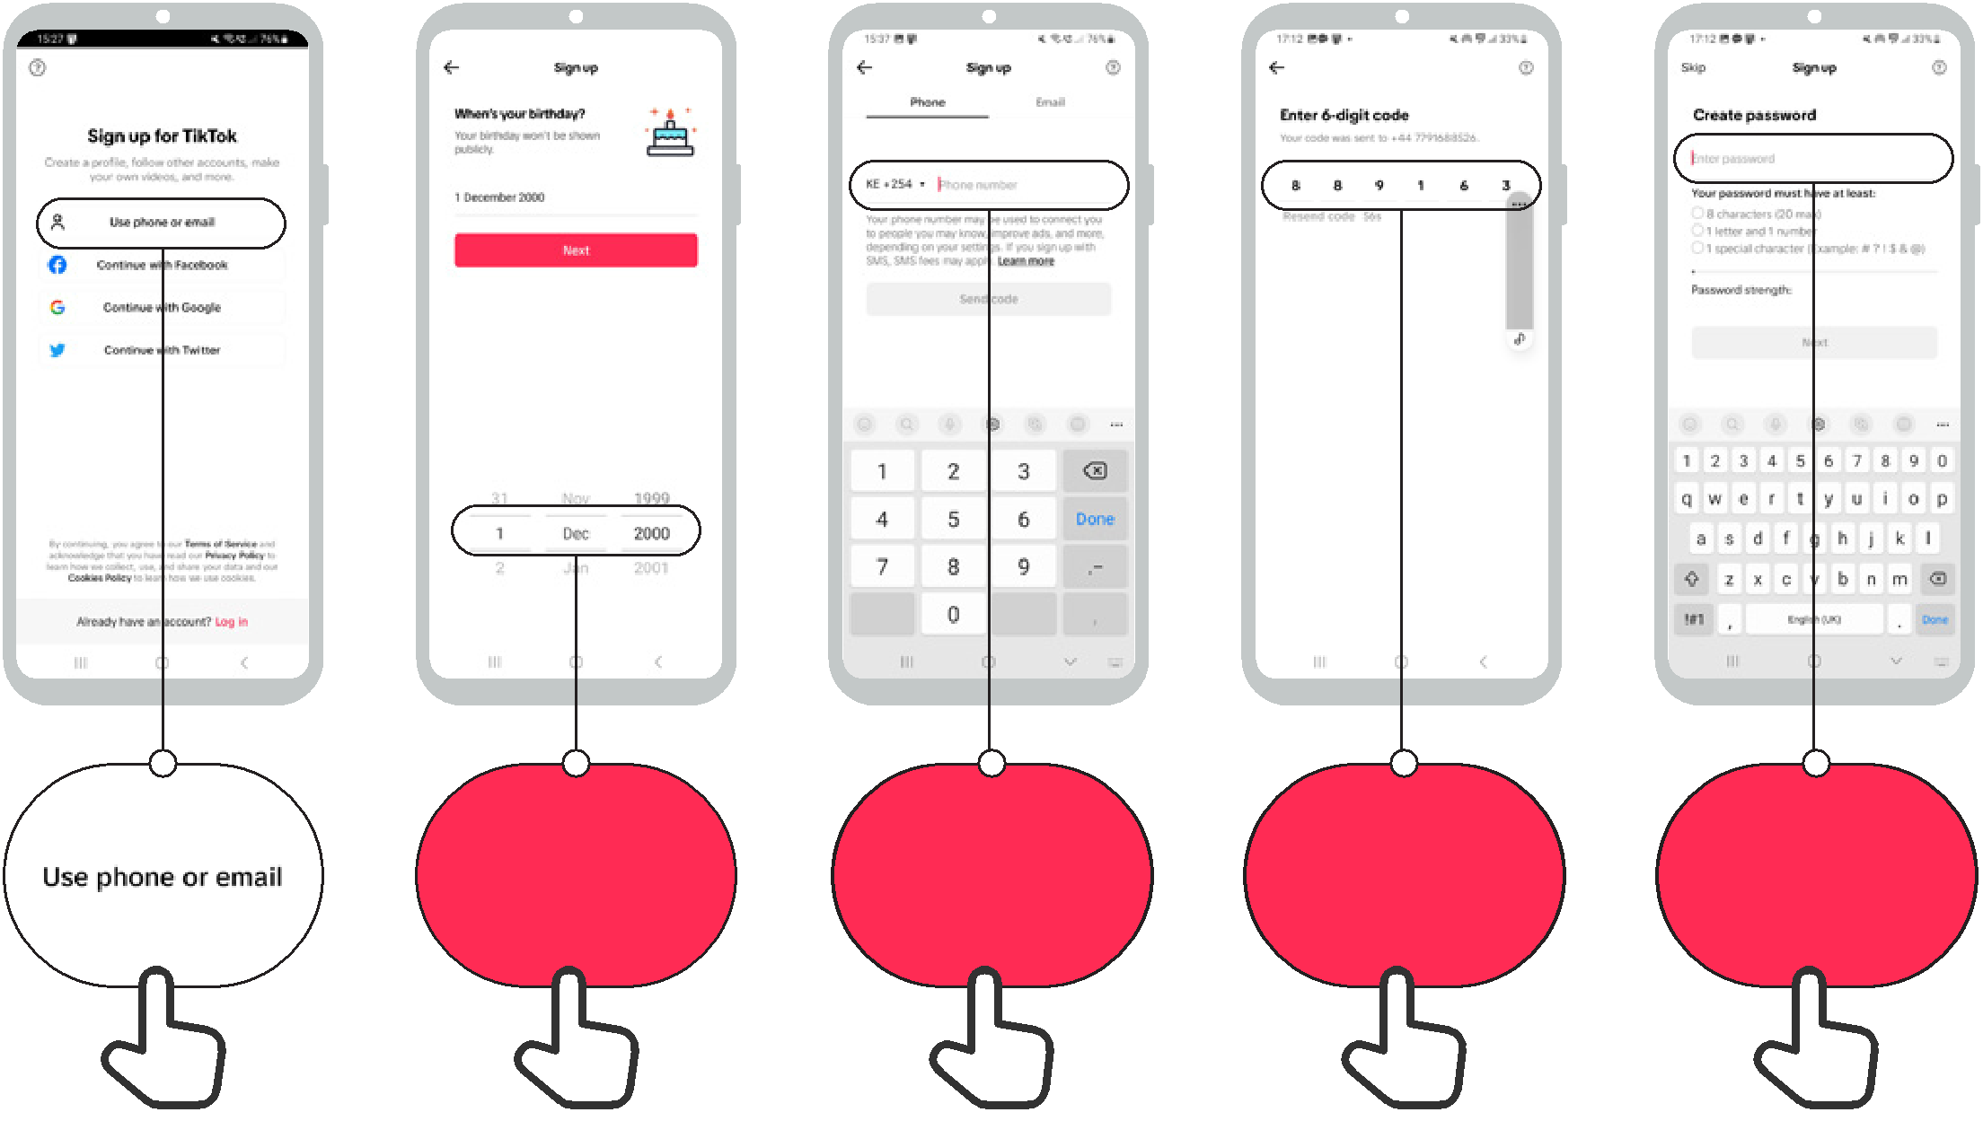

Enter Birth Date | Enter Phone | Enter SMS | Create
Enter Birth Date | Number | Code | Password

How to use
TikTok

How to search for videos on TikTok

1 2 3




Enter Search

How to use
TikTok


Understanding the TikTok ‘For You’ page

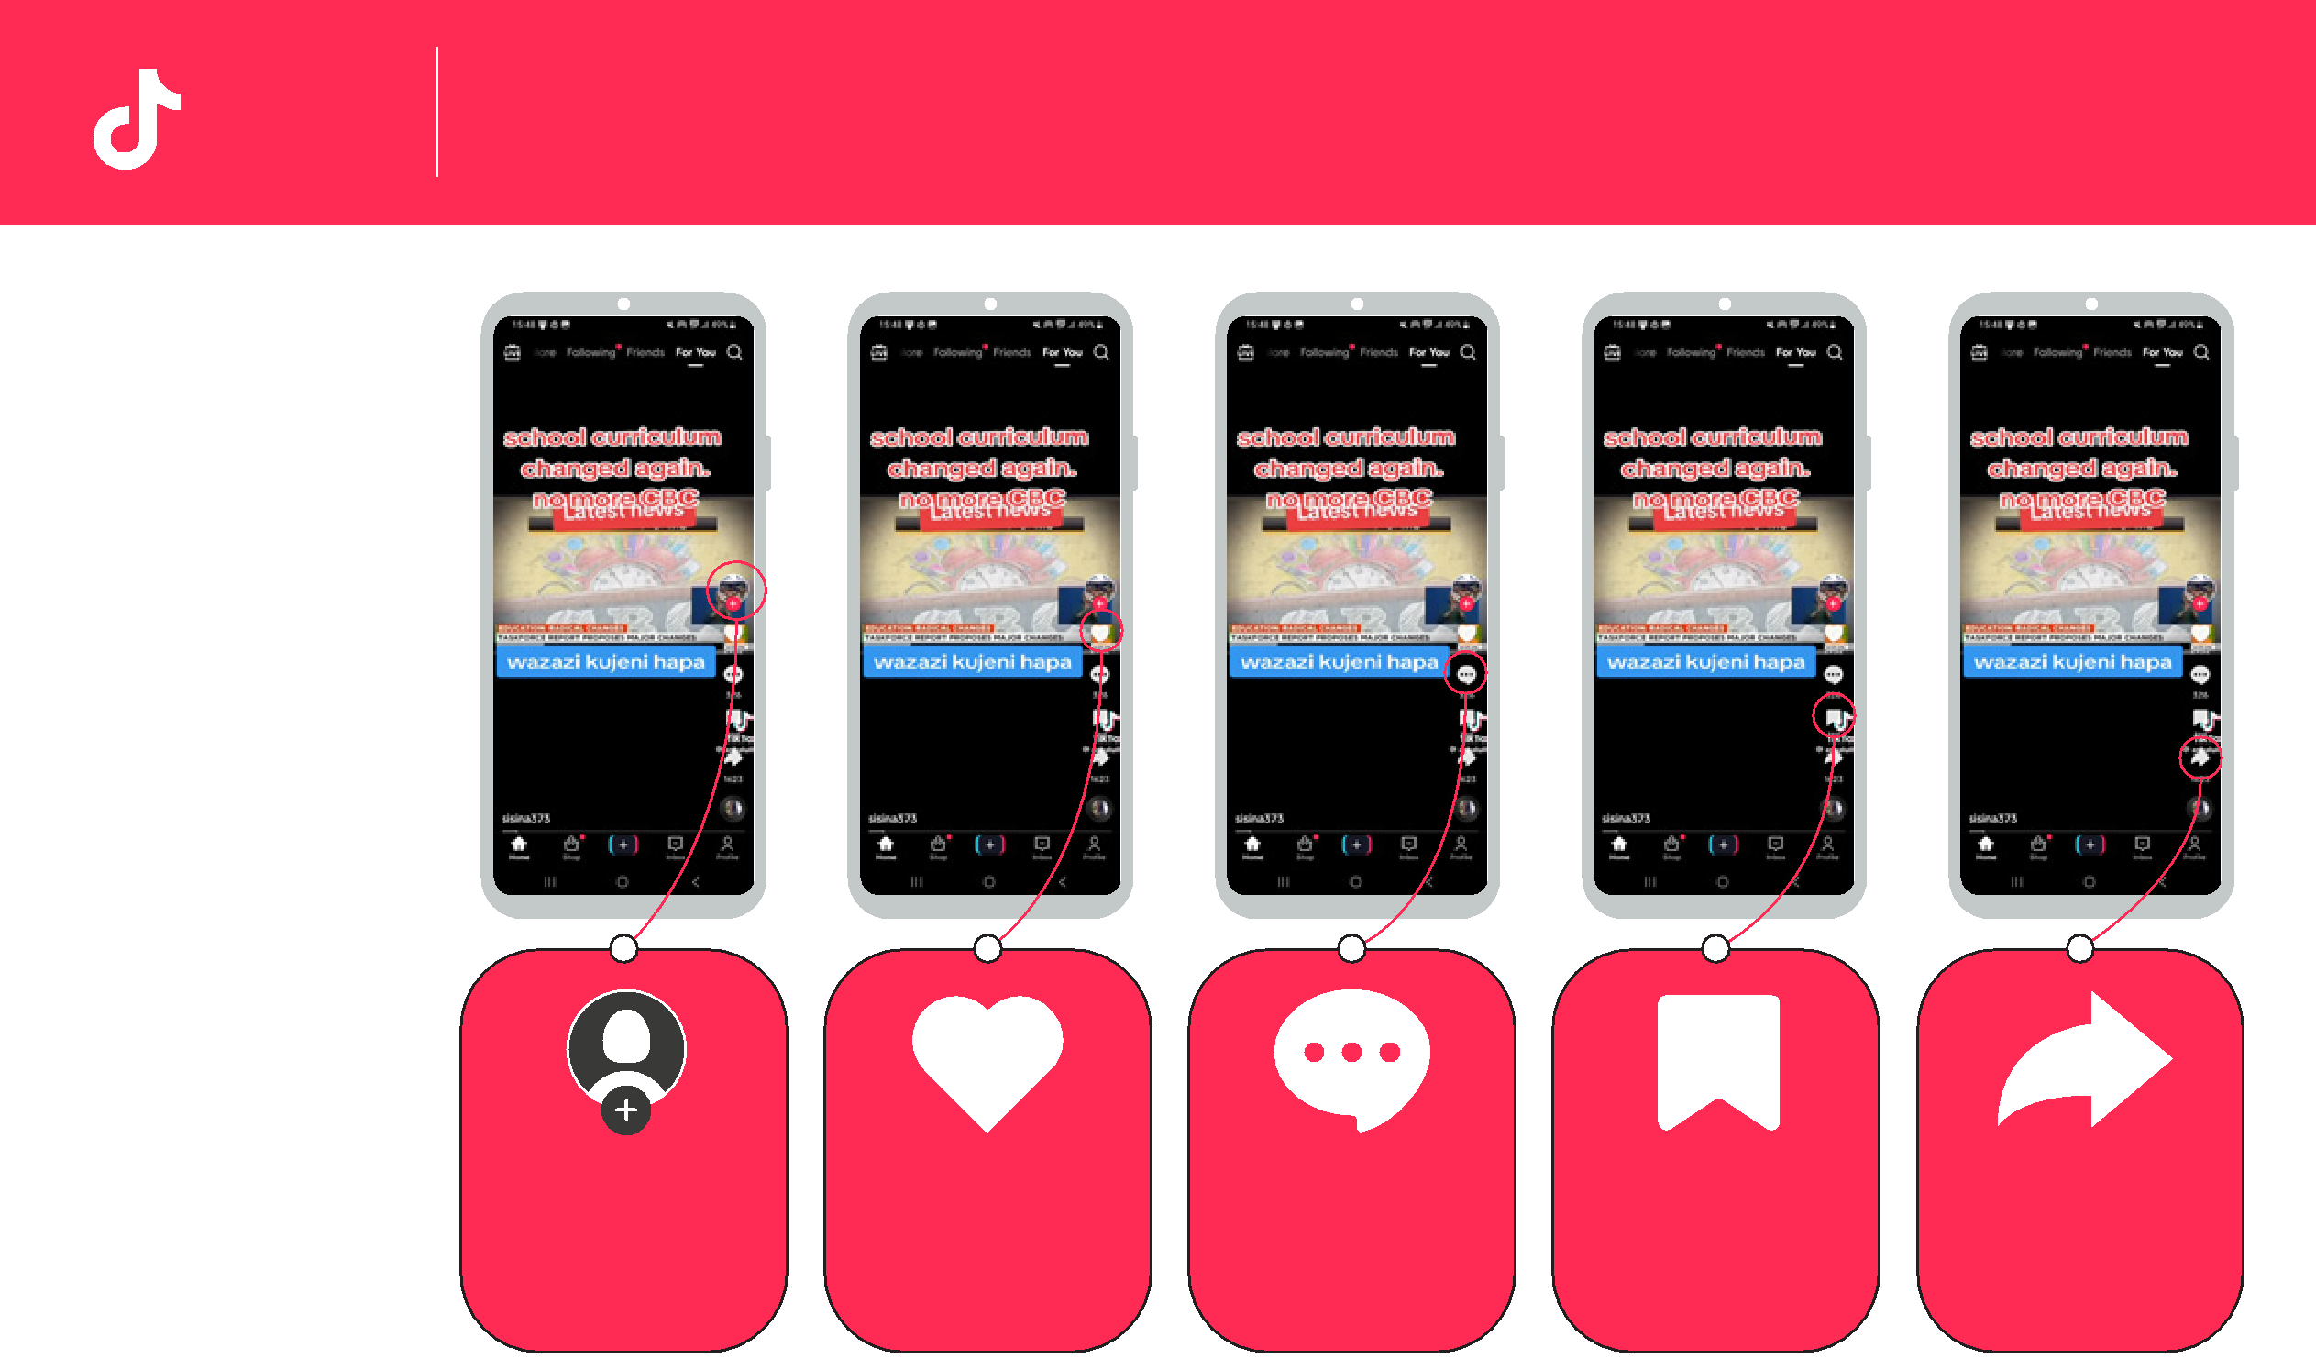

Search: | Creator’s profile: | Like: Pressing the heart | Comment if you want to | Favourite: Making this | Share: You can send this
Find videos you like. | The creator is the person | means you ‘like’ the video. | say something about this | video a ‘favourite’ means | video to your friends or
 | who made the video. You | You will get similar videos | video or look at what | you can put it on a list to | family – including by
 | can find more videos like | shown to you if you press | other people have said. | watch again later. | WhatsApp
 | this one. | ‘like’. The number is how | The number is how many
 |  | many people have liked it! | people have commented!



Swipe up: If you move |  | Swipe down: If you want
your finger up the screen |  | to see the last video again
you will move onto the |  | you can swipe your finger
next video! |  | down the screen.

How to use
TikTok

How to ‘Favourite’ a video on TikTok

1 2 3
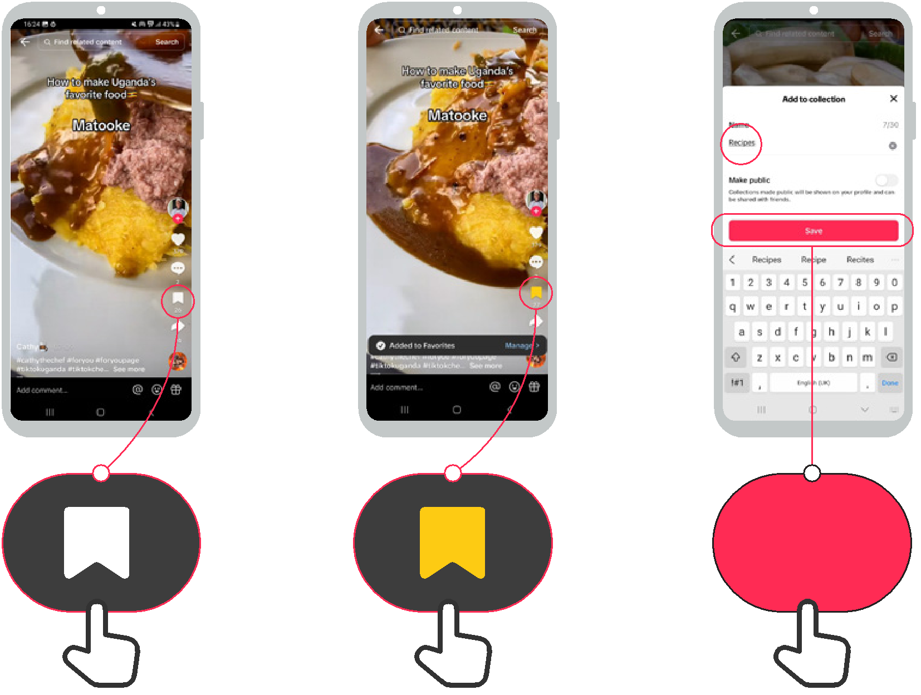

Save

How to use
TikTok

How to find ‘Favourite’ videos in TikTok

1 2 3
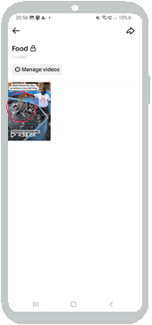



Collections

How to report a video on TikTok

How to use
TikTok



1 2 4 5
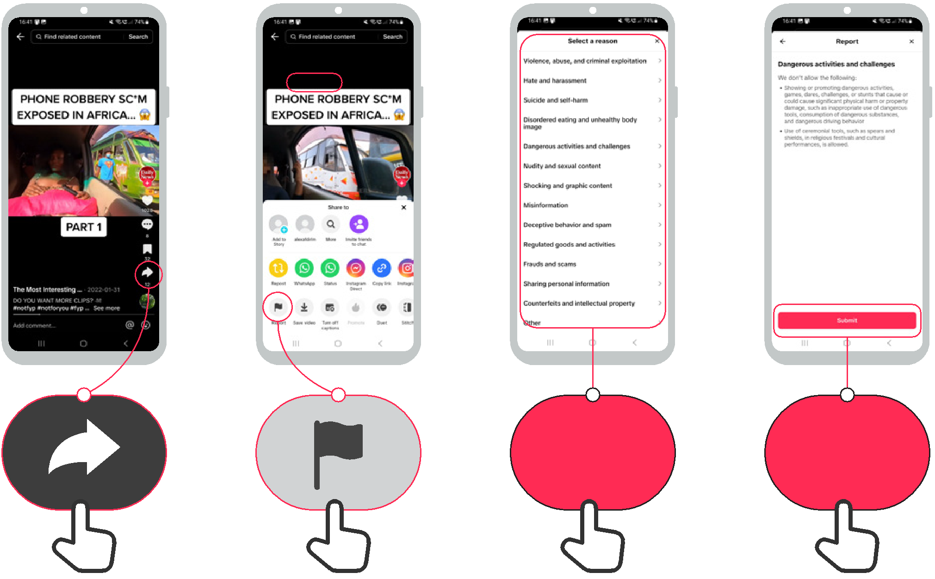

Collections Submit

How to use
TikTok

Turning on ‘data saver’ mode in TikTok

1 2 3 4 5
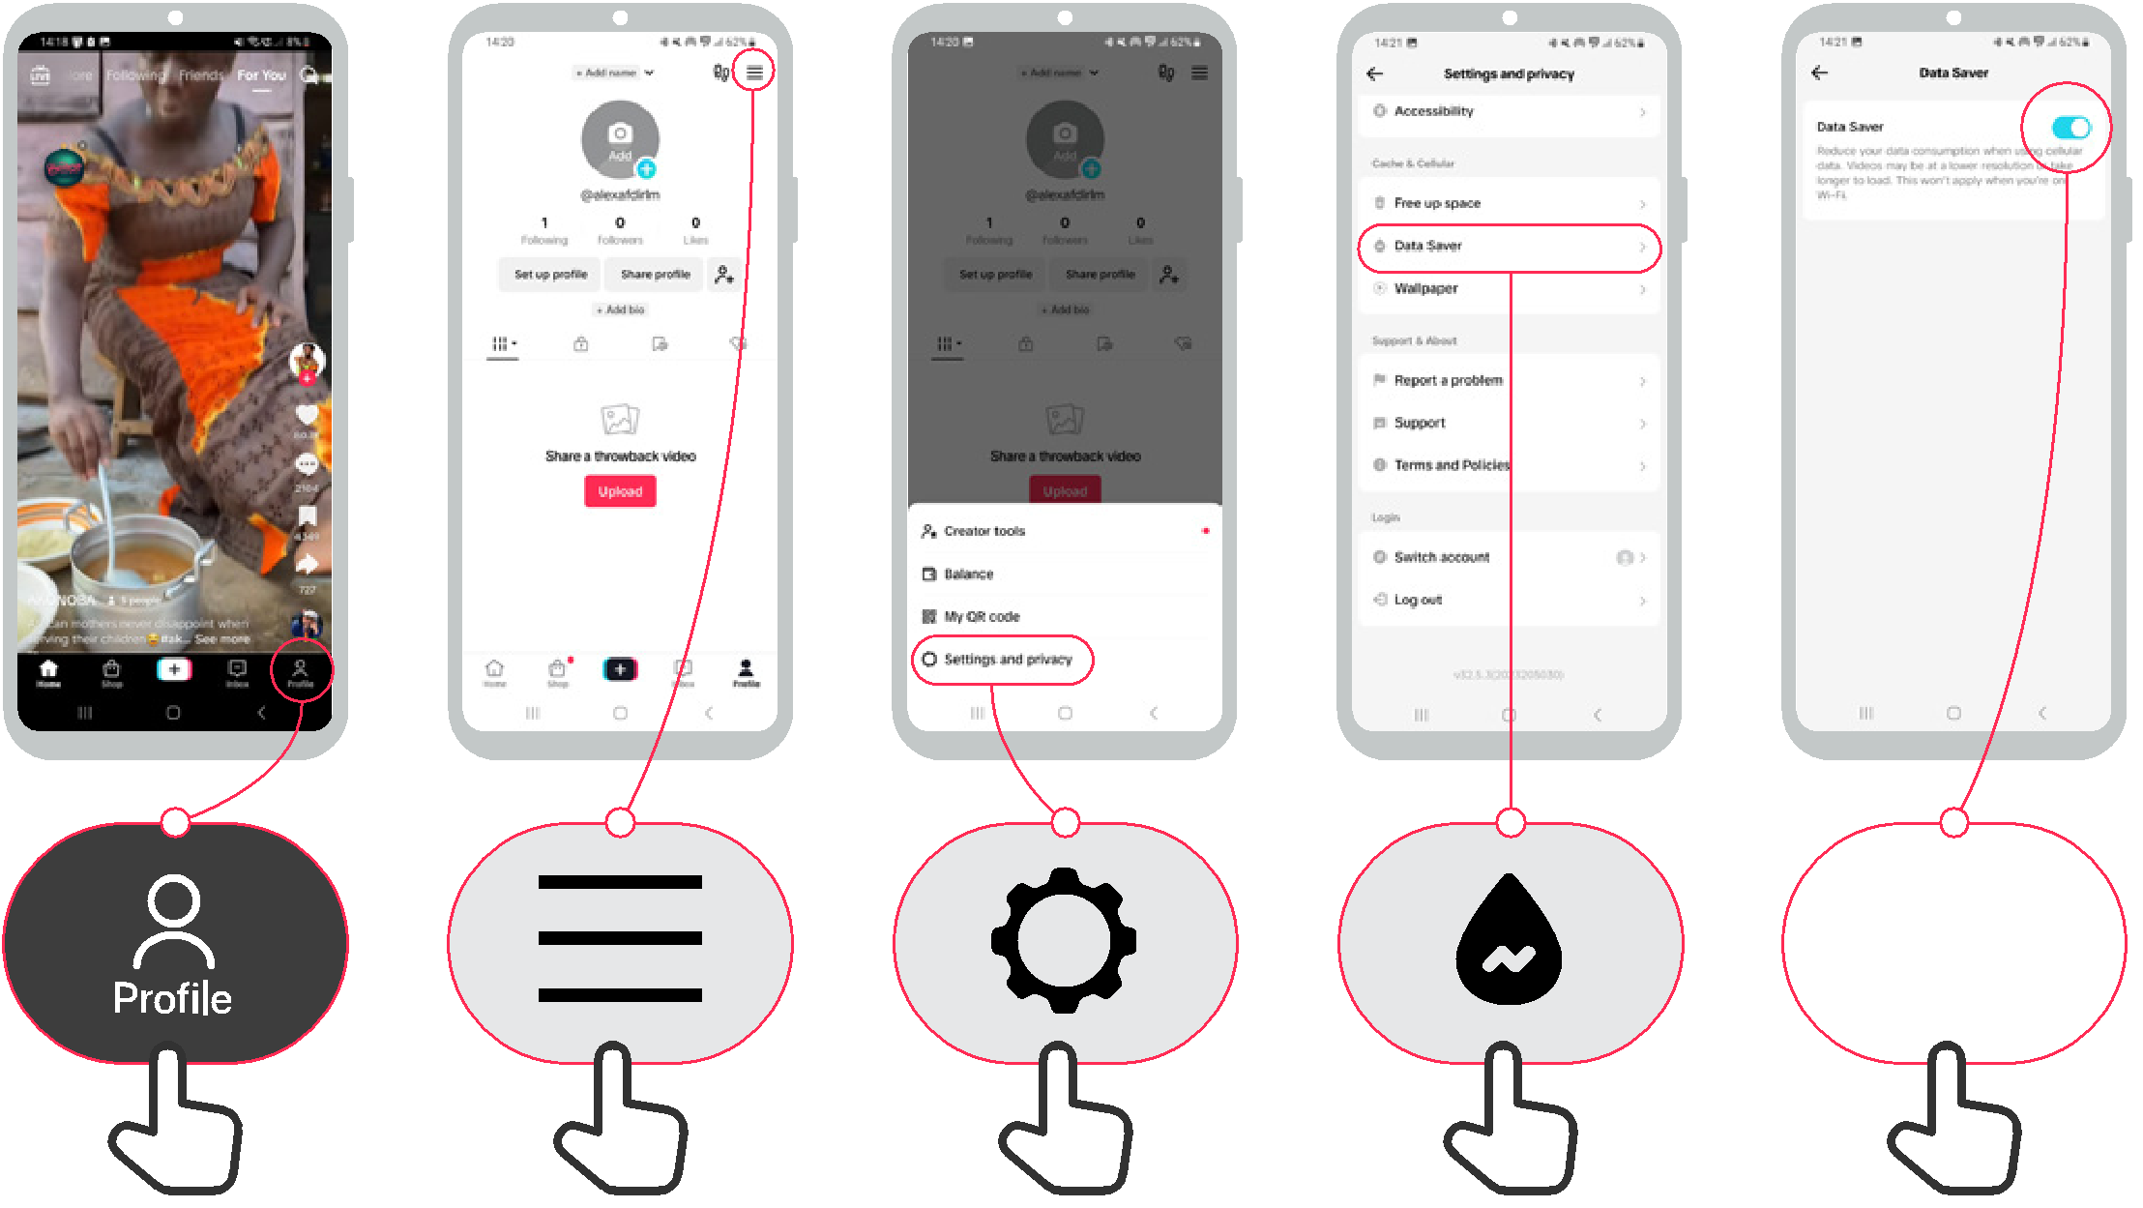

How to use
TikTok

Why you’re seeing this video

1 2 3
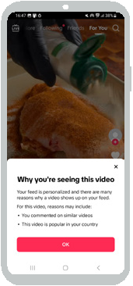




Icon Cut-Outs
TikTok


Icon Cut-Outs
TikTok


Icon Cut-Outs
TikTok


Icon Cut-Outs
TikTok



Icon Cut-Outs
TikTok


Icon Cut-Outs
TikTok


Icon Cut-Outs
TikTok



Icon Cut-Outs
TikTok



