


Mobile Internet
Skills Training
Toolkit
A guide for training people in
basic mobile internet skills
Copyright © 2024 GSM Association
In-Depth Training
TikTok

Mobile Internet
Skills Training

Toolkit

A guide for training people

in basic mobile internet skills

Module 7:
TikTok

Learning objectives
- Trainees create a TikTok account (if required).

- Trainees know how to watch videos on TikTok.

- Trainees understand the range of content available on TikTok and feel excited and motivated about accessing content in areas relevant for them that can support their interests (e.g. cooking, agriculture, business).

- Trainees understand how to stay safe and use TikTok cost- effectively.

- Some trainees will begin to understand how the TikTok algorithm works.
Time duration
45-60
minutes
Note: This training focuses on the basics of using TikTok and does not cover how to create on the platform.
Materials you will need:
  Smartphone handset |   Small rewards | 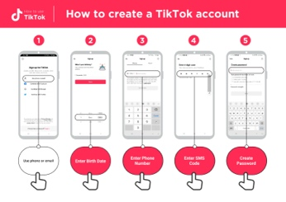  TikTok  posters x 8 | 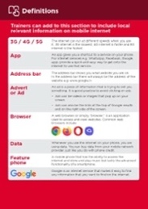  Glossary  handouts
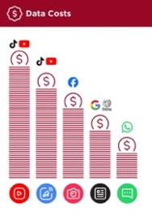  Cost poster | 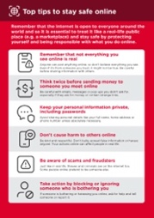  Safety tips | 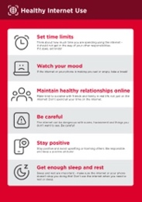  Healthy  internet use |   Icon cut-outs

Introduce TikTok

Show trainees the TikTok icon and ask them to find this on their phone

Ask: “Does anyone know what this is? What is it for? Can you find it on your phone?”

Explain how to find and open TikTok on the phone.
Make TikTok relevant for your trainees
Explain: Discuss with your trainees how TikTok can be beneficial in their lives.
Ask: “What could you learn to use TikTok for in your own life?” Give them some suggestions based on their interests. For example, help them find something about their job, something they want to learn or their main hobby

Remember: Link discussions and activities in the training back to how TikTok can be helpful or useful in your trainees’ lives. This will help to keep the training relevant and interesting for them.

Give a short explanation of Tik Tok
- “TikTok is an app on your phone that lets you watch, create or share videos. It is like YouTube, Facebook, or even TV, but normally the videos are quite short.”

- “These videos are made by people around the world – some of them may be people you know, but some you won’t. People like you and me make these videos.”

- “These videos can be about everything. A lot of videos are about the news, famous people, music or sports, but other videos can help you to learn new things that can help with your business, cooking, looking after your family or taking care of your farm.”

Bring the benefits to life!
Tell your own story of how TikTok is useful for you (the trainer), your friends and family or your community. Consider examples that will be relevant for these trainees:

Older person: Watch videos posted by friends and family who live far away; watch film clips, religious sermons or news.

Mother or homemaker: Learn how to cook a particular recipe for your family; support your children to do better in school and to complete their homework); discover tips and tricks for looking after your home.

Business owner: Learn how to cook a new recipe to grow your business; access information on business management, trends and schemes for business support; access business advice and find inspiration to grow your business.

Farmer or rural person: Learn how to grow a particular crop (e.g. seasonal planting techniques for tomatoes or corn) or tips to treat a certain pest.

Young person: Learn how to do your favourite craft and make money from it (e.g. makeup, woodworking or tailoring); watch videos to help complete school work; watch sports clips, funny videos or tutorials.

Tip: If the trainees do not want to use their phone number (or are nervous about doing so) to set up their TikTok account and want to set up their account using their Facebook, Google or Twitter / X account, then skip this activity. If they want to use their email, then follow the steps in the poster (helping the trainees access their email to get the six digit code). Allow them to take their time on this.

Activity: Creating an account on TikTok
Show the ‘How to create a TikTok account’ poster
Explain: “To use TikTok it is better to have a TikTok account that is personal to you. When you have an account, it is much easier to watch videos and even create your own.”

Explain: “If you create an account, you will be able to save videos to watch later, share them easily with friends, and follow people whose videos you like.”

Ask the trainees if they have a TikTok account. If they do not, you can help them make one using the steps on the poster.

Explain: “There are many ways to create a TikTok account. You can use your email or Facebook account but I am going to show you how to create a TikTok account using your phone number.”

Explain: “To use your TikTok account you will need a password. This is a special word you use with your TikTok app to make sure only you can access and use your TikTok account. You need to keep your password safe and don’t share it with anyone, even me. It should be a word you can remember so don’t make it too difficult.”
- Open the TikTok app. On the ‘Sign Up for TikTok’ page, select ‘Use Phone or Email.’
- Enter their date of birth.
- Have the trainees enter their phone numbers and receive the codes.
- If the six digit code doesn’t fill automatically, then enter the code sent by SMS.
- Encourage the trainees to choose a secure password that is easy to remember.

Activity: Searching for content on TikTok
Explain: “TikTok has so many videos about all sorts of things and you could never watch them all.
It is important to learn how to search for videos that are interesting and important for you.”
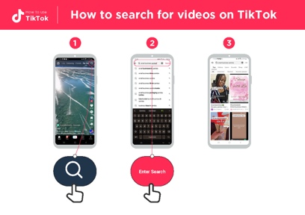
Show the ‘How to search for videos on TikTok’ poster

Explain: “To find videos and information that interest you, you can search for things on TikTok. By using search, TikTok will show you things that you might like to see.”

Explain: Using the ‘How to search for videos on TikTok’ poster, explain how to search for videos on TikTok.

- Click the search icon on the top right of the screen.
- Enter a search term into the bar. Allow the trainees to search for something they are interested in. You can give guidance on how they can best find what they want (e.g. using keywords). Examples include how to deal with pests, how to cook their favourite dish, or how to learn to juggle a ball.
- Choose one of the videos. Remember you may need to scroll down to find the best video.

Personal use
Discuss with trainees how TikTok can be beneficial in their lives

Ask: “What videos would you like to watch on TikTok?”

Discuss with your trainees what they might like to watch on TikTok. Share what you (or your friends and family) watch on TikTok.

Help them search for videos they might not know would be on TikTok. These might include: Cooking videos, educational videos for children, videos explaining how to fix something (e.g. bicycle or a leak) or something you (the trainer) are particularly interested in.

Explain: “The ‘#’ symbol is called a hashtag. If you put it in front of something (e.g. #farmingtips), TikTok will show you videos on that topic. Hashtags can help you find videos on specific topics that are useful for you.”

Ask: “Are there any videos you would like to search for using a hashtag?” Run through the ‘How to search for videos on TikTok’ poster again but this time use a hashtag.
Practise: Try searching for several different topics using a hashtag. Some examples

are: #marketingtips, #smallbusiness, #homeworkhelp.
Tip: “There may be hashtags or search terms you can use in your own language. Give it a try.”

Tip: Trainees can also search for words or phrases using voice search if they have trouble typing or writing. In the righthand side of the search bar, they can click the microphone symbol to say their keyword and get results. Give it a try.

Remember: Link discussions and activities in the training back to how TikTok can be helpful or useful in your trainees’ own lives. Continue throughout the training to highlight the use cases that trainees have shown interest in. This will help to keep the training relevant and interesting for them.
Tip: You can reinforce trainees’ knowledge of the icons by playing the ‘TikTok icon game’.
Activity: Understanding the TikTok ‘For You’ page
Explain: “The TikTok ‘For You’ feed is a page you can go to on TikTok where the app will show you videos that you may want to watch.”

Explain: “Everyone will see different videos on the ‘For You’ page, depending on what you have watched before, what you have liked and where you are in the world.”
Get practical!

Explain: “We are now going to look at the ‘For You’ page and learn what all the icons mean.”

Show trainees where the ‘For You’ page can be found at top right of screen.
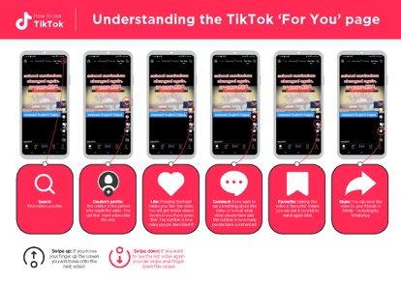
Show the ‘Understanding the TikTok ‘For You’ page’ poster

Explain: Open the ‘For You’ page on TikTok on your/the trainee’s phone and explain what the main icons mean.

Ask: “Have you got any questions about what you are looking at?”

How to favourite a video in TikTok
Explain: “TikTok lets you save videos to watch later. This is useful if you want to save a video to learn new skills – like changing the tyre on a bicycle or mending your clothes.”
Explain: “You can save videos together in a collection. This means that you can save all your videos on cooking and recipes in one area, your videos about doing business in another, and videos of your favourite music in another. This makes it easy to find videos later, which is helpful as TikTok can be confusing, and it is hard to find a video you have watched before unless you favourite it.”
Get practical!

Explain: “We are now going to favourite a video you want to save.”
Ask: “What video are you interested in saving to watch later?”

If the trainees are struggling to come up with an idea, you could suggest something. For example, a new (or favourite) dish they would like to learn to cook, tips on how to take good photos to promote their business, or a type of music or dance they like.
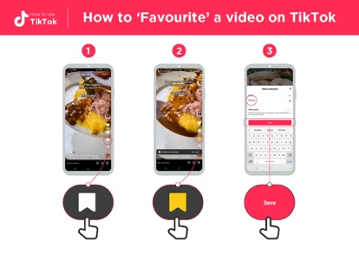
Show the ‘How to favourite a video on TikTok’ poster

Take the trainees through the steps for finding all their favourite videos using the poster.

- Go to profile.

- Select the collections tab.

- Find the video you want.

Take the trainees through the steps for favouriting a video using the poster.

- Press the favourite icon.

- When the bar appears at the bottom of the screen, press ‘manage.’

- Create a collection to save the video into (e.g. recipes, business, learning, music).

Explain: “It is easy to find videos that you favourite as they are saved in your profile.”
Ask: “Do you want to see how you find a video you have made a favourite?” If they are interested, take them through the poster below (optional).

Tip: “Remember, videos on TikTok are created by people, some may be just like you. Not everything you see on TikTok is true so think twice about acting on or sharing the videos.”
Safety
Explain: “TikTok is an exciting app and there are many things you can find there. It is important to remember that TikTok and the internet is open to everyone around the world and so it is essential to treat it like a real-life public place (e.g. a marketplace) and stay safe by protecting yourself and being responsible about what you put on the app.”
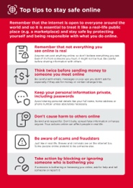 | Show the ‘Top tips to stay safe online’ poster  Discuss with your trainees what these tips mean when using TikTok.  Bring the tips to life by using examples that are relevant for your trainees. For example, people may be worried about some of the content on TikTok. Others may be worried about scammers using TikTok.  If necessary, use some of the following prompts:
Tip: “Remember videos on TikTok are created by people, some may be just like you. Not everything you see on TikTok is true so think twice about acting on or sharing the videos.”

Prompts | Potential answers
What do you do if you see a  video you don’t like or that  worries you? | You can always move to another video by ‘swiping up’ on the screen. If you are really concerned about what you see, take a break from the app or follow the instructions on how to report a video on the app.
What do you do if you feel  unsure or uncomfortable  about something someone  asks you on the app? | Tell someone you know and trust about what happened and ask for their advice. You should ignore messages or videos that make you concerned. You can block people who you don’t want to receive messages from.
What do you do if someone  you don’t know or trust  asks you for your personal  information? | Always be on the lookout for people asking you for personal information. You should never give out personal information to someone you don’t know or trust because they may misuse it.
Safety
Explain: “TikTok is an exciting app. But when using TikTok or any app on your phone, it is important that you use it in a healthy way. It is easy to watch TikTok videos for a long time, as there are so many on the app and the app will continue to show you videos until you close it. The videos will never stop on their own. However, this could mean you spend a lot of time watching videos on TikTok instead of doing something else that is important to you.”

Explain: “If you make a video and put it on TikTok, other people might use it to make something else. Everything you put on TikTok is public, so you should be careful what videos you post on TikTok because someone else might use your video in a way that you do not agree with. Remember not to put personal information about yourself or others in videos you make on TikTok.”

Discuss with your trainees what these tips mean when using TikTok.

Bring the tips to life by using examples that are relevant for your trainees. Talk about your (the trainer’s) experiences or those of friends and family.
Get practical!

Explain: “Anyone can make videos on TikTok, which makes it exciting but also means that not all information in the videos may be true. There are risks involved when using TikTok.”

Explain: “If you think a video is dangerous, illegal or a scam, you can report it to TikTok. It is important to stay safe when using TikTok.”

Tip: If trainees are concerned about or interested in online safety, you can show them the Online Safety Module or show them the ‘False information’ poster.

Activity: Report a video on TikTok
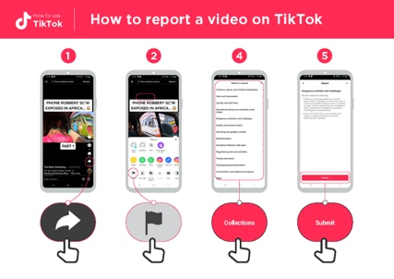
Show the ‘How to report a video on TikTok’ poster

Explain: trainees how they can report a video on TikTok using the stages listed in the poster.

- Press the share button on the video.

- Press the first icon: report.

- Show all the reasons listed. Explain any reasons that trainees do not understand. Select a reason.

- Explain that you submit a report by pressing the submit button. Do not press this unless you want to submit a report on the video.

Explain: “This lets TikTok know that there is a problem with the video. They may get in contact for more information, but they may not.”

Discuss with your trainees the different reasons that videos can be reported to TikTok. Explain the importance of avoiding bad content on TikTok.

Explain: “If you are watching videos on the ‘For You’ page, you can also tell TikTok if you don’t like a video. TikTok will then show you fewer videos like this.”

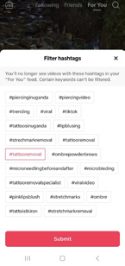

Show trainees how they can do this if they are interested. This can be done through the following steps (images below to help you):

- Press the share button on the video.

- Press the second icon: ‘Not interested.’

- If you select details, you can select any hashtags you want to see fewer videos of.

Cost
Explain: “Different activities use different amounts of data. Looking at text uses the least data, looking at images uses more, playing and downloading music uses a bit more and watching videos online uses the most.”

Explain: “The more you use your phone, the more data you will use. TikTok will start to show you videos as soon as you open TikTok. This will use data.”
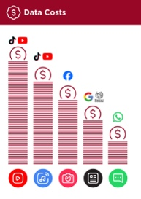
Show the ‘Data costs’ poster

Explain: “Which type of activity tends to cost more to use?”

Answer: “Videos: Watching videos on YouTube, TikTok, or other apps will use the most data.”

Explain that watching videos uses a lot of mobile data.

You can save your credit by waiting until you are connected to Wi-Fi to watch videos.

Activity: Turning on ‘data saver’ mode
Explain: “Because it is a video app, TikTok uses a lot of mobile data/ credit. If you want to reduce this, you can turn on data saver. This makes the videos less high quality but will save you money.”

Explain: You can help the trainees turn on ‘data saver’ mode in TikTok, walking them through the below steps using the poster.
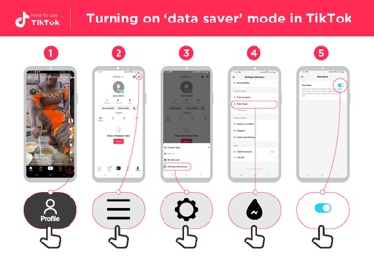
Show the ‘Turning on ‘data saver’ mode in TikTok’ poster

- Go to your profile.

- Click menu icon (the three horizontal lines on the top right of your screen).

- Go to settings and privacy.

- Scroll down to data saver.

- Turn it on using the button (it is on if the button is blue).

Recap

Play the TikTok icon game

- Hold up Hold up each TikTok icon, one at a time.

- Ask: “Where is this on the app, and what does it do?”

- Explain to your trainees what each icon is and ask if they need support.

- You can give small rewards (e.g. sweets) for correct answers and stick the icons on the wall (if you can) afterwards to help remind your trainees what they are.

- Explain: “There are other apps like TikTok where you can watch and make videos, e.g. Instagram, Snapchat or YouTube. You will see some of these icons when you are using these apps.”

Going to the next level
If you reach the end of the session and have extra time or if trainees understand the basics:

Ask: “Do you have any further questions about anything we have covered in the session?”

Ask: “What else would you like to know about TikTok?”

Some more advanced features you can discuss with your trainees could include:

- Making videos on TikTok.

- Changing the privacy settings on videos they make.

- Sending messages to contacts on TikTok.

- Why you are seeing this video.

- Show how they can control the amount of time they spend on TikTok daily using screen time within settings.

Going to the next level
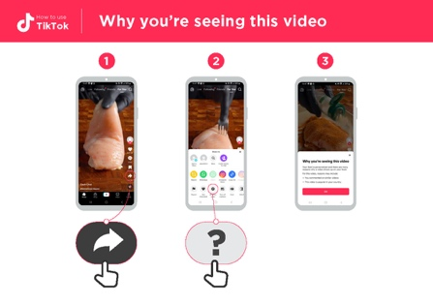
Show the ‘Why you’re seeing this video’ poster
Explain: “The ‘For You’ page shows videos that TikTok thinks you will like. This is based on where you are in the world, what videos you have watched before and what creators you like.”

Explain: “Everyone sees different videos on the ‘For You’ page, although you may get some videos that are the same as friends and family.”

Ask: “Are you interested in understanding why a video has been shown to you on your ‘For You’ screen?”
- Open the ‘For You’ page and ask the trainees to pick a video they like.

- Press the share button.

- Select the ‘why this video.’

Discuss the reasons they have been shown the video (e.g. the video is popular in their country).

In-Depth Training
TikTok

Mobile Internet
Skills Training

Toolkit

A guide for training people

in basic mobile internet skills

Posters and Cut-Outs
Session Ground Rules

This space is:

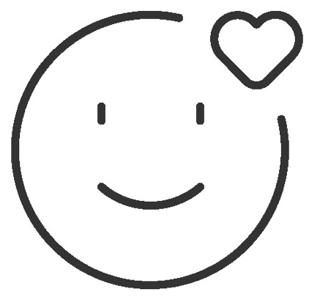

Safe

Keep all information in this training confidential. We suggest you don’t share personal numbers with the other members of group.

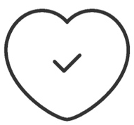

Positive & open

Please be respectful and
positive in your opinions and discussions. There are no right or wrong answers and we are not here to test you.

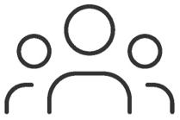

- shared
community

There are people with different backgrounds, knowledge and opinions. This is our shared space, so respect and support everyone.

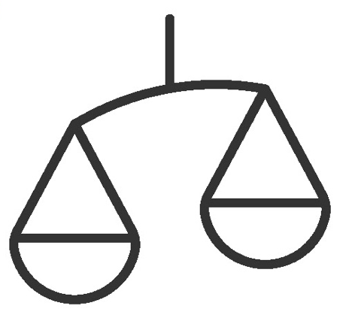

Fair

We will work in small groups and we will provide you with shared phones. We would like to give everyone an equal chance to be heard and to take turns using a phone.

Definitions

Trainers can add to this section to include local relevant information on mobile internet
3G / 4G / 5G | The internet can run at different speeds when you use it. 3G internet is the slowest, 4G internet is faster and 5G internet is the fastest.
App | An app gives you a shortcut to a service on your phone. For internet services e.g. WhatsApp, Facebook, Google, apps provide a quick and easy way to get onto the internet to use that service.
Address bar | The address bar shows you what website you are on.  In the address bar there will always be the address of the website e.g. www.google.com
Advert  or Ad | An ad is a piece of information that is trying to sell you something. It is good practice to avoid clicking on ads.  - Ads can be videos or images that pop up on your screen.  - Ads can also be the links at the top of Google results and on the right side of the screen.
Browser |   A web browser, or simply “browser,” is an application used to access and view websites. Common web browsers include:
Data | Whenever you use the internet on your phone, you are using data. You can buy data from your mobile network provider, just like you do with phone credit.
Feature  Phone | A mobile phone that has the ability to access the internet and store and play music but lacks the advanced functionality of a smartphone.
 | Google is an internet service that makes it easy to find any information that you want to find on the internet.

Definitions

Internet | The Internet is a network of millions of computers around the world connected to each other with phone lines, satellites and cables. It gives you access to a huge range of information and services and it is growing all the time. The internet is for everybody. There are no restrictions on who can use it. You just need a computer, mobile phone or tablet and a data connection.
Link | A link connects you from one website to another. To go to the other website, you can touch the link and this will connect you and take you to that other website
Megabytes & Gigabytes | Megabytes (MB) and Gigabytes (GB) are units of data that you use when using the mobile internet. GB are 1000 times bigger than MB. If you download or stream a song, that will use approximately 5MB (1MB per minute).
Search | The search function helps you find what you are looking for. You type the words to what you are looking for into a search box and then you will see a list of links to potential answers.
Smartphone | A mobile phone that has the ability to access the internet, store and play music and videos, and run ‘apps’. These phones typically also have a touchscreen.
Website | Information on the internet is kept on different websites. There are lots of separate and different websites on the internet e.g. Google is a website, YouTube is a website.
 | WhatsApp is an internet service that makes it easy to connect and communicate with people that you know; family, friends and colleagues.
WiFi | A WiFi zone is an area where you do not have to use your own  data to access the internet on your phone; you can connect to the internet for free. WiFi zones are available in some public places such as coffee shops and cafes.
 | YouTube is an internet service that makes it easy to find, watch and listen to videos on the internet (and only videos).

Trainers can add to this section to include local relevant information on mobile internet

Top tips to stay safe online

 | Remember that not everything you see online is real  Anyone can post anything online, so don’t believe everything you see. Even if it’s from someone you trust, it might not be true. Be careful before sharing information with others
 | Think twice before sending money to someone you meet online  Be careful with emails, messages or pop-ups you didn’t ask for, especially if they ask for money or contain strange links.
 | Keep your personal information private, including passwords  Avoid sharing personal details like your full name, home address or phone number unless absolutely necessary.
 | Don’t cause harm to others online  Be kind and respectful. Don’t bully, spread false information or harass anyone. Your actions online can affect people in real life.
 | Be aware of scams and fraudsters  Just like in real life, thieves and criminals are on the internet too.  Some people online pretend to be someone else.
 | Take action by blocking or ignoring someone who is bothering you  If someone is bothering or harassing you online, ask for help and tell someone or report it.

Remember that the internet is open to everyone around the world and so it is essential to treat it like a real-life public place (e.g. a marketplace) and stay safe by protecting yourself and being responsible with what you do online.

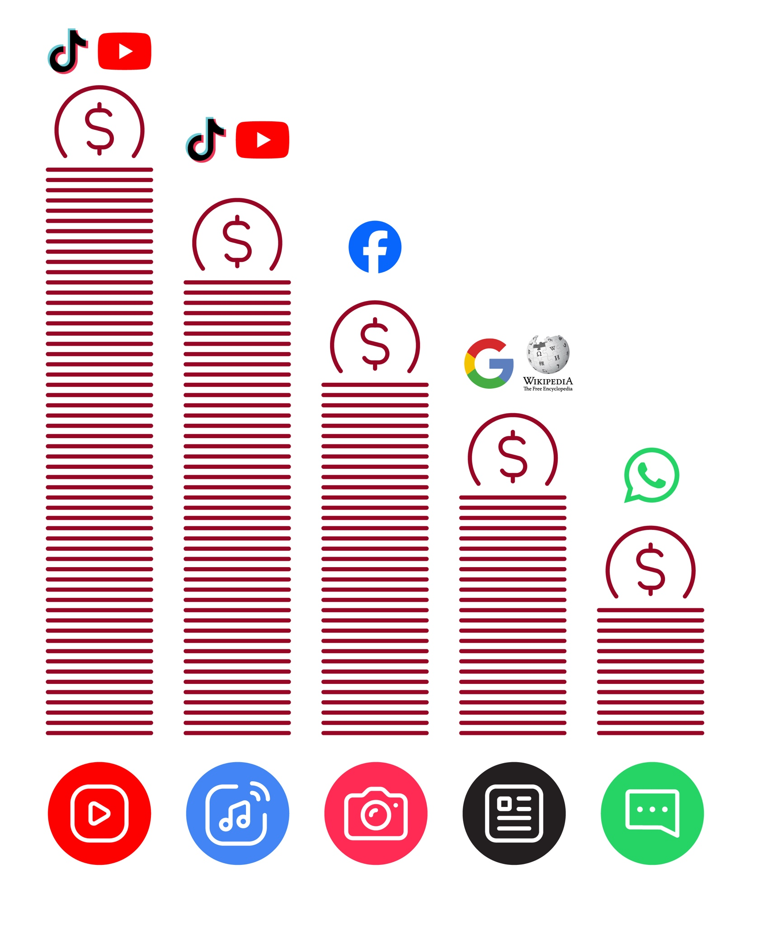
Data Costs
Healthy Internet Use

 | Set time limits  Think about how much time you are spending using the internet – it should not get in the way of your other responsibilities. If it does, set limits!
 | Watch your mood  If the internet or your phone is making you sad or angry, take a break!
 | Maintain healthy relationships online  Make time to socialise with friends and family in real life, not just on the internet! Don’t spend all your time on the internet.
 | Be careful  The internet can be dangerous with scams, harassment and things you don’t want to see. Be careful!
 | Stay positive  Stay positive and avoid upsetting or harming others. Be responsible and keep a positive attitude!
 | Get enough sleep and rest  Sleep and rest are important - make sure the internet or your phone doesn’t stop you doing this! Don’t use the internet when you need to rest or sleep.

How to create a TikTok account


How to use
TikTok




1 2 3 4 5
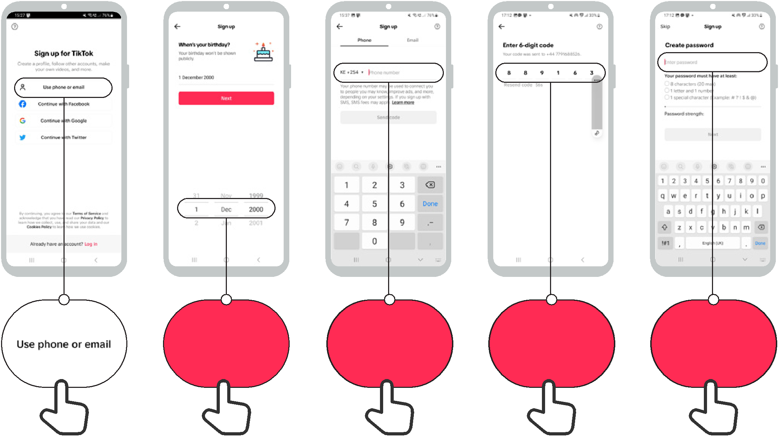

Enter birth date | Enter phone | Enter SMS | Create
Enter birth date | number | code | password

How to use
TikTok

How to search for videos on TikTok

1 2 3
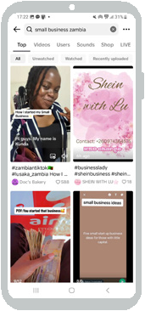



Enter search

How to use
TikTok


Understanding the TikTok ‘For You’ page

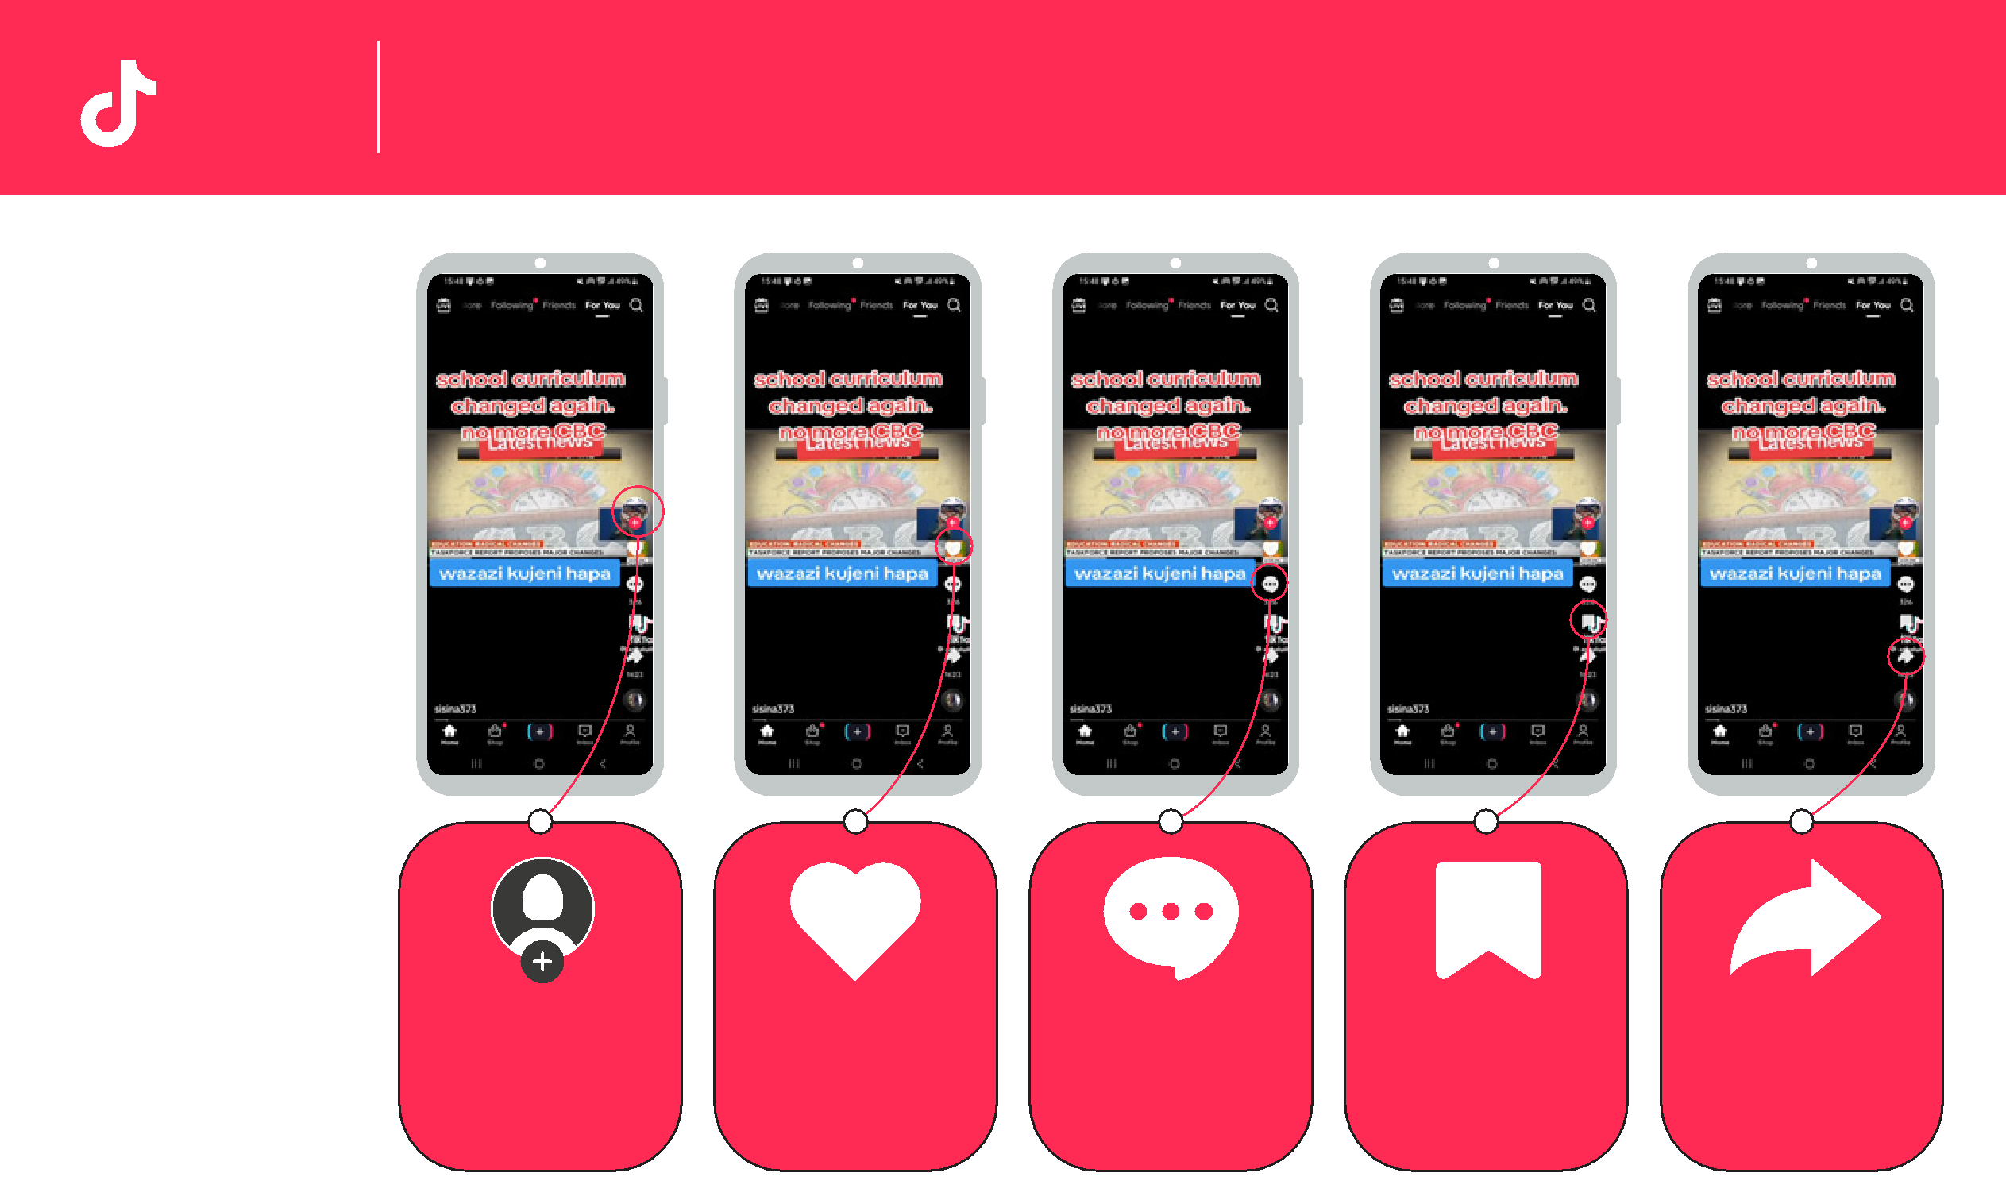

Search: | Creator’s profile: | Like: Pressing the heart | Comment if you want to | Favourite: Making this | Share: You can send this
Find videos you like. | The creator is the person | means you ‘like’ the video. | say something about this | video a ‘favourite’ means | video to your friends or
 | who made the video. You | You will get similar videos | video or look at what | you can put it on a list to | family – including by
 | can find more videos like | shown to you if you press | other people have said. | watch again later. | WhatsApp
 | this one. | ‘like’. The number is how | The number is how many
 |  | many people have liked it! | people have commented!



Swipe up: If you move |  | Swipe down: If you want
your finger up the screen |  | to see the last video again
you will move onto the |  | you can swipe your finger
next video! |  | down the screen

How to use
TikTok

How to ‘Favourite’ a video on TikTok

1 2 3
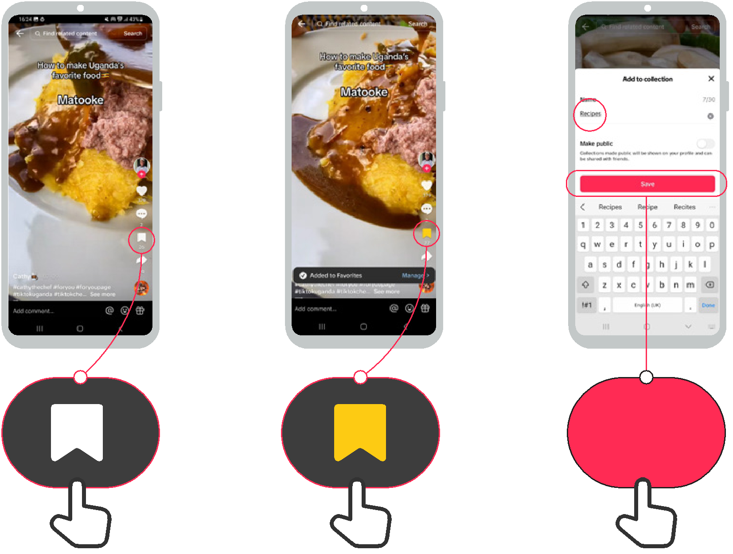

Save

How to use
TikTok

How to find ‘Favourite’ videos in TikTok

1 2 3
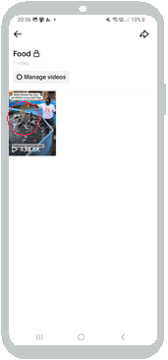



Collections

How to report a video on TikTok

How to use
TikTok



1 2 4 5
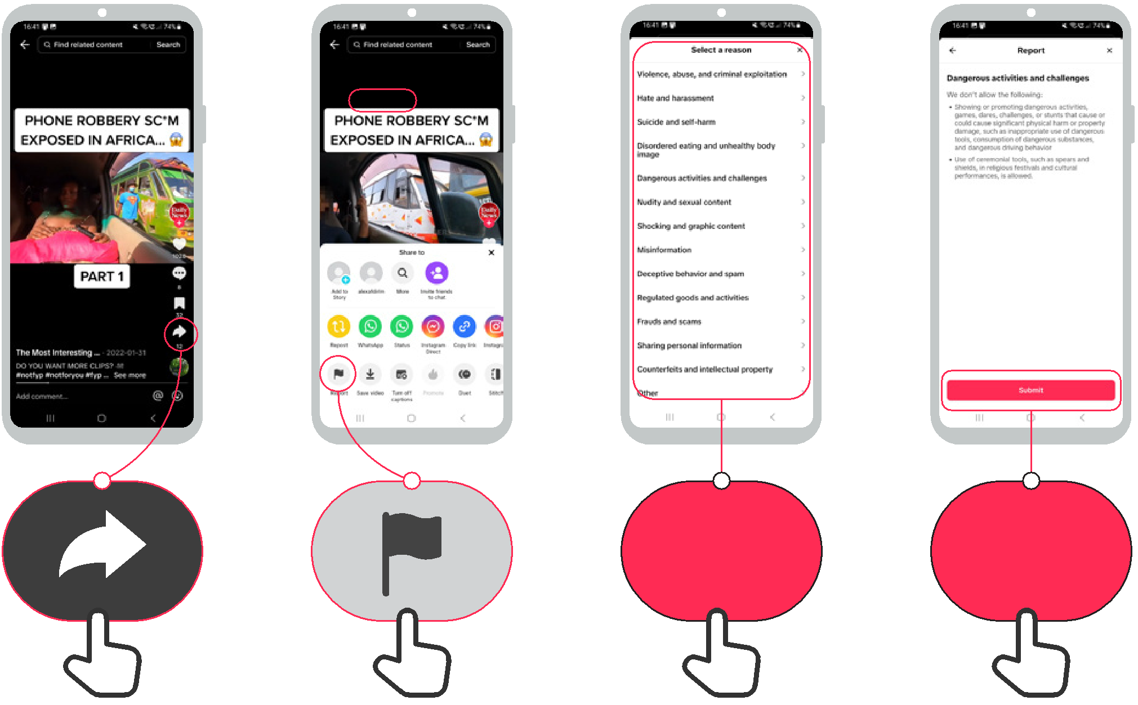

Collections Submit

How to use
TikTok

Turning on ‘data saver’ mode in TikTok

1 2 3 4 5

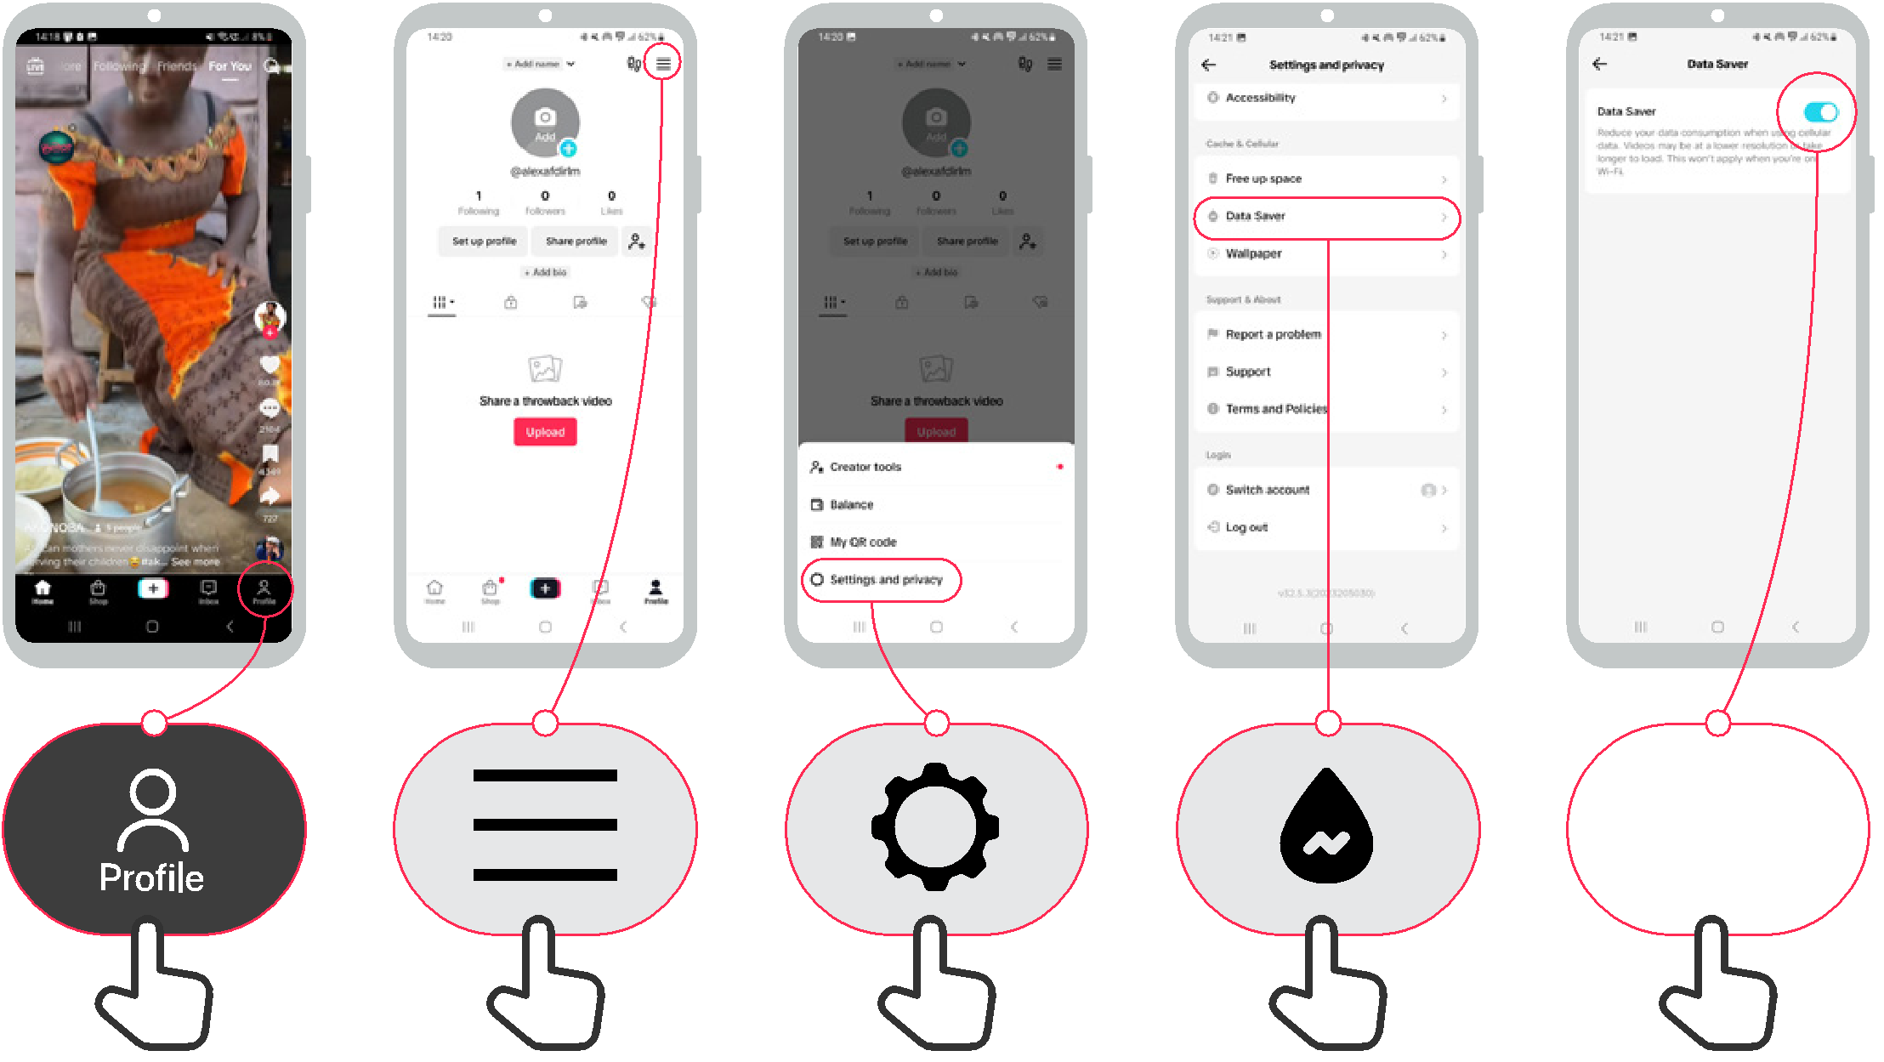

How to use
TikTok

Why you’re seeing this video

1 2 3
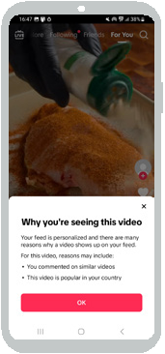




Icon Cut-Outs
TikTok


Icon Cut-Outs
TikTok


Icon Cut-Outs
TikTok


Icon Cut-Outs
TikTok



Icon Cut-Outs
TikTok


Icon Cut-Outs
TikTok


Icon Cut-Outs
TikTok



Icon Cut-Outs
TikTok




Mobile Internet Skills Training Toolkit

‘Thank you’ and close training

After you have completed the training, congratulate your trainees and hand out certificates as a reward.

Thank the trainees

Give out the handouts

- Give your trainees the handouts for the training if you haven’t already done so.

- These include the ‘Definitions’, ‘Top tips to stay safe online’, ‘Data costs’, ‘Healthy internet use’ and relevant module posters.

- Ask: “Do you feel confident to use these accessibility features?” or “Do you feel confident to use your mobile phone?”

- Thank your trainees for their time, input and participation in the training.





Conduct a closing ceremony

- Give each trainee a signed certificate (certificate templates are included in the toolkit).

- You can also provide the trainers with certificates for having completed the training ‘as trainers’.

Tip: You can make this more of a ceremony for trainees, by asking them to come up to the front of the room one person at a time to receive their certificate and shake the trainer’s hand.

here


CERTIFICATE

has completed

BASIC MOBILE INTERNET SKILLS

training

Date Signed



CERTIFICATE

has completed

BASIC MOBILE INTERNET SKILLS
training

Signed
Date

