

Mobile Internet
Skills Training
Toolkit
A guide for training people in
basic mobile internet skills

Copyright © 2024 GSM Association

Bitesize Training
WhatsApp

Mobile Internet
Skills Training

Toolkit

A guide for training people

in basic mobile internet skills
Module 2:
WhatsApp

What is it?
 | Show WhatsApp on the phone.  Explain: “WhatsApp is a messaging service, a bit like SMS, where you can also send voice messages, photos and message groups of people.”  “WhatsApp uses internet data so it can be cheaper to send messages, and the distance of the person you are messaging does not change the cost. For example, if you have a family member or friend who has moved to another country, you can message them on WhatsApp and it will not cost any more to message than if they were next door to your home.”
Materials you will need:

- Smartphone handsets
- WhatsApp posters

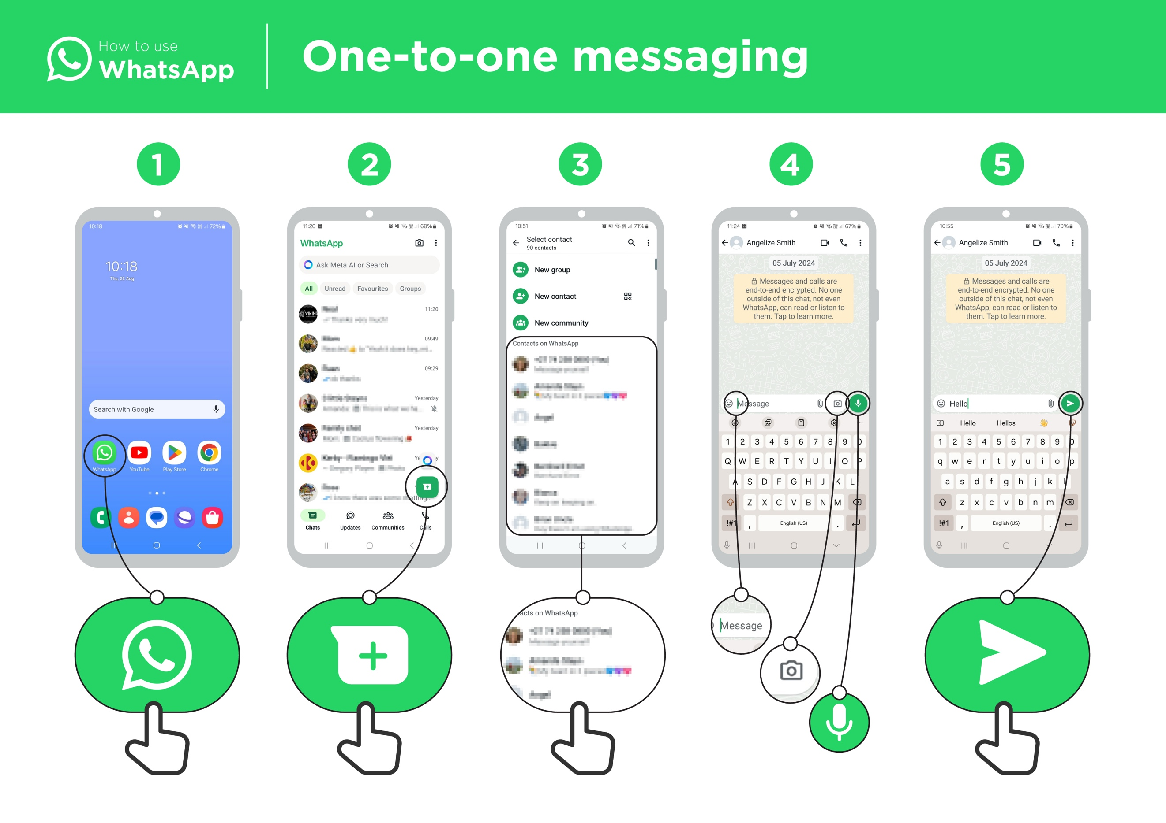

What can you use it for?
“You can use it for staying in touch easily with family and friends by making videos or voice calls or sending messages, voice notes, photos or videos.”

“You can also use it for connecting with big groups of colleagues/employees/classmates/customers/savings groups: advertising products, sharing advice, making business partnerships and deals, discussing notes or assignments from class.”

Share your own examples with the trainee about the benefits of WhatsApp and how you personally use it.
WhatsApp posters

What can you use it for?
Make it relevant to the trainee by discussing how it can be beneficial in the trainee’s own life. Consider examples that will be relevant to the following types of trainees:

Older person: Send and receive messages to share or receive life updates with family; find health information online.

Mother or homemaker: Contact health workers; stay in touch with friends and family; join mothers groups.

Business owner: Join entrepreneur groups for sharing advice; promote your products or services; sell to customers; inform customers about your latest goods.

Farmer or rural person: Join farmer groups; connect with buyers and other farmers; inform buyers about produce for sale.

Young person: Stay connected with friends, join groups such as for school, sports or employment opportunities.

How does it work?
Put the phone in the trainee’s hands and help them follow the steps.
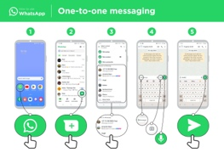
How to use WhatsApp – One-to-one messaging
Show the poster and go through the steps for sending a text, photo and voice message.

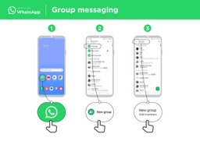

How to use WhatsApp – Group messaging
Show the poster and go through the steps for starting a group chat.

Safety
“Remember anyone can contact you on WhatsApp. Never share personal details such as mobile banking information, your address or other personal information over WhatsApp unless you know the person well.”
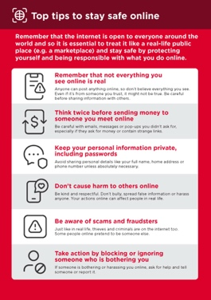

Show the ‘Top tips to stay safe online’ poster.

Discuss with your trainees what these tips mean when using WhatsApp.

Bring the tips to life by using examples that are relevant for your trainee. For example, some people may be worried about scammers using WhatsApp and some women may be more concerned about how to prevent harassment.
Practise!

“Now you know how to use WhatsApp, what do you want to use it for?”

Trainer: Provide support for the trainee to send WhatsApp messages to contacts on their phone that they want to message.

Explain that there are similar messaging services to WhatsApp. Others include Messenger, WeChat, Telegram and Viber.
Tip: “WhatsApp has many features. For example, you can call people through WhatsApp, or share your location on a map with your contacts on WhatsApp so that they know where you are.”

Bitesize Training
WhatsApp

Posters and Cut-Outs

Mobile Internet
Skills Training

Toolkit

A guide for training people

in basic mobile internet skills

Top tips to stay safe online

 | Remember that not everything you see online is real  Anyone can post anything online, so don’t believe everything you see. Even if it’s from someone you trust, it might not be true. Be careful before sharing information with others
 | Think twice before sending money to someone you meet online  Be careful with emails, messages or pop-ups you didn’t ask for, especially if they ask for money or contain strange links.
 | Keep your personal information private, including passwords  Avoid sharing personal details like your full name, home address or phone number unless absolutely necessary.
 | Don’t cause harm to others online  Be kind and respectful. Don’t bully, spread false information or harass anyone. Your actions online can affect people in real life.
 | Be aware of scams and fraudsters  Just like in real life, thieves and criminals are on the internet too.  Some people online pretend to be someone else.
 | Take action by blocking or ignoring someone who is bothering you  If someone is bothering or harassing you online, ask for help and tell someone or report it.
Remember that the internet is open to everyone around the world and so it is essential to treat it like a real-life public place (e.g. a marketplace) and stay safe by protecting yourself and being responsible with what you do online.

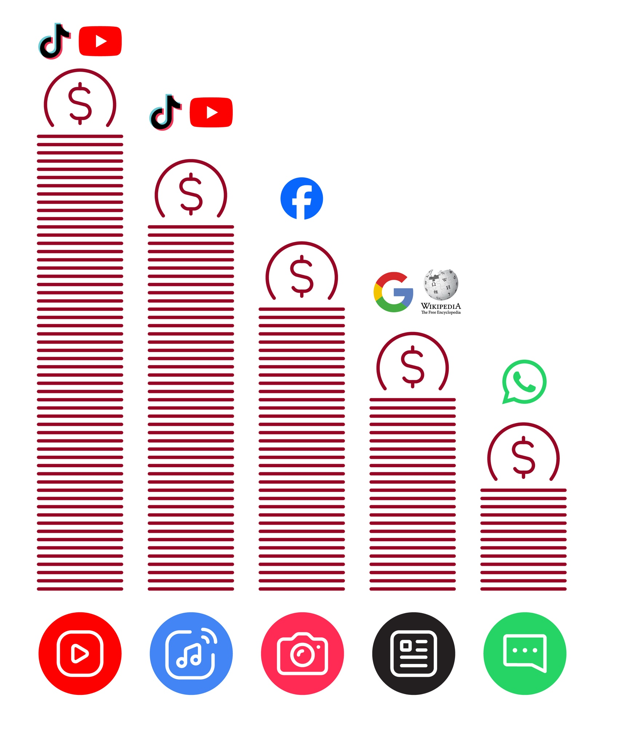
Data Costs
How to use
WhatsApp
One-to-one messaging



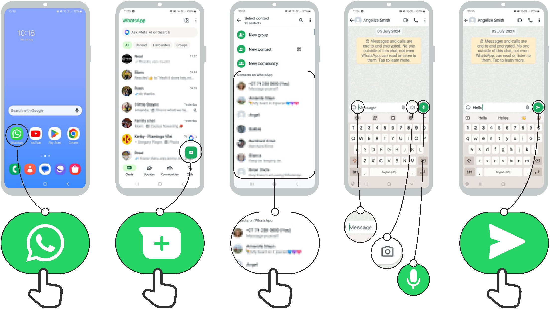
1 2 3 4 5

How to use
WhatsApp

Group messaging

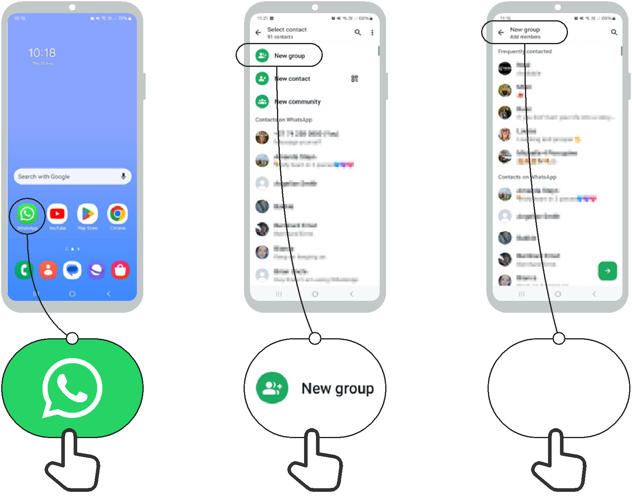

1 2 3

How to use
WhatsApp
How to block

1 2 3 4

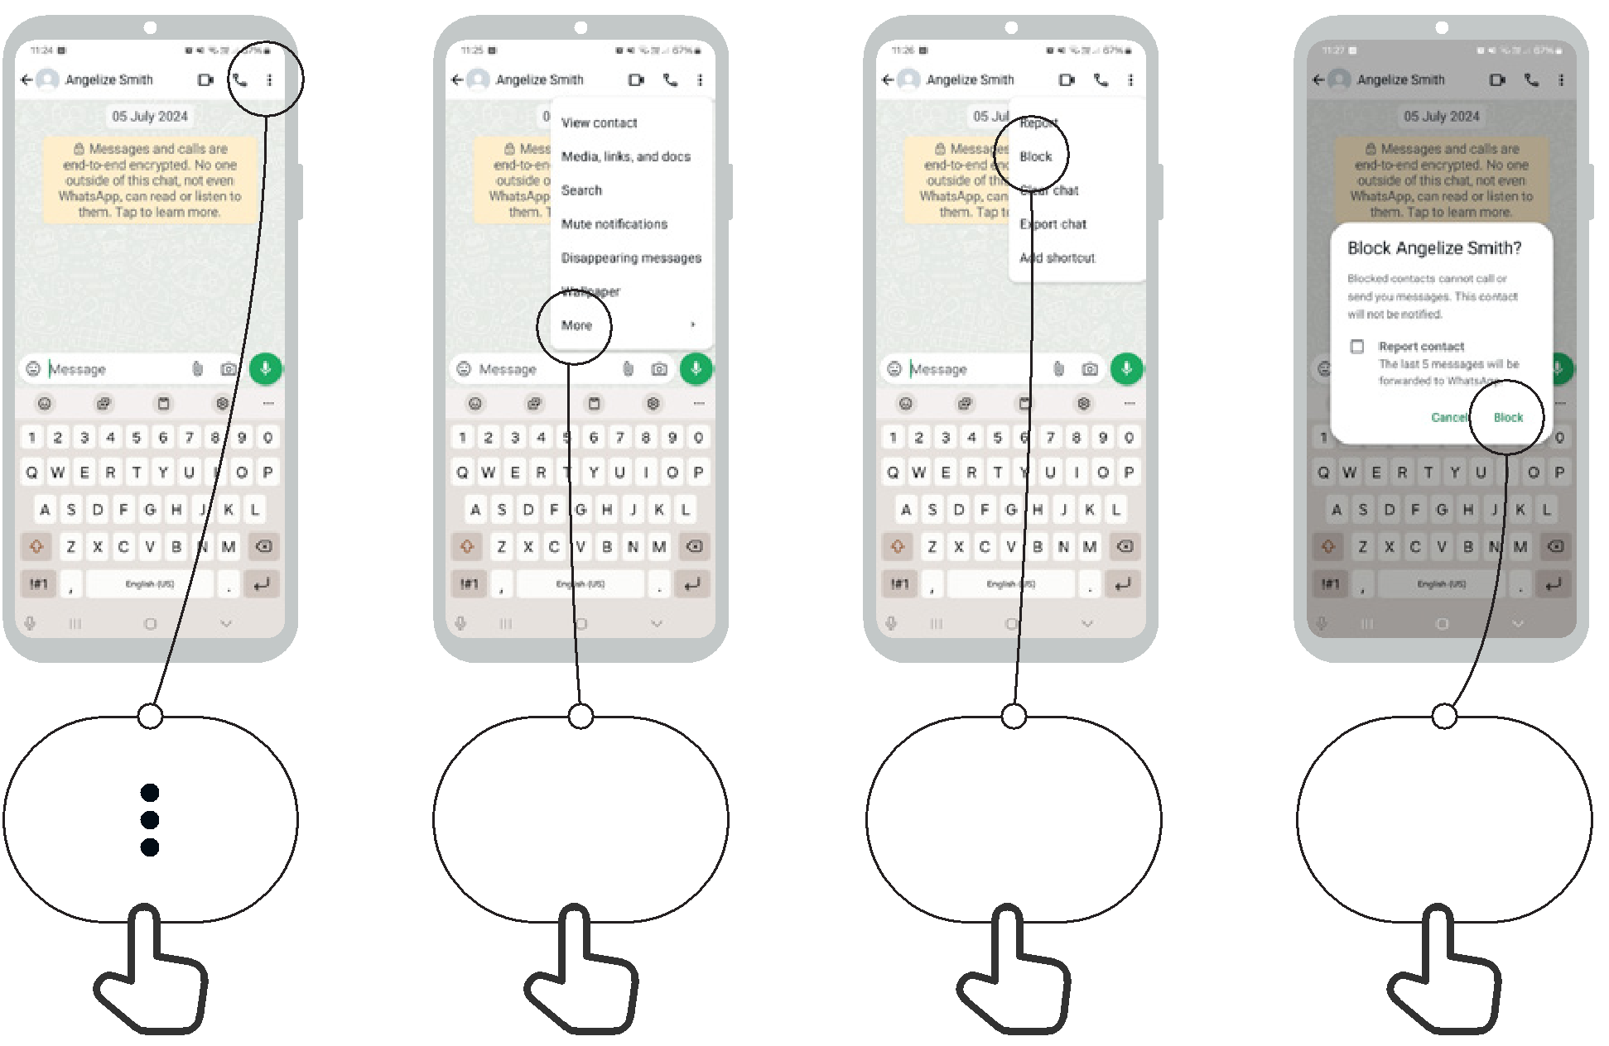

More Block Block


Icon Cut-Outs
WhatsApp



Icon Cut-Outs
WhatsApp


Icon Cut-Outs
WhatsApp



Icon Cut-Outs
WhatsApp



Icon Cut-Outs
WhatsApp

Icon Cut-Outs
WhatsApp



