

Mobile Internet
Skills Training
Toolkit
A guide for training people in
basic mobile internet skills

Copyright © 2024 GSM Association
In-Depth Training
WhatsApp

Mobile Internet
Skills Training

Toolkit

A guide for training people

in basic mobile internet skills

Module 2:
WhatsApp

Learning objectives
- The trainees understand how to communicate on WhatsApp.

- The trainees feel excited and motivated about how tools like WhatsApp can be used to connect with people.
Time duration
45-60
minutes

Materials you will need:
  Paper, pens and masking tape |   Smartphone handset |   Small rewards | 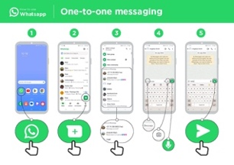  WhatsApp  posters x3
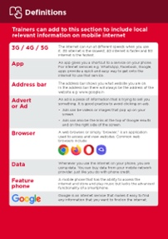  Glossary  handouts | 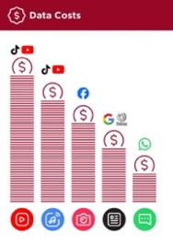  Cost poster | 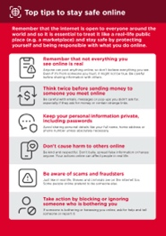  Safety tips |   Icon cut-outs

Introduce WhatsApp

Show trainees the WhatsApp icon cut-out and ask them to find this on their phone

Ask: “Does anyone know what this is?” and “what is it for?”
Bring the benefits to life!
Tell your own story of how WhatsApp is useful for you (the trainer), your friends and family or your community. Consider examples that will be relevant for these trainees:

Older person: Send and receive messages to share or receive life updates with family; find health information online.

Mother or homemaker: Contact health workers; stay in touch with friends and family; join mothers groups.

Business owner: Join entrepreneur groups for sharing advice; promote your products or services; sell to customers; inform customers about your latest goods.

Farmer or rural person: Join farmer groups; connect with buyers and other farmers; inform buyers about produce for sale.
Young person: Stay connected with friends, join groups such as for school, sports or employment opportunities.
Make WhatsApp relevant for your trainees
Discuss with trainees how WhatsApp can be beneficial in their own lives.

- Ask: “What would you like to use WhatsApp for in your own life?” Give them some suggestions based on their interests.

- Ask: “What are you most interested in and excited to learn about WhatsApp?”

Give a short explanation of WhatsApp
- “WhatsApp makes it easy to connect and chat with people, family, friends and colleagues.”

- “WhatsApp is a messaging service, a bit like SMS, but you can also send voice messages, photos and videos, as well as message groups of people. WhatsApp uses internet data rather than phone credit. This means it can be cheaper to send messages, and the distance of the person you are messaging does not change the cost.”
Remember: Link discussions and activities in the training back to how the internet can be helpful or useful in your trainees’ own lives. This will help to keep the training relevant and interesting for them.

Activity: One-to-one messaging


Get practical!

Explain: “You are now going to try using WhatsApp on the phone.”
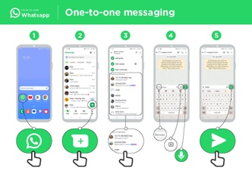
Show the ‘How to use WhatsApp: One-to-one
messaging’ poster
- Explain: “This poster shows the steps for sending one-to-one messages on WhatsApp.”
- Take your trainees through the steps on their shared phones and explain that you can send text, images or voice messages.
- Ask them to send messages to each other on the phones.
  - Send a text message greeting:  - Hold up the chat icon for WhatsApp.  - Explain where to find it and demonstrate how to use it.  - Ask the trainees to send text message greetings to each other. |   3. Send a voice message greeting:  - Hold up the microphone icon for WhatsApp.  - Explain about the microphone, where to find it and demonstrate how to use it.  - Ask the trainees to send voice message greetings to each other.  - Explain: “When you send someone a WhatsApp message, you can see if it has been delivered to their phone and if they have read it.”    Message successfully sent.   Message successfully delivered to the recipient’s phone.   The recipient has read your message.  - Ask: “Can you think of some examples of when you would send a voice message or a picture rather than a text message?”

  - Send a selfie photo of their group:
- Hold up the camera icon for WhatsApp.
- Explain about the camera, where to find it and demonstrate how to use it.
- Ask the trainees to send these photos to each other.

Tip: Leave the trainees’ WhatsApp group open for the rest of the training and ask trainees to keep participating in the group chat, e.g. ask them to share their thoughts, feelings, any pictures and feedback in the group chat.

Activity: Group messaging
Explain: “You are now going to try using group chat.”

Explain: “On WhatsApp, more than one person can be in the same group conversation.”
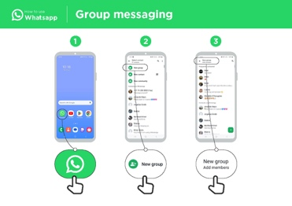
Show the ‘Group messaging’ poster
• Explain: “This poster shows the initial steps to create a WhatsApp
group.”

• Demonstrate how to create a WhatsApp group and invite your
trainees, on their shared phones, to all join one WhatsApp group
(send invites using the numbers for the shared phones).

• Send a text or a voice message to the trainees’ WhatsApp group,
asking the trainees to share their group selfies in the group chat.

• Ask: “Can you think of examples of when you would use group
messaging rather than one-to-one messaging?”

Personal use
Discuss with your trainees how WhatsApp can be beneficial in their own lives.

- Ask: “Now you know how to use WhatsApp, what do you want to use it for in your own life?” Give them some suggestions based on their interests.

- Ask: “What are you most interested in and excited about doing, now that you are learning how to use WhatsApp?”

Safety
Ask: “What does safety mean to you?”

Ask your trainees to imagine they are in a typical public place, like the market. Ask them to discuss what they would do to keep safe in this place. Prompt them with the following questions and answers:
Prompts | Potential answers
What do you do if someone you don’t | You avoid or ignore them. Be careful,
know bothers you? | they are not always who they say they are
What do you do if someone you | You don’t give out personal
don’t know or trust asks you for your | information to someone you don’t
personal information? | know or trust because they may
 | misuse it.
What do you do if you feel unsure or | Tell someone you know and trust
uncomfortable about something you | about what happened.
see or experience?
How do you treat people you interact | You are polite and respectful to people.
with?
Explain: “It is important to remember the internet is also public place, and it is important to treat it like a public place and stay safe.”

Tip: Give your trainees as much time as they need to explore and feel comfortable with the phone.

Safety
Show the ‘Top tips to stay safe online’ poster

- Discuss with your trainees what these tips mean for using the internet.

- Bring the tips to life by using examples that are relevant for your trainees. For example, women may be more concerned about how to prevent harassment.
Tip: “Remember anyone can contact you on WhatsApp. Never share personal details such as mobile banking information, your address or other personal information over WhatsApp unless you know the person well.”

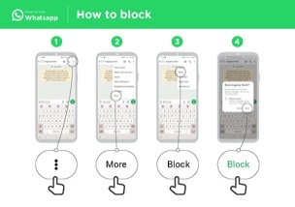
WhatsApp safety

- Ask: “If someone you do not know tries to message you, or someone tries to bother you on WhatsApp and you don’t want them to, what can you do?”

- Explain: “On WhatsApp you can block them so they can’t contact you again on the same number.”

- Show the ‘Block process’ poster and demonstrate how to block people on WhatsApp.

Cost
Explain: “Now you know how to use WhatsApp and understand what it can be used for, let’s talk about how much it costs to use. To use the internet on your phone, you have to buy data from your mobile network provider. The cost of each WhatsApp message is much cheaper than SMS. If the person you are messaging is far away (even in another country), it does not change the cost – they can be in another state or next door to your home.”
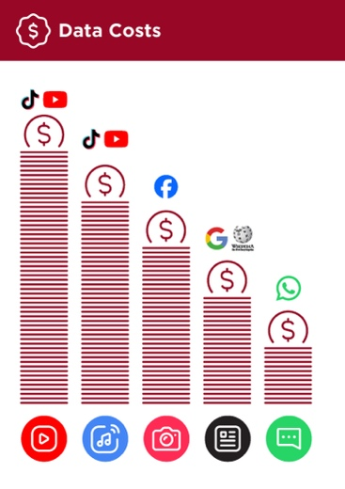
Show the ‘Data costs’ poster

- Ask: “Different activities use different amounts of data. Looking at text uses the least data, looking at images uses more, playing and downloading music uses a bit more and playing videos uses the most.”

- Explain: “Some internet services are linked to activities that use more data.”

- Ask: “Where is WhatsApp on the poster?” and “what does that mean for how much it tends to cost?”

- Ask: “What makes it cost more?” Answer: “Videos.”

- Ask: “What makes it cost less?” Answer: “Using text.”

Cost
Checking data

- Ask: “Why is it useful to check how much data you have used?”
- Answer: “To understand how much of your data you have used up and how much different activities cost to do.”
- Explain: “You can check how much data you have, just like you check how many minutes or texts you have by typing in a code on your phone from your mobile network.”
- Explain: “You can buy data in different amounts depending on what you are going to use the internet for. Ask advice from your local mobile agent on which amount is best suited to you.”
- Explain: “If you access the internet in a Wi-Fi zone, you will not use your data package. Your local mobile agent may be able to help you find your local Wi-Fi zones. However, the nearest zone may be too far to travel to.”
- Demonstrate to your trainees how to check their data.
Tip: The data checking process varies depending on which country you are in and which network the phone is on. Ask a mobile agent if you need support with how to check data.

Recap
Play the WhatsApp icon game

- Hold up each WhatsApp icon, one at a time.

- Ask: “Where is this on the phone and what is it?”

- Explain to your trainees what each icon is if they need support.

- Give small rewards (e.g. sweets) for correct answers and stick the icons on the wall afterwards to help remind your trainees what they are.

Tip: “Many apps and services on the internet use similar icons and words. When you are using the internet, look out for these icons so next time you see them, you can remember what they mean.”

Explain: “There are similar messaging services to WhatsApp. Hike is a popular service in India that is similar to WhatsApp but also allows you to send graphical stickers.”

Recap on WhatsApp
Discuss with your trainees what they have learned about using WhatsApp.

- “What have you learned about using WhatsApp?” and “what can you use it for?”

- “How is it different from SMS?” and “what can you do with WhatsApp that you can’t do with SMS?”

- “Do you still have any concerns about using WhatsApp?”

- “What do you want to use WhatsApp for in your own life? What are you most interested in and excited about using it for?”
Tip: Run the recap as a quiz and give rewards (e.g. sweets) to trainees for playing.

Tip: If trainees would like to access the internet and WhatsApp on their own phones, give them some time here to practise what they’ve learned and offer support and encouragement.

Going to the next level
If you reach the end of the session and have extra time:

- Ask: “Do you have any further questions about anything we have covered in the session?”

- Ask: “What else would you like to know about WhatsApp?”

Some more advanced features you can discuss with your trainees include:

- Uploading photos from your photo gallery to a WhatsApp conversation.

- Sharing your location on WhatsApp so that friends and family know where you are.

- Setting up a WhatsApp profile, including privacy settings.

- Downloading apps from the app store (you will need to cover email, as having email is necessary to download apps).

In-Depth Training
WhatsApp

Mobile Internet
Skills Training

Toolkit

A guide for training people

in basic mobile internet skills

Posters and Cut-Outs
Session Ground Rules

This space is:

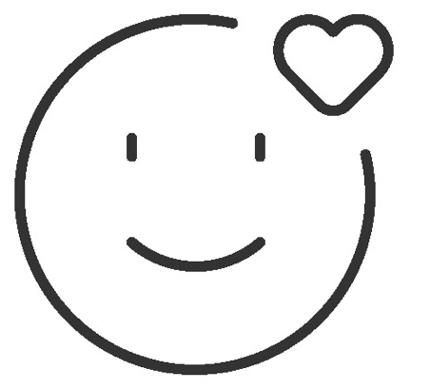

Safe

Keep all information in this training confidential. We suggest you don’t share personal numbers with the other members of group.

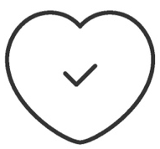

Positive & open

Please be respectful and
positive in your opinions and discussions. There are no right or wrong answers and we are not here to test you.

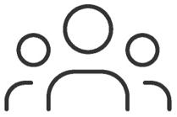

- shared
community

There are people with different backgrounds, knowledge and opinions. This is our shared space, so respect and support everyone.

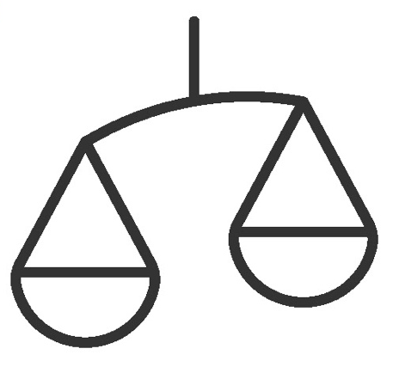

Fair

We will work in small groups and we will provide you with shared phones. We would like to give everyone an equal chance to be heard and to take turns using a phone.

Definitions

Trainers can add to this section to include local relevant information on mobile internet
3G / 4G / 5G | The internet can run at different speeds when you use it. 3G internet is the slowest, 4G internet is faster and 5G internet is the fastest.
App | An app gives you a shortcut to a service on your phone. For internet services e.g. WhatsApp, Facebook, Google, apps provide a quick and easy way to get onto the internet to use that service.
Address bar | The address bar shows you what website you are on.  In the address bar there will always be the address of the website e.g. www.google.com
Advert  or Ad | An ad is a piece of information that is trying to sell you something. It is good practice to avoid clicking on ads.  - Ads can be videos or images that pop up on your screen.  - Ads can also be the links at the top of Google results and on the right side of the screen.
Browser |   A web browser, or simply “browser,” is an application used to access and view websites. Common web browsers include:
Data | Whenever you use the internet on your phone, you are using data. You can buy data from your mobile network provider, just like you do with phone credit.
Feature  phone | A mobile phone that has the ability to access the internet and store and play music but lacks the advanced functionality of a smartphone.
 | Google is an internet service that makes it easy to find any information that you want to find on the internet.

Definitions

Internet | The Internet is a network of millions of computers around the world connected to each other with phone lines, satellites and cables. It gives you access to a huge range of information and services and it is growing all the time. The internet is for everybody. There are no restrictions on who can use it. You just need a computer, mobile phone or tablet and a data connection.
Link | A link connects you from one website to another. To go to the other website, you can touch the link and this will connect you and take you to that other website
Megabytes & Gigabytes | Megabytes (MB) and Gigabytes (GB) are units of data that you use when using the mobile internet. GB are 1000 times bigger than MB. If you download or stream a song, that will use approximately 5MB (1MB per minute).
Search | The search function helps you find what you are looking for. You type the words to what you are looking for into a search box and then you will see a list of links to potential answers.
Smartphone | A mobile phone that has the ability to access the internet, store and play music and videos, and run ‘apps’. These phones typically also have a touchscreen.
Website | Information on the internet is kept on different websites. There are lots of separate and different websites on the internet e.g. Google is a website, YouTube is a website.
 | WhatsApp is an internet service that makes it easy to connect and communicate with people that you know; family, friends and colleagues.
WiFi | A WiFi zone is an area where you do not have to use your own  data to access the internet on your phone; you can connect to the  internet for free. WiFi zones are available in some public places  such as coffee shops and cafes.
 | YouTube is an internet service that makes it easy to find, watch and listen to videos on the internet (and only videos).

Trainers can add to this section to include local relevant information on mobile internet

Top tips to stay safe online

 | Remember that not everything you see online is real  Anyone can post anything online, so don’t believe everything you see. Even if it’s from someone you trust, it might not be true. Be careful before sharing information with others.
 | Think twice before sending money to someone you meet online  Be careful with emails, messages or pop-ups you didn’t ask for, especially if they ask for money or contain strange links.
 | Keep your personal information private, including passwords  Avoid sharing personal details like your full name, home address or phone number unless absolutely necessary.
 | Don’t cause harm to others online  Be kind and respectful. Don’t bully, spread false information or harass anyone. Your actions online can affect people in real life.
 | Be aware of scams and fraudsters  Just like in real life, thieves and criminals are on the internet too.  Some people online pretend to be someone else.
 | Take action by blocking or ignoring someone who is bothering you  If someone is bothering or harassing you online, ask for help and tell someone or report it.

Remember that the internet is open to everyone around the world and so it is essential to treat it like a real-life public place (e.g. a marketplace) and stay safe by protecting yourself and being responsible with what you do online.

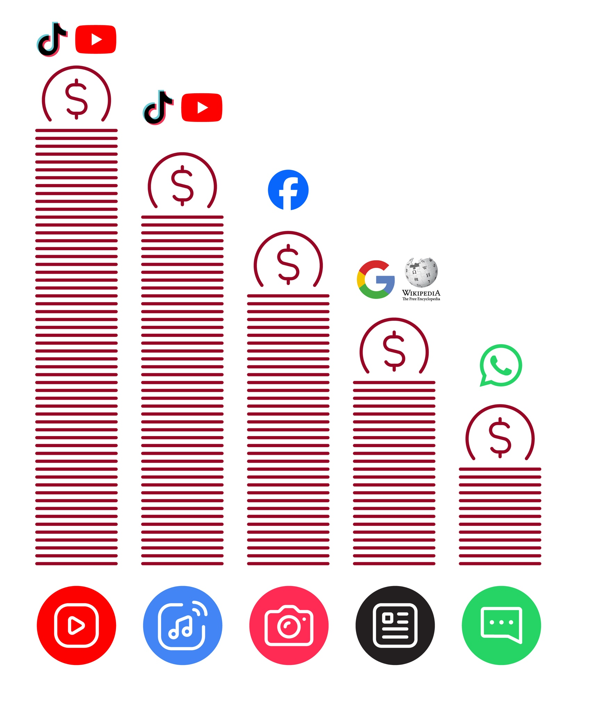
Data Costs
Healthy Internet Use

 | Set time limits  Think about how much time you are spending using the internet – it should not get in the way of your other responsibilities. If it does, set limits!
 | Watch your mood  If the internet or your phone is making you sad or angry, take a break!
 | Maintain healthy relationships online  Make time to socialise with friends and family in real life, not just on the internet! Don’t spend all your time on the internet.
 | Be careful  The internet can be dangerous with scams, harassment and things you don’t want to see. Be careful!
 | Stay positive  Stay positive and avoid upsetting or harming others. Be responsible and keep a positive attitude!
 | Get enough sleep and rest  Sleep and rest are important - make sure the internet or your phone doesn’t stop you doing this! Don’t use the internet when you need to rest or sleep.

One-to-one messaging
How to use
WhatsApp



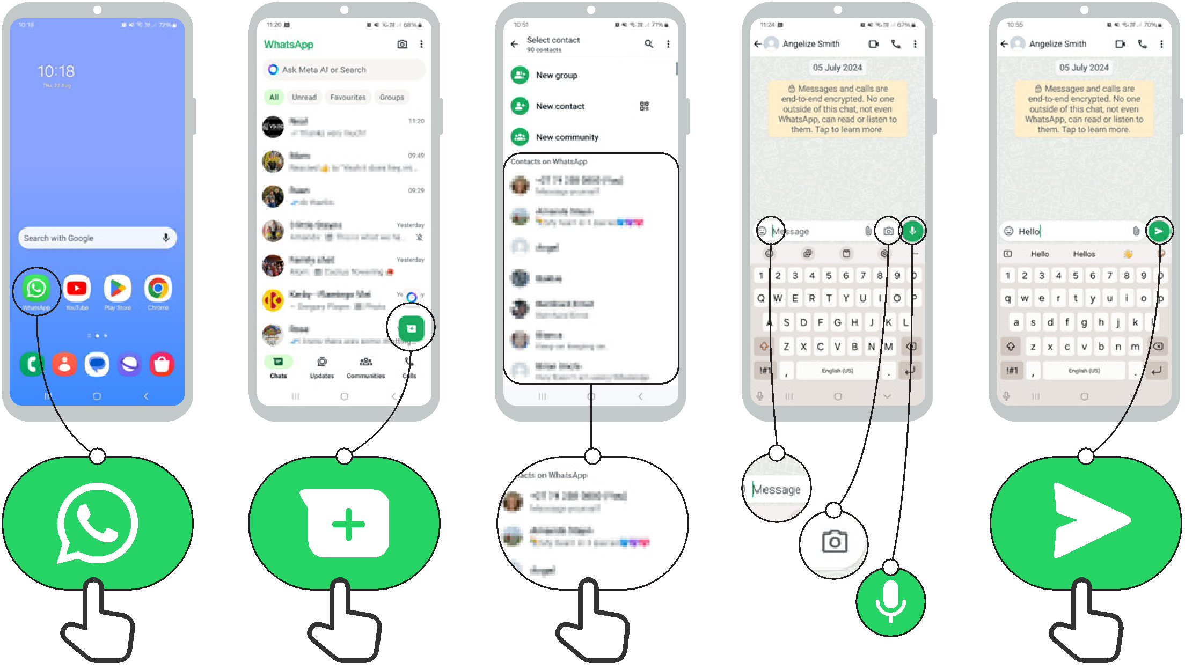
1 2 3 4 5

How to use
WhatsApp

Group messaging

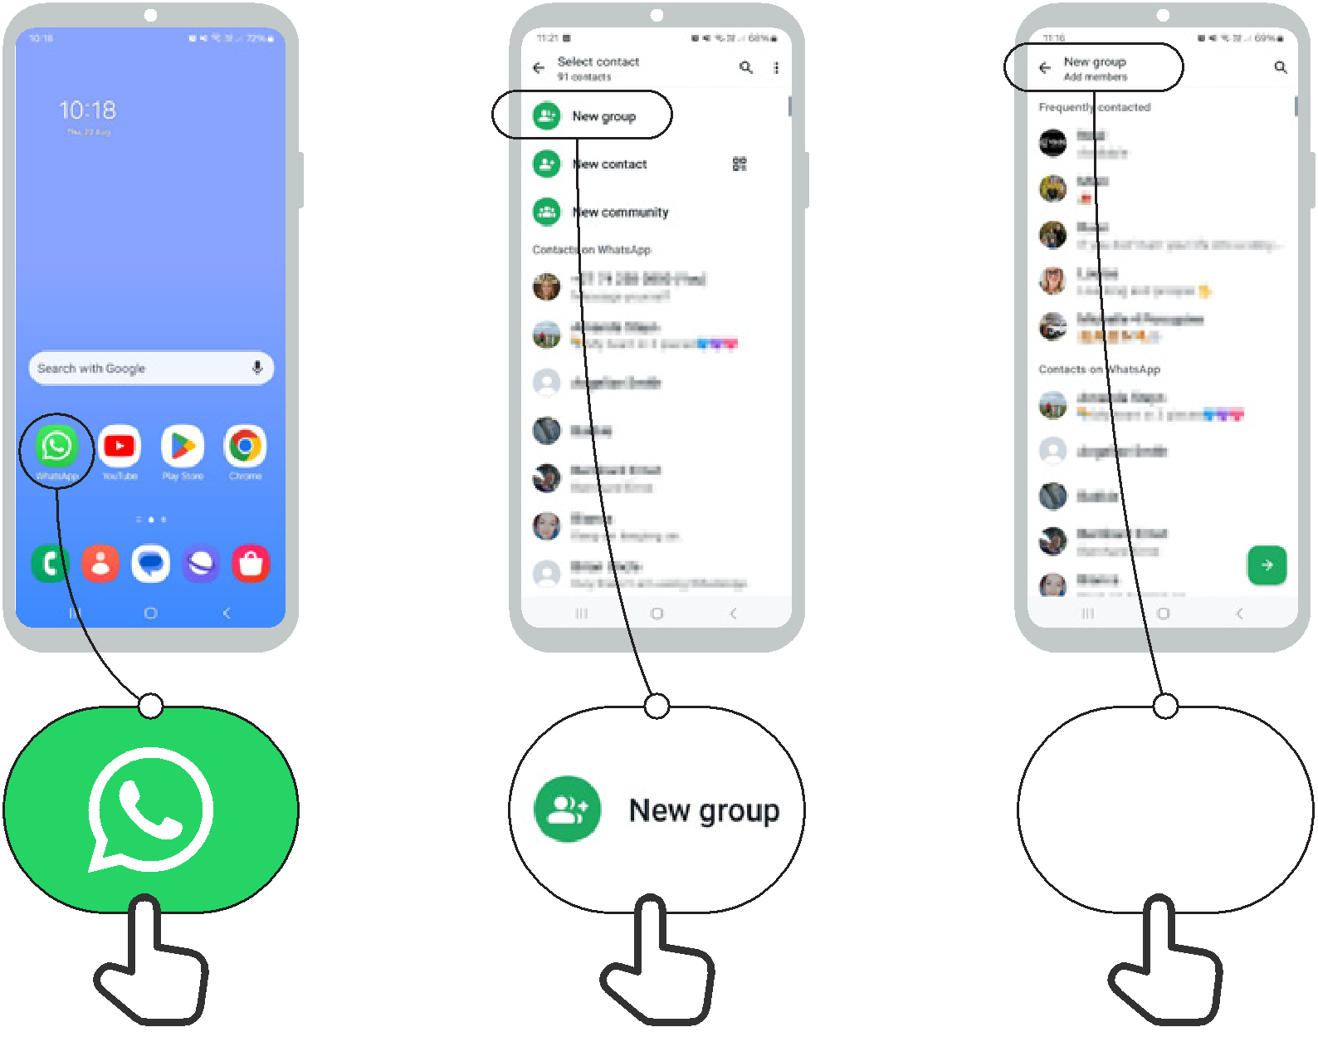
1 2 3


How to use
WhatsApp
How to block

1 2 3 4

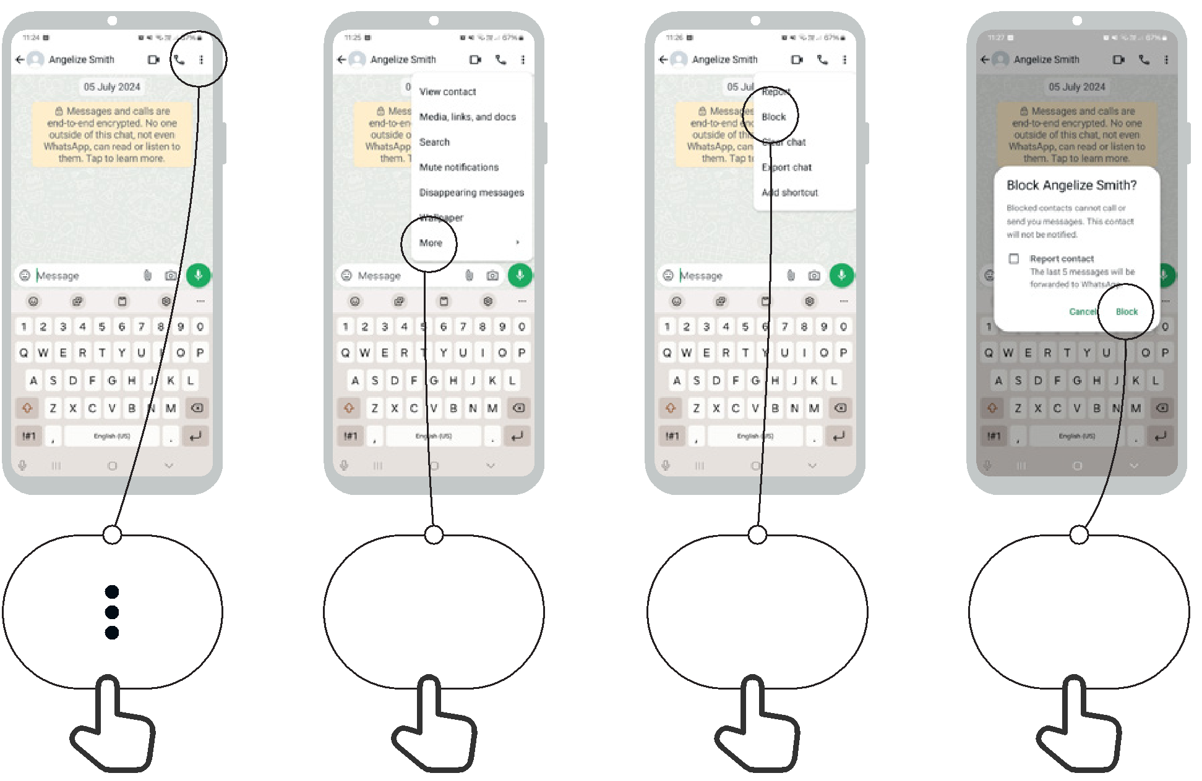

More Block Block


Icon Cut-Outs
WhatsApp



Icon Cut-Outs
WhatsApp


Icon Cut-Outs
WhatsApp



Icon Cut-Outs
WhatsApp



Icon Cut-Outs
WhatsApp

Icon Cut-Outs
WhatsApp




Mobile Internet Skills Training Toolkit

‘Thank you’ and close training

After you have completed the training, congratulate your trainees and hand out certificates as a reward.

Thank the trainees

Give out the handouts

- Give your trainees the handouts for the training if you haven’t already done so.

- These include the ‘Definitions’, ‘Top tips to stay safe online’, ‘Data costs’, ‘Healthy internet use’ and relevant module posters.

- Ask: “Do you feel confident to use these accessibility features?” or “Do you feel confident to use your mobile phone?”

- Thank your trainees for their time, input and participation in the training.

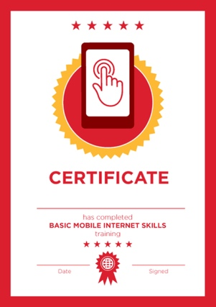

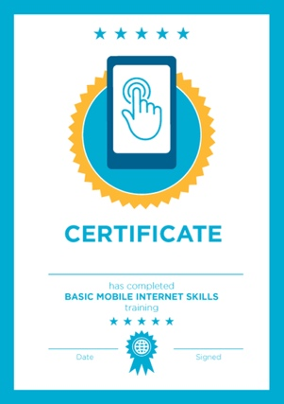

Conduct a closing ceremony

- Give each trainee a signed certificate (certificate templates are included in the toolkit).

- You can also provide the trainers with certificates for having completed the training ‘as trainers’.

Tip: You can make this more of a ceremony for trainees, by asking them to come up to the front of the room one person at a time to receive their certificate and shake the trainer’s hand.

here


CERTIFICATE

has completed

BASIC MOBILE INTERNET SKILLS

training

Date Signed

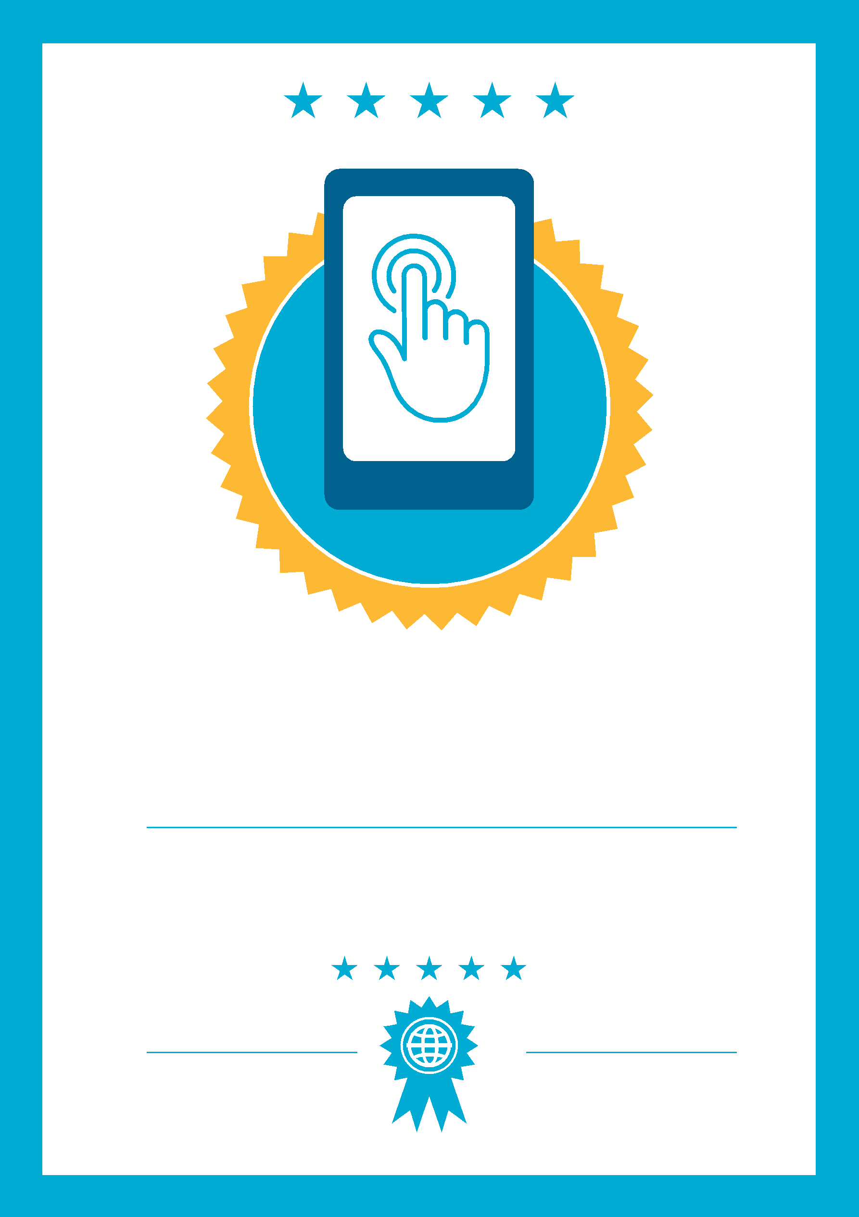

CERTIFICATE

has completed

BASIC MOBILE INTERNET SKILLS
training

Signed
Date

