
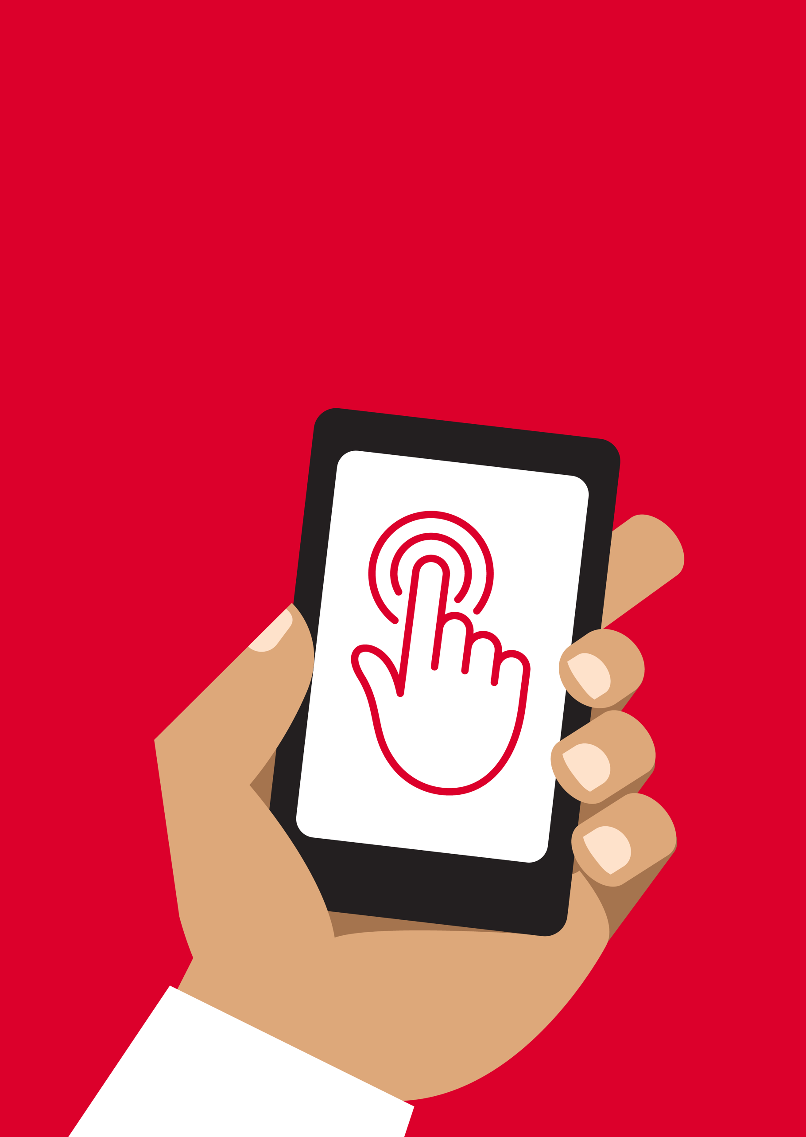

Mobile Internet
Skills Training
Toolkit
A guide for training people in
basic mobile internet skills
Copyright © 2024 GSM Association
Copyright © 2024 GSM Association
Bitesize Training
Wikipedia

Mobile Internet
Skills Training

Toolkit

A guide for training people

in basic mobile internet skills

Module 5:
Wikipedia


What is it?
 | Show Wikipedia on the phone.  Explain: “Wikipedia is a free internet reference (or encyclopedia), which provides neutral, factual information about educational topics. It is often the first site to appear when you do a Google search, or you can type the word ‘wiki’ along with the words you are searching for.”  “Wikipedia is written by ordinary people, all over the world. People make changes to the site every hour. You can make sure the information you find is reliable by looking at the bottom of every page where the sources of information are listed.”
What can you use it for?
“You can use Wikipedia to search many different subjects. For example, you can search for information about sports, music, history, other countries or science.”

“You can use Wikipedia to search for information on your tribe, your president, a type of plant you may want to grow, or subject of study for school.”

“Wikipedia is available in almost 300 languages. Each is written by people who speak that language, so some Wikipedias have more articles than others. For example, French Wikipedia has 2 million articles, but there are more than 5 million articles on English Wikipedia.”

Share your own examples with the trainee about the benefits of Wikipedia and how you personally use it.
Materials you will need:

- Smartphone handsets
- Wikipedia posters

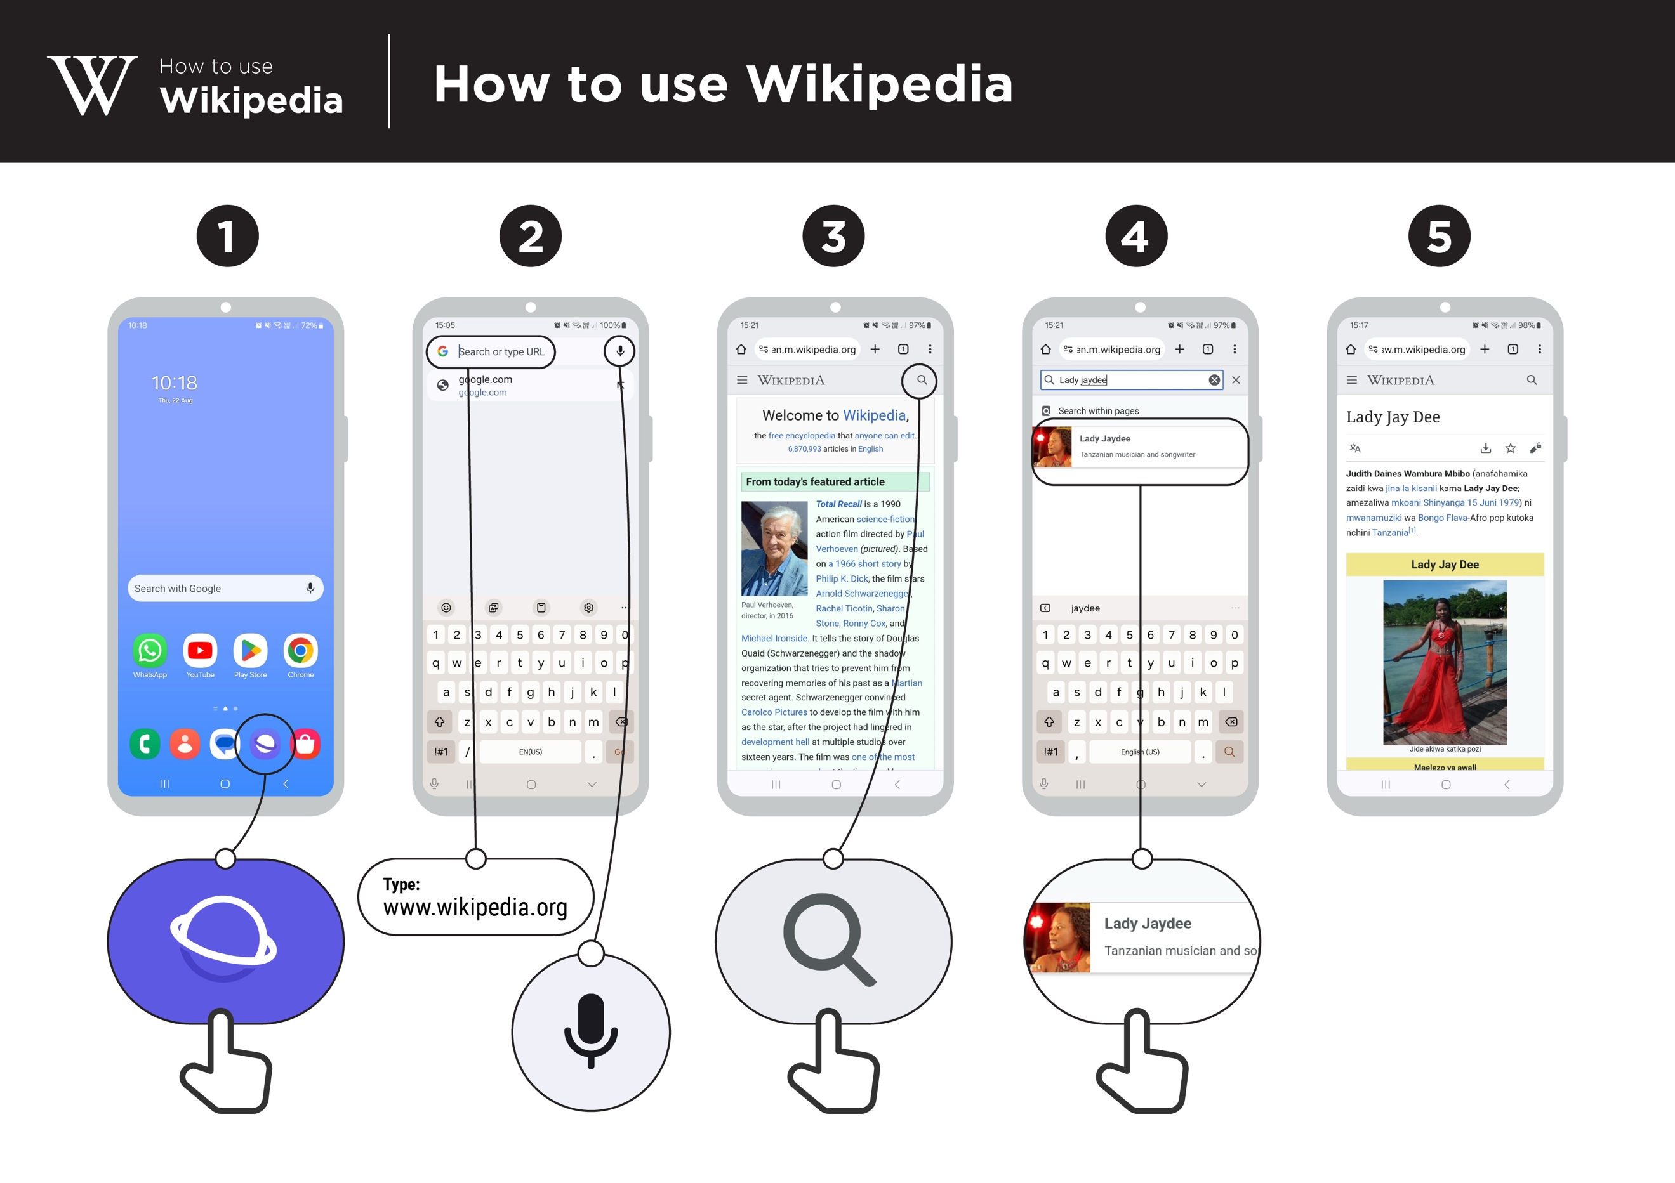

What can you use it for?
Make it relevant to the trainee by discussing how it can be beneficial in the trainee’s own life. Consider examples that will be relevant to the following types of trainees:

Older person: Research information about health or a common illness.

Mother or homemaker: Research information with your child to support them with their schoolwork or projects on topics like history or science.

Business owner: Research information on a business or business practice or a famous entrepreneur.

Farmer or rural person: Research information on a particular livestock or crop, diseases or pests, farming practices or water treatment soil management.

Young person: Research information for your studies or your business or for information on a particular type of industry for employment; find information on films, or learn about celebrities and sports.

How does it work?
Put the phone in the trainee’s hands and help them follow the steps.
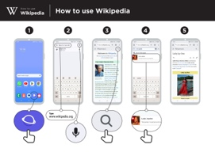
Show the poster and go through the steps for searching for a
Wikipedia article (e.g. ‘Africa’ ‘music’ or ‘World Cup’).

Safety
“Wikipedia is a website that shares information about all types of people and events. Some information is happy and positive, while some might be about sad historical events. You may come across things on Wikipedia that make you feel good or make you feel sad - you can choose to read less about the things that make you feel sad.”
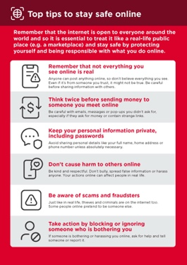

Show the ‘Top tips to stay safe online’ poster.

Explain: “You may find that Wikipedia appears when you use another service, like Google or Yahoo, to search the internet. Often Wikipedia is the first result of a search. You can look at Wikipedia first to get an overview of a topic, and then explore through the references to find more reliable information.”
Practise!

“Now you know how to use Wikipedia, what do you want to use it for?”

Give the trainee keywords to search for, according to their interest. Try to keep the search simple, use only one or two words.

Trainer: Provide support for the trainee to search for a Wikipedia article on their phone.

Bitesize Training
Wikipedia

Mobile Internet
Skills Training

Toolkit

A guide for training people

in basic mobile internet skills

Posters and Cut-Outs

Top tips to stay safe online

 | Remember that not everything you see online is real  Anyone can post anything online, so don’t believe everything you see. Even if it’s from someone you trust, it might not be true. Be careful before sharing information with others
 | Think twice before sending money to someone you meet online  Be careful with emails, messages or pop-ups you didn’t ask for, especially if they ask for money or contain strange links.
 | Keep your personal information private, including passwords  Avoid sharing personal details like your full name, home address or phone number unless absolutely necessary.
 | Don’t cause harm to others online  Be kind and respectful. Don’t bully, spread false information or harass anyone. Your actions online can affect people in real life.
 | Be aware of scams and fraudsters  Just like in real life, thieves and criminals are on the internet too.  Some people online pretend to be someone else.
 | Take action by blocking or ignoring someone who is bothering you  If someone is bothering or harassing you online, ask for help and tell someone or report it.
Remember that the internet is open to everyone around the world and so it is essential to treat it like a real-life public place (e.g. a marketplace) and stay safe by protecting yourself and being responsible with what you do online.

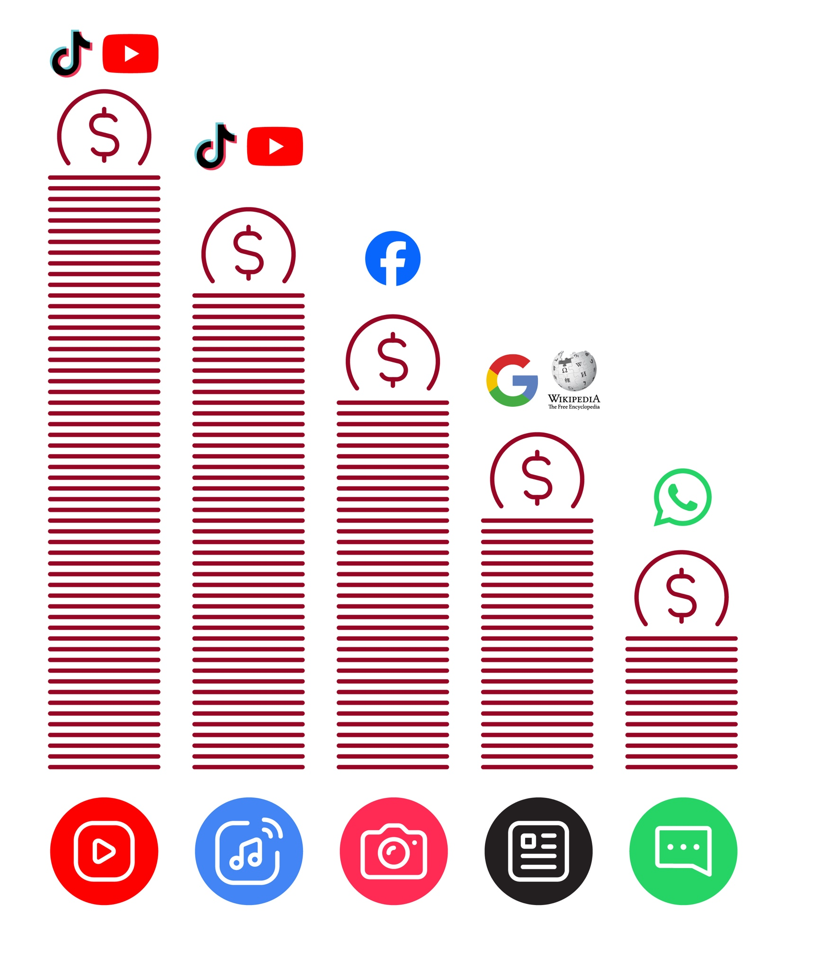
Data Costs
How to use
How to use Wikipedia
Wikipedia



1 2 3 4 5
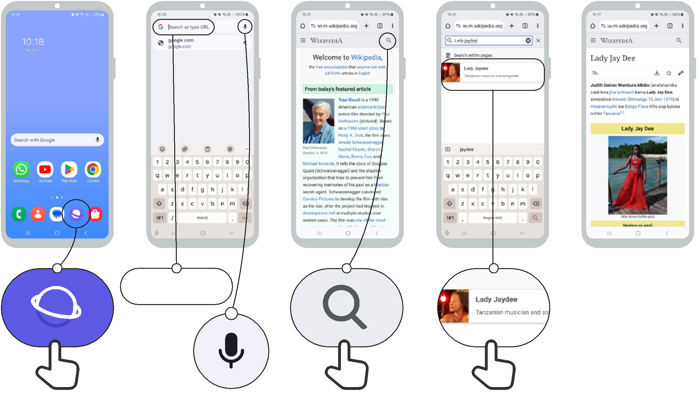

Type:
www.wikipedia.org

Icon Cut-Outs

Wikipedia


Icon Cut-Outs
Wikipedia


Icon Cut-Outs
Wikipedia


Icon Cut-Outs
Wikipedia


Icon Cut-Outs
Wikipedia


Icon Cut-Outs
Wikipedia


Icon Cut-Outs

Wikipedia


Icon Cut-Outs

Wikipedia

