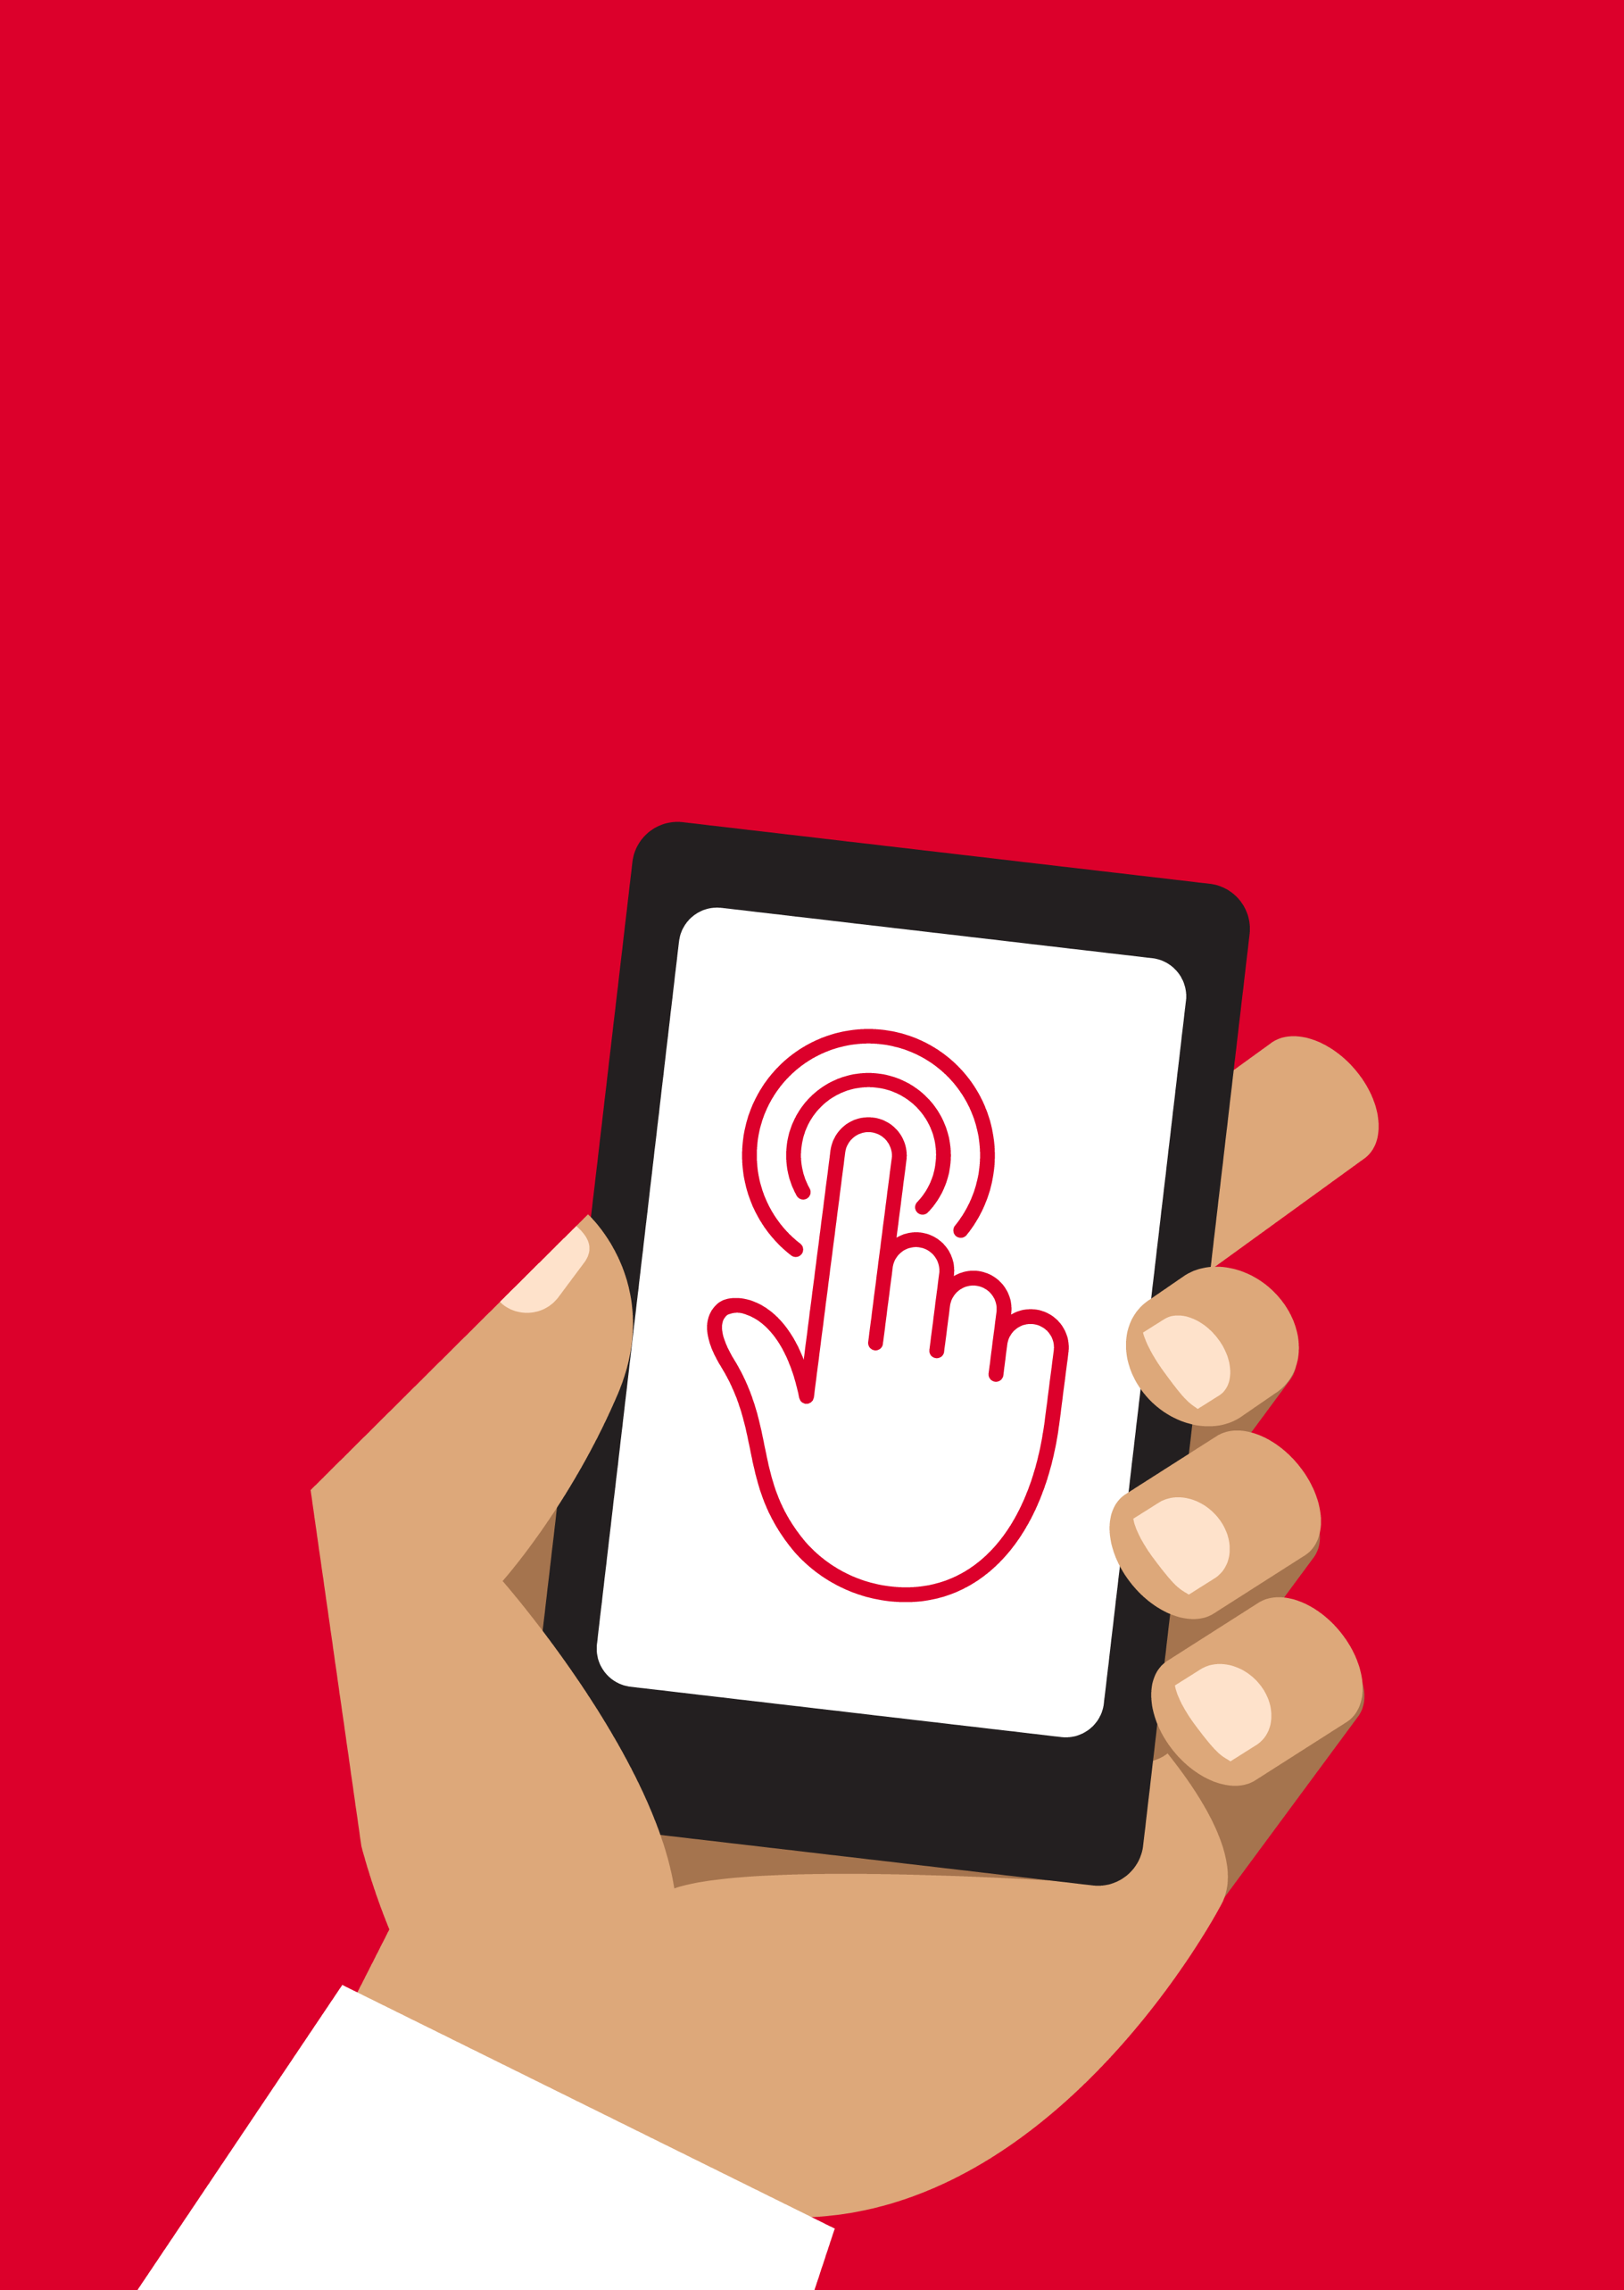


Mobile Internet
Skills Training
Toolkit
A guide for training people in
basic mobile internet skills
Copyright © 2024 GSM Association
Copyright © 2024 GSM Association
In-Depth Training
Wikipedia

Mobile Internet
Skills Training

Toolkit

A guide for training people

in basic mobile internet skills

Module 5:
Wikipedia

Learning objectives
- The trainees know how to use Wikipedia to access free knowledge and information.

- The trainees understand that Wikipedia is created by people all over the world, and feel excited about using it to learn new things.
Time duration
45-60
minutes

Materials you will need:
  Paper, pens and masking tape |   Smartphone handset |   Small rewards | 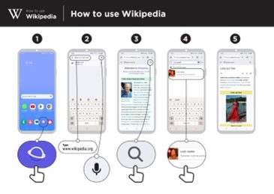  Wikipedia  poster
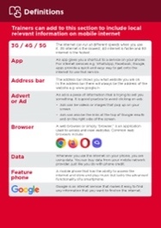  Glossary handouts | 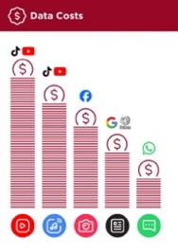  Cost poster | 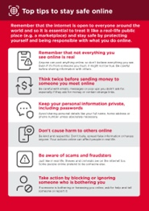  Safety tips | 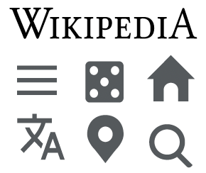  Icon cut-outs

Introduce Wikipedia

Show the trainees the Wikipedia logo cut-out

Ask: “Does anyone know what this is?” and “what is it for?”

Explain that trainees can access Wikipedia by searching through Google. Ask them to open Google and search for Wikipedia.
Make Wikipedia relevant for your trainees
- Discuss with the trainees how Wikipedia might benefit their own lives.

- Ask: “What questions would you like to answer using Wikipedia?” Give them some suggestions based on their interests.

- Sports (e.g. the Olympic Games, the World Cup)

- Pop culture (e.g. music)

- History (e.g. Africa)

- Learn about other countries (e.g. France)

- Science (e.g. solar eclipse)

Remember: Link discussions and activities in the training back to how the internet can be helpful in your trainees’ lives. This will help to keep the training relevant and interesting for them.
Give a short explanation of Wikipedia
- “Wikipedia is a free internet reference (or encyclopedia), which provides neutral, factual information about educational topics.”

- “Wikipedia is a website. It is often the first site to appear when you do a Google search, or you can type the word ‘wiki’ along with the words you are searching for.”

- “Wikipedia is written by ordinary people, all over the world. People make changes to the site every hour. You can make sure the information you find is reliable by looking at the bottom of every page, where the sources of information are listed.”

Bring the benefits to life!
Tell your own story of how Wikipedia is useful for you (the trainer), your friends and family or your community. Consider examples that will be relevant for these trainees:

Older person: Research information about health or a common illness.

Mother or homemaker: Research information with your child to support them with their schoolwork or projects on topics like history or science.

Business owner: Research information on a business or business practice or a famous entrepreneur.

Farmer or rural person: Research information on a particular livestock or crop, diseases or pests, farming practices or water treatment soil management.

Young person: Research information for your studies or your business or for information on a particular type of industry for employment; find information on films, or learn about celebrities and sports.

Activity: Basic use of Wikipedia

Get practical!

Explain: “You are now going to try using Wikipedia on the phone.”
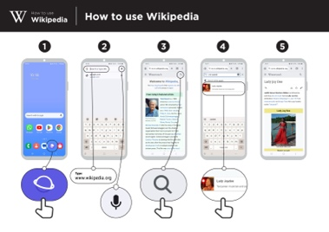
Show the ‘How to use Wikipedia’ poster

Explain: “This poster shows the steps for using Wikipedia to search for information.”

Take your trainees through the steps on their shared phones and do a simple search for their favourite musician.

Explain what your trainees are looking at:

- “Each page begins with a summary of the thing you have searched for.

- As you read further down the page, you will discover more details, including history, politics, or other people connected.

- Each fact has a number at the end. This matches the number of a reference at the bottom of the page, which is where the information came from.”

Ask: “Have you got any questions about what you are looking at here?”
Show trainees how to learn more about topics

Explain: “Wikipedia is organised by topic. There is a page is about your favourite musician, but also about music in your country, and another page about African music.”

- “From any Wikipedia page, you can go directly to other pages because all of the blue words are links.”

- “Clicking on a blue word will take you to another Wikipedia page, with more information about the word.”

Ask your trainees to click on any of the words in the page about Afropop and then share what they find.

Tip: Encourage your trainees to click through the blue words on each article to find more information that is interesting to them.
Activity: Checking information
Discuss with your trainees how Wikipedia can help them in their lives.

Explain: “Wikipedia is written by people all over the world. Anyone can add to an article, or update information. Anyone who edits Wikipedia has to explain where the information came from, so you can check for yourself to see whether what you read is true.”

Ask your trainees to search for the Wikipedia page for their country and then scroll down to the references on the bottom of the page.
Activity: Personal searches
Ask your trainees to practise searching for information about the following topics within Wikipedia:

- Type your country into the search bar.

- Type the name of the nearest large city into the search bar.

- Invite your trainees to type a topic into the search bar that is relevant to their interests (e.g. sports players, hobbies, professions).

Wikipedia is available in multiple languages.

Explain: “Wikipedia is available in almost 300 languages. Each is written by people who speak that language, so some Wikipedias have more articles than others. For example, the French Wikipedia has 2.5 million articles, but there are nearly seven million articles on the English Wikipedia.”

Show your trainees the ‘Read in another language’ button at the top of the page.

Safety
Ask: “What does safety mean to you?”

Ask your trainees to imagine they are in a typical public place, like the market. Ask them to discuss what they would do to keep safe in this place. Prompt them with the following questions and answers:
Prompts | Potential answers
What do you do if someone you don’t | You avoid or ignore them. Be careful,
know bothers you? | they are not always who they say they
 | are.
What do you do if someone you don’t know or trust asks you for your personal information? | You don’t give out personal information to someone you don’t know or trust because they may misuse it.
What do you do if you feel unsure or | Tell someone you know and trust  about what happened.
uncomfortable about something you | Tell someone you know and trust  about what happened.
see or experience? | Tell someone you know and trust  about what happened.
How do you treat people you interact | You are polite and respectful to people.
with? | You are polite and respectful to people.
Explain: “It is important to remember the internet is also public place, and it is important to treat it like a public place and stay safe.”
Ask: “Is there anything that you are concerned about when using Wikipedia?”

Ask: “If you click on something in Wikipedia and you see or open something you think is bad or offensive, what can you do next?”

Explain and demonstrate for your trainees: “You can press the back button, and click on other links within Wikipedia.”

Tip: “The data checking process varies depending on which country you are in and which network the phone is on. Ask a mobile agent if you need support with how to check data.”

Cost
If you have already covered cost in the previous modules, only use this as a recap.
Explain: “Now you know how to use Google and what it can be used for, let us talk about how much it costs to use. To use the internet on your mobile, you have to buy data from your mobile network provider, just like you do with phone credit.”
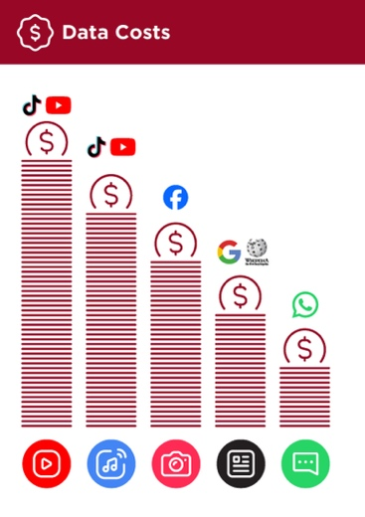
Show the ‘Data costs’ poster

- Explain: “Different activities use different amounts of data. Looking at text uses the least data, looking at images uses more, playing and downloading music uses a bit more and playing videos uses the most.”

- Explain: “Some internet services are linked to activities that use more data.”

- Ask: “Which service tends to cost more to use?”
- Answer: “YouTube. Watching videos on YouTube tends to use a lot of
data.”
Checking data

- Ask: “Why is it useful to check how much data you have used?”

- Answer: “To understand how much of your data you have used up and how much different activities cost to do.”

- Explain: “You can check how much data you have, just like you check how many minutes or texts you have by typing in a code on your phone from your mobile network.”
- Explain: “You can buy data in different amounts depending on what you are going to use the internet for. Ask advice from your local mobile agent on which amount is best suited to you.”

- Explain: “If you access the internet in a Wi-Fi zone, you will not use your data package. Your local mobile agent may be able to help you find your local Wi-Fi zones. However, the nearest zone may be too far to travel to.”

- Demonstrate to your trainees how to check their data.

Tip: The data checking process varies depending on which country you are in and which network the phone is on. Ask a mobile agent if you need support with how to check data.

Recap
Play the Wikipedia icon game

- Hold up each Google icon, one at a time.
- Ask: “What does this do on Wikipedia?”
- Explain to your trainees what each icon is if they need support.
- Give small rewards (e.g. sweets) for correct answers and stick the icons on the wall afterwards to help remind your trainees what they are.
Explain: “You may find that Wikipedia appears when you use another service, like Google or Yahoo, to search the internet. Often Wikipedia is the first result of a search. You can look at Wikipedia first to get an overview of a topic, and then explore through the references to find more reliable information.”

Recap on Wikipedia

Discuss with your trainees what they have learned about using Wikipedia.

- “How would you describe Wikipedia to a friend or family member?”

- “Do you still have any concerns about using Wikipedia?”

- “What personal or professional use could you have for Wikipedia?”

- “What are you most excited to explore on Wikipedia?”
Tip: “If trainees would like to explore Wikipedia on their own phones, give them some time here to practise what they have learned and offer support and encouragement.

Going to the next level
If you reach the end of the session and have extra time:

- Ask: “Do you have any further questions about anything we have covered in the session?”

- Ask: “What else would you like to know about the mobile internet?”

- Some more advanced features you can discuss with your trainees include:

- Download the Wikipedia app. Explain: “You can search directly in Wikipedia by going to the app.”

- To discuss: “Are there additional features/questions we want to cover?”

In-Depth Training
Wikipedia

Mobile Internet
Skills Training

Toolkit

A guide for training people

in basic mobile internet skills

Posters and Cut-Outs
Session Ground Rules

This space is:

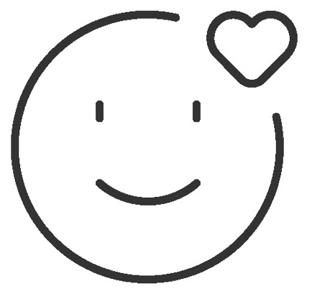

Safe

Keep all information in this training confidential. We suggest you don’t share personal numbers with the other members of group.

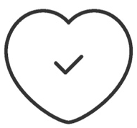

Positive & open

Please be respectful and
positive in your opinions and discussions. There are no right or wrong answers and we are not here to test you.

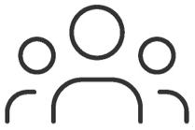

- shared
community

There are people with different backgrounds, knowledge and opinions. This is our shared space, so respect and support everyone.

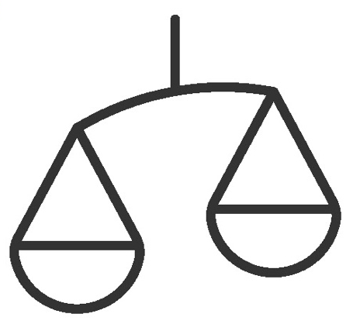

Fair

We will work in small groups and we will provide you with shared phones. We would like to give everyone an equal chance to be heard and to take turns using a phone.

Definitions

Trainers can add to this section to include local relevant information on mobile internet
3G / 4G / 5G | The internet can run at different speeds when you use it. 3G internet is the slowest, 4G internet is faster and 5G internet is the fastest.
App | An app gives you a shortcut to a service on your phone. For internet services e.g. WhatsApp, Facebook, Google, apps provide a quick and easy way to get onto the internet to use that service.
Address bar | The address bar shows you what website you are on.  In the address bar there will always be the address of the website e.g. www.google.com
Advert  or Ad | An ad is a piece of information that is trying to sell you something. It is good practice to avoid clicking on ads.  - Ads can be videos or images that pop up on your screen.  - Ads can also be the links at the top of Google results and on the right side of the screen.
Browser |   A web browser, or simply “browser,” is an application used to access and view websites. Common web browsers include:
Data | Whenever you use the internet on your phone, you are using data. You can buy data from your mobile network provider, just like you do with phone credit.
Feature  Phone | A mobile phone that has the ability to access the internet and store and play music but lacks the advanced functionality of a smartphone.
 | Google is an internet service that makes it easy to find any information that you want to find on the internet.

Definitions

Internet | The Internet is a network of millions of computers around the world connected to each other with phone lines, satellites and cables. It gives you access to a huge range of information and services and it is growing all the time. The internet is for everybody. There are no restrictions on who can use it. You just need a computer, mobile phone or tablet and a data connection.
Link | A link connects you from one website to another. To go to the other website, you can touch the link and this will connect you and take you to that other website
Megabytes & Gigabytes | Megabytes (MB) and Gigabytes (GB) are units of data that you use when using the mobile internet. GB are 1000 times bigger than MB. If you download or stream a song, that will use approximately 5MB (1MB per minute).
Search | The search function helps you find what you are looking for. You type the words to what you are looking for into a search box and then you will see a list of links to potential answers.
Smartphone | A mobile phone that has the ability to access the internet, store and play music and videos, and run ‘apps’. These phones typically also have a touchscreen.
Website | Information on the internet is kept on different websites. There are lots of separate and different websites on the internet e.g. Google is a website, YouTube is a website.
 | WhatsApp is an internet service that makes it easy to connect and communicate with people that you know; family, friends and colleagues.
WiFi | A WiFi zone is an area where you do not have to use your own  data to access the internet on your phone; you can connect to the  internet for free. WiFi zones are available in some public places  such as coffee shops and cafes.
 | YouTube is an internet service that makes it easy to find, watch and listen to videos on the internet (and only videos).

Trainers can add to this section to include local relevant information on mobile internet

Top tips to stay safe online

 | Remember that not everything you see online is real  Anyone can post anything online, so don’t believe everything you see. Even if it’s from someone you trust, it might not be true. Be careful before sharing information with others
 | Think twice before sending money to someone you meet online  Be careful with emails, messages or pop-ups you didn’t ask for, especially if they ask for money or contain strange links.
 | Keep your personal information private, including passwords  Avoid sharing personal details like your full name, home address or phone number unless absolutely necessary.
 | Don’t cause harm to others online  Be kind and respectful. Don’t bully, spread false information or harass anyone. Your actions online can affect people in real life.
 | Be aware of scams and fraudsters  Just like in real life, thieves and criminals are on the internet too.  Some people online pretend to be someone else.
 | Take action by blocking or ignoring someone who is bothering you  If someone is bothering or harassing you online, ask for help and tell someone or report it.

Remember that the internet is open to everyone around the world and so it is essential to treat it like a real-life public place (e.g. a marketplace) and stay safe by protecting yourself and being responsible with what you do online.

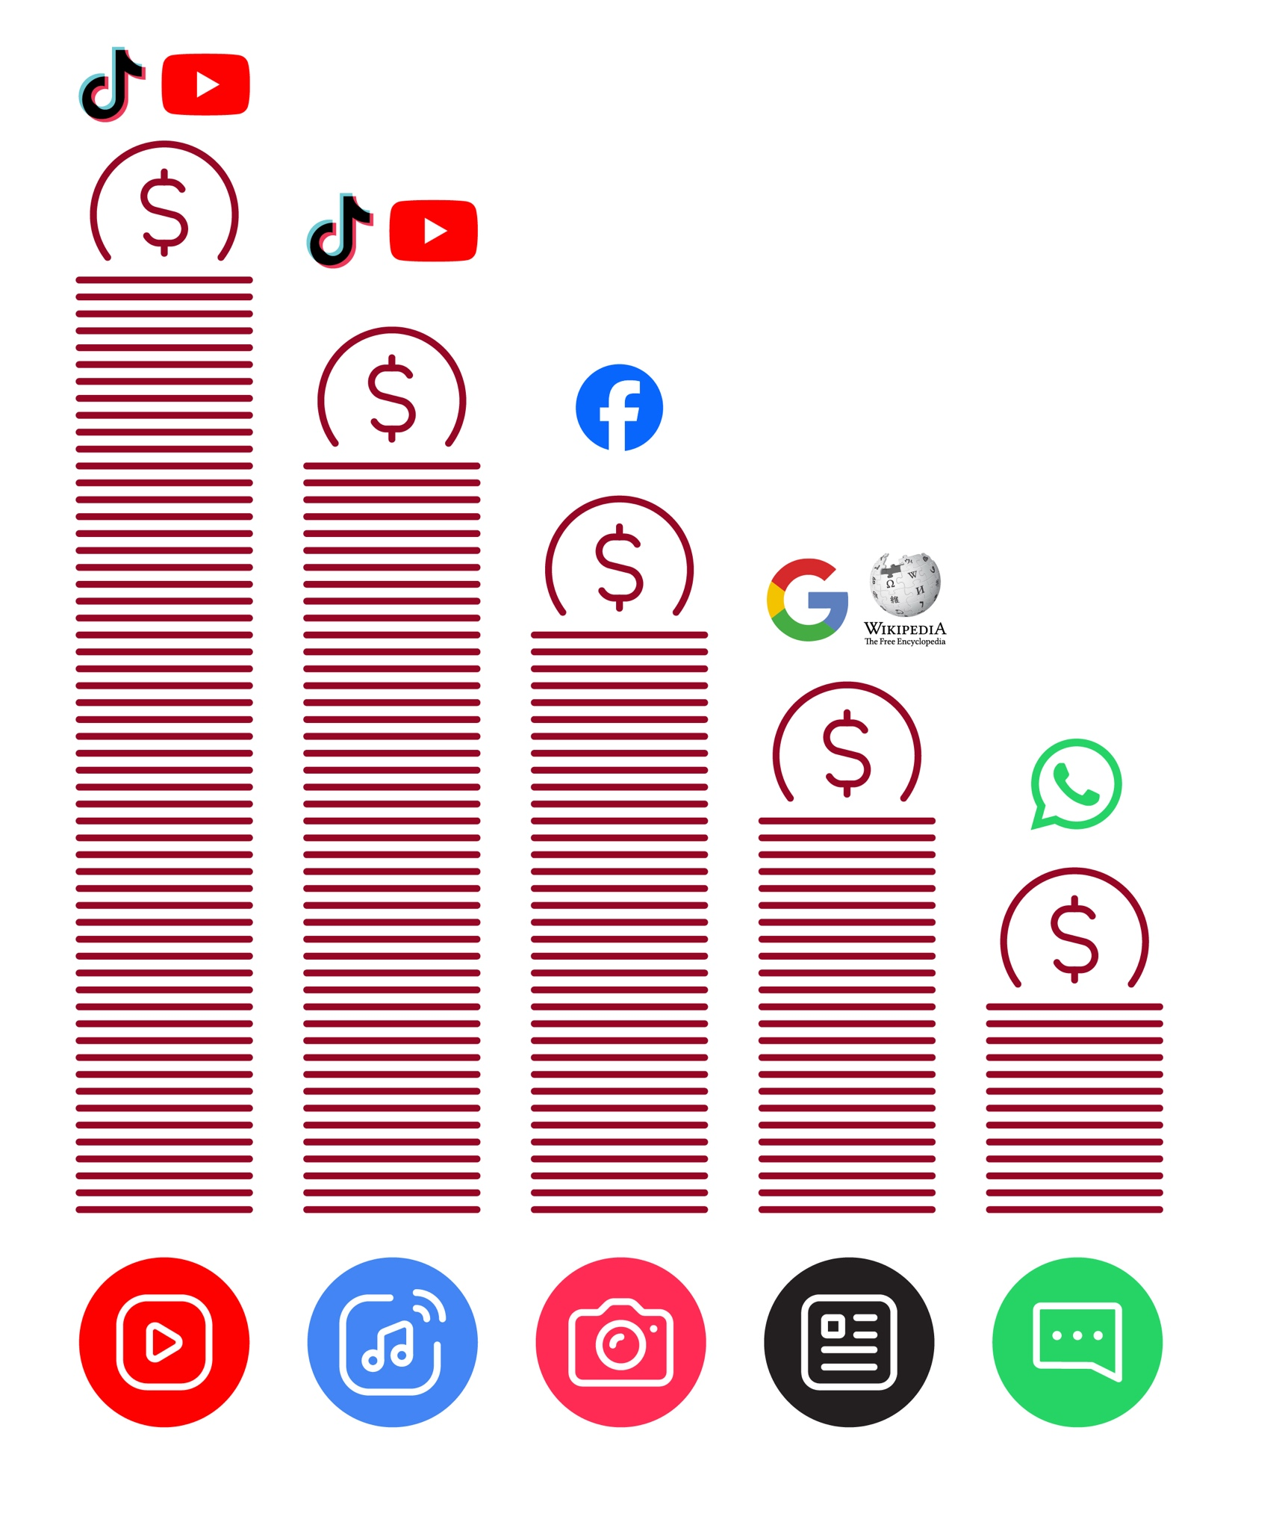
Data Costs
 | Set time limits  Think about how much time you are spending using the internet – it should not get in the way of your other responsibilities. If it does, set limits!
 | Watch your mood  If the internet or your phone is making you sad or angry, take  a break!
 | Maintain healthy relationships online  Make time to socialise with friends and family in real life, not just on the internet! Don’t spend all your time on the internet.
 | Be careful  The internet can be dangerous with scams, harassment and things you don’t want to see. Be careful!
 | Stay positive  Stay positive and avoid upsetting or harming others. Be responsible and keep a positive attitude!
 | Get enough sleep and rest  Sleep and rest are important - make sure the internet or your phone doesn’t stop you doing this! Don’t use the internet when you need to rest or sleep.
Healthy Internet Use

Healthy Internet Use

How to use Wikipedia
How to use

Wikipedia



1 2 3 4 5
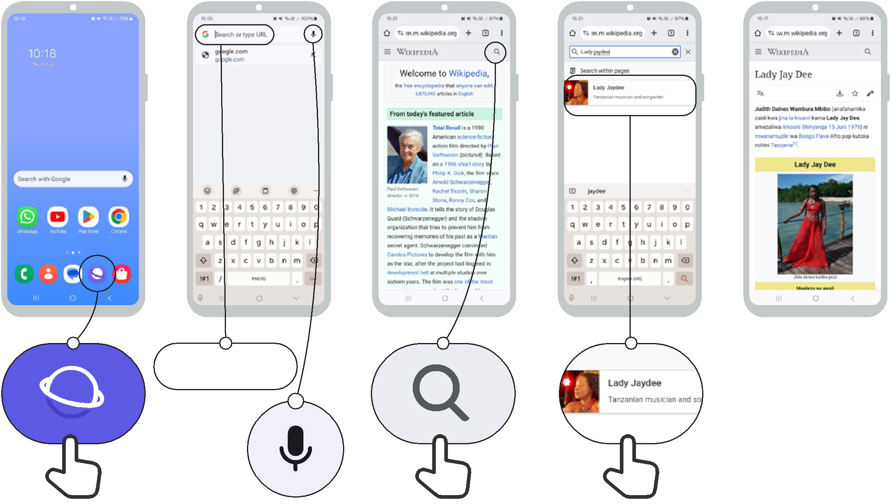

Type:
www.wikipedia.org

Icon Cut-Outs

Wikipedia


Icon Cut-Outs
Wikipedia


Icon Cut-Outs
Wikipedia


Icon Cut-Outs
Wikipedia


Icon Cut-Outs
Wikipedia


Icon Cut-Outs
Wikipedia


Icon Cut-Outs

Wikipedia


Icon Cut-Outs

Wikipedia


Mobile Internet Skills Training Toolkit

‘Thank you’ and close training

After you have completed the training, congratulate your trainees and hand out certificates as a reward.

Thank the trainees

Give out the handouts

- Give your trainees the handouts for the training if you haven’t already done so.

- These include the ‘Definitions’, ‘Top tips to stay safe online’, ‘Data costs’, ‘Healthy internet use’ and relevant module posters.

- Ask: “Do you feel confident to use these accessibility features?” or “Do you feel confident to use your mobile phone?”

- Thank your trainees for their time, input and participation in the training.

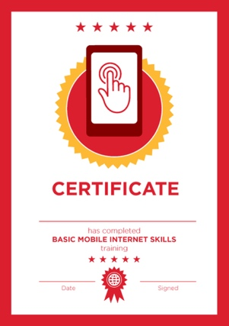

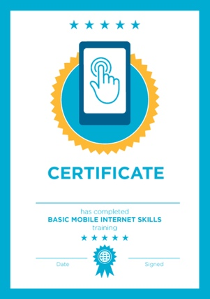

Conduct a closing ceremony

- Give each trainee a signed certificate (certificate templates are included in the toolkit).

- You can also provide the trainers with certificates for having completed the training ‘as trainers’.

Tip: You can make this more of a ceremony for trainees, by asking them to come up to the front of the room one person at a time to receive their certificate and shake the trainer’s hand.

here
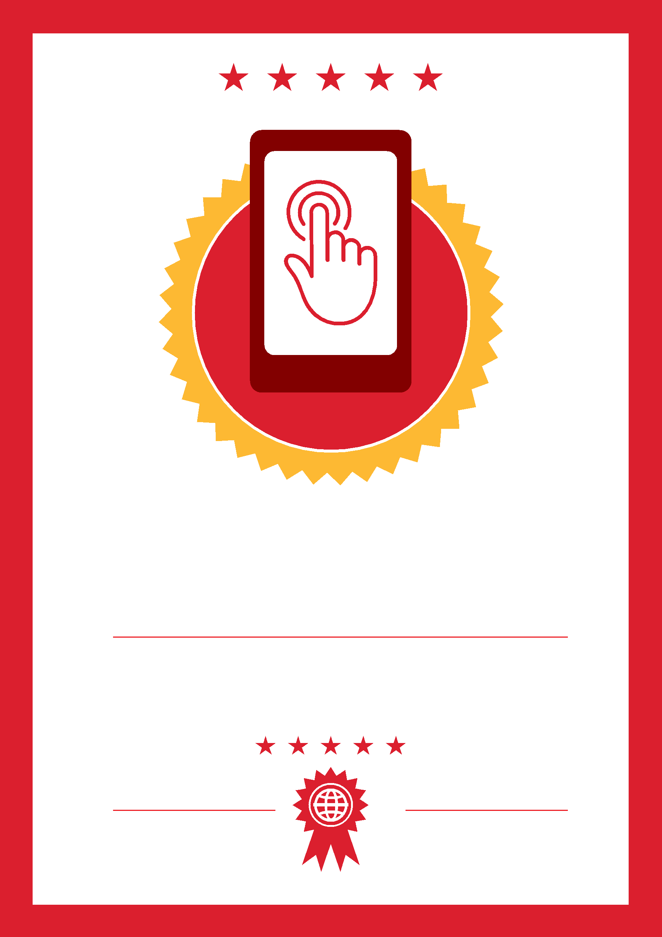

CERTIFICATE

has completed

BASIC MOBILE INTERNET SKILLS

training

Date Signed

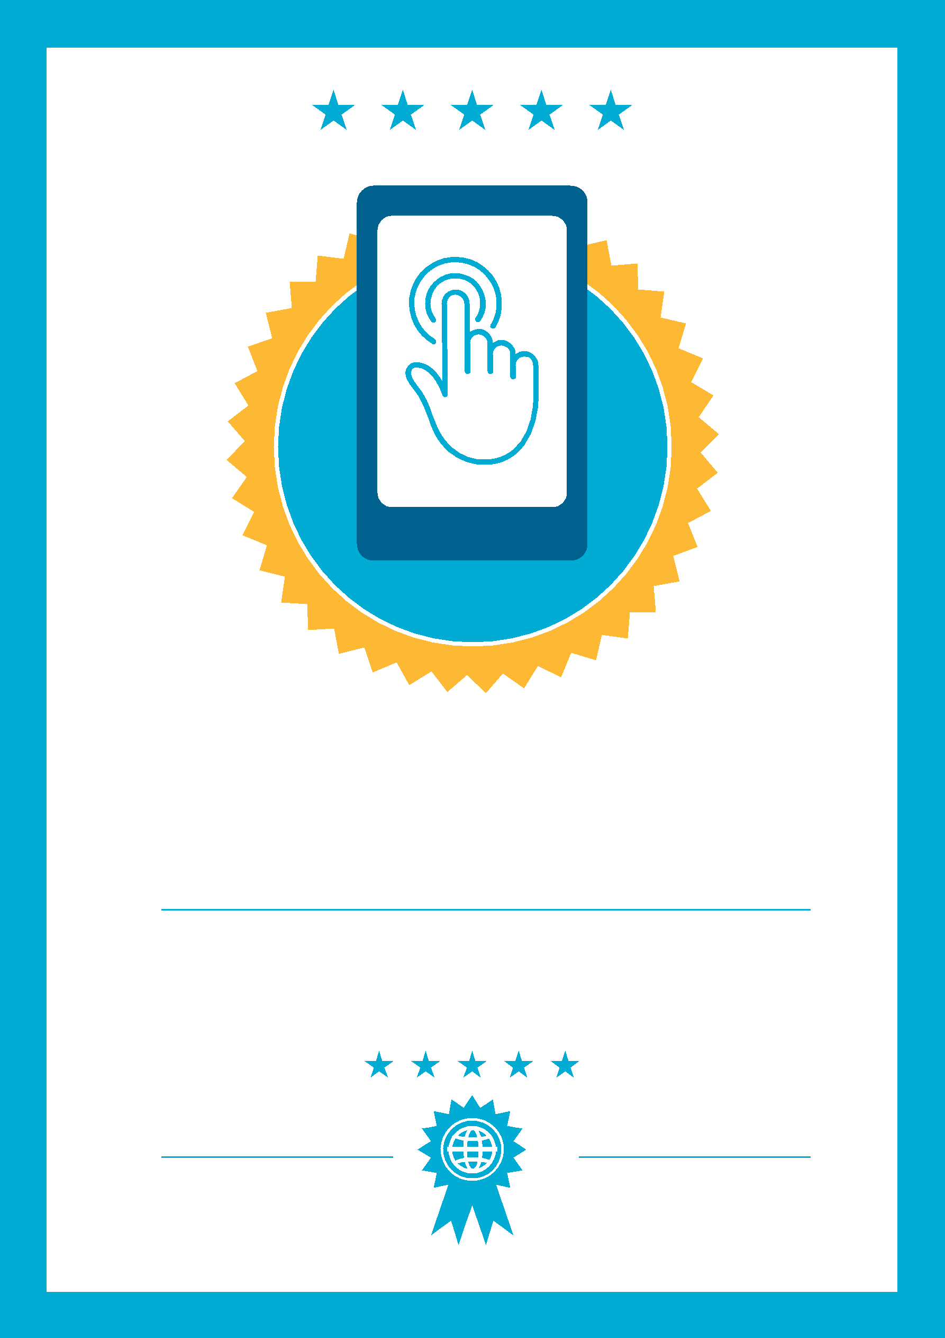

CERTIFICATE

has completed

BASIC MOBILE INTERNET SKILLS
training

Signed
Date

