


Mobile Internet
Skills Training
Toolkit
A guide for training people in
basic mobile internet skills
Copyright © 2024 GSM Association
Copyright © 2024 GSM Association
Bitesize Training
YouTube

Mobile Internet
Skills Training

Toolkit

A guide for training people

in basic mobile internet skills

Module 3:
YouTube


What is it?
  Materials you will need:  - Smartphone handsets  - YouTube posters  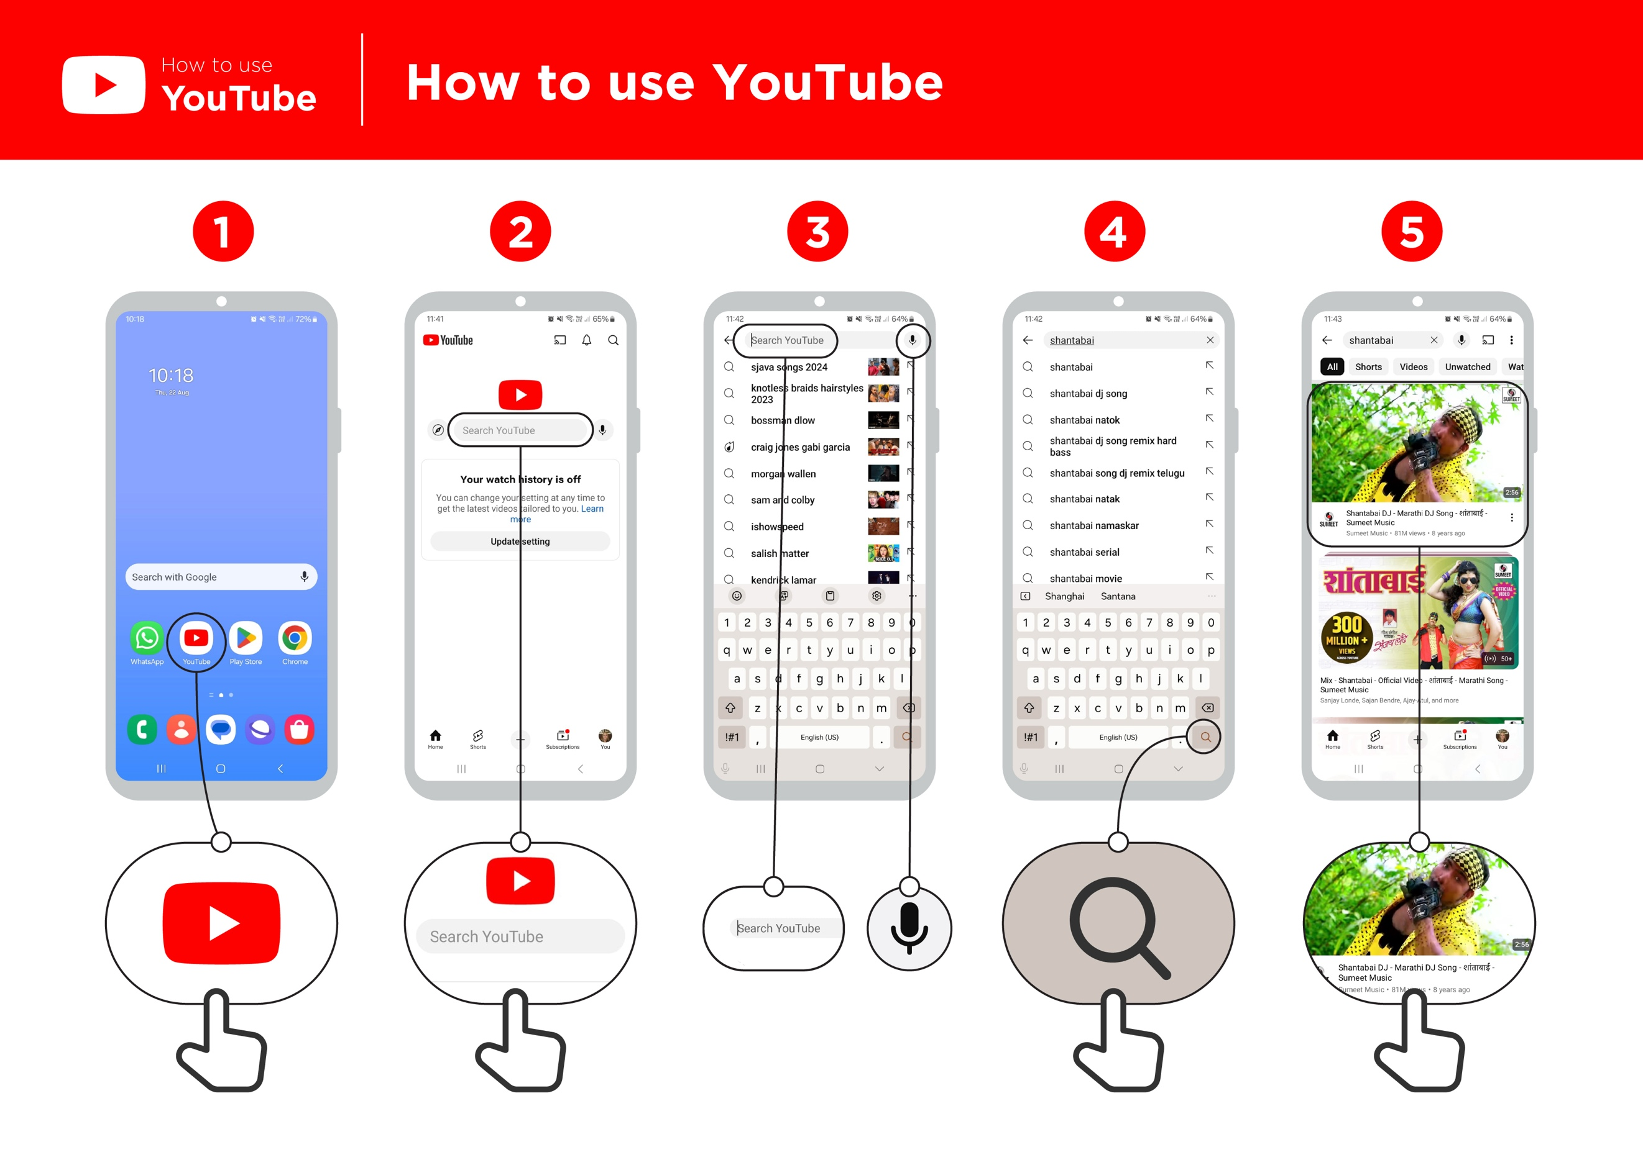 | Show YouTube on the phone.  Explain: “YouTube lets you watch videos, like TV, but you have more videos to choose from, and you can also choose what videos to watch and when to watch them.”  “You tell YouTube what kind of videos you want to find, and it will search through all the videos that people have put on YouTube to find the kinds of videos that you want.”
What can you use it for?
“You can watch lots of different videos including films, songs, news, sports, recipes and educational videos. There are also lots of ‘how to’ videos e.g. how to learn a language, how to do a dance, how to cook a recipe or how to fix a tyre on a bicycle.”

“You can also create your own videos and share them on YouTube.”

Share your own examples with the trainee about the benefits of YouTube and how you personally use it.
WhatsApp posters

What can you use it for?
Make it relevant to the trainee by discussing how it can be beneficial in the trainee’s own life. Consider examples that will be relevant to the following types of trainees:

Older person: Watch videos on YouTube about news, sermons, entertaining programmes and music.

Mother or homemaker: Watch videos to learn a new recipe; manage your home or business; help your children with their health or schoolwork; mend clothes and more.

Business owner: Learn and discover new things for your business like how to register or manage a business; get tips and ideas from other business owners like new recipes, hairstyles, clothing patterns, repair tricks etc.

Farmer or rural person: Watch videos to learn better ways to grow crops, protect them from pests, change crops in different seasons, and keep the soil healthy. This helps you grow more food and take good care of your land for the future.

Young person: Watch videos to help you with your education or learn new skills to get a job or start a business; watch videos to get help on your CV or tips for finding jobs; watch videos of sports or of your favourite actor or singer.

How does it work?
Put the phone in the trainee’s hands and help them follow the steps.

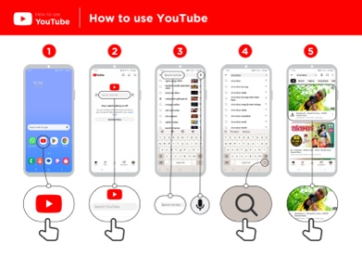
Show the poster and go through the steps for a simple video
search (e.g. search a popular local song).
“The microphone can be used to do voice searches. You do not
have to type in any text.”

Demonstrate the microphone: Where it is and how to use it.

Safety
“YouTube has many videos created by people, some may be just like you. You might not like or agree with all the videos you see - you can choose not to watch these. Remember that not everything you see on YouTube is true so think twice about acting on or sharing the videos.”
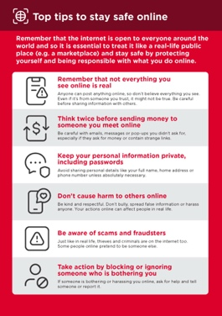

Show the ‘Top tips to stay safe online’ poster.

Discuss with your trainees what these tips mean when using YouTube.

Bring the tips to life by using examples that are relevant for your trainee. For example, certain people may be worried about some of the content on YouTube. Some people may be worried about scammers using YouTube and some women may be more concerned about how to prevent harassment.
Practise!

“Now that you know about YouTube, what are you interested in using it for?”

Give the trainee keywords to search for, according to their interest. Try to keep the search simple, use only one or two words.

Tip: “YouTube is great for videos, but the internet is bigger than YouTube. There is a lot more information on the internet. If you want to search the whole internet, you can try using Google Search.”

Explain that there are other similar services to YouTube, which allow people to upload and watch videos. Some examples of this are Dailymotion and TikTok.

Bitesize Training
YouTube

Mobile Internet
Skills Training

Toolkit

A guide for training people

in basic mobile internet skills

Posters and Cut-Outs

Top tips to stay safe online

 | Remember that not everything you see online is real  Anyone can post anything online, so don’t believe everything you see. Even if it’s from someone you trust, it might not be true. Be careful before sharing information with others
 | Think twice before sending money to someone you meet online  Be careful with emails, messages or pop-ups you didn’t ask for, especially if they ask for money or contain strange links.
 | Keep your personal information private, including passwords  Avoid sharing personal details like your full name, home address or phone number unless absolutely necessary.
 | Don’t cause harm to others online  Be kind and respectful. Don’t bully, spread false information or harass anyone. Your actions online can affect people in real life.
 | Be aware of scams and fraudsters  Just like in real life, thieves and criminals are on the internet too.  Some people online pretend to be someone else.
 | Take action by blocking or ignoring someone who is bothering you  If someone is bothering or harassing you online, ask for help and tell someone or report it.
Remember that the internet is open to everyone around the world and so it is essential to treat it like a real-life public place (e.g. a marketplace) and stay safe by protecting yourself and being responsible with what you do online.

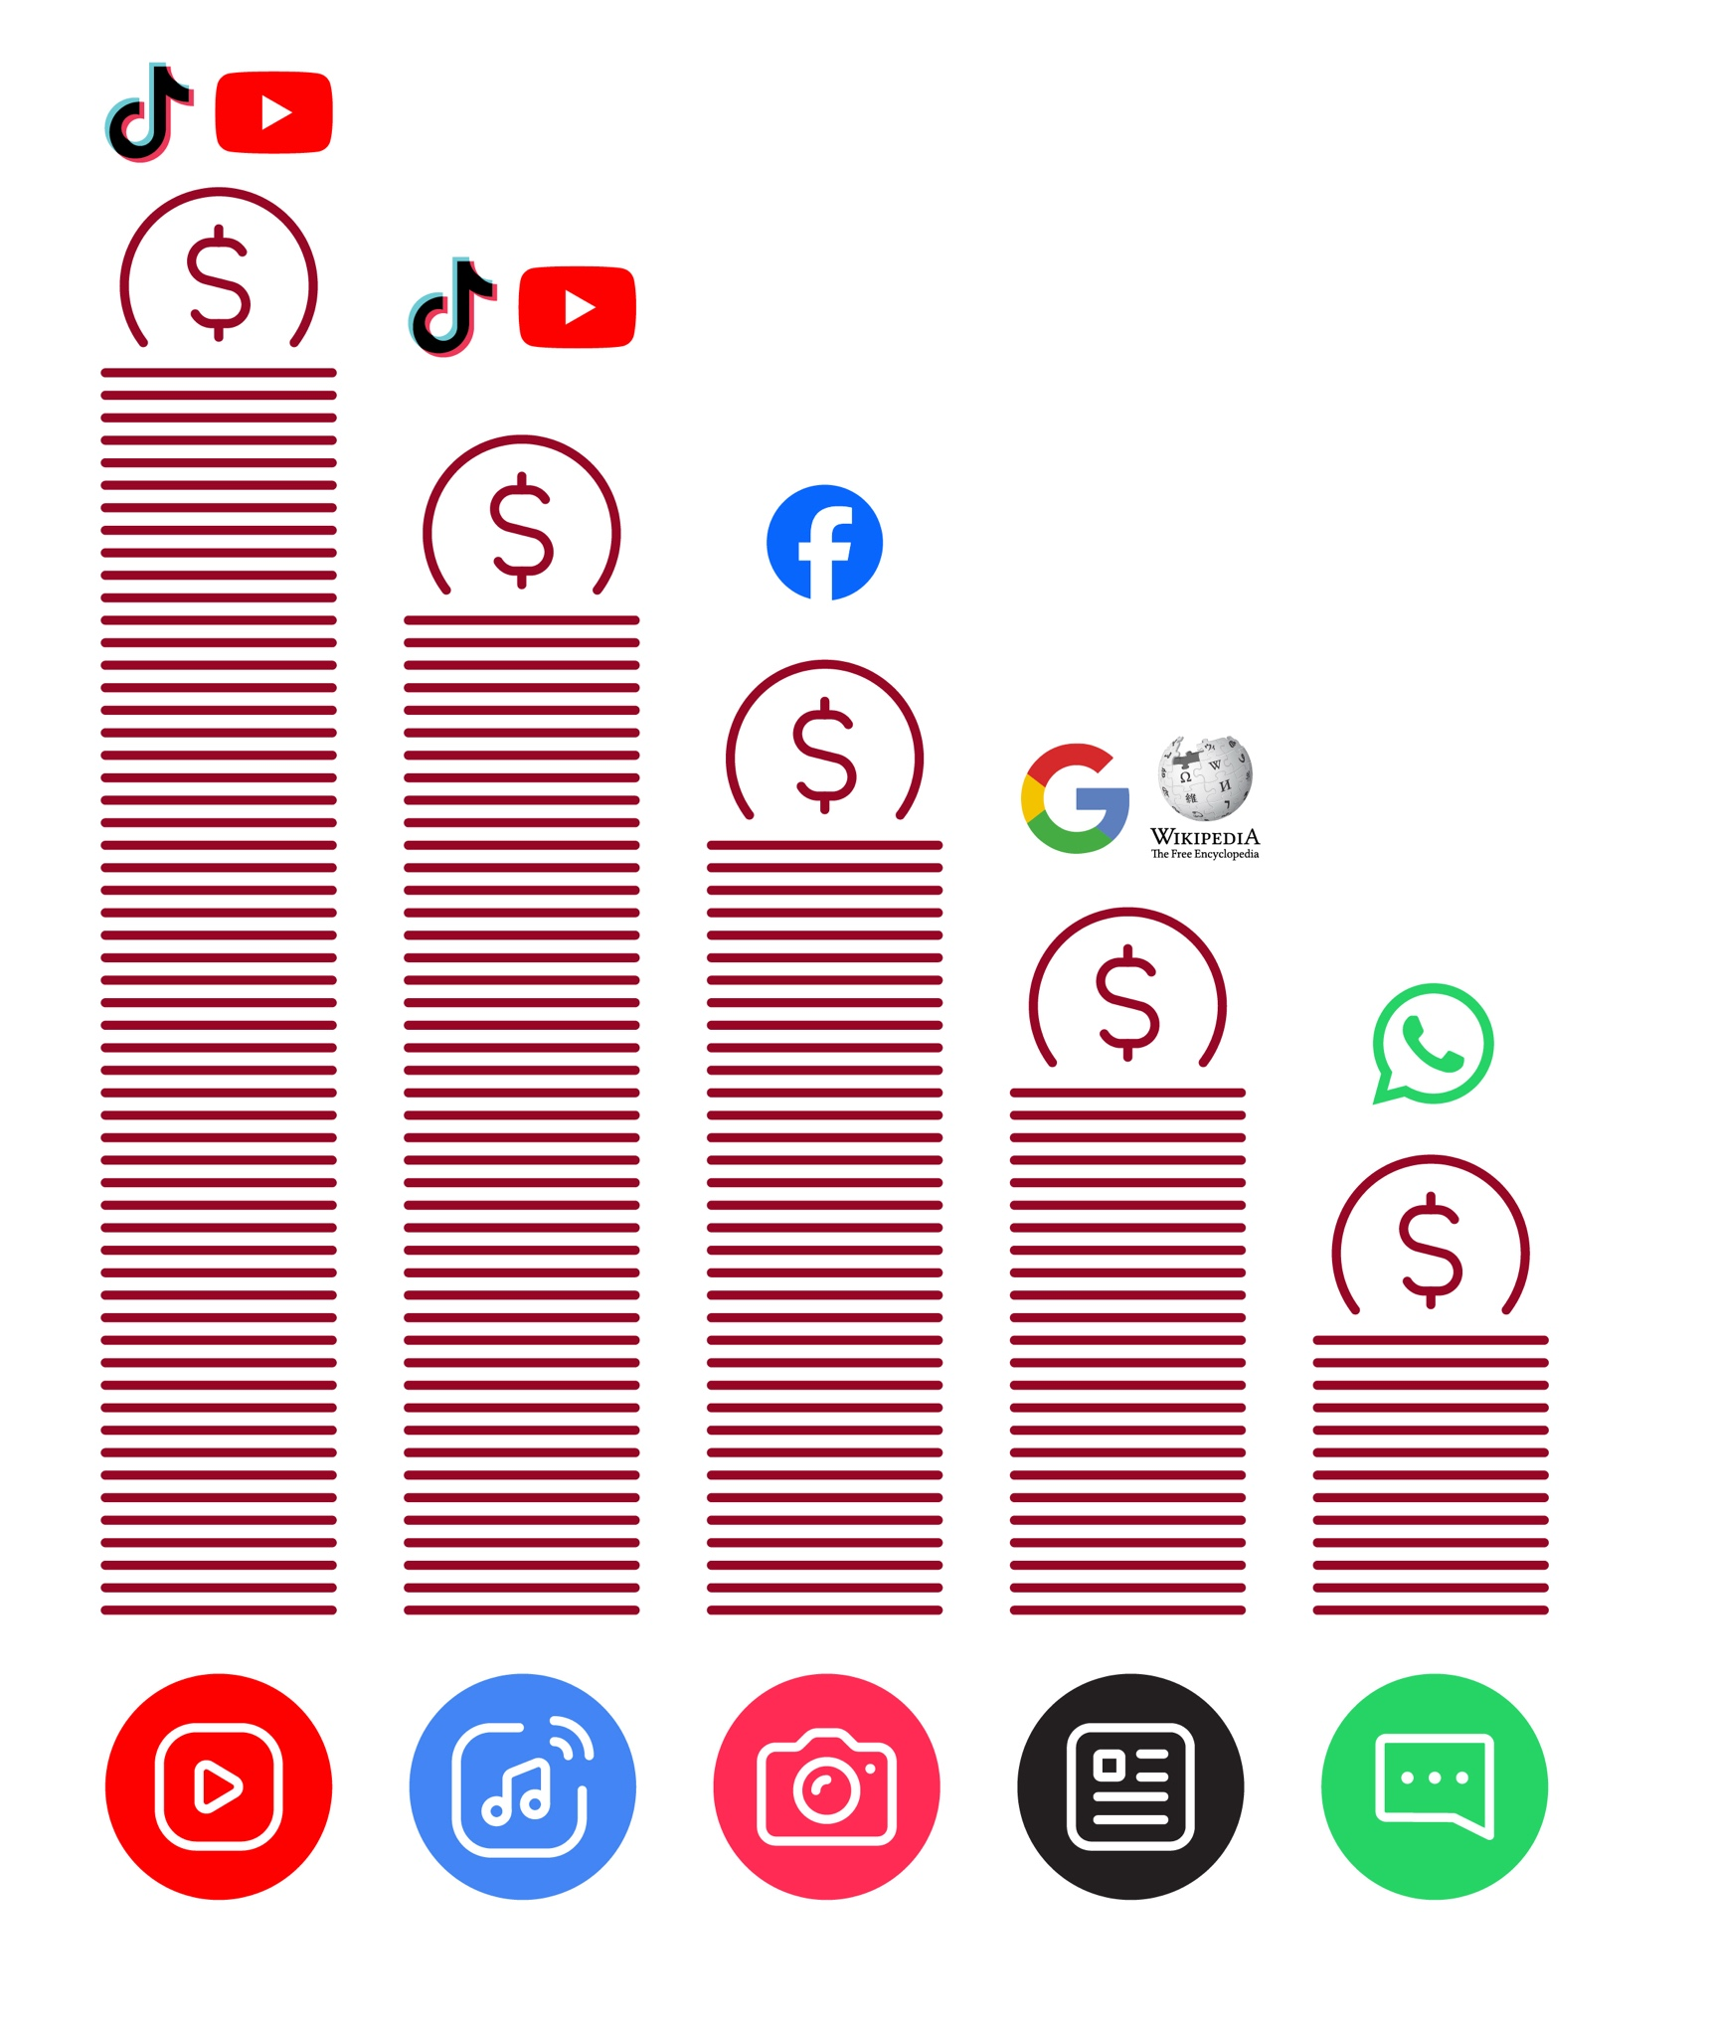
Data Costs
How to use
YouTube

How to use YouTube



1 2 3 4 5
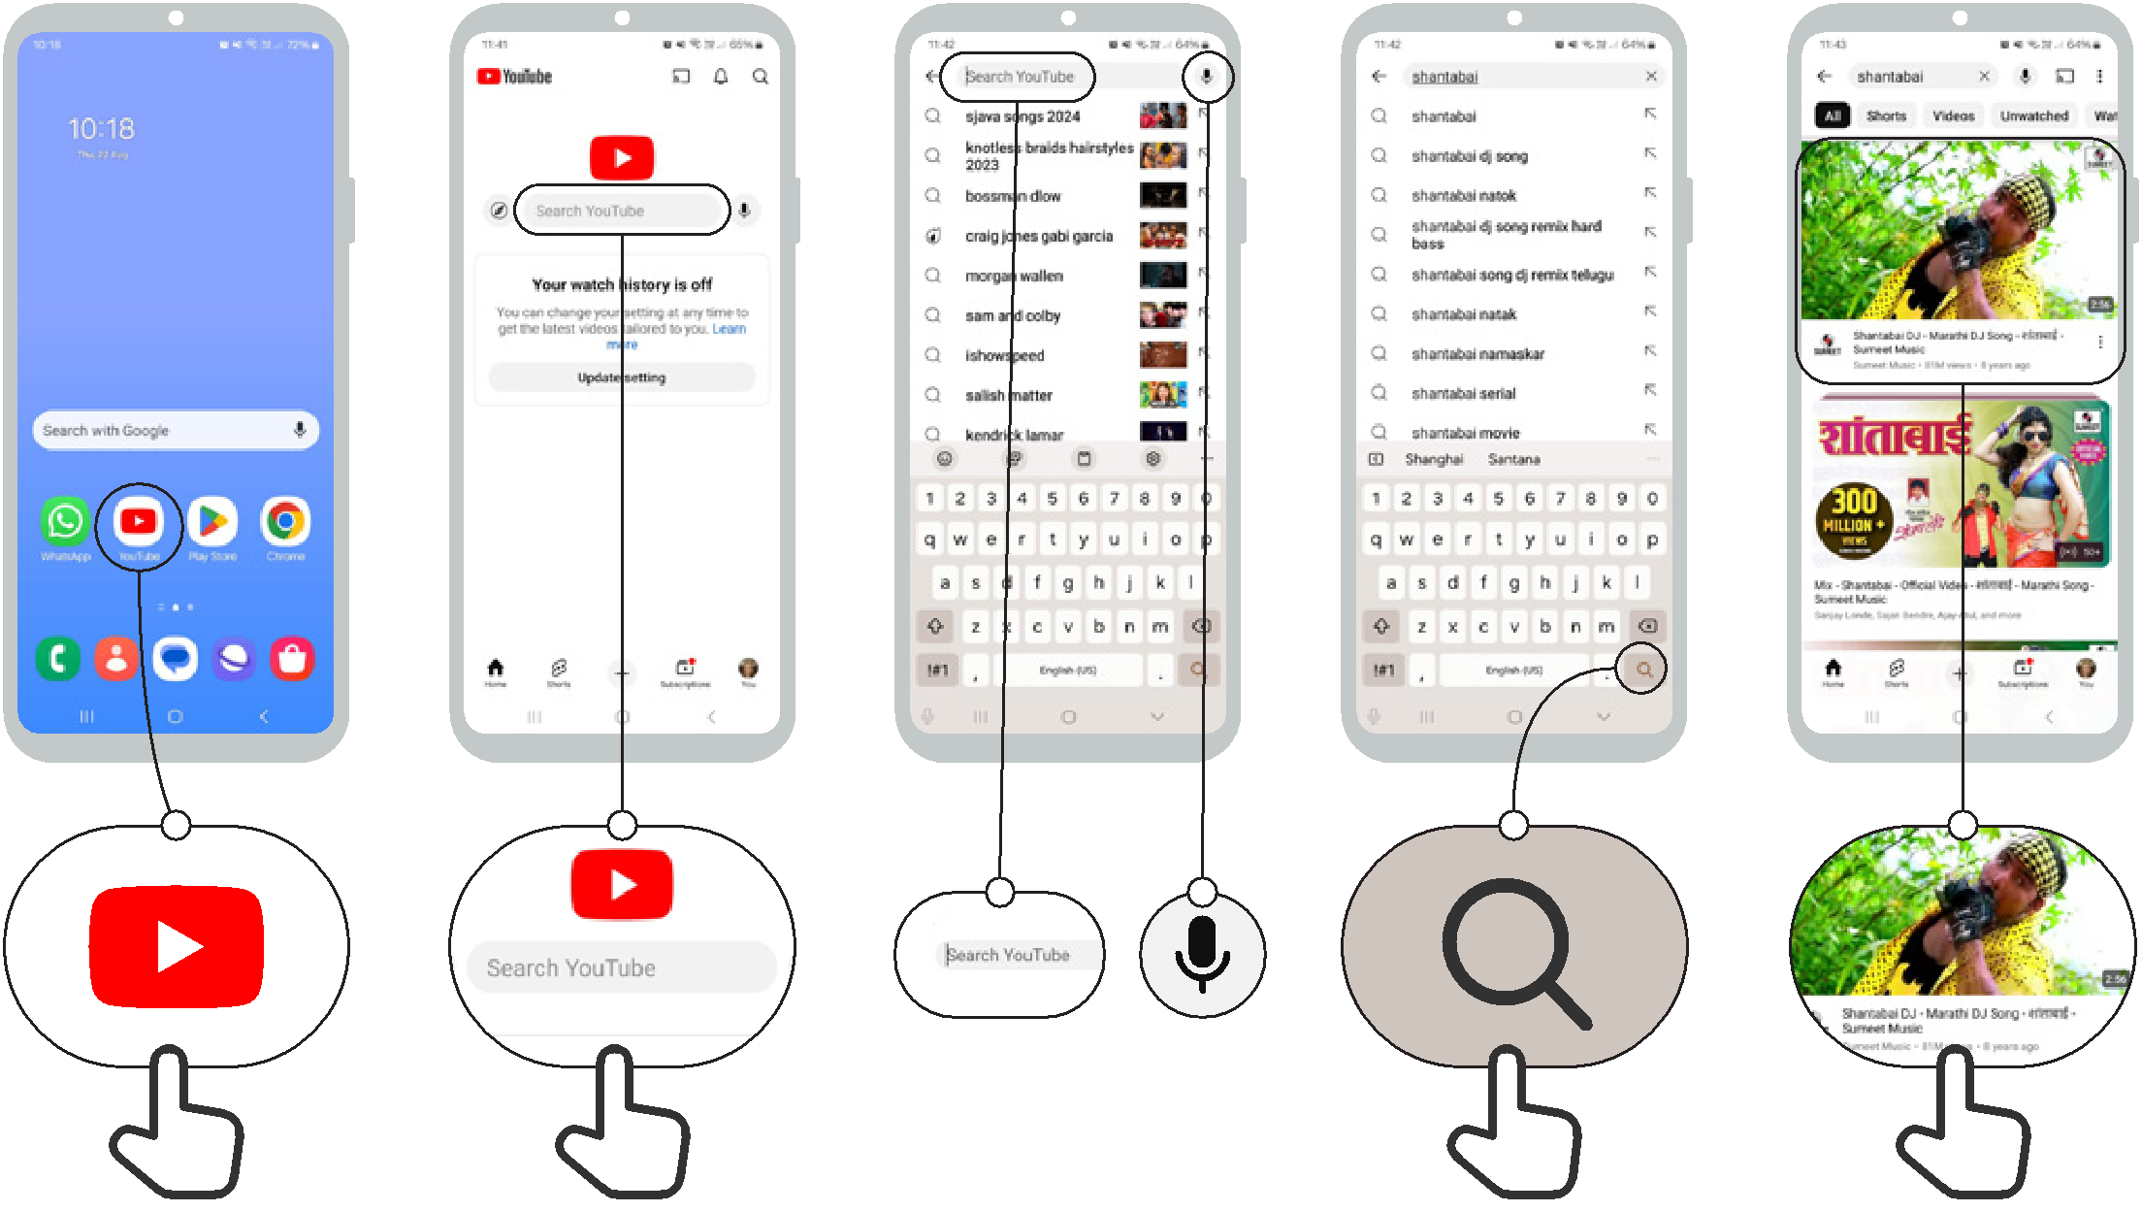

Icon Cut-Outs

YouTube


Icon Cut-Outs
YouTube


Icon Cut-Outs
YouTube


Icon Cut-Outs
YouTube


Icon Cut-Outs

YouTube



Icon Cut-Outs

YouTube



