


Mobile Internet
Skills Training
Toolkit
A guide for training people in
basic mobile internet skills
Copyright © 2024 GSM Association
Copyright © 2024 GSM Association
In-Depth Training
YouTube

Mobile Internet
Skills Training

Toolkit

A guide for training people

in basic mobile internet skills

Module 3:
YouTube

Learning objectives
- Trainees know how to use YouTube to access videos and music.

- Trainees understand the range of content available and feel excited and motivated about accessing relevant content on YouTube.
Time duration
45-60
minutes

Remember: YouTube may not be available to use in all locations due to connectivity issues. In these instances, we suggest either not doing the YouTube module, or using another audio/visual application that requires less data to run.

Alternatively, you can change the YouTube account settings on the phone so that it plays videos using a lower bandwidth. Additionally, you can download YouTube videos to play offline by clicking on the icon under the video.

Materials you will need:
  Paper, pens and masking tape |   Smartphone handset |   Small rewards | 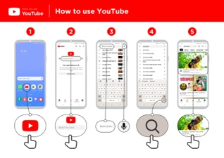  YouTube  poster
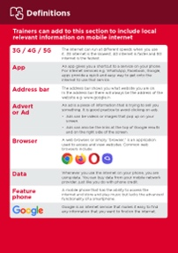  Glossary handouts | 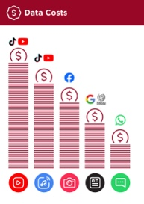  Cost poster | 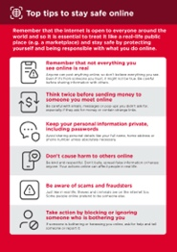  Safety tips | 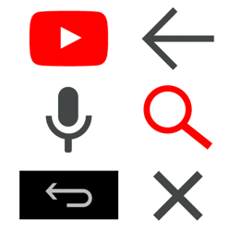  Icon cut-outs

Introduce YouTube

Show trainees the YouTube icon and ask them to find this on their phone

- Ask: “Does anyone know what this is?” and “what is it for?”
Make YouTube relevant for your trainees
Discuss with your trainees how YouTube can be beneficial in their own lives:

- Ask: “What could you learn to use YouTube for in your own life?” Give them some suggestions based on their interests.

- Ask: “What are you most interested in and excited to learn about?”

Give a short explanation of YouTube
- “YouTube lets you watch videos, like TV, but you have more videos to choose from, and you can also choose what videos to watch and when to watch them.”
- “You tell YouTube what kind of videos you want to find, and it will search through all the videos that people have put on YouTube to find the kinds of videos that you want.”

- “You can watch lots of different videos; movies, songs, news, sports, recipes, and educational videos. There are also lots of ‘how to’ videos, e.g. how to learn a language, how to do a dance, how to cook a recipe, how to fix a tyre on a bicycle and others.”

- “You can also create your own videos and share them on YouTube.”
Remember: Link discussions and activities in the training back to how the internet can be helpful or useful in your trainees’ own lives. This will help to keep the training relevant and interesting for them.

Bring the benefits to life!
Tell your own story of how YouTube is useful for you (the trainer), your friends and family or your community. Consider examples that will be relevant for these trainees:
Older person: Watch videos on YouTube about news, sermons, entertaining programmes and music.

Mother or homemaker: Watch videos to learn a new recipe; manage your home or business; help your children with their health or schoolwork; mend clothes and more.
Business owner: Learn and discover new things for your business like how to register or manage a business; get tips and ideas from other business owners like new recipes, hairstyles, clothing patterns, repair tricks etc.

Farmer or rural person: Watch videos to learn better ways to grow crops, protect them from pests, change crops in different seasons, and keep the soil healthy. This helps you grow more food and take good care of your land for the future.

Young person: Watch videos to help you with your education or learn new skills to get a job or start a business; watch videos to get help on your CV or tips for finding jobs; watch videos of sports or of your favourite actor or singer.

Activity: Basic use of YouTube
Get practical!

Explain: “You are now going to try using YouTube on the phone.”
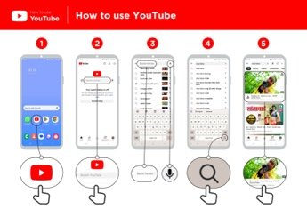
Show the ‘How to use YouTube’ poster
Explain: “This poster shows the steps for using YouTube to search for videos.”

Take your trainees through the steps on their shared phones for a simple
YouTube search.
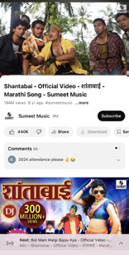
Show the result page for a popular video

Explain what your trainees are looking at:

- “The image at the top is the video – you can tap on it to make it play or pause.”

• “This is the number of times the video has been viewed by people on YouTube and can give you an indication of how popular it is.”
- “You can like or dislike the video by clicking on the thumb icons. The number next to each shows how many people have liked and disliked it.”

• “These are links to other videos you can play that are similar.”


- “When you scroll down to the bottom, you see a comments box, where
people have written comments about the video.

You can add your own comment here about the video.”

Ask: “Have you got any questions about what you are looking at here?”

Activity: Basic use of YouTube
Hold up the microphone icon for YouTube:

“You are now going to try using group chat.”

- Explain: “The microphone can be used so that you do not have to type any text. When you can’t spell or write the words you want to search, you can just tell YouTube the words you want to search for.”

- Demonstrate where to find it: “Click in the search box and the microphone will appear on the right.”

- Demonstrate how to use it: “Press the microphone icon and speak loudly, clearly and slowly.”

- Ask your trainees to search for ‘Shantabai’ using the microphone.
Ask your trainees to practise searching for videos with the following exercises:

- Type the name of a popular local song into the YouTube search box and play it.

- Type a local famous location into the search box and play it.

- Give your trainees one word to type into the search box that is relevant to them e.g. recipes, jobs, farming, and play the results.

Activity: Multiple word search
Explain: “We are now going to try a more detailed search by using more search words – this can be helpful to find the videos you want.”

Ask your trainees to practise searching for videos by putting different combinations of two to three words into the YouTube search box. They can do this using the microphone or by typing in text. Give your trainees different words to combine, based on what they searched for earlier. For example:

- Africa, new, music

- Premier League, best, goals
Tip: Give your trainees plenty of time to explore different results and different word combinations.

Activity: Personal searches
Discuss with your trainees how YouTube can help them in their own lives.

- Ask: “Now you know how to use YouTube, what do you want to use it for in your own life?” Give them some suggestions based on their interests.

- Discuss with your trainees what words they can use to search according to their interest. Keep your search word suggestions simple, and use only one or two words.
- Ask each trainee to take turns using the phone to search for videos they are interested in and ask the other trainees to support them with this.

- Ask: “What videos do you want to search for next?”
Tip: “There is a lot of great information on the internet, but also some which is not so great, and some that is not completely truthful. It is always best to look at two or three results to get the best answer to what you are looking for.”

Safety
Ask: “What does safety mean to you?”

Ask your trainees to imagine they are in a typical public place, like the market. Ask them to discuss what they would do to keep safe in this place. Prompt them with the following questions and answers:
Prompts | Potential answers
What do you do if someone you don’t | You avoid or ignore them. Be careful,
know bothers you? | they are not always who they say they
 | are.
What do you do if someone you don’t know or trust asks you for your personal information? | You don’t give out personal information to someone you don’t know or trust because they may misuse it.
What do you do if you feel unsure or | Tell someone you know and trust  about what happened.
uncomfortable about something you | Tell someone you know and trust  about what happened.
see or experience? | Tell someone you know and trust  about what happened.
How do you treat people you interact | You are polite and respectful to people.
with? | You are polite and respectful to people.
Explain: “It is important to remember the internet is also public place, and it is important to treat it like a public place and stay safe.”

Tip: Give your trainees as much time as they need to explore and feel comfortable with the phone.

Safety
Give your trainees the ‘Top tips to stay safe online’ poster.

- Discuss with your trainees what these tips mean for using the internet.

- Bring the tips to life by using examples that are relevant for your trainees. For example, women may be more concerned about how to prevent harassment.
Tip: “You are in control of what you search for – you can search for good things or you can search for bad things. It is your responsibility to search for good things.”


YouTube safety

- Ask: “Is there anything that you are concerned about when using YouTube?”

- Ask: “If you are looking at videos on YouTube and you see one that you think is bad or offensive, what can you do next?”
- Explain and demonstrate for your trainees: “You can press the back button, delete the words in your search box and refine your search by using different words.”

Tip: “YouTube has many videos created by people, some may be just like you. You might not like or agree with all the videos you see - you can choose not to watch these and you can click the ‘thumbs down’ icon to see less of videos that you don’t like. Remember that not everything you see on YouTube is true so think twice about acting on or sharing the videos.”

Cost
Explain: “Now you know how to use YouTube and what it can be used for, let us talk about how much it costs to use. To use the internet on your mobile, you have to buy data from your mobile network provider, just like you do with phone credit.”
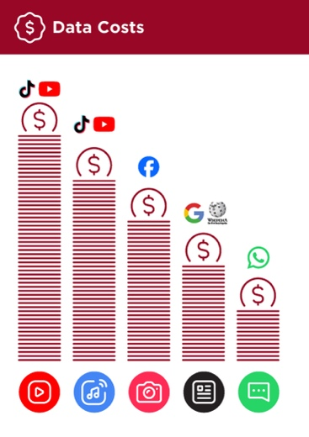
Show the ‘Data costs’ poster

- Explain: “Different activities use different amounts of data. Looking at text uses the least data, looking at images uses more, playing and downloading music uses a bit more and playing videos uses the most.”

- Explain: “Some internet services are linked to activities that use more data.”

- Ask: “Which service tends to cost more to use?”
- Answer: “YouTube. Watching videos on YouTube tends to use a lot of
data.”
Checking data

Ask: “Why is it useful to check how much data you have used?”

Answer: “To understand how much of your data you have used up and how much different activities cost to do.”

Explain: “You can check how much data you have, just like you check how many minutes or texts you have by typing in a code on your phone from your mobile network.”
Explain: “You can buy data in different amounts depending on what you are going to use the internet for. Ask advice from your local mobile agent on which amount is best suited to you.”

Explain: “If you access the internet in a Wi-Fi zone, you will not use your data package. Your local mobile agent may be able to help you find your local Wi-Fi zones. However, the nearest zone may be too far to travel to.”

Demonstrate to your trainees how to check their data.

Tip: “The data checking process varies depending on which country you are in and which network the phone is on. Ask a mobile agent if you need support with how to check data.”

Recap
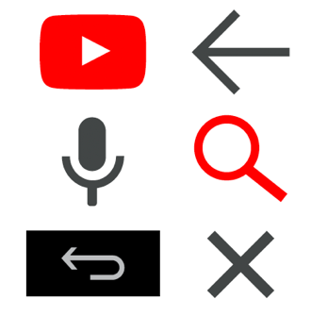
Play the YouTube icon game

- Hold up each YouTube icon, one at a time.

- Ask: “Where is this on the phone and what is it?”

- Explain to your trainees what each icon is if they need support.

- Give small rewards (e.g. sweets) for correct answers and stick the icons on the wall afterwards to help remind your trainees what they are.
Explain that there are other similar services to YouTube, which allow people to upload and watch videos. Some examples are Dailymotion and TikTok.

Recap on YouTube
Discuss with your trainees what they have learned about using YouTube:

- “What have you learned about using YouTube?”

- “How is it different from watching TV?” and “what can you do with YouTube that you can’t do with TV?”

- “Do you still have any concerns about using YouTube?”

- “What personal uses could you have for it?” and “what professional uses could you have for it?”

- “What do you want to use YouTube for in your own life? What are you most interested in and excited about using it for?”

Tip: Run the recap as a quiz and give rewards (e.g. sweets) to trainees for playing.

Tip: “Many apps and services on the internet use similar icons and words. When you are using the internet, look out for these icons so next time you see them, you can remember what they mean.”

Tip: “YouTube is a great place to find videos, but there is a lot more information on the internet that is not video and that will not be accessible through YouTube. The internet is much bigger than only YouTube. One way to find other information can be through Google Search.”

Tip: If trainees would like to access the internet and YouTube on their own phones, give them some time here to practise what they’ve learned and offer support and encouragement.

Going to the next level
If you reach the end of the session and have extra time:

- Ask: “Do you have any further questions about anything we have covered in the session?”

- Ask: “What else would you like to know about the mobile internet?”

Some more advanced features you can discuss with your trainees include:

- Evaluating results: “How do you decide which video to select on the search results page? How do you know if one option is better than another?”

- Creating videos: “You can also create your own videos and share them on YouTube.”

- Sharing videos: “If you were able to share your own YouTube videos, what would you share?”

- Downloading apps from the app store (you will need to cover email also, as having email is necessary to download apps).

In-Depth Training
YouTube

Mobile Internet
Skills Training

Toolkit

A guide for training people

in basic mobile internet skills

Posters and Cut-Outs
Session Ground Rules

This space is:

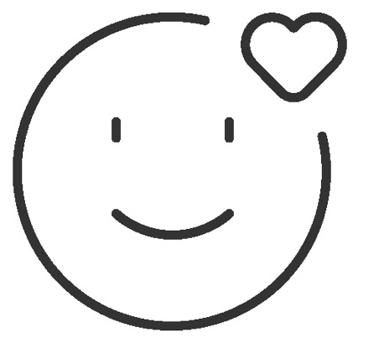

Safe

Keep all information in this training confidential. We suggest you don’t share personal numbers with the other members of group.

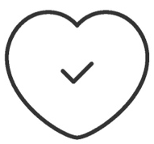

Positive & open

Please be respectful and positive in your opinions and discussions. There are no right or wrong answers and we are not here to test you.

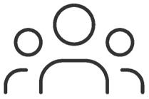

- shared
community

There are people with different backgrounds, knowledge and opinions. This is our shared space, so respect and support everyone.

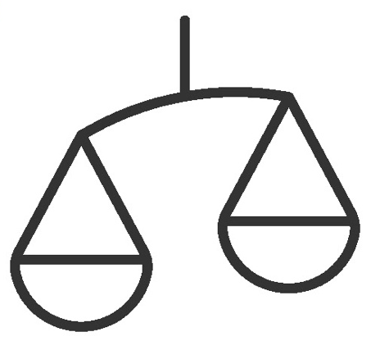

Fair

We will work in small groups and we will provide you with shared phones. We would like to give everyone an equal chance to be heard and to take turns using a phone.

Definitions

Trainers can add to this section to include local relevant information on mobile internet
3G / 4G / 5G | The internet can run at different speeds when you use it. 3G internet is the slowest, 4G internet is faster and 5G internet is the fastest.
App | An app gives you a shortcut to a service on your phone. For internet services e.g. WhatsApp, Facebook, Google, apps provide a quick and easy way to get onto the internet to use that service.
Address bar | The address bar shows you what website you are on.  In the address bar there will always be the address of the website e.g. www.google.com
Advert  or Ad | An ad is a piece of information that is trying to sell you something. It is good practice to avoid clicking on ads.  - Ads can be videos or images that pop up on your screen.  - Ads can also be the links at the top of Google results and on the right side of the screen.
Browser |   A web browser, or simply “browser,” is an application used to access and view websites. Common web browsers include:
Data | Whenever you use the internet on your phone, you are using data. You can buy data from your mobile network provider, just like you do with phone credit.
Feature  phone | A mobile phone that has the ability to access the internet and store and play music but lacks the advanced functionality of a smartphone.
 | Google is an internet service that makes it easy to find any information that you want to find on the internet.

Definitions

Internet | The Internet is a network of millions of computers around the world connected to each other with phone lines, satellites and cables. It gives you access to a huge range of information and services and it is growing all the time. The internet is for everybody. There are no restrictions on who can use it. You just need a computer, mobile phone or tablet and a data connection.
Link | A link connects you from one website to another. To go to the other website, you can touch the link and this will connect you and take you to that other website
Megabytes & Gigabytes | Megabytes (MB) and Gigabytes (GB) are units of data that you use when using the mobile internet. GB are 1000 times bigger than MB. If you download or stream a song, that will use approximately 5MB (1MB per minute).
Search | The search function helps you find what you are looking for. You type the words to what you are looking for into a search box and then you will see a list of links to potential answers.
Smartphone | A mobile phone that has the ability to access the internet, store and play music and videos, and run ‘apps’. These phones typically also have a touchscreen.
Website | Information on the internet is kept on different websites. There are lots of separate and different websites on the internet e.g. Google is a website, YouTube is a website.
 | WhatsApp is an internet service that makes it easy to connect and communicate with people that you know; family, friends and colleagues.
WiFi | A WiFi zone is an area where you do not have to use your own  data to access the internet on your phone; you can connect to the  internet for free. WiFi zones are available in some public places  such as coffee shops and cafes.
 | YouTube is an internet service that makes it easy to find, watch and listen to videos on the internet (and only videos).

Trainers can add to this section to include local relevant information on mobile internet

Top tips to stay safe online

 | Remember that not everything you see online is real  Anyone can post anything online, so don’t believe everything you see. Even if it’s from someone you trust, it might not be true. Be careful before sharing information with others
 | Think twice before sending money to someone you meet online  Be careful with emails, messages or pop-ups you didn’t ask for, especially if they ask for money or contain strange links.
 | Keep your personal information private, including passwords  Avoid sharing personal details like your full name, home address or phone number unless absolutely necessary.
 | Don’t cause harm to others online  Be kind and respectful. Don’t bully, spread false information or harass anyone. Your actions online can affect people in real life.
 | Be aware of scams and fraudsters  Just like in real life, thieves and criminals are on the internet too.  Some people online pretend to be someone else.
 | Take action by blocking or ignoring someone who is bothering you  If someone is bothering or harassing you online, ask for help and tell someone or report it.

Remember that the internet is open to everyone around the world and so it is essential to treat it like a real-life public place (e.g. a marketplace) and stay safe by protecting yourself and being responsible with what you do online.

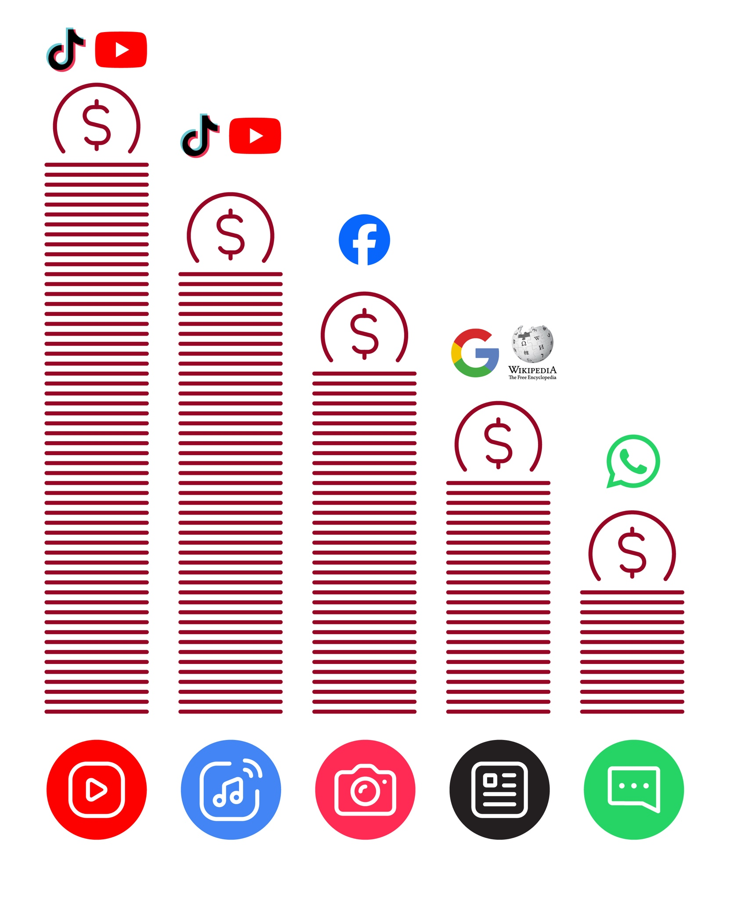
Data Costs
Healthy Internet Use

 | Set time limits  Think about how much time you are spending using the internet – it should not get in the way of your other responsibilities. If it does, set limits!
 | Watch your mood  If the internet or your phone is making you sad or angry, take a break!
 | Maintain healthy relationships online  Make time to socialise with friends and family in real life, not just on the internet! Don’t spend all your time on the internet.
 | Be careful  The internet can be dangerous with scams, harassment and things you don’t want to see. Be careful!
 | Stay positive  Stay positive and avoid upsetting or harming others. Be responsible and keep a positive attitude!
 | Get enough sleep and rest  Sleep and rest are important - make sure the internet or your phone doesn’t stop you doing this! Don’t use the internet when you need to rest or sleep.

How to use
YouTube

How to use YouTube



1 2 3 4 5
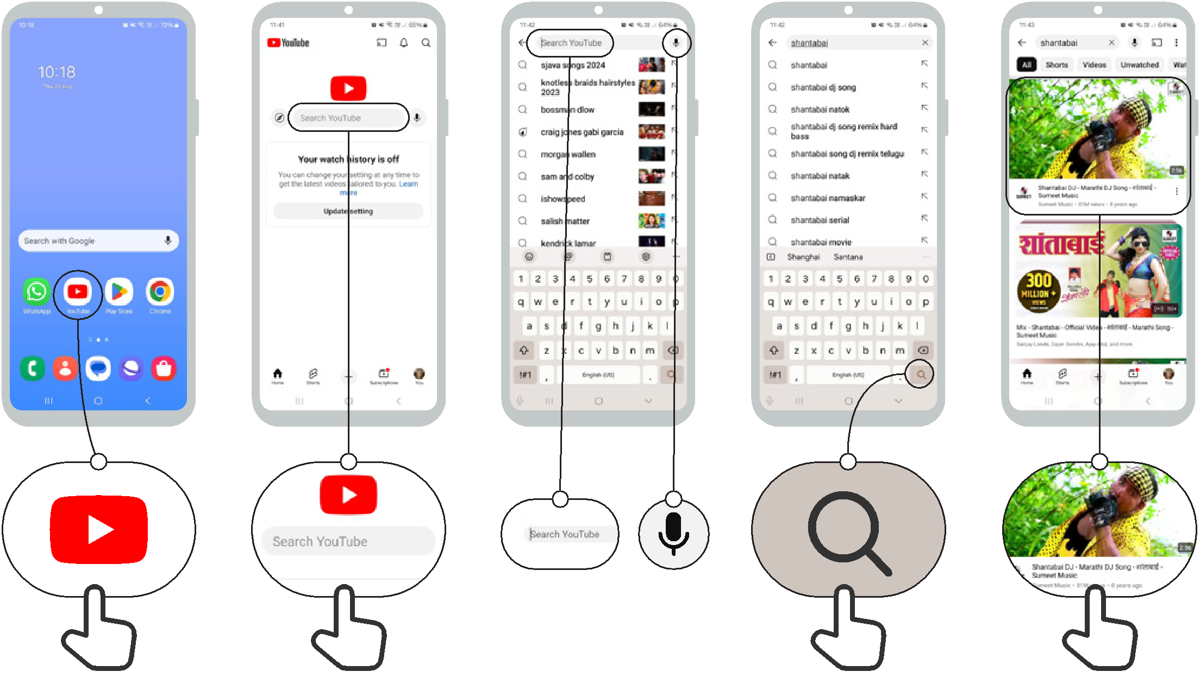

Icon Cut-Outs

YouTube


Icon Cut-Outs
YouTube


Icon Cut-Outs
YouTube


Icon Cut-Outs
YouTube


Icon Cut-Outs

YouTube



Icon Cut-Outs


YouTube

Mobile Internet Skills Training Toolkit


‘Thank you’ and close training

After you have completed the training, congratulate your trainees and hand out certificates as a reward.

Thank the trainees

Give out the handouts

- Give your trainees the handouts for the training if you haven’t already done so.

- These include the ‘Definitions’, ‘Top tips to stay safe online’, ‘Data costs’, ‘Healthy internet use’ and relevant module posters.

- Ask: “Do you feel confident to use these accessibility features?” or “Do you feel confident to use your mobile phone?”

- Thank your trainees for their time, input and participation in the training.



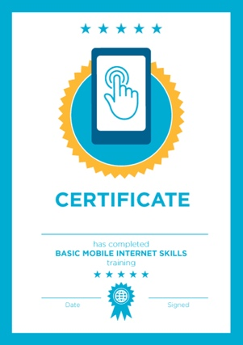

Conduct a closing ceremony

- Give each trainee a signed certificate (certificate templates are included in the toolkit).

- You can also provide the trainers with certificates for having completed the training ‘as trainers’.

Tip: You can make this more of a ceremony for trainees, by asking them to come up to the front of the room one person at a time to receive their certificate and shake the trainer’s hand.

here


CERTIFICATE

has completed

BASIC MOBILE INTERNET SKILLS

training

Date Signed

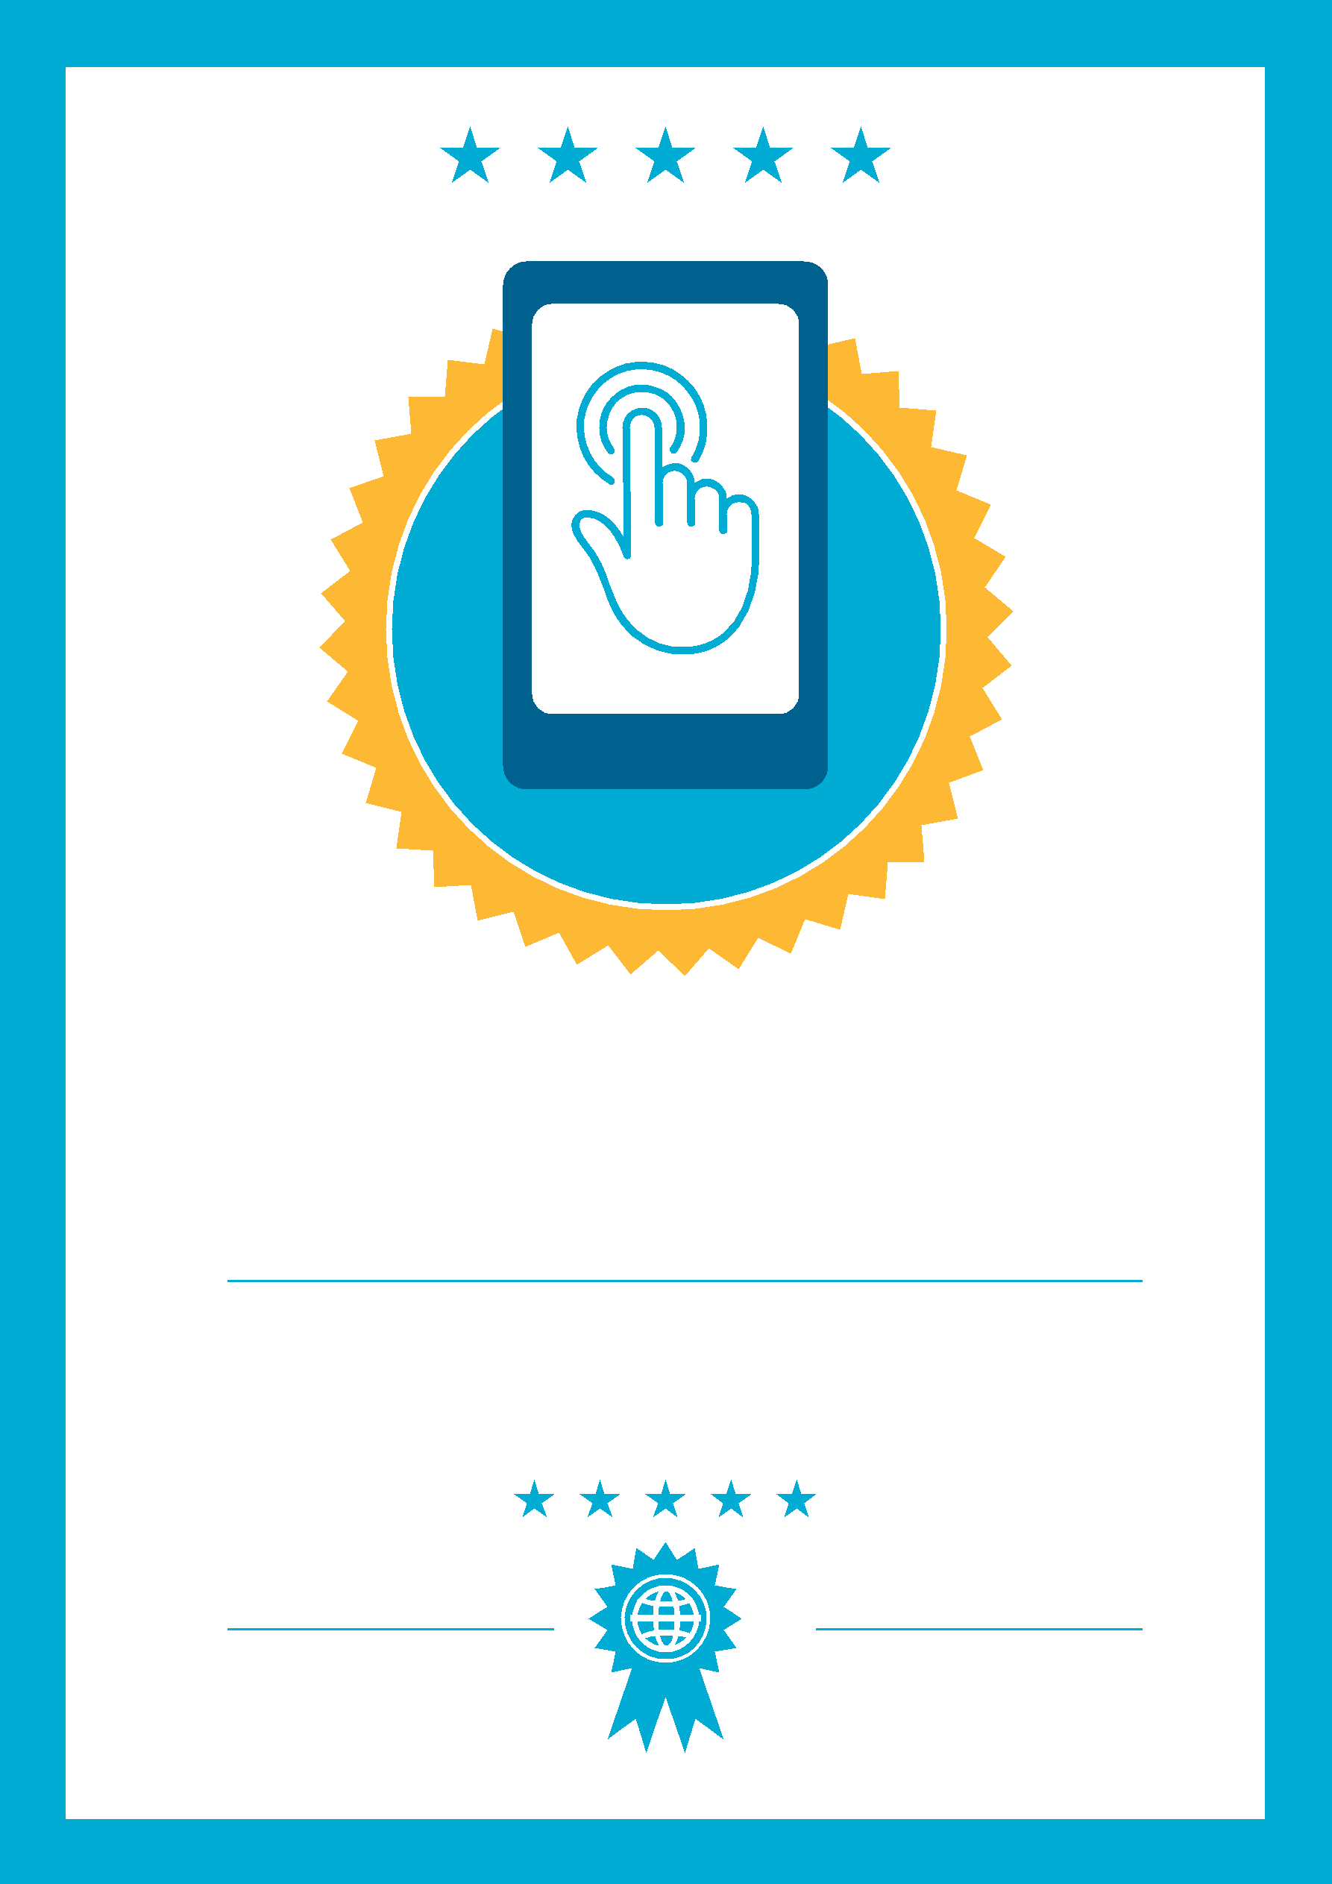

CERTIFICATE

has completed

BASIC MOBILE INTERNET SKILLS
training

Date
Signed

