EID Definition and Assignment Process

Version 1.1

22 March 2024

Security Classification: Non-confidential
Access to and distribution of this document is restricted to the persons permitted by the security classification. This document is confidential to the Association and is subject to copyright protection. This document is to be used only for the purposes for which it has been supplied and information contained in it must not be disclosed or in any other way made available, in whole or in part, to persons other than those permitted under the security classification without the prior written approval of the Association.
Copyright Notice
Copyright © 2024 GSM Association
Disclaimer
The GSM Association (“Association”) makes no representation, warranty or undertaking (express or implied) with respect to and does not accept any responsibility for, and hereby disclaims liability for the accuracy or completeness or timeliness of the information contained in this document. The information contained in this document may be subject to change without prior notice.
Antitrust Notice
The information contain herein is in full compliance with the GSM Association’s antitrust compliance policy.

Table of Contents
1 History of EID issuance 4
2 Scope 4
3 Reference 4
4 Abbreviations 5
5 Definitions 5
6 EID Usage 5
7 EID Principles 5
8 EID Scheme Requirements 6
9 Requirements on Assignment Authorities 6
10 eUICC Numbering System 7
11 Criteria for ERHI1 Assignment 8
12 ERHI1 Assignment Process 9
13 ERHI1 Cancellation Process 11
14 GSMA Responsibilities 12
15 Subsequent Level EIN Assignment Authorities Responsibilities 12
Annex A Document Management 14
A.1 Document History 14
Other Information 14

History of EID issuance
The main purpose of the eUICC Identifier (EID) is to provide a unique global serial number for eUICCs, it is not related to service subscriptions and cannot be used to identify them. The original format of the eUICC issuer Identifier (EID) was inherited from the Integrated Circuit Card Identifier (ICCID) format where certain fields of the ICCID were embedded in the EID structure. The ICCID is defined by the ITU-T recommendation E.118 [6] as a Primary Account Number. Within ICCID the Issuer Identifier Number (IIN) is typically administrated by national authorities as part of the IIN allocation. However:
- The EID is not a Primary Account Number (PAN) as its main purpose is not the charging of services.
- Different National Regulatory Authorities issue IINs/ICCIDs for use as EIDs using different rules, creating different operating conditions for manufacturers and in some cases making it impossible for manufacturers to obtain EIDs.
In 2019, the GSMA was asked by industry stakeholders to assume responsibility for the administration of the EID.

Scope
This document specifies:
- the EID principles and requirements to be followed by the entities that assign EID numbers;
- the format of the EID; and,
- the EID assignment process to be followed by assignment authorities.
When approved, this document establishes the GSMA as the only appointed First Level EIN Assignment Authority. However, EIDs assigned under the ITU-T E.118 [6] based scheme will remain valid in the eSIM ecosystem.

Reference
Ref | Document Number | Title
[1] | SGP.01 | Embedded SIM Remote Provisioning Architecture
[2] | SGP.02 | Remote Provisioning of Embedded UICC Technical specification
[3] | SGP.21 | RSP Architecture Specification
[4] | SGP.22 | RSP Technical Specification
[5] | ISO/IEC 7812-1 | ISO/IEC 7812-1, Identification cards – Identification of issuers – Part 1: Numbering system.
[6] | ITU-T E.118 | ITU-T Recommendation E.118, The international telecommunication charge card
[7] | GSMA PRD AA.35 | Procedures for Industry Specifications

Abbreviations
Abbreviation | Description
EAA | EIN Assignment Authority
EID | eUICC Identifier
EIN | EUM Identification Number
ERHI | EID Range Holder Identifier
ESIN | EUM Specific Identification Number
EUM | eUICC Manufacturer
ICCID | Integrated Circuit Card Identifier
IIN | Issuer Identifier Number
PAN | Primary Account Number

Definitions
Term | Definition
Device Manufacturer | As defined in SGP.21 [3].
First Level EIN Assignment Authority | The global authority that assigns the ERHI1s.  In the scope of this specification, this authority is the GSMA.
Group of Device Manufacturers | A collection of Device Manufacturers represented by a single entity.
National Authority | National Authorities are entities nominated or authorized for the local government to carry out regulatory task within the country.
Primary Account Number | A number that is used to identify an individual account holder as defined by ISO/IEC 7812-1 [5].

EID Usage
The EID is the eUICC Identifier used in the context of Remote SIM Provisioning and Management of the eUICC as defined in [1], [2], [3] and [4].

EID Principles
This section contains the principles related to the EID.
Principle No | Description
EID.P01 | Existing mechanisms for ICCID issuance by national numbering authorities, and subsequent subscriber identification shall not be affected.
EID.P02 | The central purpose of the EID is to uniquely identify an individual eUICC (this is independent of the eUICC form factor and includes both discrete or integrated eUICC forms).  NOTE: Uniqueness is required for cryptographic mutual authentication and eUICC security mechanisms.
EID.P03 | The EID is not a Primary Account Number (PAN).
EID.P04 | The EID is not intended to be used to charge for telecommunication services.
EID.P05 | The EID assignment shall be separate from the ICCID and IIN assignment.
EID.P06 | The EID is not required to maintain compatibility with ISO/IEC 7812-1 [5] e.g.: limit the first 2 digits to 89.

EID Scheme Requirements
Requirements No | Description
EID.R01 | The length of the EID SHALL be 32 digits.
EID.R02 | The EID SHALL identify uniquely an eUICC.
EID.R03 | The EID defined in this document SHALL be defined independently of ITU-T E.118 [6].

Requirements on Assignment Authorities
Requirements No | Description
AE.R01 | The uniqueness of the EID SHALL be maintained regardless of the assignment authority.
AE.R02 | The EID assignment defined in this document SHALL not use EIDs that start with 89; such values are reserved for the ITU-T E.118 based scheme [6].
AE.R03 | Criteria for eligibility SHALL exist for all assignment authorities involved in the assignment of EIDs.

eUICC Numbering System
The length of the EID shall be 32 digits. It is composed of the following parts (see Figure 1):

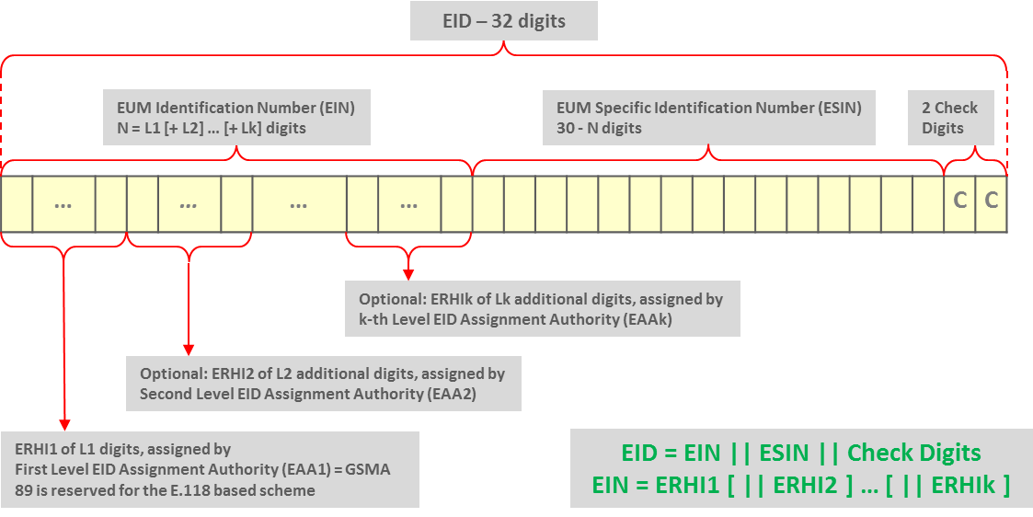Figure 1: EID Structure

- The EUM Identification Number (EIN): N digits (variable length)
  - EIN consists of one or multiple concatenated EID Range Holder Identifiers (ERHIx) with the last ERHI being assigned to an EUM.
  - Each ERHI is assigned by an EIN Assignment Authority (EAA) to either an EUM, or a subsequent EAA.
  - Each EAA is responsible for the uniqueness of the ERHIs it assigns.
  - Assigned ERHIs do not need to be of the same length.
  - The EAA determines the number of digits in the assigned ERHIs.
  - Example: ERHI 11 is assigned to entity A. As a consequence, ERHIs 110 to 119 or any other number starting with 11 can no longer be assigned. However, ERHIs 120 to 129 can be assigned to entities B to K.
  - The First Level EAA is the GSMA.
  - GSMA will assign ERHI1s to:
      - EUMs or
      - National Authorities or
      - Device Manufacturers
      - Group of Device Manufacturers

Examples on chains of ERHIs:
      - Example 1: ERHI1 is assigned to an EAA by the GSMA, ERHI2 values are assigned to Device Manufacturers by the EAA (identified by its GSMA-assigned ERHI1 value), ERHI3 is assigned to an EUM by the Device Manufacturer (identified by its EAA-assigned ERHI2 value)
      - Example 2: ERHI1 is assigned to a Device Manufacturer by the GSMA, ERHI2 values are assigned to an EUM by the Device Manufacturer (identified by its GSMA-assigned ERHI1 value)
      - Example 3: ERHI1 is assigned to a Group of Device Manufacturers by the GSMA, ERHI2 values are assigned to a single Device Manufacturer by the Group of Device Manufacturers (identified by its GSMA-assigned ERHI1 value), ERHI3 is assigned to an EUM by the single Device Manufacturer (identified by its EAA-assigned ERHI2 value)

- The EUM Specific Identification Number (ESIN): 30-N digits (variable length depending on EIN)
  - The ESINs are assigned by the EUM.
  - The EUM is responsible for the uniqueness of the ESINs it assigns.
- The Check Digits: 2 digits containing check digits calculated by the EUM over all 32 digits as specified below
- Set the two check digits to 0,
- Using the resulting 32 digits as a decimal integer, compute the remainder
of that number on division by 97,
- Subtract the remainder from 98, and use the decimal result for the two
check digits, if the result is one digit long, its value SHALL be prefixed by one digit of 0.
Verification of the check digits of an EID can be performed by any interested party as follows:

- Using the 32 digits as a decimal integer, compute the remainder of that number on division by 97.
- If the remainder of the division is 1, the verification is successful; otherwise the EID is invalid.

Criteria for ERHI1 Assignment
Applications for an ERHI1 SHALL meet all the criteria for approval below:
- The applicant applying for an ERHI1 SHALL NOT already have an ERHI1 assigned to it, except in the justified exceptions;
- The applicant SHALL commit to use the ERHI1 preferably within 12 months of the release date.
- For non-National Authorities,
  - The applicant SHALL be an EUM or Device Manufacturer or Group of Device Manufacturers, and
  - the applicant SHALL be a single corporate entity operating under a specific legislative regulation.

ERHI1 Assignment Process
@startuml
skinparam sequenceMessageAlign center
skinparam sequenceArrowFontSize 11
skinparam noteFontSize 11
skinparam monochrome true
skinparam lifelinestrategy solid

participant "<b>Applicant" as A
participant "<b>GSMA EIN Assignment Services" as GSMA

rnote over A #FFFFFF
[1] Fill Registration Form
end rnote
A -> GSMA : [2] Registration Form Submission

rnote over GSMA #FFFFFF
[3] GSMA Verification Process
(No more than 5 days)
end rnote

GSMA --> A : Verification fails

rnote over GSMA #FFFFFF
[4] Assign the ERHI1
end rnote

group GSMA Confirmation
GSMA -> A : [5.1] Notify the new ERHI1

rnote over GSMA #FFFFFF
end rnote
end
@enduml

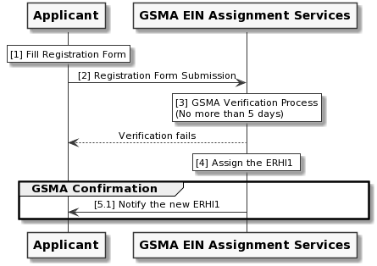
Figure 2: ERHI Level 1 Assignment
The ERHI1 Assignment involves five stages that are detailed below:

- Form filling
The applicant completes the necessary details defined in the Registration Form that can be found on gsma.com.

- Submission
The applicant sends the completed and signed Registration Form to EISRegistration@gsma.com.

- Verification Process
GSMA verifies the authenticity of the applicant company and the validity of the application.
It is estimated that the entire verification process will not take more than 5 working days after receipt of the form.
If the verification fails, GSMA may take further actions depending on the reason of the verification fail (e.g., attempt of fraud to a legitimate ERHI1 owner).

- ERHI1 Assignment/Rejection
If the verification in step 3 is successful, GSMA assigns the ERHI1 .
- GSMA Confirmation
After the documentation is verified by GSMA, GSMA:
  - notifies the applicant of the assigned ERHI1 by sending the completed registration form.

ERHI1 Cancellation Process
@startuml
skinparam sequenceMessageAlign center
skinparam sequenceArrowFontSize 11
skinparam noteFontSize 11
skinparam monochrome true
skinparam lifelinestrategy solid

participant "<b>Applicant" as A
participant "<b>GSMA EIN Assignment Services" as GSMA

rnote over A #FFFFFF
[1] Fill Cancellation Form
end rnote
A -> GSMA : [2] Cancellation Form Submission with the ERHI1 to be cancelled

rnote over GSMA #FFFFFF
[3] GSMA Verification Process
(No more than 5 days)
end rnote

GSMA --> A : Verification fails

rnote over GSMA #FFFFFF
[4] Cancel the ERHI1 Number
end rnote

group GSMA Confirmation
GSMA -> A : [5.1] Notify the Cancellation of the ERHI1

rnote over GSMA #FFFFFF
end rnote
end
@enduml
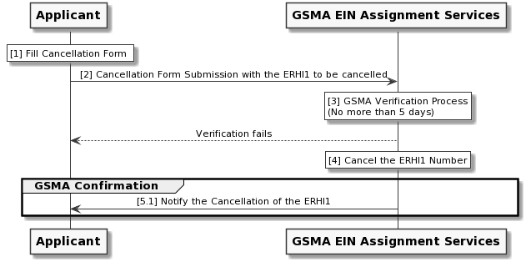
Figure 3: ERHI1 Cancellation

In addition to the EIN Assignment Process, an ERHI1 that is no longer used by a company may be cancelled by the EIN Assignment Authority. An applicant can ask to GSMA to cancel an existing ERHI1 following the process described below:

- Form filling
The applicant completes the necessary details defined in the Cancellation Form that can be found on gsma.com.

- Submission
The applicant sends the completed and signed Cancellation Form to EISRegistration@gsma.com.

- Verification Process
GSMA verifies the authenticity of the applicant company and the validity of the application.
It is estimated that the entire verification process will not take more than 5 working days after receipt of the correct form.
If the verification fails, GSMA may take further actions depending on the reason of the verification fail (e.g., attempt of fraud to a legitimate ERHI1 owner).

- GSMA Confirmation
If the verification in step 3 is successful, GSMA:
  - Notifies the applicant that the ERHI1 has been cancelled.

GSMA Responsibilities
Within the context of this document, the GSMA has the following responsibilities.

- Register or cancel any ERHI1
- Maintain a list of assigned ERHI1s and their status.
- Ensure integrity of the EID Assignment process.
  - This includes a yearly review by GSMA and a report to the group in GSMA responsible for issuing this document about the actual assignments and their usage by Subsequent Level EAAs.
- Provide expertise and advice on EID issues where appropriate.
- Ensure that if the ERHI1 has been cancelled, it is not assigned to any other entity.

Subsequent Level EIN Assignment Authorities Responsibilities
Within the context of this document, any Level X EIN Assignment Authority (X>=2) SHALL have the following responsibilities:

- Comply with the EID requirements defined in Section 8, with the Assignment Authority Requirements defined in Section 9, and the Numbering Scheme defined in Section 10.
- Complete all the information with regards to the Registration or Cancellation Forms, respectively.
- Ensure that each ERHIx is unique.
- Only the verified company SHALL request the cancellation of their own identifier.
- Once an ERHIx has been cancelled, it SHALL NOT be used after the date indicated in the Cancellation Form.
- Comply with the assignment reporting requirements for their Level X-1 EAA.

- Document Management

A.1 Document History
Version | Date | Brief Description of Change | Entity | Approval Authority | Editor / Company
1.0 | 31 July 2020 | First Release of this document | eSIMG | ISAG | Yolanda Sanz, GSMA
1.1 | 22 March 2024 | Draft 0 of SGP.29 v1.1 | eSIMWG2 | ISAG | Yolanda Sanz, GSMA
 |  | CR11000R06 Allow the Device Manufacturers to get a ERHI1 value from the GSMA  CR11001R02 Adding Group of Manufacturers definitions | ESIMWG2 | ISAG | Yolanda Sanz

Other Information

Type | Description
Document Owner | eSIMG
Editor / Company | Yolanda Sanz, GSMA

It is our intention to provide a quality product for your use. If you find any errors or omissions, please contact us with your comments. You may notify us at prd@gsma.com

Your comments or suggestions & questions are always welcome.

