

SGP.21 RSP Architecture

Version 2.7

24th April 2026

Security Classification: Non-confidential
Access to and distribution of this document is restricted to the persons permitted by the security classification. This document is subject to copyright protection. This document is to be used only for the purposes for which it has been supplied and information contained in it must not be disclosed or in any other way made available, in whole or in part, to persons other than those permitted under the security classification without the prior written approval of the Association.
Copyright Notice
Copyright © 2026 GSM Association
Disclaimer
The GSMA makes no representation, warranty or undertaking (express or implied) with respect to and does not accept any responsibility for, and hereby disclaims liability for the accuracy or completeness or timeliness of the information contained in this document. The information contained in this document may be subject to change without prior notice.
Compliance Notice
The information contain herein is in full compliance with the GSM Association’s antitrust compliance policy.
This Permanent Reference Document is classified by GSMA as an Industry Specification, as such it has been developed and is maintained by GSMA in accordance with the provisions set out in GSMA AA.35 - Procedures for Industry Specifications.

Table of Contents
1 Introduction 6
1.1 Overview 6
1.2 Scope 6
1.3 Intended Audience 6
1.4 Definition of Terms 6
1.5 Abbreviations 12
1.6 References 14
1.6.1 Normative references 14
1.6.2 Informative references 16
1.7 Conventions 16
2 Principles 16
2.1 Basic Principles 16
2.2 Profile Principles 17
3 Roles 18
3.1 eUICC Manufacturer 18
3.2 Device Manufacturer 18
3.3 Operator and Service Provider 18
3.4 Subscriber and End User 19
3.5 Certificate Issuer 19
3.6 Application Developer 19
4 Remote SIM Provisioning System Architecture 19
4.1 eUICC Architecture 20
4.1.1 eUICC Architecture Overview 20
4.1.1.1 ECASD 21
4.1.1.2 ISD-R 21
4.1.1.3 ISD-P 22
4.1.1.4 MNO-SD 22
4.1.1.5 Profile Policy Enabler 22
4.1.1.6 Telecom Framework 22
4.1.1.7 Profile Package Interpreter 22
4.1.1.8 LPA Services 22
4.2 Interfaces 23
4.2.1 Operator – SM-DP+ (ES2+) 23
4.2.2 Operator – End User (ESop) 23
4.2.3 End User - LUI (ESeu) 23
4.2.4 Operator – eUICC (ES6) 24
4.2.5 SM-DP+ – LPD (ES9+) 24
4.2.6 SM-DP+ – eUICC (ES8+) 24
4.2.7 SM-DP+ – SM-DS (ES12) 24
4.2.8 LDS – SM-DS (ES11) 24
4.2.9 EUM – eUICC (ESeum) 24
4.2.10 LDS – LPA Services (ES10a) 24
4.2.11 LPD – LPA Services (ES10b) 24
4.2.12 LUI – LPA Services (ES10c) 25
4.2.13 SM-DS – SM-DS (ES15) 25
4.2.14 Device – SM-DP+ (Established Connection) 25
4.2.15 General Interface Requirements 25
4.3 eUICC Requirements 26
4.4 eUICC Eligibility Check 30
4.4.1 eUICC Eligibility Check Requirements 30
4.5 Device Requirements 31
4.5.1 Device Capability Requirements 32
4.5.2 Device with Integrated eUICC 32
4.6 Device Initialisation 33
4.6.1 Device Reset Requirements 33
4.6.2 eUICC Memory Reset Requirements 33
4.6.3 eUICC Test Memory Reset Requirements 33
4.7 Profile Requirements 33
4.7.1 Test Profile Requirements 33
4.7.2 Provisioning Profile Requirements 34
4.8 Profile Metadata Requirements 35
4.9 NFC Requirements 36
4.10 Subscription Manager Data Preparation + (SM-DP+) 37
4.10.1 SM-DP+ Overview 37
4.10.2 SM-DP+ Requirements 38
4.10.3 Default SM-DP+ Address on the eUICC Requirements 40
4.11 Local Profile Assistant (LPA) 41
4.11.1 LPA Overview 41
4.11.2 Operational LPA Modes 42
4.11.2.1 LPA in the eUICC 42
4.11.2.2 LPA in the Device 43
4.11.3 LPA Requirements 44
4.11.4 LDS Requirements 48
4.12 Subscription Manager – Discovery Service (SM-DS) 48
4.12.1 SM-DS Overview 48
4.12.2 SM-DS Implementation 50
4.12.3 SM-DS Implementation Guidelines 50
4.12.4 SM-DS functions 51
4.12.5 SM-DS Requirements 51
4.12.6 Event Registration/Deletion Procedure 54
4.12.6.1 Event Registration Procedure 54
4.12.6.2 Event Deletion Procedure 55
4.12.7 Discovery Request Procedure 55
4.13 Profile Policy Management 57
4.13.1 Introduction 57
4.13.2 Profile Policy Management Requirements 57
4.13.3 Policy Rules 58
4.13.4 Profile Policy Enabler Requirements 59
4.14 Certification 59
4.14.1 eUICC Certification Requirements 59
4.14.2 Device Compliance Requirement 60
4.14.3 SM-DP+ Certification Requirements 61
4.14.4 SM-DS Certification Requirements 61
4.14.5 LPA Certification Requirements 62
4.14.6 Public Key Certificates Management Requirements 62
4.15 eUICC OS Update 63
4.16 Requirements for Interoperable Applications 63
5 Operational Procedures 64
5.1 LPA Initiated Download 64
5.1.1 LPA Initiated Download Requirements 64
5.1.2 LPA Initiated Download Procedure 64
5.2 Profile Download with Activation Code 67
5.2.1 Activation Code Requirements 67
5.2.2 Profile Download with Activation Code Procedure 67
5.3 Local Profile Management 70
5.3.1 Local Profile Management Procedures 70
5.3.1.1 Enable Profile 70
5.3.1.2 Disable Profile 72
5.3.1.3 Delete Profile 73
5.3.1.4 Add/Update Profile Nickname 74
5.3.1.5 Query Profile Metadata 75
5.3.1.6 eUICC Memory Reset 75
5.3.1.7 Add Profile with Activation Code 77
5.3.1.8 Edit SM-DP+ Address 77
5.3.1.9 Retrieve Activation Code 78
Annex A Security Threats, Risks and Creation Process Requirements (Informative) 80
A.1. New Profile on New Primary Device (Off Device Activation) 80
A.2. Profile Deletion 80
A.3. Profile Switch 80
A.4. Profile Swap 80
A.5. Cryptographic Related Risks 81
A.6. Quality of Service 81
A.7. Non-human or Unpredictable 81
A.8. New Profile during Subscriber Journey 81
A.9. Device Swap 82
A.10. Loss of Privacy 82
A.11. Others 82
A.12. Creation Process 82
Annex B Profile Production Procedure (Informative) 84
B.1 Profile Production Procedure 84
B.1.1 Profile Description Definition 85
B.1.2 Operator Credentials Generation 86
B.1.3 Protected Profile Package Generation 86
B.1.4 Contract Conclusion and Link Profile 88
B.1.4.1 Activation Code with Known EID 89
B.1.4.2 Activation Code with Unknown EID 90
B.1.4.3 Activation Code with EID Provided to the Operator 91
Annex C Local Profile Management Operations implementation (Informative) 93
Annex D eUICC Categories (Normative) 94
Annex E LPA Settings (Informative) 95
Annex F Certifications Chain and Security Model (Normative) 96
F.1 Security Model 97
Annex G LPA Integrity (Normative) 104
Annex H Rules Authorisation Table (Informative) 105
Annex I LPA Invocation of the Provisioning Profile Example Flow (Informative) 106
Annex J [Void] 107
Annex K Document Management 107
K.1 Document History 107
K.2 Detailed Document History for V2.7 107
Other Information 108

Introduction
  - Overview
This document provides an architecture approach as a proposed solution for the Remote SIM Provisioning of Devices across all markets.
The main goal of the Architecture is to define a mechanism for the Remote SIM Provisioning of Devices with the necessary credentials to gain mobile network access.
This version focuses on Devices for the consumer market.
Please note that SGP.21 V1.0 [23] has not been superceded.
  - Scope
The aim of this document is to define a common architecture framework to enable the Remote SIM Provisioning and management of the eUICC in Devices. The adoption of this architecture framework will aim to provide the basis for ensuring global interoperability for Remote SIM Provisioning between Operators in different deployment scenarios.
  - Intended Audience
Technical experts working within Operators, SIM solution providers, Device vendors, standards organisations, network infrastructure vendors, Service Providers and other industry bodies.
  - Definition of Terms
Term | Description
Activation Code | Information issued by an Operator/Service Provider to an End User. It is used by the End User to request for the download and installation of a Profile.
Activation Code Retrieval | The process for the LPA to retrieve from the SM-DP+ the Activation Code that is associated with a specific Profile currently installed on the eUICC. This process is associated with the Local Profile Management Operation, 'retrieve Activation Code'.
Activation Code Token | A part of the Activation Code information provided by the Operator/Service Provider to refer to a Subscription.
Alternative SM-DS | SM-DS used in cascade mode with a Root SM-DS to redirect Event Registration from a SM-DP+ to the Root SM-DS or direct Event Registration from a SM-DP+ for an installed Profile.
Application Developer | An entity that develops Interoperable Applications.
Bound Profile Package | A Protected Profile Package which has been cryptographically linked to a particular eUICC.
Certificate or Public Key Certificate | A certificate as defined in RFC.5280 [1][1][1] and GlobalPlatform specifications GPC_SPE_034 [9].
Certified eUICC | An eUICC meeting the GSMA requirements for Remote SIM Provisioning and certified according to the GSMA compliance programme defined in SGP.24 [38].  NOTE: Unless stated otherwise, the word eUICC in this specification refers to a Certified eUICC.
Companion Device | A Device that relies on the capabilities of a Primary Device for the purpose of Remote SIM Provisioning.
Confirmation Code | A code entered by an End User required by the SM-DP+ for the download of a Profile.
Confirmation Code Required Flag | A parameter to indicate whether the Confirmation Code is required or not.
Confirmation Level | Refers to the hierarchy of User Intent and Confirmation Request, where:  - User Intent is the first and lowest level  - Simple Confirmation is the second level  - Strong Confirmation is the third and highest level  NOTE: For examples of implementation, please refer to 0.
Confirmation Request | Describes a request for Strong Confirmation or a Simple Confirmation as defined in this specification.
Device | User equipment used in conjunction with an eUICC to connect to a mobile network. E.g. a tablet, wearable, smartphone or handset.
Device Manufacturer | An entity responsible for manufacturing Devices. The Device Manufacturer MAY be responsible for the selection and insertion of eUICCs in Devices.
Device Test Mode | A mode hidden from the End User that allows access to and use of Test Profiles.
Disabled Profile | The state of a Profile where all files and applications (e.g. NAA) present in the Profile are not selectable.
Discovery Request | An interrogation of the Discovery Service by a Device for Event Records that are registered for its eUICC.
Discrete eUICC | An eUICC implemented on discrete standalone hardware, including its own dedicated volatile and non-volatile memory.  A Discrete eUICC can be removable or non-removable.
eUICC | A UICC which enables the local management of Profiles in a secure way.  NOTE: The term originates from “embedded UICC”.
eUICC OS Update | A mechanism to correct existing features on the eUICC by the original OS manufacturer.
Enabled Profile | The state of a Profile when its files and/or applications (e.g. NAA) are selectable.
End User | The person using the Device.
End User Data | Information that pertains to the identity of an End User e.g. personal details, name, address, biometric characteristics, assigned identification numbers, etc.
eUICC Authorisation | Used by the SM-DS to authenticate the eUICC.
eUICC Certificate | A Certificate issued by the EUM for a specific eUICC.  This Certificate can be verified using the EUM Certificate.
eUICC Eligibility Check Information | The information set sent from the eUICC to the SM-DP+ to allow eligibility checks.
eUICC Manufacturer (EUM) | The eUICC Manufacturer provides eUICC products.
eUICC Memory Reset | An action that returns the eUICC to a state equivalent to a factory state.
eUICC Test Memory Reset | An action that deletes all post-issuance Test Profiles on an eUICC.
EUM Certificate | A Certificate issued by a GSMA CI to a GSMA accredited EUM which can be used to verify eUICC Certificates.
Event | A Profile download which is set by an SM-DP+ on behalf of an Operator, to be processed by a specific eUICC.
Event-ID | Unique identifier of an Event for a specific EID generated by the SM-DP+/SM-DS.
Event Record | The set of information stored on the SM-DS for a specific Event, via the Event Registration procedure. This information consists of either:  - the Event-ID, EID, and SM-DP+ address or  - the Event-ID, EID, and SM-DS address
Event Record Query | A query to the SM-DS (Root or Alternative) executed to verify Event Registration success or determine that an Event Record still exists.
Event Registration | A process notifying the SM-DS on the availability of information on either a specific SM-DP+ or a specific SM-DS for a specific eUICC.
Field-Test eUICC | A pre-production eUICC whose functional or security certifications are not yet completed by the EUM.
Form Factor | Physical manifestation of the UICC.
GSMA Certificate Issuer | A Certificate Authority accredited by GSMA.
ICCID | Unique number to identify a Profile in an eUICC as defined by ITU-T E.118 [14].
Integrated eUICC | An eUICC implemented on an Integrated TRE.
Integrated eUICC Test Interface | An external interface for the purpose of testing eUICC functionality.
Integrated TRE | A TRE implemented inside a larger System-on-Chip (SoC), optionally making use of remote volatile and/or non-volatile memory.
International Mobile Subscriber Identity | Unique identifier owned and issued by Operators as defined in 3GPP TS 23.003 [3] Section 2.2.
Interoperable Application | An application that can be downloaded, installed, executed and removed on any eUICC compliant with technical requirements of a runtime environment (resources, APIs, version, ...), regardless of its Form Factor, its Manufacturer, Device type, Device Manufacturer, Operator, and Mobile Service Provider.
Link Profile | The process that associates a Protected Profile Package with a specific eUICC so that a Profile Download including Bound Profile Package generation can be triggered.  NOTE: This is normally an offline process, binding is an online process happening during the communication between the SM-DP+ and the eUICC.
Local Profile Assistant (LPA) | A functional element in the Device or in the eUICC that provides the LPD, LDS and LUI features.
Local Profile Management | Local Profile Management are operations that are locally initiated on the ESeu interface.
Local Profile Management Operation | Local Profile Management Operations are enable Profile, disable Profile, delete Profile, query Profile Metadata, eUICC Memory Reset, eUICC Test Memory Reset, set/edit nickname, add Profile, edit default SM-DP+ address, and retrieve Activation Code.
LPA Integrity | Assurance that the LPA has not been compromised or affected. The assurance SHALL be provided to the various Remote SIM Provisioning entities to ensure that the LPA can be trusted to execute the actions requested  NOTE: This could be linked with a certification process.
LPA Mode | Defines the Operation LPA Mode which is either LPA in the eUICC or in the Device.
LPA Procedures | Refers to processes that trigger Local Profile Management Operations.
Minimum Security Level | As defined in ETSI TS 102 226 [42]
Mobile Network Operator | An entity providing access capability and communication services to its Subscribers through a mobile network infrastructure.
Mobile Virtual Network Operator | An entity providing access capability and communication services to its Subscribers through a mobile network infrastructure but does not have an allocation of spectrum.
Multi-Factor Authentication (MFA) | A method of authentication in which an End User is only granted access after successfully presenting several separate pieces of evidence to an authentication mechanism – typically at least two of the following categories: knowledge (something they know), possession (something they have), and inherence (something they are).
Network Access Application | Application residing in a Profile providing authorisation to access a network.
Network Access Credentials | Data required to authenticate to an ITU E.212 [4] network. This MAY include data such as Ki/K and IMSI stored within a NAA.
NFC Device | Device with NFC capability.
NFC eUICC | eUICC with NFC capability.
Nonce | An arbitrary random number generated for one time use, employed for cryptographic communication.
Notification | A report about a Profile download or Local Profile Management Operation processed by the eUICC.
Notification Receivers | A list of SM-DP+ defined in the Profile containing SM-DP+s that are to receive Notifications concerning the Profile.
Operational Profile | A combination of Operator data and applications to be provisioned on an eUICC for the purpose of providing services by the Operator. The Profile SHALL be in support of a Subscription with the relevant Operator and allow connectivity to a mobile network. Applications MAY be included to provide non-telecommunication services.
Operator | A Mobile Network Operator or Mobile Virtual Network Operator; a company providing wireless cellular network services.
Operator Credentials | A set of credentials owned by the Operator, including Network Access Credentials, OTA Keys for Remote File/Application management, and authentication algorithm parameters.
OTA Keys | The credentials included in the Profile used in conjunction with OTA Platforms.
OTA Platform | A platform used by an Operator for the Remote File/Application management of enabled Profiles on eUICCs.
Policy Enforcement | A function that executes Policy Rules to implement a policy.
Policy Rule | Defines the atomic action of a policy and the conditions under which it is executed.
Primary Device | A Device that can be used to provide some capabilities to a Companion Device for the purpose of Remote SIM Provisioning.
Profile | A combination of data and applications to be provisioned on an eUICC for the purpose of providing services.
Profile Application | An Interoperable Application installed within a Profile under the control of the Profile Owner.
Profile Description | The description of a Profile in a format specific to the Operator; example formats could be an Excel table, xml format, or plain text.
Profile Management | A combination of local and remote management operations (enable Profile, disable Profile, delete Profile, and query Profile Metadata)
Profile Metadata | Information pertaining to a Profile used for the purpose of Local Profile Management.
Profile Owner | The entity that controls the operations that can be performed upon its Profile. With the exception of Test Profile, this is always an Operator.
Profile Package | A personalised Profile using an interoperable description format that is transmitted to an eUICC to load and install a Profile [5].
Profile Policy Enabler | The functional element within the Profile management system that interprets and enforces Profile Policy Rules.
Profile Policy Management | A policy control system that allows the Service Provider to implement, manage and enforce its subscription terms and conditions associated with the installed Profile.
Profile Policy Rule | Defines a qualification for or enforcement of an action to be performed on a Profile when a certain condition occurs.
Protected Profile Package | A Profile Package which has been encrypted for storage but not to a specific eUICC.
Provisioning Profile | A combination of Operator data and applications to be provisioned on an eUICC for the purposes of providing connectivity to a mobile network solely for the purpose of the provisioning of Profiles on the eUICC.
Remote Memory | Volatile or non-volatile memory residing outside of the TRE
Remote SIM Provisioning | The downloading, installing, enabling, disabling, and deleting of a Profile on an eUICC.
Replay Attack | An attack based on previously used or outdated data.
Root Certificate | A Certificate used to authenticate other entities within the Remote SIM Provisioning framework.
Root SM-DS | A globally identified central access point for finding Events from one or more SM-DP+(s).
Service Provider | The Service Provider provides Subscriptions to Subscribers either as part of an Operator or as a party with a wholesale agreement with an Operator. The Service Provider could also be the Operator.
Simple Confirmation | A secure and non-interceptable mechanism by which the End User confirms their action, e.g. by selecting Yes/No, OK/Cancel.
SM-DP+ Certificate | A Certificate issued by a GSMA CI to a GSMA accredited SM-DP+.
SM-DS Certificate | A Certificate used by a GSMA CI to a GSMA accredited SM-DS.
SMDPid | Identifier of the SM-DP+ that is globally unique and is included as part of the SM-DP+ Certificate.  NOTE: This is referred to as the smdpOid in SGP.22 [24].
Strong Confirmation | A secure and non-interceptable mechanism to guarantee a higher level of User Intent than Simple Confirmation by which the End User confirms their action, e.g., by inputting PIN or fingerprint, repeating Simple Confirmation, entering Confirmation Code, etc.
Subscriber | An entity (associated with one or more users) that is engaged in a Subscription with an Operator. The Subscriber is allowed to subscribe and unsubscribe to services, as well as register an End User or a list of End Users authorised to use these services.
Subscriber Data | Information that pertains to the identity of a Subscriber such as contract details, authentication credentials, cryptographic keys etc.  NOTE: In many instances, the Subscriber is also the End User and therefore Subscriber Data is likely to include End User Data.
Subscription | A Subscription describes the commercial relationship between the Subscriber and the Service Provider.
Subscription Manager Data Preparation+ (SM-DP+) | This role prepares Profile Packages, secures each with a Profile protection key, stores Profile protection keys in a secure manner as well as the Protected Profile Packages in a Profile Package repository, and links the Protected Profile Packages to specified EIDs.  The SM-DP+ binds Protected Profile Packages to the respective EID and securely downloads these Bound Profile Packages to the LPA of the respective eUICC.
Subscription Manager Discovery Server (SM-DS) | This is responsible for providing addresses of one or more SM-DP+(s) to a LDS.
Tamper Resistant Element | A security module consisting of hardware and low-level software providing resistance against software and hardware attacks, capable of securely hosting operating systems together with applications and their confidential and cryptographic data.
Test Certificate Issuer | A Certificate Authority that issues test PKI certificates as described in SGP.26 [41].
Test eUICC | An eUICC, Certified or not, configured following the RSP Test Specification (SGP.23 [36]) and using test PKI certificates and test EID as defined in SGP.26 [41].
Test Profile | A combination of data and applications to be provisioned on an eUICC to provide connectivity to test equipment for the purpose of testing the Device and the eUICC. A test Profile is not intended to store any Operator Credentials.
Trusted Link | According to NIST SP 800-53r4 [18], a mechanism by which an End User (through an input Device) can communicate directly with the security functions of the information system with the necessary confidence to support the system security policy. This mechanism can only be activated by the End User or the security functions of the information system and cannot be imitated by untrusted software.
User Intent | Describes the direct, real time acquisition of the manual End User input on the LUI to trigger locally a Profile download or Profile Management operation.
  - Abbreviations
Abbreviation | Description
AC | Activation Code
ARA-M | Access Rule Application - Master
ARF | Access Rule File
AuC | Authentication Centre
BSS | Business Support Services
CI | Certificate Issuer
DNSCurve | Domain Name System Curve
DNSSEC | Domain Name System Security Extensions
ECASD | eUICC Controlling Authority Security Domain
EID | eUICC Identifier
eSVN | eUICC Specification Version Number
ETSI | European Telecommunications Standards Institute
EUM | eUICC Manufacturer
FASG | Fraud and Security Group
FFS | For Further Study
GSMA | GSM Association
GSMA CI | GSMA Certificate Issuer
HLR | Home Location Register
HTTP | Hypertext Transfer Protocol
ICCID | Integrated Circuit Card Identifier
IMSI | International Mobile Subscriber Identity
ISD-P | Issuer Security Domain - Profile
ISD-R | Issuer Security Domain - Root
ISIM | IP Multimedia Services Identity Module
ITU | International Telecoms Union
LDS | Local Discovery Service
LPA | Local Profile Assistant
LPD | Local Profile Download
LUI | Local User Interface
M4M | Mifare4Mobile
MFA | Multi-Factor Authentication
MNO | Mobile Network Operator
MNO-SD | Mobile Network Operator - Security Domain
MSISDN | Mobile Subscriber International Subscriber Directory Number
MSL | Minimum Security Level
NAA | Network Access Application
OS | Operating System
OTA | Over The Air
PFS | Perfect Forward Secrecy
RAM | Remote Application Management
RAT | Rules Authorisation Table
RFM | Remote File Management
RMPF | Remote Memory Protection Function
SAS | Security Accreditation Scheme
SD | Security Domain
SIM | Subscriber Identity Module
SM-DP+ | Subscription Manager - Data Preparation +
SM-DS | Subscription Manager - Discovery Server
SSD | Supplementary Secure Domain
Test CI | Test Certificate Issuer
TL | Trust Link
TRE | Tamper Resistant Element
USIM | Universal Subscriber Identity Module
  - References

Normative references
Ref | Document Number | Title
[1] | RFC 5280 | X.509 Public Key Infrastructure Certificate and Certificate Revocation List (CRL) Profile
[2] | ETSI TS 102 221 | UICC-Terminal interface; Physical and logical characteristics
[3] | 3GPP TS 23.003 | Digital cellular telecommunications system (Phase 2+);  Universal Mobile Telecommunications System (UMTS);  Numbering, addressing and identification
[4] | ITU E.212 | The international identification plan for public networks and Subscriptions
[5] | TCAAPP | Trusted Connectivity Alliance (former SIMalliance): eUICC Profile Package - Interoperable Format Technical Specification  http://simalliance.org/euicc/euicc-technical-releases/
[6] | RFC 2119 | “Key words for use in RFCs to Indicate Requirement Levels”, S. Bradner  http://www.ietf.org/rfc/rfc2119.txt
[7] | 3GPP TS 21.133 | 3G security; Security threats and requirements
[8] | SGP.02 | GSMA Remote SIM Provisioning of Embedded UICC Technical specification
[9] | GPC_SPE_034 | GlobalPlatform Card Specification with its Amendments
[10] | 3GPP TS 35.231 | Specification of the TUAK Algorithm Set; Document 1: Algorithm Specification
[11] | 3GPP TS 35.205 | Specification of the MILENAGE Algorithm Set; Document 1: General
[12] | 3GPP TS 35.206 | Specification of the MILENAGE Algorithm Set; Document 2: Algorithm Specification
[13] | EUM SAS | FS.04 - Security Accreditation Scheme for UICC Production – Standard
[14] | ITU-T E.118 | The International Telecommunication Charge Card
[15] | GPD_SPE_013 | GlobalPlatform Device Technology Secure Element Access Control - Version 1.1
[16] | 3GPP TS 22.022 | Personalisation of Mobile Equipment - Mobile functionality specification
[17] | TS.26 | GSMA NFC Handset Requirements
[18] | NIST SP 800-53r4 | Security and Privacy Controls for Federal Information Systems and Organisations – Revision 4
[19] | OMAPI | Trusted Connectivity Alliance (former SIMalliance) Open Mobile API Specification
[20] | SGP.03 | NFC UICC Requirements Specification V6.1
[21] | SGP.05 | Embedded UICC Protection Profile
[22] | FS.08 | FS.08 SAS-SM Standard v3.1 or higher
[23] | SGP.21 | SGP.21 Architecture Specification - Version 1.0
[24] | SGP.22 | SGP.22 Technical Specification
[25] | SGP.25 | SGP.25 RSP eUICC for Consumer Device Protection Profile or SGP.25 eUICC for Consumer and IoT Device Protection Profile
[26] | SGP.14 | SGP.14 GSMA eUICC PKI Certificate Policy v1.1
[27] | EMVCo_Sec | EMVCo Security Evaluation Process 5.1 – June 2016
[28] | FS.09 | FS.09 SAS-SM Methodology v8.0 or higher
[29] | [Void]
[30] | [Void]
[31] | [Void]
[32] | [Void]
[33] | JIL-Application-of-Attack-Potential-to-Smartcards-v3-1 | Application of Attack Potential to Smartcards and Similar Devices  Version 3.1, June 2020
[34] | [Void]
[35] | [Void]
[36] | SGP.23 | RSP Test Specification
[37] | RFC 8174 | Ambiguity of Uppercase vs Lowercase in RFC 2119 Key Words  https://www.rfc-editor.org/info/rfc8174
[38] | SGP.24 | RSP Compliance Process
[39] | SGP.08 | Security Evaluation of Integrated eUICC based on PP-0084
[40] | SGP.18 | Security Evaluation of Integrated eUICC based on PP-0117
[41] | SGP.26 | eSIM Test Certificates
[42] | ETSI TS 102 226 | Remote APDU structure for UICC based applications

Informative references
Ref | Document Number | Title
[i.01] | TCA STEPPING STONES | Stepping Stones for Java Card Applet Developers - Version 1.0 – Trusted Connectivity Allliance  https://trustedconnectivityalliance.org/wp-content/uploads/2024/04/Java-Card-Stepping-Stones_FINAL.pdf
  - Conventions
The key words “MUST”, “MUST NOT”, “REQUIRED”, “SHALL”, “SHALL NOT”, “SHOULD”, “SHOULD NOT”, “RECOMMENDED”, “MAY”, and “OPTIONAL” in this document are to be interpreted as described in RFC2119 [6] and clarified by RFC8174 [37], when, and only when, they appear in all capitals, as shown here.
“FFS” or “For Further Study” means that it will be covered in the next version of SGP.21.
- Principles
This section contains the principles related to the GSMA Remote SIM Provisioning system for the eUICC.
The solution based on the requirements described within this document has to be provided in a non-discriminatory manner.
  - Basic Principles
Principle no. | Description
BAS1 | Existing standards and specifications SHALL be used where possible for the specification of the eUICC and related provisioning systems.
BAS2 | GlobalPlatform specifications SHALL be used as a framework of choice for the implementation of the eUICC.
BAS3 | The overall security of the eUICC in combination with the related management processes SHALL at all times and under all circumstances be at least equivalent to the current removable UICC and its provisioning processes.
BAS4 | The architecture of the eUICC and its Remote SIM Provisioning system SHALL comply with the requirements of 3GPP TS 21.133 [7].
BAS5 | The architecture SHALL support a level of security with respect to the protection of Operator Credentials which is at least equivalent to the present levels of security. This applies in particular to:  - the confidentiality of cryptographic keys and authentication parameters;  - the integrity of Subscriber identities (e.g. IMSI).
BAS6 | The architecture SHALL support a level of security for all Profile content which is at least equivalent to the current state of the art level of security of the UICC.
BAS7 | The architecture SHALL NOT compromise the security and privacy of Subscriber Data, nor the security and privacy of End User Data. Examples depending on territory include identities that can be used for tracking such as ICCID, MSISDN, EID, IMSI Ki etc.
BAS8 | Regulatory issues are considered outside the scope of this document. However, any data which could be used to identify an individual SHALL be treated as personal data and subject to local regulations e.g. the EID, ICCID, etc.
Table 2.1.1: Basic Principles
  - Profile Principles
Principle no. | Description
PRO1 | Profiles are the property of and SHALL be under the control of the issuing Operator.
PRO2 | A Profile does not exist outside of an eUICC. I.e. a Profile is always located on a particular eUICC.
PRO3 | A Profile SHALL be uniquely identified by its ICCID.
PRO4 | An Enabled Profile in combination with an eUICC SHALL be able to carry all logical characteristics of a UICC.
PRO5 | Once the Profile is enabled, all relevant UICC characteristics or features as described in ETSI 102 221 [2] specifications SHALL apply, with the exceptions as defined within this specification.
PRO6 | It SHALL be possible to delete Profiles only when in a disabled state, with the exception of eUICC Memory Reset, and eUICC Test Memory Reset functions.
PRO7 | Profile Management SHALL be governed by policy.
PRO8 | A Profile SHALL be either an Operational Profile, a Provisioning Profile or a Test Profile.
PRO9 | Any Java Application contained in a Profile SHALL have passed bytecode verification.
Table 2.2.1: Profile Principles
- Roles
  - eUICC Manufacturer
Role no. | Description
EUM1 | The eUICC Manufacturer is responsible for the initial cryptographic configuration and security architecture of the eUICC.
EUM2 | The eUICCs are delivered by the eUICC Manufacturer (EUM).
EUM3 | Relevant parts of the eUICC Manufacturer’s products and processes are certified by a GSMA-approved certification process.
EUM4 | The EUM issues the eUICC Certificate to allow:  - eUICC authentication and proof of certification to other entities;  - authenticated keyset establishment between a SM-DP+ and an eUICC.
EUM5 | The eUICC Manufacturer is responsible for the implementation of any LPA elements that reside in the eUICC and the compliance of the LPA with the requirements in Section 4.11.3.
EUM6 | Field-Test eUICCs SHALL be tracked by the EUM.
EUM7 | Test eUICCs SHALL be tracked by the EUM.
EUM8 | Any Java Application installed by the EUM in the eUICC SHALL be bytecode verified.
Table 3.1.1: eUICC Manufacturer Role
  - Device Manufacturer
Role no. | Description
DM1 | The Device Manufacturer is responsible for the implementation of any LPA elements that reside on the Device and the compliance of the LPA with the requirements in Section 4.11.
DM2 | The Device Manufacturer is responsible for the implementation of any application that resides on the Primary Device allowing Local User Interface access to the Companion Device.
Table 3.2.1: Device Manufacturer Role
  - Operator and Service Provider
This section describes the characteristics of the Operator and Service Provider roles relevant to this architecture and its operation. Other characteristics exist but are considered out of scope.
Role no. | Description
OPE1 | The Operator has access to a SM-DP+ via the ES2+ interface.
OPE2 | In the event that a Subscriber has selected a Service Provider, that Service Provider will initiate the provisioning of a Profile Package.
OPE3 | The Operator, potentially on behalf of the Service Provider, specifies the Profile characteristics and any features and applications analogous to removable UICCs.
OPE4 | The Operator is able to use an OTA Platform to manage the content of its Enabled Profile in the eUICC (RAM, RFM).
OPE5 | The Operator is responsible to ensure that any Java Application it installs on the eUICC (via SM-DP+, via OTA platform or pre-loading) has passed bytecode verification.
Table 3.3.1: Operator Role
  - Subscriber and End User
Role no. | Description
SEU1 | The Subscriber is the contract partner of the Service Provider for the Subscription.  NOTE: The Subscriber MAY not be the End User.
SEU2 | The End User is a human and uses the Device and/or the services related to the Enabled Profile.
Table 3.4.1: Subscriber and End User Role
  - Certificate Issuer
Role no. | Description
CIS1 | The Certificate Issuer issues Certificates for GSMA accredited Remote SIM Provisioning entities and acts as a trusted third party for the purpose of authenticating the entities of the system.
CIS2 | The Certificate Issuer communicates with the SM-DP+, SM-DS and the EUM through interfaces that are out of scope of this specification according to SGP.14 [26].
Table 3.5.1: Certificate Issuer Role
  - Application Developer
Role no. | Description
AD01 | The Application Developer develops and provides Interoperable Applications with the intent to be included in a Profile or outside of a Profile within an eUICC.
Table 3.6.1: Application Developer Role
- Remote SIM Provisioning System Architecture
This section contains the functional description of the Remote SIM Provisioning system architecture for the eUICC.
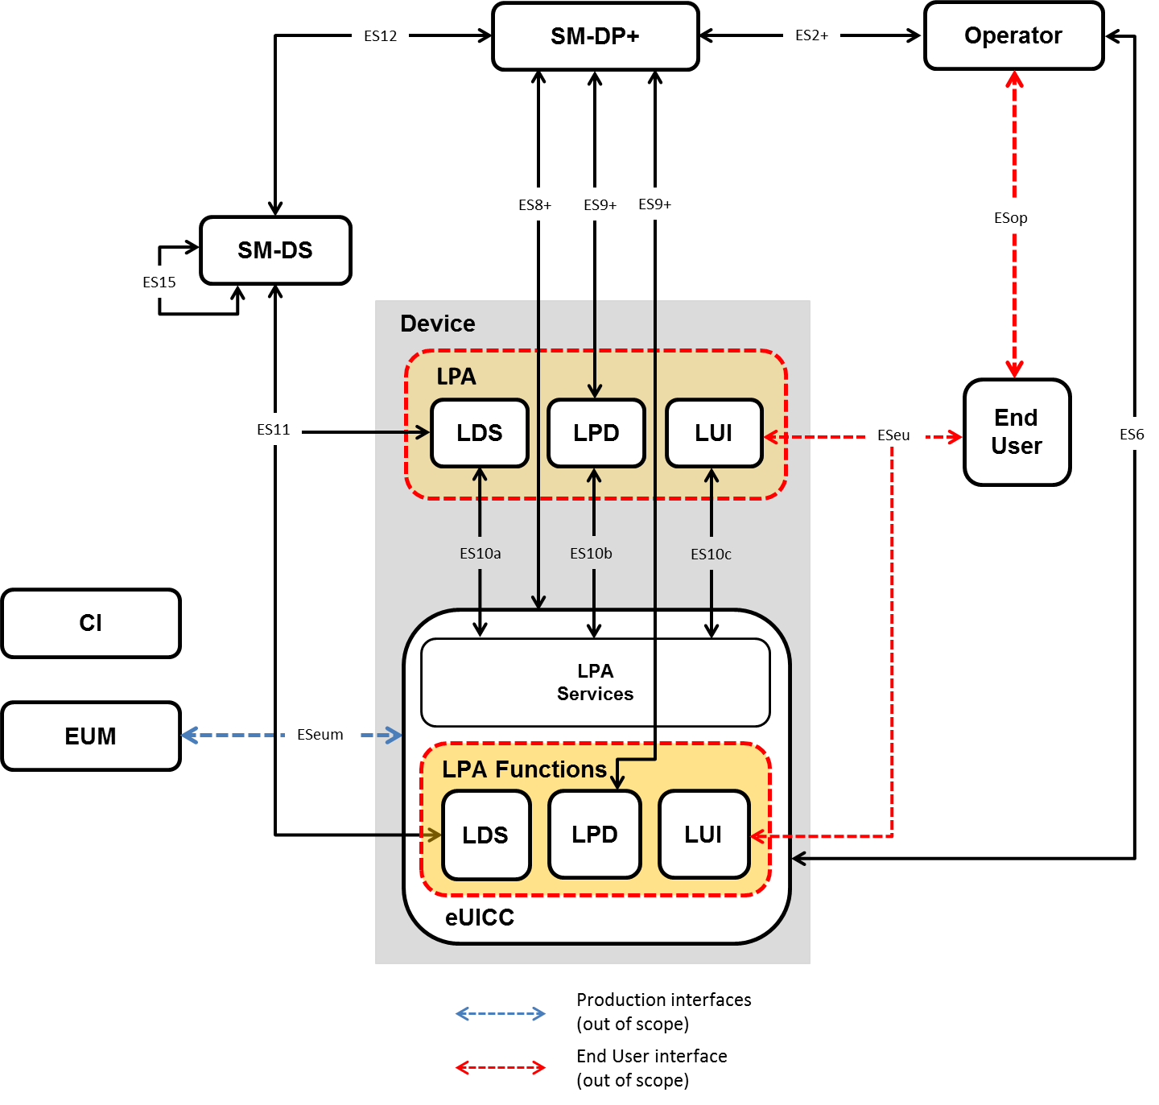
Figure 4.1: Remote SIM Provisioning System Architecture
  - eUICC Architecture
    - eUICC Architecture Overview
This section describes the internal high-level architecture of the eUICC. The eUICC architecture is similar to that used in the GSMA Remote SIM specification [8]. Profiles are provisioned based on the security framework defined in the GlobalPlatform Card Specification [9].
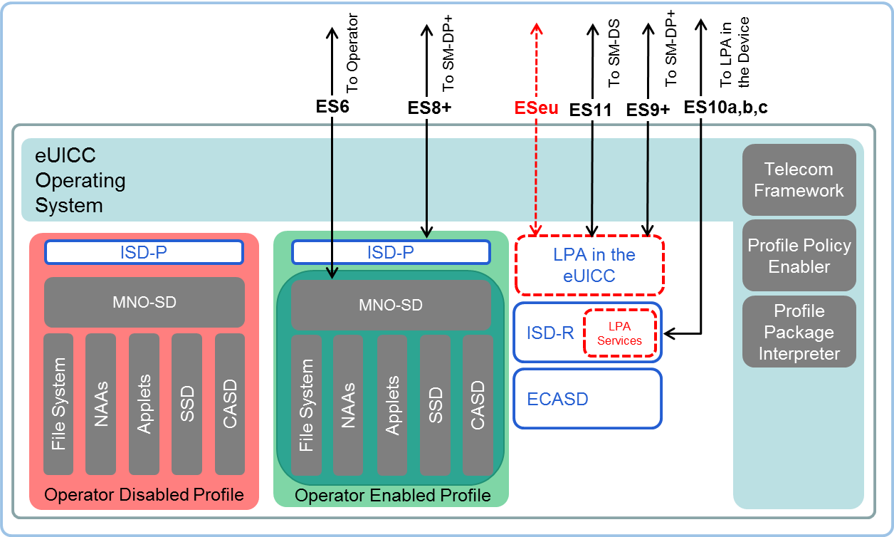
Figure 4.1.1.1: Schematic Representation of the eUICC

ECASD
The eUICC Controlling Authority Security Domain (ECASD) is responsible for the secure storage of credentials needed to support the required security domains on the eUICC.
There SHALL only be one ECASD on an eUICC. The ECASD SHALL be installed and personalised by the EUM during the eUICC manufacturing as described in GlobalPlatform Card Specification [9].
The ECASD SHALL contain the following:
- eUICC private keys for creating signatures.
- Associated Certificates for eUICC authentication.
- The Certificate Issuers’ (CI) root public keys for verifying SM-DP+ and SM-DS Certificates.
- eUICC Manufacturers’ (EUMs) keyset for key/Certificate renewal.
Additionally, the ECASD SHALL provide security functions used during key establishment and eUICC authentication.

ISD-R
The ISD-R is responsible for the creation of new ISD-Ps and the lifecycle management of all ISD-Ps.

ISD-P
The ISD-P is a secure container (security domain) for the hosting of a Profile. The ISD-P is used for Profile download and installation in collaboration with the Profile Package interpreter for the decoding/interpretation of the received Bound Profile Package.
The ISD-P is the on-card representative of the SM-DP+.

MNO-SD
The MNO-SD is the on-card representative of the Operator. It contains the Operator’s Over-The-Air (OTA) Keys and provides a secure OTA channel.

Profile Policy Enabler
The eUICC Operating System (OS) service which offers Profile Policy Rules validation and enforcement.

Telecom Framework
The telecom framework is an operating system service that provides standardised network authentication algorithms to the NAAs hosted in the ISD-Ps. Furthermore, it offers the capability to configure the algorithms with the necessary parameters.

Profile Package Interpreter
The Profile Package interpreter is an eUICC operating system service that translates the Profile Package data into an installed Profile using the specific internal format of the target eUICC.

LPA Services
The LPA services provide necessary access to the services and data required by the LPA functions for the following:
- The Root SM-DS address.
- The optionally stored default SM-DP+ address.
- Facilitates the reception of the Bound Profile Package in transfer from the LPA.
- Provide information regarding the installed Profiles and their Profile Metadata.
- Provides Local Profile Management.
- Provides functions for the LPA to authenticate and interact with the SM-DS.
- Ensures access to the EID is restricted to only the LPA.
  - Interfaces
Figure 4.2.1: Interfaces on the eUICC Architecture with the LPA in the Device Configuration

Operator – SM-DP+ (ES2+)
The ES2+ interface is used by the Operator to order Profiles for specific eUICCs as well as other administrative functions.

Operator – End User (ESop)
ESop is the interface between the Operator and the End User.
This interface is out of scope of this specification.

End User - LUI (ESeu)
ESeu is the interface between the End User and the LUI.
In a Primary/Companion Device scenario the LUI used SHALL only reside within the Companion Device or its eUICC.
The ESeu interface is used to support the following requirements:
Req no. | Description
ESeu1 | [Void]
ESeu2 | Each Local Profile Management Operation SHALL be explicitly initiated by the End User, and verified by User Intent.
ESeu3 | The ESeu interface SHALL support the triggering and confirmation of the Profile download and installation operation and Local Profile Management Operations requested by the End User.
Table 4.2.3.1: End User to LUI (ESeu) Interface Requirements

Operator – eUICC (ES6)
The ES6 interface is used by the Operator for the management of Operator services via OTA services.

SM-DP+ – LPD (ES9+)
The ES9+ interface is used to provide a secure transport for the delivery of the Bound Profile Package between the SM-DP+ and the LPD.

SM-DP+ – eUICC (ES8+)
The ES8+ interface provides a secure end-to-end channel between the SM-DP+ and the eUICC for the administration of the ISD-P and the associated Profile during download and installation.

SM-DP+ – SM-DS (ES12)
The ES12 interface allows any SM-DP+ to issue or remove Event Registrations on the SM-DS.

LDS – SM-DS (ES11)
The ES11 interface allows the LDS to retrieve Event Records for the respective eUICC.

EUM – eUICC (ESeum)
ESeum is the interface between the EUM and the eUICC. This interface is out of scope of this specification.

LDS – LPA Services (ES10a)
The ES10a interface is used by the LPA in the Device to get the configured addresses from the eUICC for Root SM-DS, and optionally the default SM-DP+.

LPD – LPA Services (ES10b)
The ES10b interface is used by the LPD in the Device and the LPA services to transfer a Bound Profile Package to the eUICC.

LUI – LPA Services (ES10c)
The ES10c interface is used between the LUI in the Device and the LPA services for Local Profile Management by the End User.

SM-DS – SM-DS (ES15)
In the case of deployments with cascaded SM-DSs, the ES15 interface is used to connect the SM-DSs.

Device – SM-DP+ (Established Connection)
This connection will be provided either by:
- An internet connectivity available or provided on the same Device where the LPA resides
or
- An internet connection shared from another Device via a local go-between connection
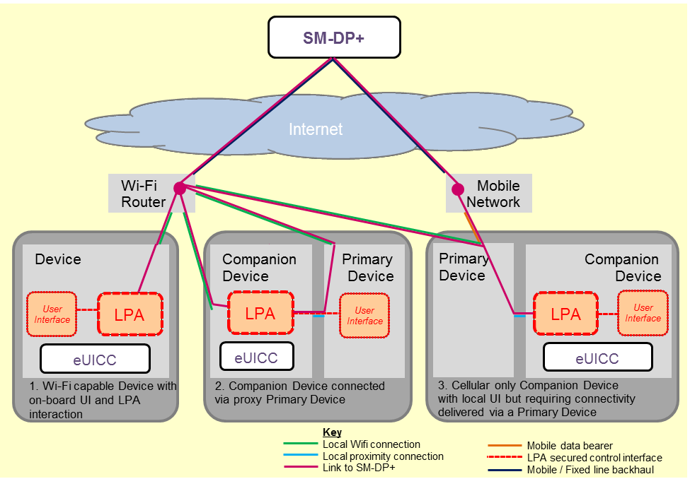
Figure 4.2.14.1: Example Connection Methods for Companion Devices to reach out to the SM-DP+

General Interface Requirements
Req no. | Description
INT1 | All interfaces from the eUICC SHALL indicate the eSVN.
INT2 | The behaviour of all interfaces SHALL support the indicated eSVN.
INT3 | During the indication of the supported eSVN from the eUICC to the SM-DP+, the eUICC version SHALL be used or the procedure SHALL fail. See table below.
INT4 | All communicating entities involved in Remote SIM Provisioning SHALL be mutually authenticated. The Device and the eUICC are considered as one entity in this context.
Table 4.2.15.1: General Interface Requirements
Platform | Version 1 (V1) | Version 2 (V2) | Version 3 (V3)
eUICC V1 | Platform uses V1 | Platform uses V1 or fails. | Platform uses V1 or fails.
eUICC V2 | ✗ | Platform uses V2 | Platform uses V2 or fails.
eUICC V3 | ✗ | ✗ | Platform uses V3
Table 4.2.15.2: eUICC Version vs. Platform

eUICC Requirements
Req no. | Description
EUICC1 | The eUICC SHALL be a discrete or integrated tamper resistant component consisting of hardware and software, capable of securely hosting applications as well as confidential and cryptographic data.  NOTE: Wherever a distinction is required, the former is referred to as Discrete eUICC, and the latter as Integrated eUICC.
EUICC2 | A removable eUICC is packaged in a standardised ETSI Form Factor [2].
EUICC3 | The Discrete eUICC SHALL be either removable or non-removable.
EUICC4 | The behaviour of the eUICC with an Enabled Profile SHALL be equivalent to the UICC.
EUICC5 | The eUICC SHALL be able to contain zero or more Profiles.
EUICC6 | At a maximum, only one Profile SHALL be enabled at any point in time.
EUICC7 | The behaviour of a NAA USIM or ISIM within a Profile on an eUICC SHALL be identical to a removable UICC NAAs USIM or ISIM.  NOTE: No changes to existing 3GPP/3GPP2 USIM, CSIM and ISIM specifications are expected.
EUICC8 | The eUICC SHALL support Milenage [11][12] and TUAK [10] algorithm sets.
EUICC9 | The ownership of the eUICC MAY change throughout its lifetime as can the Device.  NOTE: According to CERTEU11, the EUM keyset belongs to the EUM for the lifetime of the eUICC.
EUICC10 | If any Profile Management operation does not complete successfully, the eUICC SHALL maintain the state it was in before it received the request.
EUICC11 | The eUICC SHALL contain an ECASD and ISD-R security domains installed and personalised during manufacture.
EUICC12 | It SHALL not be possible to delete or disable the ECASD after eUICC manufacture.
EUICC13 | The ISD-R SHALL be responsible for the creation of new ISD-Ps and the lifecycle management of all ISD-Ps.
EUICC14 | The ISD-R SHALL be installed and personalised by the EUM during eUICC manufacturing as described in GlobalPlatform Card Specification [9].
EUICC15 | The eUICC SHALL support an eUICC Memory Reset. This can only be requested by the End User.
EUICC16 | If the eUICC supports Test Profiles, the eUICC SHALL support eUICC Test Memory Reset.
EUICC17 | The eUICC SHALL support the eUICC Profile Package Interoperable format as defined by Trusted Connectivity Alliance [5].
EUICC18 | An ISD-R SHALL:  - be created within an eUICC at the time of manufacture;  - NOT be deleted or disabled;  - NOT be able to perform any operations inside an ISD-P.
EUICC19 | An eUICC MAY provide LPA functions.
EUICC20 | An ISD-P SHALL be created by the ISD-R at the request of the SM-DP+.
EUICC21 | Communication between the eUICC and the SM-DP+ SHALL be protected in authenticity, integrity and confidentiality.
EUICC22 | The eUICC SHALL NOT export Profiles installed on the eUICC.
EUICC23 | The eUICC SHALL enforce an isolation of Profiles and prevent Profiles from operating outside of their execution environment i.e. Profile SHALL run in a sandbox.
EUICC24 | The integrity of the Bound Profile Package SHALL be ensured during its installation on the eUICC.
EUICC26 | Profile keys and algorithm parameters SHALL NOT be extractable from the eUICC.
EUICC27 | All cryptographic functions SHALL be implemented in a robust tamper-resistant way and be resistant to side-channel attacks.
EUICC28 | The Operator SHALL be able to update the OTA Keys in its Profile on the eUICC in a secure and confidential way, reusing existing OTA Platform mechanisms.
EUICC29 | A downloaded Profile Package SHALL be installed on the eUICC in a disabled state.
EUICC30 | The eUICC SHALL always report its eSVN in the first communication during the commencement of each session with the SM-DP+ or SM-DS.
EUICC31 | The EUM SHALL install an eUICC Certificate in the eUICC used to authenticate the eUICC and verify the eUICC certification.
EUICC32 | The EUM SHALL install an EUM Certificate in the eUICC used to verify the eUICC Certificate.
EUICC33 | The eUICC SHALL have a means to authenticate itself to the SM-DS.
EUICC34 | The eUICC SHALL protect itself against unauthorised access.
EUICC35 | Upon Profile deletion, the eUICC SHALL ensure a complete deletion of all data related to the Profile.
EUICC36 | The eUICC SHALL only accept Profile Management operations sent from the LPA in either the eUICC, or the Device.
EUICC37 | The eUICC SHALL reject any Profile Management operations that are in conflict with the Profile Policy Rules of the respective Profile.
EUICC38 | If any Bound Profile Package download or installation does not complete successfully, the eUICC SHALL maintain the state it was in before it received the request.
EUICC39 | The eUICC SHALL support GlobalPlatform Secure Element Access Control [15].
EUICC40 | There SHALL be a means to pre-set a default SM-DP+ address in the eUICC.
EUICC41 | The eUICC SHALL store the Root SM-DS address.
EUICC42 | The eUICC SHALL be able to send a delete Notification to the LPA to notify the Notification Receivers that the Profile has been deleted.
EUICC43 | In EUICC42, if connectivity is not available to send the Notification of deletion to the Notification Receivers, each Notification SHALL be retained and sent as soon as connectivity becomes available again.
EUICC44 | The delete Notification process SHALL also be executed for each deleted Profile in case of eUICC Memory reset.
EUICC45 | The eUICC SHALL support a set of standard functions and services including, but not limited to Java Applications, USIM Toolkit functions and GlobalPlatform features. The list of supported functions and services (e.g. API package names and versions) SHALL be explicitly referenced within the technical specification (SGP.22 [24]). A different set of functions and services MAY be defined/supported according to the different eUICC categories as defined in Annex D.
EUICC46 | The eUICC SHALL support at least the following USIM Toolkit commands:  - PROVIDE LOCAL INFORMATION including the following fields: local info, IMEI, network measure results, date & time, access technology  - TERMINAL PROFILE  - ENVELOPE (SMS-PP DOWNLOAD)  - SEND SHORT MESSAGE  - DISPLAY TEXT  - GET INPUT  - RING TONE
EUICC47 | An eUICC SHALL support at least two sets of elliptic curve parameters preloaded by the EUM during eUICC manufacturing, defined in GSMA SGP.22 [24].
EUICC48 | Each Notification SHALL be uniquely identifiable and SHALL be signed by the eUICC.
EUICC49 | Each Notification SHALL be protected against re-play attacks and signed by the eUICC.
EUICC50 | [Void]
EUICC51 | [Void]
EUICC52 | The Profile SHALL be able to contain a list of zero or more Notification Receivers for each type of Notification.
EUICC53 | The eUICC SHALL support SHA-1. Usage of SHA-1 SHALL be strictly limited to applications inside the Profile where the use of SHA-1 is required.
EUICC54 | The EID SHALL not be modifiable. The EID SHALL not be affected by any of the procedures, including the change of the eUICC Private keys.
EUICC55 | An Integrated eUICC SHALL be certified according to SGP.08 [39] or SGP.18 [40] as described in SGP.24 [38].
EUICC56 | The Integrated eUICC SHALL be based on an Integrated TRE.
EUICC57 | An Integrated eUICC SHALL be able to execute the test cases defined in SGP.23 [36].
EUICC58 | For the purpose of integration and/or end-to-end testing, a Field-Test eUICC MAY contain certificates that chain up to the GSMA CI.
EUICC59 | The Integrated eUICC SHALL allow the SM-DP+ to identify the type of the Integrated TRE including its component configuration (e.g. use of internal or Remote Memory, use of other optional components), its manufacturer, in addition to the RSP OS provider.
EUICC60 | The Integrated TRE SHOULD have priority access to Remote Memory in cases of shared resource contention.
EUICC61 | The Integrated eUICC Test Interface SHALL be compatible with commonly used interfaces for smartcard testing.
EUICC62 | The eUICC SHALL NOT be impacted by the Activation Code Retrieval.
EUICC63 | The eUICC MAY have a mechanism that enforces a Minimum Security Level (as defined in ETSI TS 102 226 [42]) to any Application with RAM/RFM configuration included in the Profile Package.
EUICC64 | With respect to EUICC63, if during Profile installation, any Application with RAM/RFM configuration in the Profile Package presents an MSL lower than the one set by the eUICC, then the Profile installation SHALL fail.
EUICC65 | Where EUICC63 is supported, there SHALL be a single value for the Minimum Security Level.
EUICC66 | The eUICC MAY have a mechanism that permits the installation of Test Profiles with RAM capabilities and/or Profile Applications only from SM-DP+ Servers specified in an allow-list, which is stored in and enforced within the eUICC.
EUICC67 | With respect to EUICC66, if supported by the eUICC, the allow-list SHALL be updatable by an EUM-specific mechanism.
EUICC68 | An eUICC MAY have a mechanism that rejects any Java Application installation into an already installed Test Profile.  NOTE: This requirement is not related to Java Applications included in the Test Profile Package.
EUICC69 | The eUICC SHALL implement a runtime environment where Interoperable Applications are isolated from other applications and Profiles, subject to the provisions of EUICC70.
EUICC70 | With respect to EUICC69, inter-application communication within a Profile or with the eUICC platform SHALL be allowed only where the target application explicitly provides an interface to share services or data.
Table 4.3.1: eUICC Requirements

eUICC Eligibility Check
The eUICC eligibility check enables a SM-DP+ to validate the eligibility of an eUICC for the installation of a Profile using information sent by the eUICC. The set of information sent by the eUICC to the SM-DP+ for eligibility checking purposes is referenced herein as the eUICC Eligibility Check Information. Some eUICC eligibility check parameters MAY be required due to Device capabilities which must be supported by the Profile/eUICC and delivered as part of the eUICC Eligibility Check Information set.
NOTE: Device capability refers to a Device feature or service-enabling function provided by the Device that MAY have a direct effect on the content of the Profile or the procedure used to download the Profile, and consequently requires support from the eUICC.

eUICC Eligibility Check Requirements
Req no. | Description
ELG1 | The eUICC SHALL indicate the specification version it is supporting. This parameter SHALL be transmitted to the SM-DP+ during the eUICC eligibility check.
ELG2 | The eUICC SHALL include the available memory in the eUICC Eligibility Check Information.
ELG3 | The eUICC SHALL declare in the Eligibility Check Information if it is unable to accept an additional Profile.
ELG4 | The eUICC SHALL provide a valid current Certificate to the SM-DP+ signed by the EUM with the Eligibility Check Information.
ELG5 | The eUICC SHALL provide an identification of the EUM with the Eligibility Check Information.
ELG6 | The eUICC SHALL provide in the Eligibility Check Information, the current OS version.
ELG7 | The eUICC SHALL provide in the Eligibility Check Information Device enabler information relating to services that MAY need Profile support (e.g. NFC enablers).
ELG8 | Eligibility Check Information SHALL be integrity and authenticity protected by the eUICC for its sending to the SM-DP+.
ELG9 | The eUICC SHALL indicate the application runtime environment name, version and libraries versions supported in eUICC Eligibility Check Information.
ELG10 | The eUICC SHALL indicate cryptographic algorithms and their respective key lengths supported in the eUICC Eligibility Check Information.
ELG11 | The eUICC SHALL declare in the Eligibility Check Information the list of supported CIs.
ELG12 | The eUICC SHALL indicate its current certification status in the Eligibility Check Information.
ELG13 | If the eUICC is NFC capable (e.g. CAT3) the Device SHALL indicate its support for the relevant NFC services including its current certification status during the eUICC Eligibility Check.
ELG14 | The eUICC SHALL indicate its category (see Annex D). This parameter SHALL be transmitted to the SM-DP+ during the eUICC Eligibility Check.
ELG15 | An eUICC SHALL provide information indicating if it is a Discrete eUICC or an Integrated eUICC.
ELG16 | An eUICC SHALL indicate in the Eligibility Check Information if it is Field-Test eUICC.
ELG17 | Void (placeholder to align with SGP.21 Version 3 requirement structure).
ELG18 | The eUICC SHALL declare in the Eligibility Check Information if it supports eUICC OS Update.
ELG19 | As per EUICC63, the eUICC SHALL indicate the Minimum Security Level (as defined in ETSI TS 102 226 [42]) expected for any Application with RAM/RFM configuration.
Table 4.4.1.1: eUICC Eligibility Check Requirements
NOTE: It is assumed that the EID is normally shared to the SM-DP+ by other means and could be used for the eligibility check procedure.
  - Device Requirements
Req no. | Description
DEV1 | The Device SHALL conform to the terminal requirements within ETSI TS 102 221 [2] with the exceptions as defined in this specification.
DEV2 | There SHALL be a means for the End User to obtain the EID through the Device software. This SHALL only be possible through the LUI.
DEV3 | If an eUICC is within the Device packaging, then the EID SHALL be printed in machine readable form on the Device packaging.
DEV4 | Bearer connection of the Companion Device to the SM-DP+ SHALL only be determined by the bearer availability.  NOTE: The Companion Device MAY use any connectivity method available to connect to the SM-DP+.
DEV5 | Devices compliant with the GSMA NFC Handset Requirements [17] SHALL support the Open Mobile API [19] used by the Device applications to exchange data with their counterpart applications running in the Enabled Profile on the eUICC.
DEV6 | The implementation of the Remote SIM Provisioning specification in the Device SHALL not impact the potential use of the SIM Lock mechanism defined in 3GPP TS 22.022 [16].
DEV7 | In the case where the Device supports both the LPA in the Device, and the LPA in the eUICC, the Device SHALL have a mechanism (setting or configuration parameter) that sets which LPA SHALL be used.
DEV8 | The End User SHALL be able to modify the parameter defined in DEV7.
DEV9 | A Device that supports an eUICC without an LPA in the eUICC, SHALL provide LPA functions.
DEV10 | A Device that supports only an eUICC with an LPA in the eUICC, MAY provide LPA functions.
DEV11 | If the Device supports Device Test Modes, the Device SHALL support eUICC Test Memory Reset. eUICC Test Memory Reset can only be requested by the End User when the Device is in Device Test Mode.
DEV12 | Where technically feasible, the Device SHALL implement a mechanism allowing the End User to protect the access to the Device and its Profile Management Operations with personal data. Implementation is OEM specific.  NOTE: This can be achieved by the implementation of a Device PIN lock, fingerprint, password, facial recognition (etc.)
DEV13 | The End User SHOULD be able to enable/disable the mechanism described in DEV12. Implementation is OEM specific.  NOTE: The mechanism described in DEV12 should be enabled by default.
DEV14 | With respect to LPA41, a Device containing any additional feature that affects the status of Operational Profiles SHOULD enforce the Confirmation Level of the equivalent Local Profile Management Operations defined in this specification. The mechanism and process of the Confirmation Level is implementation specific. The End User SHOULD be able to revoke/unset a cached Confirmation previously given, if any.  NOTE: In case the LPA or a Device application performs automatic Profile management, the Device or the application must ensure that the End User has been made fully aware of the conditions under which the service operates.  NOTE: The Device protects against abuse or malevolence of management of profiles as compared to the specified LPA functionalities.
Table 4.5.1: Device Requirements

Device Capability Requirements
Req no. | Description
DEVCAP1 | There SHALL be a mechanism that is able to provide the Device capabilities to the SM-DP+.
Table 4.5.1.1: Device Capability Requirements

Device with Integrated eUICC
Req no. | Description
DIE1 | Access to any Remote Memory used by the TRE to store software and data SHALL be protected against attacks on availability (e.g. Denial of Service, memory corruption, tampering) by other Device components.
DIE2 | All Integrated TRE software and data stored in Remote Memory outside the SoC SHALL be protected against access by non Integrated TRE components.
Table 4.5.2.1: Device with Integrated eUICC Requirements
  - Device Initialisation

Device Reset Requirements
Req no. | Description
FAC1 | It SHALL be possible for the End User to perform any type of Device reset without affecting the status of the eUICC.
FAC2 | The Device SHALL by means of a secured procedure, trigger/request the eUICC Memory Reset.
FAC3 | The Device SHALL by means of a secured procedure, trigger/request the eUICC Test Memory Reset.
Table 4.6.1.1: Device Reset Requirements

eUICC Memory Reset Requirements
Req no. | Description
MEM1 | eUICC Memory Reset SHALL delete all Profiles on the eUICC apart from pre-installed Profiles that are flagged as permanent.
MEM2 | eUICC Memory Reset SHALL delete all Profiles on the eUICC regardless of their Profile Policy Rules but not the Provisioning Profile or preinstalled Test Profiles.
MEM3 | Strong Confirmation SHALL be verified in order to initiate eUICC Memory Reset.
MEM4 | In addition to MEM3, other secure means MAY be provided to perform the eUICC Memory Reset function. The same level of security as is offered by the LUI based reset function SHALL apply. User Intent and Confirmation Request SHALL apply.
Table 4.6.2.1: eUICC Memory Reset Requirements
    - eUICC Test Memory Reset Requirements
Req no. | Description
MEMT1 | eUICC Test Memory Reset SHALL delete all post-issuance installed Test Profiles on the eUICC including the Enabled Test Profile if any.
MEMT2 | Simple Confirmation SHALL be verified in order to enable eUICC Test Memory Reset.
MEMT3 | If Test Profiles are not supported, then eUICC Test Memory Reset is not required.
Table 4.6.3.1: eUICC Test Memory Reset Requirements

Profile Requirements

Test Profile Requirements
Req no. | Description
TPRO1 | It is OPTIONAL for the removable eUICC to support the requirements of Test Profiles described in this section. If Test Profiles are not supported, it SHALL not be possible to download Test Profiles into the eUICC.
TPRO2 | Test Profiles SHALL NOT be able to authenticate to an Operator’s mobile network using Operator Credentials. The eUICC SHALL ensure that such Profiles cannot be used to connect to any Operator’s mobile network even if authentication information is contained in the Test Profile.
TPRO3 | A Test Profile SHALL be installed in its own individual ISD-P.
TPRO4 | Test Profiles MAY be pre-installed on the eUICC.
TPRO5 | Test Profiles SHALL only be visible and usable when the Device is in Device Test Mode.
TPRO6 | It SHALL be possible to download, install, enable or disable Test Profiles in the eUICC only in Device Test Mode with the exception of the eUICC Memory Reset operation.
TPRO7 | Test Profiles, as with any other Profile, SHALL be managed through a certified SM-DP+.
TPRO8 | The enabling of a Test Profile SHALL override the ‘Disabling of this Profile is not allowed’ (POL RULE1) Profile Policy Rule.
TPRO9 | When the Device Test Mode is deactivated, the LPA SHALL disable any enabled Test Profile.
TPRO10 | When the Test Profile is disabled, the eUICC SHALL enable the Operational Profile that was previously enabled, if any.
TPRO11 | The Device Test Mode activation SHALL be obfuscated from the End User.
TPRO12 | When exiting Device Test Mode, an End User notice SHALL be presented to prompt the tester to perform an eUICC Test Memory Reset.
TPRO13 | The LPA MAY delete any Test Profile without user consent when in or out of the Device Test Mode.
TPRO14 | It MAY be possible to download Java Applications to a Test Profile installed on a Test eUICC.
TPRO15 | Test Profiles MAY contain Profile Applications.
TPRO16 | When an eUICC contains an eUICC certificate chaining to the GSMA CI, the Test Profile MAY have RFM and RAM capabilities.
TPRO17 | Where an eUICC contains an eUICC certificate chaining to the GSMA CI and TPRO16 applies, Test Profiles SHALL only have confidentially managed keys, used for application and file management, that are unique per Profile.
Table 4.7.1.1: Test Profiles Requirements
The Device MAY implement a mechanism for connecting an external SIM card for the purpose of testing in the context of Device repair, without affecting the state of the eUICC.

Provisioning Profile Requirements
Req no. | Description
PPRO1 | Provisioning Profiles SHALL be based on the same format structure as described for the Profile (Figure 4.1.1.1).
PPRO2 | A Provisioning Profile MAY be enabled by the LPA upon End User request for operations defined in PPRO6 if establishment of the connectivity using the currently Enabled Profile is unsuccessful. If this results in an Operational Profile being disabled, the End User SHALL first give consent to the loss of communication provided by the Enabled Profile.
PPRO3 | Provisioning Profiles and their associated Profile Metadata SHALL not be visible to the End User on the LUI.
PPRO4 | Provisioning Profiles SHALL not be selectable by the End User.
PPRO5 | Provisioning Profiles SHALL not be deleted through any action by the End User including the use of eUICC Memory Reset.
PPRO6 | Provisioning Profile SHALL only be used for the intended purposes of Profile downloading and related Profile maintenance functions. The Provisioning Profile SHALL not be used as an Operational Profile.
PPRO7 | PPRO6 SHALL be enforceable in the RSP architecture.
Table 4.7.2.1: Provisioning Profile Requirements

Profile Metadata Requirements
Req no. | Description
META1 | All Profiles SHALL have associated Profile Metadata.
META2 | The Profile Metadata SHALL be stored in the eUICC.
META3 | The Profile Metadata SHALL be accessible irrespective of the state of the Profile.
META4 | The Profile Metadata SHALL include a field for the Service Provider name.  NOTE: EFSPN is already used in a different context outside of this specification and could be blank.
META5 | The Profile Metadata SHALL include a field for the ICCID of the Profile.
META6 | The Profile Metadata SHALL include a field for the End User nickname of the Profile.
META7 | The Profile Metadata SHALL include a field for containing a short description of the Profile defined by the Operator/Service Provider.
META8 | The eUICC SHALL support the ‘set/edit nickname’ function.
META9 | The Profile Metadata SHALL always be available to the LUI.
META10 | The Profile Metadata SHALL include an OPTIONAL field to allow the display of an icon defined by the Operator/Service Provider for the respective Profile.
META11 | The Profile Metadata SHALL be able to include a copy of the Profile Policy Rules associated to the Profile.
META12 | All Profiles SHALL be uniquely identified in the Profile Metadata as Operational, Provisioning or Test Profile.
META13 | An Operator SHALL be able to access and update the following Profile Metadata of its Profile using the ES6 interface if the Profile is Enabled:  - Service Provider name  - Short description of the Profile  - Icon of the Profile
META14 | The Profile Metadata SHALL be able to include additional proprietary information. The additional proprietary information SHALL include a field for uniquely identifying the issuer of the additional proprietary information.
META15 | With regard to META14, the eUICC SHALL ignore fields it does not support.
META16 | With regard to META14, the LPA SHALL ignore fields it does not support.
META17 | The information defined in META14 SHALL NOT impact the functionalities and Profile Management Operations defined in this specification that are not Vendor specific.
META18 | The information defined in META14 SHALL NOT impact the interoperability of the solution defined in this specification (incl. Devices, Profiles and SM-DP+).
META19 | With regard to META14, the eUICC SHALL store the additional proprietary information in its memory if indicated by the Profile Owner.
Table 4.8.1: Profile Metadata Requirements

NFC Requirements
An NFC Device and an NFC eUICC SHALL be compliant with the following list of requirements:
Req no. | Description
NFC1 | An NFC Device SHALL be compliant with GSMA TS 26 [17] .
NFC2 | After installation of an Operational Profile, the NFC eUICC SHALL support all requirements as specified in the SGP.03 GSMA NFC UICC Requirements Specification [20].
NFC3 | The NFC Device SHALL retrieve and enforce access control rules as specified in the GlobalPlatform SEAC specification [15].
NFC4 | The eUICC SHALL be able to generate proof that the Operational Profile has been deleted.
NFC5 | All NFC applications and NFC enabling applications (e.g. ARA-M, PPSE, CRS, CREL, etc.) attached to an Operational Profile SHALL be included under the ISD-P created for the Profile, either under the MNO-SD or in an SD hierarchy with a self-extradited SSD with authorised management privilege.
NFC6 | The NFC eUICC solution SHALL be able to provide assurance to NFC application Service Providers that the combination of an eUICC and Operational Profile is trusted. This solution SHALL be based on the CASD that is part of the Operational Profile and scenario Push 2B and scenario 3 as specified by SGP.03 [20].
NFC7 | If the NFC eUICC is compliant with M4M, the eUICC SHALL reset all the M4M virtual cards associated to that Profile when a Profile containing M4M applications is disabled.
NFC8 | The appropriate NFC related certification information SHALL be part of the information shared with the SM-DP+ during the eUICC Eligibility Check.
NFC9 | A NFC Device SHALL at least have an embedded eUICC or have the capability to support a removable eUICC that is compliant with CAT3 and SGP.03 [20] in either instance.
Table 4.9.1: NFC Requirements
  - Subscription Manager Data Preparation + (SM-DP+)

SM-DP+ Overview
The SM-DP+ is responsible for the creation, generation, management and the protection of resulting Profiles upon the input/request of the Operator. It is also responsible for the delivery of a Profile within a Bound Profile Package, making the Bound Profile Package available for the secure delivery. In addition, the SM-DP+ is responsible for requesting the creation of the ISD-P in the eUICC into which the Profile will be installed. The SM-DP+ will also be the off-card entity that will be responsible for the lifecycle management of the ISD-P that was created at its request. This is performed via the distinct functions listed below.
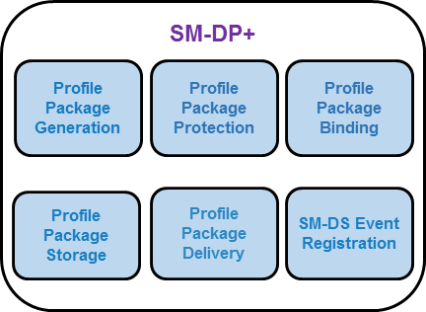
Figure 4.10.1.1: SM-DP+ Functions
Function name | Description
Profile Package Generation | Creates Profile Packages [i.e. Personalised Profiles, including (IMSI, Ki, ICCID…)] from Profile Descriptions agreed with Operators. This can be an off-line batch or real time process.
Profile Package Protection | Secures each Profile Package according to the security process creating the Protected Profile Package.
Profile Package Binding | Binds the Protected Profile Package to a target eUICC using the security process thus creating the Bound Profile Package.
Profile Package Storage | Temporarily stores Protected Profile Packages or Bound Profile Packages for subsequent delivery to the eUICC.
Profile Package Delivery | Securely transmits and installs the Bound Profile Package to the eUICC through the LPA.
SM-DS Event Registration | Notifies the SM-DS of a pending operation for a specific eUICC.
Table 4.10.1.1: SM-DP+ Function Descriptions

SM-DP+ Requirements
Req no. | Description
SMDP1 | The SM-DP+ SHALL act on behalf of an Operator.
SMDP2 | The SM-DP+ SHALL be able to initiate the request for ISD-P creation as part of the Bound Profile Package delivery.
SMDP3 | The SM-DP+ SHALL establish an end-to-end secure channel to the eUICC to download and install Bound Profile Packages on the eUICC.
SMDP4 | The SM-DP+ SHALL link a Protected Profile Package for binding to a specific eUICC only at the request of the respective Operator.
SMDP5 | The SM-DP+ SHALL create a Bound Profile Package from the linked Protected Profile Package only at the request of the respective eUICC.
SMDP6 | The SM-DP+ SHALL be able to create a Bound Profile Package for any Certified eUICC.
SMDP7 | Only the target eUICC SHALL be able to decrypt the content of a Bound Profile Package delivered by the SM-DP+.
SMDP8 | Profile Packages SHALL only leave the SM-DP+ after completing all production steps, Profile Package Protection, and binding.
SMDP9 | Communication session between the SM-DP+ and the LPA SHALL be terminated by the SM-DP+ after execution of intended Operation(s).
SMDP10 | End-to-end communication between the SM-DP+ and the eUICC involved in the Profile download and installation SHALL be protected in terms of integrity, authenticity and confidentiality.
SMDP11 | Profile Packages stored within the SM-DP+ SHALL always be protected through encryption.
SMDP12 | On the SM-DP+, backups as well as used data within the Profile creation and storage infrastructure SHALL be discarded using secure deletion procedures (logically and physically).
SMDP13 | SM-DP+/eUICC communication SHALL incorporate Perfect Forward Secrecy (PFS).
SMDP14 | The transport used for the Bound Profile Package SHALL implement anti-replay mechanisms between the SM-DP+ and the eUICC.
SMDP15 | Connectivity to the SM-DP+ SHALL be aborted and an explicit error message SHALL be triggered by the SM-DP+ upon failure to verify authenticity of the connecting party. (No message SHALL be sent to the connecting party)
SMDP16 | After a configurable number of failed attempts to download a Bound Profile Package to the LPA, the transport encryption procedure SHALL be renewed.  If subsequent attempts to download the Bound Profile Package fail more than a configurable number of times, the provisioning transaction SHALL be terminated and the Operator SHALL be notified.
SMDP17 | The SM-DP+ SHALL use a secure version of Internet protocols whenever available (e.g. DNSSEC, DNSCurve, etc.).
SMDP18 | The SM-DP+ SHALL prepare Profile Packages following the eUICC Profile Package Interoperable Format Specification as defined by Trusted Connectivity Alliance [5].
SMDP19 | The SM-DP+ SHALL be able to create Bound Profile Packages on demand.
SMDP20 | It SHALL be possible for the SM-DP+ to create Profile Packages in bulk.
SMDP21 | The SM-DP+ SHALL send a confirmation of the successfully completed download and installation of a Profile to the Operator.
SMDP22 | There SHALL be a mechanism to remove any relationship between any SM-DP+ and the ISD-P following the successful installation of the Profile. Such a mechanism SHALL either be ordered by the Operator or be performed by the Operator itself. If such deletion mechanism is used, there will be no off-card entity responsible for managing the ISD-P of the installed Profile.
SMDP23 | The SM-DP+ SHALL be globally uniquely identified by its SMDPid.
SMDP24 | The SM-DP+ Certificate SHALL include the SMDPid.
SMDP25 | The SM-DP+ SHALL be able to send a Notification to the Operator informing them that a specific Bound Profile Package download is about to start.
SMDP26 | The SM-DP+ SHALL be able to send an eUICC Eligibility Check Information report and other relevant information (e.g. Activation Code, ICCID, etc.) to the Operator ahead of/prior to the eUICC Bound Profile Package download.
SMDP27 | The SM-DP+ SHALL be able to perform Event Registrations to the SM-DS.
SMDP28 | The SM-DP+ SHALL be able to request from an Alternative SM-DS not to propagate the Event Registration to the Root SM-DS.
SMDP29 | The SM-DP+ SHALL be able to send a Profile delete Notification to the Operator owning a Profile when a related delete Notification is received from the eUICC.
SMDP30 | The SM-DP+ SHALL support the following states for a Profile Package, triggered by the Profile Owner:  - A Profile Package is not released for Profile Package download.  - A Profile Package is released for Profile Package download.
SMDP31 | The SM-DP+ SHALL be able to select the elliptic curve parameter in the Profile download procedure.
SMDP32 (FFS) | It SHALL be possible for a SM-DP+ to conduct an Event Record Query to a SM-DS (Root or Alternative) for the purpose of auditing Event Registrations it owns.
SMDP33 (FFS) | The SM-DP+ SHALL be able to query the existence of an Event Record on the Root SM-DS or the Alternative SM-DS, identified by the EID or the Event-ID over the ES12 interface.
SMDP34 (FFS) | Response to a SM-DP+ Event Record Query SHALL only occur where the Root SM-DS or Alternative SM-DS validates the Event Record ownership.
SMDP35 (FFS) | Ownership validation of a SM-DP+ Event Record Query SHALL only use the requester’s address or the submitted Event-ID against the components of the Event Record held.
SMDP36 | A SM-DP+ SHALL support all sets of elliptic curve parameters as defined in GSMA SGP.22 [24].
SMDP37 | If a Profile Package is not yet released for download then the LPA SHALL be informed by means of a specific error code.
SMDP38 | An SM-DP+ SHALL be able to distinguish a Field-Test eUICC from a Certified eUICC through eUICC Eligibility Check Information.
SMDP39 | The SM-DP+ SHALL be able to be instructed by the Profile Owner to reject Profile download to Field-Test eUICCs.  NOTE: The mechanism is out of scope of this document and it is left to the implementation.
SMDP40 | The SM-DP+ SHALL NOT perform a Profile download to a Field-Test eUICC if it has been instructed so by the Profile Owner as per SMDP39.
SMDP41 | It is OPTIONAL for the SM-DP+ to support Activation Code Retrieval. If supported, SMDP42, SMDP43, SMDP44 and SMDP45 SHALL apply.
SMDP42 | With regards to LPA70, the SM-DP+ SHALL only provide the Activation Code associated with the requested Profile after successful common mutual authentication with the eUICC where the target Profile is currently installed and if allowed by the Profile Owner.
SMDP43 | If requested by the Profile Owner, the SM-DP+ SHALL notify the Profile Owner of any Activation Code Retrieval operation over ES2+ (including the ICCID and the EID).
SMDP44 | The SM-DP+ SHALL release the Profile Package associated with the Activation Code as per SMDP42 only after successful reception of the Delete Notification of the target Profile from the eUICC.
SMDP45 | The Profile Owner SHALL be able to accept or reject over ES2+, the Activation Code Retrieval request received by the SM-DP+.
SMDP46 | With regard to LPA71, the SM-DP+ supporting Activation Code Retrieval SHALL be able to provide an indication to the LPA whether Activation Code Retrieval is available or not for the requested Profile.
Table 4.10.2.1: SM-DP+ Requirements

Default SM-DP+ Address on the eUICC Requirements
Req no. | Description
DF1 | The default SM-DP+ address in the eUICC SHALL be ignored if an SM-DP+ address is present in an AC being presented to the LUI.
DF2 | The default SM-DP+ address in the eUICC SHALL be accessible by the LPA to establish a connection to this SM-DP+.
DF3 | The default SM-DP+ address in the eUICC MAY be left blank.
DF4 | If the default SM-DP+ address in the eUICC is blank, then the use of the SM-DS discovery procedure or an SM-DP+ address in an AC SHALL be required to establish the target SM-DP+.
DF5 | [Void]
Table 4.10.3.1: Default SM-DP+ Address on the eUICC Requirements

Local Profile Assistant (LPA)
Figure 4.11.1: End User Interaction and Interfaces between a Primary and Companion Device, where the Companion Device MAY have a UI

LPA Overview
This role exists both within the Device in conjunction with LPA Services provided by the eUICC, and within the eUICC with the LPA function provided by the eUICC. It provides three distinct functions, the Local User Interface (LUI), the Local Profile Download (LPD) and the Local Discovery Service (LDS) as described below. Whilst the eUICC alone cannot provide any of these functions without Device interaction, the specific level of interaction will depend upon the capability within the Device. The way this variability is implemented across different Devices and Device types is for further study.
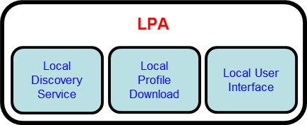
Figure 4.11.1.1: LPA Functions
Function name | Description
Local Discovery Service  (LDS) | Where required, the LDS is responsible for retrieving pending Event Records from the SM-DS.
Local Profile Download  (LPD) | This plays a proxy role for the efficient download of a Bound Profile Package in two stages: (i) the download of a Bound Profile Package from the SM-DP+ to the LPD in a single transaction, and (ii) the onward transfer of the Bound Profile Package into the eUICC in segments.  This function will depend on network, Device, and eUICC capabilities.
Local User Interface  (LUI) | This function allows the End User to perform Local Profile Management on the Device. User Intent SHALL be enforced.
Table 4.11.1.1: LPA Function Descriptions

Operational LPA Modes
When there is an LPA in the Device and in the eUICC, then the LPA to be used is specified by the Device settings (DEV7):
- LPA in the Device
- LPA in the eUICC

LPA in the eUICC
LPA functions are provided by the eUICC.
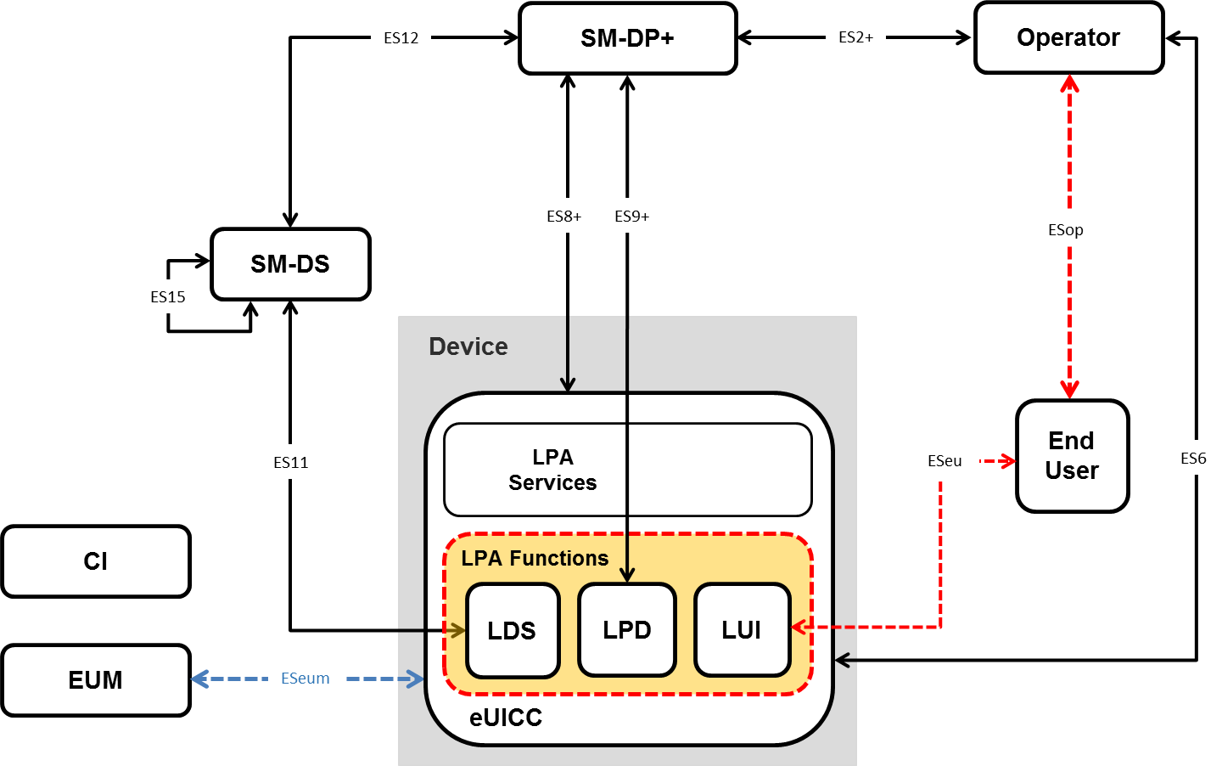
Figure 4.11.2.1.1: LPA in the eUICC

LPA in the Device
LPA functions are provided by the Device.
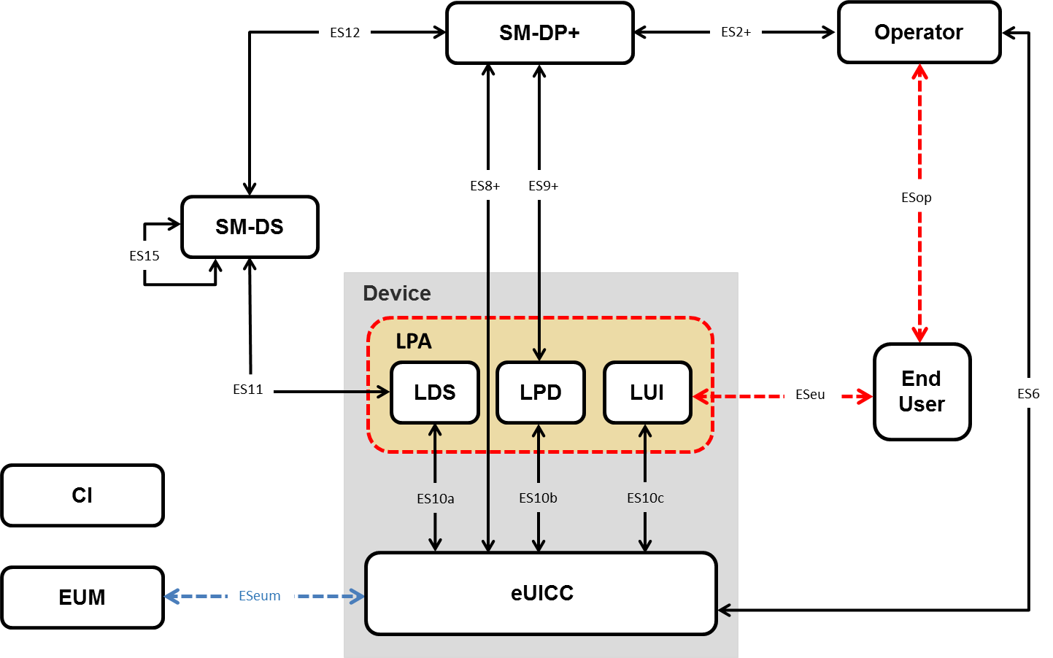
Figure 4.11.2.2.1: LPA in the Device

LPA Requirements
Req no. | Description
LPA1 | The LPA SHALL be responsible for instructing the eUICC to perform Local Profile Management Operations as per End User request.
LPA2 | A mechanism SHALL be implemented between any LPA elements outside the eUICC, and the eUICC to ensure that the communication is not compromised wherever the LPA is located.
LPA3 | A secure mechanism SHALL be implemented between the LUI and the associated display or input applications on the Device.
LPA4 | Access to the LUI SHALL be protected according to current best practices. This SHALL be enforced by the Device OS.
LPA5 | All Local Profile Management Operations SHALL require User Intent.
LPA6 | LUI access SHALL require User Intent.
LPA7 | The End User SHALL be able to easily access the list of installed Profiles.
LPA8 | The LPA SHALL protect Profile Metadata from unauthorised access.
LPA9 | The Local Profile Management Operation, ‘enable’ SHALL be supported. This operation SHALL allow the End User to select the Profile to be enabled.
LPA10 | The Local Profile Management Operation, ‘disable’ SHALL be supported.
LPA11 | The Local Profile Management Operation, ‘delete’ SHALL be supported. This operation SHALL allow the End User to delete a Disabled Profile from the eUICC. The End User SHALL acknowledge the message of consequences for the deletion of the Profile. Strong Confirmation SHALL be enforced.
LPA12 | The Local Profile Management Operation ‘query’ SHALL be supported. This operation SHALL allow the End User to view the list of installed Operational Profiles on the eUICC and relevant associated information through their Profile Metadata.
LPA13 | The Local Profile Management Operation, ‘edit default SM-DP+ address’ SHOULD be supported. When supported, this operation SHALL allow the End User to edit the default SM-DP+ address. Simple confirmation SHALL be enforced. If the LPA does not support ‘edit default SM-DP+ address’, alternative Device-specific method(s) to edit the default SM-DP+ address SHALL be provided to the End User.
LPA14 | The Local Profile Management Operation ‘eUICC Memory Reset’ SHALL be supported. This operation SHALL execute the eUICC Memory Reset as described in Section 4.6.2. The End User SHALL acknowledge the message of consequences of ‘eUICC Memory Reset’. Strong Confirmation SHALL be enforced.
LPA15 | The Local Profile Management Operation ‘eUICC Test Memory Reset’ SHALL execute the eUICC Test Memory Reset as described in Section 4.6.3. Simple Confirmation SHALL be enforced.
LPA16 | The Local Profile Management Operation ‘set/edit nickname’ SHOULD be supported. This operation SHALL allow the End User to add or modify a nickname for the selected Profile. The operation SHALL NOT modify the Service Provider name. If the LPA does not support ‘set/edit nickname’, alternative vendor-specific methods to distinguish Profiles on the LUI SHOULD be provided by the LPA.
LPA17 | The Local Profile Management Operation ‘add Profile’ SHALL be supported. This operation SHALL allow the LPA to download and install a new Profile to the eUICC.  At least three mechanisms SHALL be supported by the LPA depending on the type of Device where technically capable:  - Profile download from default SM-DP+  - Profile download via SM-DS service discovery  - Profile download with Activation Code  Simple Confirmation SHALL be enforced.
LPA18 | [Void]
LPA19 | [Void]
LPA20 | The LPA provider SHALL enforce a secure and non-interceptable Simple Confirmation located on the Device as described in this document.
LPA21 | [Void]
LPA22 | [Void]
LPA23 | [Void]
LPA24 | [Void]
LPA25 | [Void]
LPA26 | [Void]
LPA27 | When enforced, any Confirmation Request SHALL allow the End User to cancel the Local Profile Management Operation.
LPA28 | It SHALL be possible to expose the LUI of a Companion Device allowing input from an End User interface on the Primary Device.
LPA29 | When a Companion Device LUI allows input from a Primary Device, the Companion Device LUI SHALL be able to restrict the actions that can be applied. For example:  - not offer the eUICC Memory Reset;  - only ‘enable’ and ‘disable’ operation are exposed.  - Profile enabling is exposed only if no Profile is already enabled on the Companion Device.
LPA30 | The LUI of the Companion Device SHALL be able to request an End User initiated action on the Companion Device before the establishment of any proximity secure link (used for inputs into the LUI from another Device).
LPA31 | A point-to-point proximity secure link initiated by the End User and offering confidentiality and integrity SHALL be established between the Companion and Primary Device for any input executed from the Primary Device.
LPA32 | When operating a Companion Device LUI from a Primary Device, any required User Intent or Confirmation Request SHALL only be executed by the LPA on the Companion Device. The physical End User input MAY be done in either the Primary or the Companion Device.
LPA33 | The Device Manufacturer of the Companion Device SHALL implement a secure measure to ensure integrity and eligibility of any application accessing the LUI.
LPA34 | [Void]
LPA35 | The LPA SHALL be able to utilise any on-Device and existing connection to the internet, such as Wi-Fi or Wi-Fi direct, in order to reach out to the SM-DP+. Over such connection, ES8+ and ES9+ interfaces can be established.
LPA36 | The LPA SHALL be able to utilise any internet connection offered by another Device, via other connectivity mechanisms such as cabled tethering, locally shared Wi-Fi connections or Bluetooth in order to reach out to the SM-DP+. Over such connection, ES8+, and ES9+ interfaces can be established.
LPA37 | The LPA SHALL be able to determine if connectivity to the SM-DP+ is available by any means.
LPA38 | The LPA SHALL be able to notify the End User that there is no connection to the internet and or no connection to the SM-DP+ in order to allow the End User to enable or troubleshoot required connectivity.
LPA39 | The LPA SHALL only be able to access the eUICC if it has assigned privileges.
LPA40 | There SHALL only be one LPA on the Device.
LPA41 | The LPA MAY be extended to support additional features which are not described in this specification.  NOTE: These additional features could be (but not limited to) interaction with entities external to LPA, automation or batch processing of Local Profile Management Operations, etc.
LPA41a | The LPA including additional features SHALL maintain the interoperability of the solution defined in this specification.
LPA42 | [Void]
LPA43 | When multiple Operational Profiles are installed, the Local Profile Management Operation ‘enable’ SHALL first initiate the ‘disable’ operation for any Enabled Profile prior to initiating the ‘enable’ operation for the selected Profile.
LPA44 | The LPA SHALL be able to read the Profile Policy Rules.
LPA45 | When a Profile with Profile Policy Rules is installed, in the case where End User consent is requested, the LPA SHOULD display the consequences of the Profile Policy Rule to the End User. This message SHALL be formulated in a descriptive and non-discriminatory manner (e.g. for “Non-Delete” Profile Policy Rule: “The profile that you are about to install cannot be deleted under the terms you have agreed with your service provider. Approve installation YES/NO?”). Strong Confirmation SHOULD be enforced.
LPA46 | Prior to downloading a new Profile, the LPA SHALL check the condition for whether the Enabled Profile, if any, has enabled POL RULE1. If this is the case, a dedicated message SHALL be displayed identifying the consequences to the End User. Examples of information that may be displayed would be:  - Enabling of the new Profile will not be possible because the currently Enabled Profile cannot be disabled.  - The Profile name of the Enabled Profile.  - For more information, the End User should contact the Profile Owner of this Profile.  With displaying this message, the End User SHALL be able to decide on whether to continue the download or to cancel the operation.  This dialogue MAY be combined with the regular End User Intent for confirming a Profile download.
LPA47 | The communication between the End User interface of the Primary Device and the LUI of the Companion Device SHALL be protected (confidentiality, integrity and authentication).
LPA48 | [Void]
LPA49 | Confirmation Requests for consecutive Local Profile Management Operations MAY be achieved in one step as long as the different actions are clearly explained to the End User. For instance, upon installation of a new Profile, the LPA MAY propose ‘add Profile’ and ‘enable’ into one single step with a single confirmation only (e.g. “Do you want to install profile ‘ProfileName’ on your Device and enable it? Yes / No / Install only”)
LPA50 | When consecutive operations are achieved in one single step (LPA49), the highest level of confirmation SHALL be applied - i.e. in the case of two operations having respectively Strong and Simple Confirmation Requests, the single step SHALL use the Strong Confirmation Request.
LPA51 | The Local Profile Management Operations ‘enable’ (LPA9), ‘disable’ (LPA10), and ‘delete’ (LPA11) SHALL be able to trigger a Notification to the Notification Receivers of the respective Profile being managed to indicate that this operation was actioned. These Notifications are sent on a best effort basis and SHALL not impact otherwise the operation.
LPA52 | The LPA SHALL provide a Trusted Link from the End User to the eUICC through the LUI.
LPA53 | The End User SHALL be able to configure the LPA such that the automatic Event Record retrieval from the SM-DS is disabled.
LPA54 | The LPA SHALL be able to read any SM-DS and SM-DP+ addresses configured in the eUICC.
LPA55 | It SHALL be possible to check the LPA Integrity. If the integrity check fails, communication between the eUICC and the LPA SHALL not occur.
LPA56 | LPA Integrity SHALL be ensured using the best practice methods on the targeted platform. See 0.
LPA57 | The polling mechanism in the LPA SHALL have two types of triggers; those that are event based, and those that are End User initiated.
LPA58 | Event based triggers for polling SHOULD include Device power-up when no Operational Profile is installed; in addition other triggers MAY be provided. Event based triggers MAY be disabled by the End User.
LPA59 | End User initiated triggers for polling SHALL include:  - The ‘Add Profile’ operation to trigger the default SM-DP+ if configured, and the Root SM-DS.  - In addition, other manual triggers MAY be provided.
LPA60 | [Void]
LPA61 | Error/retry handling of the LPA polling mechanism SHALL be implemented e.g. advise the End User to retry or automatically retry as appropriate. The corresponding confirmation needs to be enforced in the retry cases.
LPA62 | As part of the initial Device setup, if no Operational Profile is already installed, means SHALL be provided to the End User to retrieve pending Profiles waiting on the Default SM-DP+ if configured, via the Root SM-DS, and via the Activation Code procedure.  Simple Confirmation is required.  NOTE: Implementation is left to the OEM and retrieval does not need to happen exactly during the initial Device setup if the End User, as an example, is informed on how to retrieve these profiles after the setup.
LPA63 | The End User SHALL always be able to manually request the retrieval of any waiting Event Record via the LPA if there is no default SM-DP+ address.  NOTE: This may be achieved through the combination with existing operations – e.g. pressing “Add Profile” would contact the server to retrieve an Event.
LPA64 | The Operator/Service Provider name SHALL be given in the signalling information from the SM-DP+ to the LPA when initiating the download of a Profile and shown to the End User before the Profile is downloaded.  Simple Confirmation SHALL be enforced.
LPA65 | The LPA SHOULD present the EID to the End User as both text and in a defined scannable format (e.g. QR Code).
LPA66 | [Void]
LPA67 | If the SM-DP+ stops the Profile download procedure, the LPA SHALL notify the End User.
LPA68 | [Void]
LPA69 | It is OPTIONAL for the LPA to support the Activation Code Retrieval operation.
LPA70 | The LPA supporting Activation Code Retrieval SHALL support the Local Profile Management Operation 'retrieve Activation Code'. This Operation SHALL allow the LPA to request the Activation Code associated with a specific Profile currently installed on the eUICC.
LPA71 | The LPA supporting Activation Code Retrieval MAY check the eligibility of the Activation Code Retrieval from the SM-DP+ for a specific Profile installed on the eUICC.
Table 4.11.3.1: LPA Requirements

LDS Requirements
Req no. | Description
LDS1 | The LDS SHALL be able to read out the address described in EUICC41 and only use the address to connect to the SM-DS
Table 4.11.4.1: LDS Requirement

Subscription Manager – Discovery Service (SM-DS)

SM-DS Overview
The role of the SM-DS is to provide mechanisms that allow an SM-DP+ to inform the LDS within any Device that an SM-DP+ wishes to communicate with it. The purpose of the SM-DS to LDS communication SHALL be informing the LDS of a pending Event.
The principle of operation remains the same for all use cases. The SM-DP+ will send an Event Registration message for a target Device to a SM-DS.
In a simple deployment, only the Root SM-DS is configured on the eUICC. The Root SM-DS address is unique and filled in the eUICC. The LDS in the target Device polls the Root SM-DS using the same logical location. When the Root SM-DS has an Event-ID for the target Device it will respond with the SM-DP+ address, or if there is no Event-ID the response will be a null response.
In a deployment with cascaded SM-DSs, the SM-DP+ will send an Event Registration to an Alternative SM-DS, which may not be configured as the Root SM-DS on the eUICC. This Alternative SM-DS will cascade the Event Registration to the Root SM-DS. The LDS in the target Device polls the Root SM-DS and will receive the Alternative SM-DS address. It will then request the Event from the Alternative SM-DS, which will respond with the SM-DP+ address.
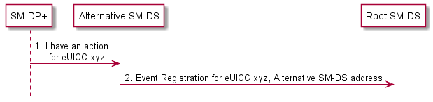
Figure 4.12.1.1: Alternative Device to Root SM-DS Event Registration

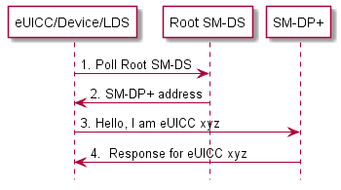
Figure 4.12.1.2: Root SM-DS Event Registration

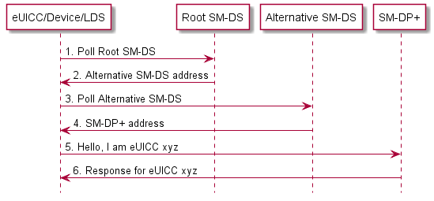
Figure 4.12.1.3: Alternative SM-DS Discovery

SM-DS Implementation
Two configurations of the SM-DS MAY exist:
- A Root SM-DS
- An Alternative SM-DS
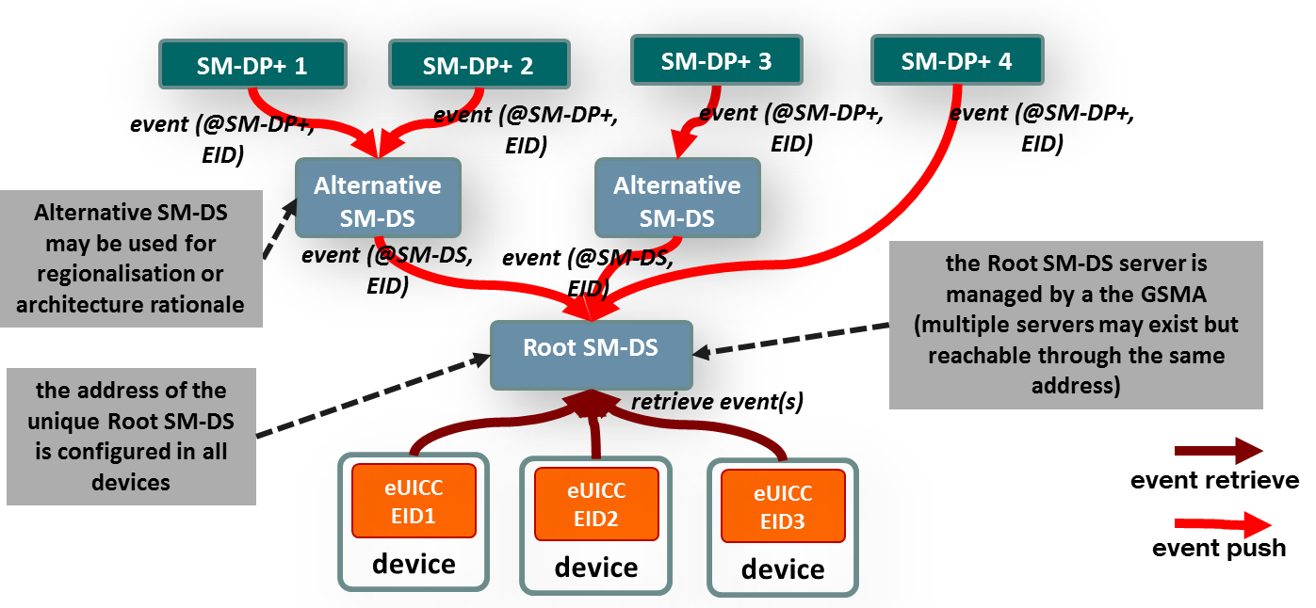
Figure 4.12.2.1: SM-DS Implementation
Figure 4.12.2.1 shows both configurations. The Root SM-DS is configured at the time of Device manufacture and is invariant.

SM-DS Implementation Guidelines
The following statements SHOULD be considered when defining a technical implementation:
- A competitive environment on the supply of SM-DS services SHOULD be favoured by the approach.
- There SHOULD be no single-points-of-failure.
- Implementation SHOULD inherently provide both vertical and horizontal performance/scalability.
- There SHOULD be no need for pre-registration of Devices or eUICCs at a certain SM-DS as required in SGP.02 [8] (GSMA Embedded SIM for the SM-SR).

SM-DS functions
The SM-DS has three distinct functions:
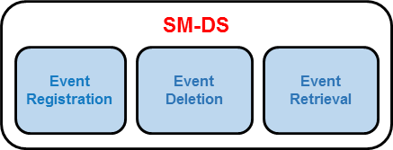
Figure 4.12.4.1: SM-DS Functions
Function name | Description
Event Registration | Process by which an Event Record received from a SM-DP+ is stored.
Event Deletion | Process by which an SM-DP+ can delete its own Event Record.
Event Retrieval | Provides all registered Event Records, upon Discovery Request from any enquiring LDS.
Table 4.12.4.1: SM-DS Function Descriptions

SM-DS Requirements
Req no. | Description
SMDS1 | The SM-DS SHALL enable a LDS to discover its own Event Records registered by SM-DP+(s) or by Alternative SM-DS(s).
SMDS2 | The SM-DS SHALL not be able to identify the nature of an Event.  NOTE: The nature of the Event may be ‘Profile Package available for download’.
SMDS3 | All valid Discovery Requests and Event Registrations SHALL be processed in a non-discriminatory manner.
SMDS4 | The SM-DS SHALL only accept Event Registrations from  - any authorised and authenticated SM-DP+(s) having a valid Certificate.  - any authorised and authenticated SM-DS(s) having a valid Certificate.
SMDS5 | The SM-DS SHALL only accept Discovery Requests authenticated by an eUICC via the corresponding LDS.
SMDS6 | The SM-DS and the SM-DP+ as well as connected SM-DSs SHALL be mutually authenticated.
SMDS7 | The SM-DS SHALL NOT have visibility of any data that may be used to compromise the End User´s privacy.
SMDS8 | The SM-DS SHALL support multiple concurrent Event Registrations per eUICC and SHALL present to the LDS all currently valid Event Records in the same order as they were received by the SM-DS (first in, first out).
SMDS9 | The SM-DS SHALL only store Event Records destined for specific EIDs.
SMDS10 | Subscriber Specific data and Profile related contents SHALL NOT be stored within the SM-DS.
SMDS11 | The SM-DS SHALL NOT allow the harvesting of any information such as Operator, EIDs, Device Manufacturers, Devices, etc.
SMDS12 | The SM-DS SHALL only return to the LDS, the Event Records related to the served eUICC.
SMDS13 | The SM-DS SHALL NOT have any contact with the Profile Packages e.g. SHALL NOT store or process any Profile Package.
SMDS14 | The SM-DS SHALL provide the same data regardless of the status of the Device that queries it (i.e. consistent in time and in geographic location).
SMDS15 | The SM-DS SHOULD NOT significantly impact the end-to-end provisioning time.
SMDS16 | The SM-DS SHALL provide defence against DoS attacks.
SMDS17 | All communications to, from and between entities of the SM-DS SHALL be encrypted.
SMDS18 | The SM-DP+ SHALL be able to delete any of its own Event Records registered on the SM-DS.
SMDS19 | An Alternative SM-DS SHALL be able to delete any of its own Event Records registered on the Root SM-DS (In response to an SM-DP+ delete operation defined in SMDS18).
SMDS20 | An Alternative SM-DS SHALL propagate the Event Record to the Root SM-DS if requested by the SM-DP+.
SMDS21 | If there are multiple Event Records registered on the SM-DS for one eUICC, these SHALL all be sent as a single response.
SMDS22 | An SM-DP+ SHALL be able to send an Event Record to an LDS either by the Root SM-DS or via any Alternative SM-DS selected by the SM-DP+. If an Alternative SM-DS is selected, the Event Record to the LDS SHALL come from this Alternative SM-DS.
SMDS23 | There SHALL be a unique Root SM-DS.  NOTE: This requirement does not forbid the potential load-balancing of this Root SM-DS.
SMDS24 | The Root SM-DS SHALL be managed by the GSMA.
SMDS25 (FFS) | It SHALL be possible for the Alternative SM-DS to conduct an Event Record Query to the Root SM-DS for the purpose of auditing Event Registrations it owns.
SMDS26 (FFS) | A SM-DS response to an Event Record Query SHALL only confirm Event Record existence and SHALL NOT include additional information.
SMDS27 (FFS) | An Alternative SM-DS SHALL be able to query the existence of an Event Record on the Root SM-DS, identified by the EID or the Event-ID over the ES15 interface.
SMDS28 (FFS) | Response to a SM-DS Event Record query SHALL only occur where the responder validates the Event Record ownership.
SMDS29 (FFS) | Ownership validation of a SM-DS Event Record Query SHALL only use the requester’s address or the submitted Event-ID against the components of the Event Record held.
SMDS30 (FFS) | The SM-DS (Root or Alternative) MAY inform the SM-DP+ directly or via another SM-DS, that a Discovery Request from an authorised LDS has been answered by issuing an Event Record.
SMDS31 (FFS) | The SM-DS SHALL only inform the Event Record’s owning SM-DP+ or SM-DS that it has replied to a Discovery Request.
Table 4.12.5.1: SM-DS Requirements

Event Registration/Deletion Procedure
The figure below shows the procedure for a deployment with the Root SM-DS and an Alternative SM-DS (cascade mode).
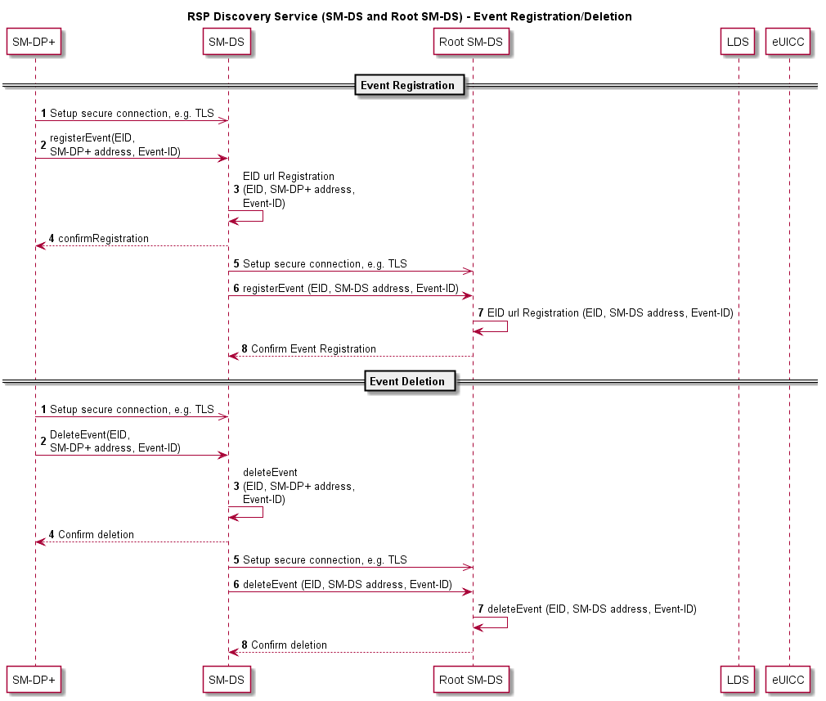
Figure 4.12.6.1: Event Registration/Deletion Procedure

Event Registration Procedure
Starting Condition:
  - The SM-DP+ has an Event Registration action waiting for a target eUICC identified by the EID.
Procedure:
- The SM-DP+ establishes a secure connection to an Alternative SM-DS of the Profile Owner´s choice.
- The SM-DP+ notifies the Alternative SM-DS about an Event Registration action.
3. to 4. The Alternative SM-DS registers and confirms the Event Registration.
5. The Alternative SM-DS establishes a secure connection to the Root SM-DS.
- The Alternative SM-DS informs the Root SM-DS that for the given EID, an Event Record is waiting at the Alternative SM-DS.
- The Root SM-DS registers the Event Registration.
- The Root SM-DS confirms the receipt of the information.

Event Deletion Procedure
Starting Condition:
  - The SM-DP+ has an Event Deletion action waiting for a target eUICC identified by the EID
Procedure:
- The SM-DP+ establishes a secure connection to an Alternative SM-DS of the Profile Owner´s choice.
- The SM-DP+ notifies the Alternative SM-DS about an Event Deletion action.
3. to 4. The Alternative SM-DS deletes the Event Record and confirms the Event Deletion.
5. The Alternative SM-DS establishes a secure connection to the Root SM-DS.
6. The Alternative SM-DS informs the Root SM-DS that for the given EID, an Event Record has to be deleted.
7. The Root SM-DS deletes the Event Record.
8. The Root SM-DS confirms the deletion of the Event Record.

Discovery Request Procedure
The figure below shows the procedure for a deployment with an Alternative SM-DS and the Root SM-DS (cascade mode). #
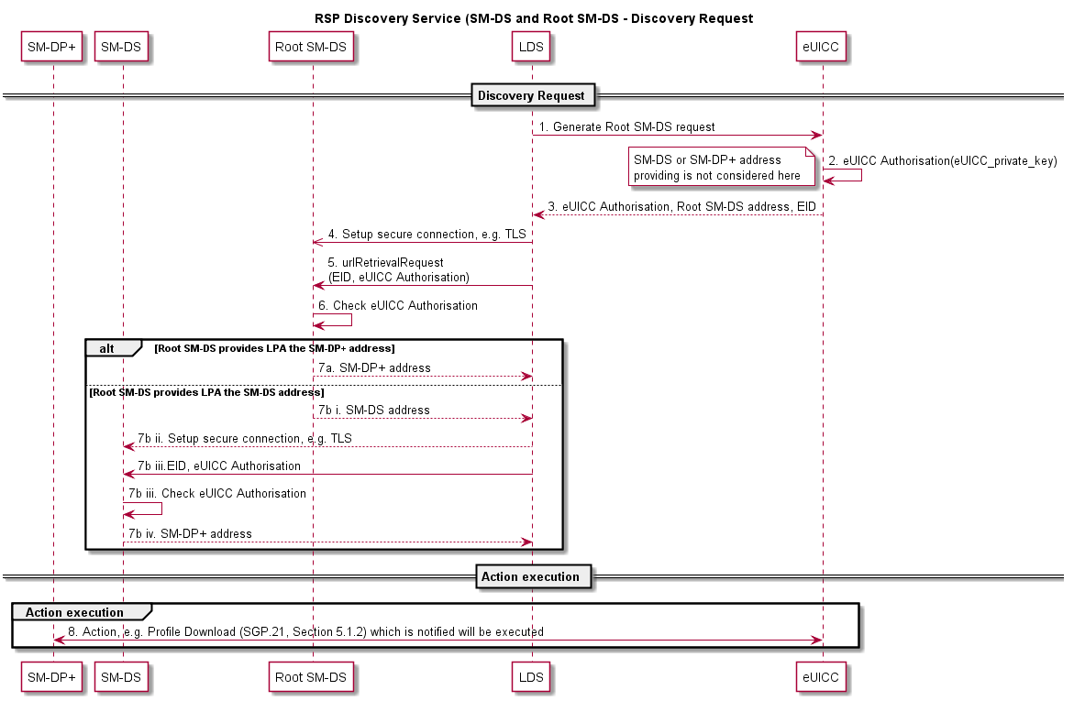
Figure 4.12.7.1: Discovery Request Procedure
Procedure:
1. to 3. In order to generate a Discovery Request, the LDS requests the eUICC to generate an eUICC Authorisation which contains (at least) the eUICC-Certificate and is signed by the eUICC.
4. to 5. The LDS establishes a secure communication to the Root SM-DS.
- The Root SM-DS verifies the authenticity of the eUICC by checking the eUICC Authorisation.
- In case the eUICC is authentic and an Event Record is waiting, it delivers back:
  - The address of the SM-DP+, where an action is waiting.
or
  - The rest of the following actions:
    - The address of the Alternative SM-DS, where an Event Record can be retrieved.
    - The LDS establishes a secure connection to the Alternative SM-DS.
    - The Alternative SM-DS verifies the authenticity of the eUICC by checking the eUICC Authorisation.
    - In case the eUICC is authentic and an Event Record has been received, it delivers back the address of the SM-DP+, where an action is waiting.
- The LPA establishes a connection to the SM-DP+ and the waiting action can be performed.
  - Profile Policy Management

Introduction
The Profile Policy Management function provides mechanisms by which Service Providers are able to reinforce the conditions or policies (operational and business) under which services are provided to the Subscriber. In some instances this MAY also include the enforcement of the policies set by the Subscriber.
Profile Policy Management MAY also be applied with other already existing policy enforcement technologies which are also subject to agreement by the Subscriber.
The realisation of the Profile Policy Management function is based on two key elements. The first element is the Profile Policy Enabler which is contained within the eUICC. The second element is a set of defined Profile Policy Rules which are required for the actual enforcement of specific policies.

Profile Policy Management Requirements
Policy no. | Description
POL1 | A Profile Policy Rule SHALL only be configured within a Profile.
POL2 | Each Profile MAY have Profile Policy Rules associated to itself.
POL3 | A Profile Policy Rule SHALL only apply to the Profile that contains it.
POL4 | Profile Policy Enforcement SHALL be consistent across implementations.
POL5 | Profile Policy Enforcement SHALL be able to resolve any Profile Policy Rule conflict.
POL6 | The updating of a Profile’s Policy Rules SHALL be restricted to the Profile Owner.
POL7 | The mechanism used for the update of a Profile Policy Rule SHALL be atomic.
POL8 | The set of Profile Policy Rules SHALL be extensible for future releases.
POL9 | There SHALL be a Profile Policy Rule scheme to allow extensibility of the Policy Rules, e.g. described like ‘operational command, scope of application, qualification’
POL10 | A Profile Policy Rule SHALL be enforced whenever a Profile state change is attempted.
POL11 | Downloading and installing a Profile with the Profile Policy Rule ‘Disabling of this Profile is not allowed’ (POL RULE1) SHALL only be possible if no other Operational Profile is currently installed.
POL12 | The LPA and the eUICC SHALL prevent the downloading and installation of a Profile containing Profile Policy Rules that conflict with the Profile Policy Rules of the already installed Profiles.  NOTE: The technical specification SHALL describe exhaustively each conflict that MAY occur.
POL12a | The LPA MAY cancel the Profile download procedure if it does not support the downloading of Profiles containing Profile Policy Rules to a removable eUICC regardless of its RAT.
POL13 | An Operator SHALL be able to deactivate the Profile Policy Rules of its Profile using the ES6 interface if the Profile is enabled.  NOTE: The activation of Profile Policy Rules on the ES6 interface is a potential feature for a future release.
POL14 | Before a Profile is installed with Profile Policy Rules, the End User SHALL be able to be notified about the Profile Policy Rules and if notified, the installation SHALL thereafter be conditional on End User Strong Confirmation.  This prompting may not be needed if the installation is directly allowed by the RAT.
POL15 | The request for End User consent for the installation of Profile Policy Rules and Profile download MAY be combined into a single prompt therefore requiring a single confirmation by the End User.
POL16 | Profile Policy Rules SHALL be enforced by the Profile Policy Enabler in the eUICC.
POL17 | The Profile Policy Enabler SHALL only support the Profile Policy Rules defined in this specification.
POL18 | The Profile Policy Enabler SHALL be capable of supporting all the Profile Policy Rules as defined in this specification.
POL19 | POL RULE3 SHALL be enforceable in all cases with the exception of the enabling of a Provisioning Profile.  NOTE: POL RULE3 is defined for use in specific use cases that have not yet been fully defined and is not applicable for this version of the specification.
POL20 | Allowing the installation of a Profile with Profile Policy Rules SHALL be subject to compliance with local regulatory requirements.
POL21 | Profile Policy Rules MAY be configured for Profiles only if the Profile Owner can be identified in the Metadata.  NOTE: POLPPE requirements depend on the identification of the Profile Owner.
Table 4.13.2.1: Profile Policy Management Requirements

Policy Rules
Policy no. | Description
POL RULE1 | The Profile Policy Rule ‘Disabling of this Profile is not allowed’ SHALL be supported.
POL RULE2 | The Profile Policy Rule ‘Deletion of this Profile is not allowed’ SHALL be supported.
POL RULE3 | The Profile Policy Rule ‘Deletion of this Profile is required upon its successful disabling’ SHALL be supported.  NOTE: POL RULE3 is defined for use in specific use cases that have not yet been fully defined and is not applicable for this version of the specification.
Table 4.13.3.1: Policy Rules Requirements

Profile Policy Enabler Requirements
Policy no. | Description
POLPPE1 | The Rules Authorisation Table (RAT) SHALL be stored in the Profile Policy Enabler in the eUICC.
POLPPE2 | The Profile Policy Enabler SHALL enforce the contents of the installed RAT, if any, only at Profile installation time.
POLPPE3 | The RAT SHALL allow multiple Profile Owners to have Profile Policy Rules enabled in their Profiles.
POLPPE4 | The RAT SHALL be able to support specific configurations which allow a set of or all Profile Policy Rules for any Profile Owner.
POLPPE5 | The RAT SHALL only be installed at pre-issuance or during the initial Device setup provided there are no Operational Profiles installed.
POLPPE6 | The RAT SHALL not be affected by the eUICC Memory Reset function.
POLPPE7 | To support identifiable regulatory requirement, a RAT SHALL be able to support a specific configuration which MAY forbid any Profile Owner to set a specific Profile Policy Rule.
POLPPE8 | If POLPPE7 is set, this information SHALL be part of the eligibility check information shared between the SM-DP+ and the eUICC.
POLPPE9 | Where the RAT allows the Profile Policy Rules for the Profile being installed, installation SHALL proceed as stated in POL14.
POLPPE10 | The RAT SHALL be able to support a setting to display the consequences of the Profile Policy Rules to the End User before installation of the Profile.
POLPPE11 | The OEM or EUM SHALL be responsible for providing the RAT.
POLPPE12 | A fixed RAT SHALL be implemented in the eUICC.  NOTE: RAT configuration examples are described in 0.
Table 4.13.4.1: Profile Policy Enabler Requirements
  - Certification

eUICC Certification Requirements
Req no. | Description
CERTEU1 | The EUM SHALL be GSMA SAS UP accredited [13].
CERTEU2 | The EUM SHALL be required to declare eUICC product compliance with GSMA SGP.22 [24].
CERTEU3 | The eUICC SHALL be certified according to the Protection Profile defined by the GSMA [25].
CERTEU4 | The eUICC Protection Profile SHALL at least include the following elements: ISD-R, Profile storage, isolation of Profiles, and Telecom Framework.
CERTEU5 | The eUICC protection Profile SHALL be equivalent to the eUICC Protection Profile defined in SGP.05 [21].
CERTEU6 | The Evaluation Assurance Level of the eUICC Protection Profile SHALL be (at least) EAL4 augmented with AVA_VAN.5 and ALC_DVS.2 (EAL 4+) [33].
CERTEU7 | The eUICC public key Certificate used for authentication SHALL contain the EID.
CERTEU8 | It SHALL be possible to obtain the technical reference of the product, for example the Common Criteria certification report number and if applicable, the EMVco PCN (Platform Certification Number) associated with a specific eUICC.
CERTEU9 | The EUM Public Key Certificate(s) SHALL be signed by a GSMA CI.
CERTEU10 | The eUICC Certificate(s) SHALL be signed by the EUM using its EUM private key corresponding to its Certificate (CERTEU9).
CERTEU11 | The eUICC private key(s) SHOULD not be modifiable. If they are, they should be modifiable only by the EUM that issued the corresponding Certificate.
CERTEU12 | If the eUICC private key(s) are modifiable, it SHALL use the mechanism defined in the GlobalPlatform specification with a Minimum Security Level corresponding to the AES algorithm using a key length of 128 bits.
CERTEU13 | If the eUICC's EUM Certificate is updatable, then the eUICC SHALL support a secure mechanism to update its EUM Certificate.
CERTEU14 | If the eUICC's CI public keys are updatable, then the eUICC SHALL support a secure mechanism to update its CI public keys.
CERTEU15 | If the eUICC's Certificate is updatable, then the eUICC SHALL support a secure mechanism to update its eUICC Certificate.
CERTEU16 | Where appropriate, the eUICC SHOULD be certified according to EMVCo Security Evaluation process [27].
CERTEU17 | Field-Test eUICCs SHALL use a certified hardware according to SGP.24 [38].
Table 4.14.1.1: eUICC Certification Requirements

Device Compliance Requirement
Req no. | Description
CERTDEV1 | There SHALL be a compliance process for all parts of Local Profile Management implementations in accordance with the GSMA.
CERTDEV2 | The certification process for Integrated TRE using Remote Memory residing outside the SoC as per DIE1 SHALL cover the Integrated TRE, internal and external SoC interfaces used for Integrated eUICC implementation, and Remote Memory residing outside the SoC.
CERTDEV3 | The certification process for Integrated TRE implementations SHALL ensure that software and data stored in Remote Memory residing outside the SoC as per DIE1 are protected against confidentiality, integrity, and availability attacks.
CERTDEV4 | The certification process for Integrated TRE implementations SHALL ensure that any interfaces between the Integrated TRE and the SoC are protected against confidentiality and integrity attacks.
Table 4.14.2.1: Device Compliance Requirement

SM-DP+ Certification Requirements
Req no. | Description
CERTDP1 | The SM-DP+ provider SHALL be required to declare product (SM-DP+) compliance with GSMA SGP.22 [24].
CERTDP2 | The SM-DP+ SHALL be accredited according to FS.08 SAS-SM Standard v3 [22] and FS.09 SAS-SM Methodology [28].
CERTDP3 | SM-DP+ elements SHALL use Hardware Security Modules (HSM) for cryptographic related operations (key storage, derivation, cryptographic operations).  NOTE: This is to be covered by the SAS documents “HSM certified according to FIPS 140-2 level 3 or higher”
CERTDP4 | The SM-DP+ SHALL implement privileges isolation (Log, Audit, Operation, and Administration).
CERTDP5 | The SM-DP+ SHALL implement operating system hardening mechanisms.
CERTDP6 | The SM-DP+ SHALL implement separation of control, user and administrative planes.
CERTDP7 | [Void]
CERTDP8 | [Void]
CERTDP9 | The private keys of SM-DP+ Certificates used for Profile Binding with eUICC SHALL be protected and stored in HSM according to CERTDP3.
CERTDP10 | The SM-DP+ SHALL implement rate-limiting mechanisms to mitigate against DoS attacks.
CERTDP11 | [Void]
CERTDP12 | The SM-DP+ Public Key Certificate(s) SHALL be signed by a GSMA CI.
CERTDP13 | The SM-DP+ processes SHALL ensure that any Java Application to be included in Profile Package(s) is bytecode verified.  NOTE 1: As per CERTDP2, the SM-DP+ processes are verified in the scope of SAS-SM.  NOTE 2: It is sufficient to enforce this requirement once for a given Java Application contained within an unpersonalised Profile.
Table 4.14.3.1: SM-DP+ Certification Requirements

SM-DS Certification Requirements
Req no. | Description
CERTDS1 | The SM-DS provider SHALL be required to declare product compliance with GSMA SGP.22 [24].
CERTDS2 | The SM-DS SHALL be accredited according to FS.08 SAS-SM Standard v3 [22] and FS.09 SAS-SM Methodology v3 [28].
CERTDS3 | The SM-DS SHALL implement isolation of privileges (Log, Audit, Operation, and Administration).
CERTDS4 | The SM-DS SHALL implement operating system hardening mechanisms.
CERTDS5 | The SM-DS SHALL implement separation of control, user and administrative planes.
CERTDS6 | [Void]
CERTDS7 | [Void]
CERTDS8 | The SM-DS Public Key Certificate(s) SHALL be signed by a GSMA CI.
Table 4.14.4.1: SM-DS Certification Requirements

LPA Certification Requirements
Req no. | Description
CERTLPA1 | There SHALL be a certification process for all the LPA elements communicating with Remote SIM Provisioning entities.
CERTLPA2 | The certification process SHALL ensure that Local Profile Management Operations are sent by authorised LPA elements only.
CERTLPA3 | The certification process SHALL ensure a mechanism exists to block compromised LPAs.
CERTLPA4 | The LPD SHALL authenticate the SM-DP+ during the TLS session.
CERTLPA5 | The LDS SHALL authenticate the SM-DS during the TLS session.
CERTLPA6 | The LPA SHALL only accept valid TLS Certificates as defined in CERTPK10a for SM-DP+ and SM-DS authentication.
Table 4.14.5.1: LPA Certification Requirements

Public Key Certificates Management Requirements
Req no. | Description
CERTPK1 | The eUICC SHALL verify the Public Key Certificate of the SM-DP+.
CERTPK2 | The LPD SHALL verify the Public Key Certificate of the SM-DP+.
CERTPK3 | The LDS SHALL verify the Public Key Certificate of the SM-DS.
CERTPK4 | The LDS authentication of an SM-DS using an invalid Public Key Certificate SHALL fail (see CERTPK11), and on-going communication SHALL stop.
CERTPK5 | The LPD authentication of an SM-DP+ using an invalid Public Key Certificate SHALL fail (see CERTPK11), and on-going communication SHALL stop.
CERTPK6 | The SM-DP+ authentication of an eUICC using an invalid Public Key Certificate SHALL fail (see CERTPK11), and on-going communication SHALL stop.
CERTPK7 | The eUICC authentication of an SM-DP+ using an invalid Public Key Certificate SHALL fail (see CERTPK11), and on-going communication SHALL stop.
CERTPK8 | The GSMA CI SHALL revoke the Public Key Certificate of any entities (SM-DP+, SM-DS, EUM) if it is compromised (e.g. private key theft).
CERTPK9 | The eUICC SHALL be able to support a set of GSMA CIs.
CERTPK9a | The EUM SHALL ensure that the support of GSMA CI and Test CI are mutually exclusive on any given eUICC.
CERTPK10 | A Public Key Certificate SHALL be considered as valid if:  - it has a valid signature  - it is signed by a GSMA CI, or a trusted chain of Certificates up to a GSMA CI. Certificate Path validation SHALL follow the process defined in RFC 5280 [1].  - it has not been revoked, and no Certificate in the trust chain has been revoked  - it has not expired  If any of these applicable verifications fail, the Public Key Certificate SHALL be considered as invalid.
CERTPK10a | A TLS Public Key Certificate SHALL be considered as valid if:  - it has a valid signature  - it is signed by a GSMA CI, or a public trusted CA, or a trusted chain of Certificates up to a GSMA CI or a public trusted CA. Certificate Path validation SHALL follow the process defined in RFC 5280 [1].  - it has not been revoked, and no Certificate in its trust chain has been revoked  - it has not expired  If any of these applicable verifications fail, the TLS Public Key Certificate SHALL be considered as invalid.
CERTPK11 | The eUICC, LPA, SM-DS and SM-DP+ SHALL have knowledge of revoked Public Key Certificates.  NOTE: This requirement also applies to TLS Certificates that chain to either the GSMA CI or a public trusted CA.
Table 4.14.6.1: Public Key Certificates Management Requirements
  - eUICC OS Update
Req no. | Description
OSUpd1 | An eUICC SHOULD support a secure mechanism to allow an eUICC OS Update. While its implementation detail is out of scope of specification, the use of eUICC OS Update PP-Module as described in SGP.25 [21] is mandatory.
OSUpd2 | If such a mechanism is used, the eSIM Products for which the compliance is affected by the eUICC OS update SHALL maintain compliance as specified in SGP.24 [27].
Table 4.15.1: eUICC OS Update Requirements
  - Requirements for Interoperable Applications
Req no. | Description
APP01 | Application Developers SHALL develop Interoperable Applications according to current best practices.  NOTE: The “Stepping Stones for Java Card Applet Developers” [i.01] can be used for guidance on the development of Java Card Applets.
Table 4.16.1: Requirements for Interoperable Applications

Operational Procedures

LPA Initiated Download

LPA Initiated Download Requirements
Req no. | Description
LID1 | The LPA SHALL use any Root SM-DS or default SM-DP+ address populated on the eUICC if it has not been provided already by the Activation Code.
LID2 | In the context of LID1, if both a Root SM-DS and a default SM-DP+ address are populated, the LPA SHALL first contact the SM-DP+ and then SM-DS to initiate a Remote SIM Provisioning transaction.
Table 5.1.1.1: LPA Initiated Download Requirements

LPA Initiated Download Procedure
This following procedure describes the Events that are part of the Profile Package download and installation procedure initiated by the LPA.
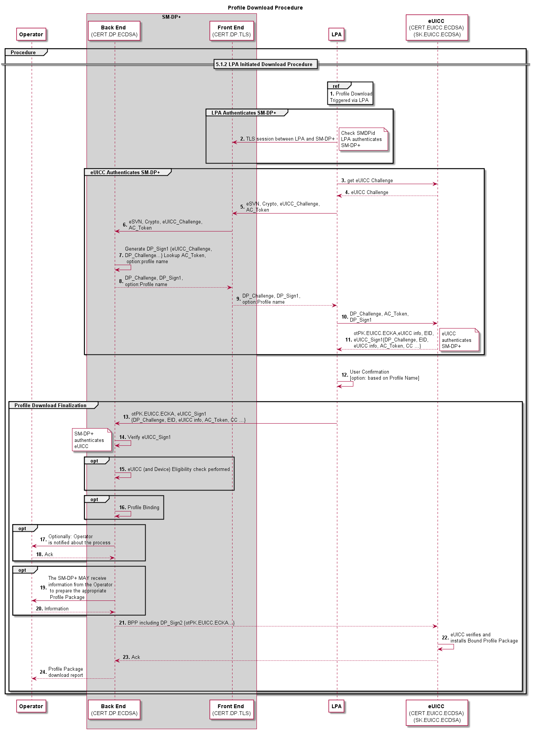
Figure 5.1.2.1: Profile Download Procedure
Start conditions:
- The Subscriber has completed the Subscription process to the selected Operator/Service Provider offer.
- The Profile ordering process related to this Subscription has been completed (i.e. an assigned Protected Profile Package is stored on the SM-DP+).
Procedure:
- The LPA initiates Profile Package download and identifies the address of the SM-DP+ where the Profile is stored and available for download (via e.g. URL, QR code, manual input, etc.) as well as other information provided (e.g. Token, SMDPId, Confirmation Code).
2. The LPA authenticates the SM-DP+ through establishing a TLS connection with the SM-DP+, and verifying the SMDPid if such information has been provided.
3. to 4. The LPA gets an eUICC challenge
5. to 6. The LPA sends the eUICC challenge and any other relevant information to the SM-DP+.
7. to 9. The SM-DP+ signs the eUICC challenge, and generates a DP_Challenge to be sent back to the eUICC.
10. The LPA sends the material received by the SM-DP+ and the AC Token to the eUICC; the eUICC checks the SMDPid and authenticates the SM-DP+.
11. The eUICC sends back a signed set of information including the DP_Challenge, the AC Token, the EID and its Certificate to the LPA.
12. The End User confirms the download of the Profile, optionally with the display of the Profile name of the Operator.
13. The LPA sends the set of information received in Step 11 from the eUICC to the SM-DP+.
14. The SM-DP+ verifies the signature; the eUICC is authenticated.
15. to 16. OPTIONAL: The eUICC Eligibility Check and Profile binding functions are performed by the SM-DP+.
17. to 22. OPTIONAL
17. The Operator is notified about the Profile Package that is about to be downloaded.
18. If the Operator has been notified, it MAY request to stop the download process by indicating an error code to the SM-DP+.
19. If the Operator sends an error code to the SM-DP+, the SM-DP+ stops the download process and indicates the error code to the LPA.
20. The LPA notifies the End User with an appropriate message.
21. to 22. The SM-DP+ MAY receive information from the Operator to prepare the appropriate Profile Package.
23. to 25. The Bound Profile Package is sent to the eUICC and installed on the eUICC.
26. The Profile Package download report is sent from the SM-DP+ to the Operator.
End Condition:
  - The Profile is installed in the eUICC in a Disabled state

Profile Download with Activation Code

Activation Code Requirements
Req no. | Description
AC1 | Where used, the Activation Code SHALL trigger the download of a Bound Profile Package from a specific SM-DP+.
AC2 | The Activation Code SHALL comprise of the following parameters:  - SM-DP+ address  - Activation Code Token (Includes OPTIONAL Confirmation Code Required Flag)  - SMDPid (OPTIONAL)
AC3 | The Activation Code Token SHALL be able to include a parameter indicating whether a Confirmation Code is required or not.  If such a Confirmation Code is required, the LPA SHALL ask the End User to input a Confirmation Code. The SM-DP+ SHALL verify the Confirmation Code before delivering the Bound Profile Package.  NOTE: How the Confirmation Code is created and provided to the End User is out of scope of this specification.
AC4 | The Activation Code SHALL be verified by the SM-DP+ before delivering the Bound Profile Package.
AC5 | The Activation Code input in the LPA by the End User SHALL support at least manual typing and QR code scanning.
AC6 | All Activation Code procedures SHALL be implemented natively as part of the LPA.
AC7 | [Void]
AC8 | Following the Activation Code procedure, the Profile Package download procedure SHALL be used.
AC9 | The Activation Code procedure SHALL preserve eco-system security, privacy and validation of User Intent.
AC10 | The Activation Code procedure SHALL be used for the sole purpose of downloading a Profile package to the targeted eUICC. The Activation Code procedure SHALL prevent sending IMEI and EID information to a non-authenticated SM-DP+.
AC11 | The Activation Code SHALL uniquely identify the Operator/Service Provider.
AC12 | The Activation Code request to the SM-DP+ SHALL be extended by the LPA with the EID after the specific SM-DP+ has been authenticated.
Table 5.2.1.1: Activation Code Requirements

Profile Download with Activation Code Procedure
The Activation Code procedure defines a common functionality which allows the Subscriber or the End User on behalf of the Subscriber to “activate” a Device by means of requesting the download of an Operational Profile from the Device itself.

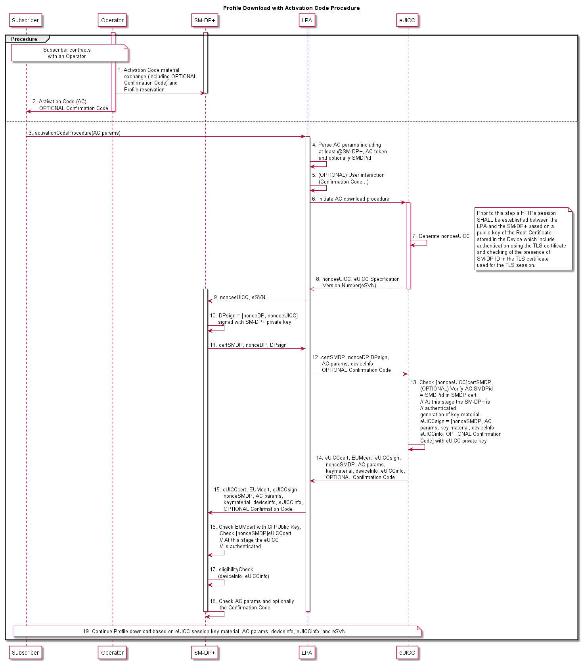
Figure 5.2.2.1: Profile Download with Activation Code Procedure
Start Conditions:
- A Subscription has been established by the Subscriber.
- Activation Code material and optionally a Confirmation Code has been provided to the SM-DP+ (Step 1), and an Activation Code has been provided to the End User and optionally a Confirmation Code (side channel) (Step 2).
Procedure:
- The End User inputs the Activation Code to the LPA through the LUI.
- The LPA parses the Activation Code parameters to recognise the SM-DP+ address, the Activation Code Token, the LPA Mode and optionally the SMDPid. In addition, the LPA MAY parse in the Activation Token the information that a Confirmation Code is required.
- If the Confirmation Code parameter in the Activation Code Token is set to “require Confirmation Code”, the End User is prompted to input a Confirmation Code provided to them by the issuing Operator/Service Provider.
- The Activation Code download procedure is initiated by the LPA. The LPA requests a nonceeUICC from the eUICC.
- The eUICC creates a nonceeUICC associated with the supported eUICC Specification Version Number (eSVN).
- The eUICC transmits the nonceeUICC associated with the supported eSVN to the LPA.
- The LPA sends the nonceeUICC associated with the supported eSVN to the SM-DP+.
NOTE: Prior to this step a HTTPs session SHALL be established between the LPA and the SM-DP+ based on a public key of the Root Certificate stored in the Device which includes authentication using the TLS Certificate and checking for the presence of the SMDPid in the TLS Certificate used for the TLS session.

- Upon receiving the nonceeUICC and the associated eSVN, the SM-DP+ creates nonceSMDP and signs both the nonceSMDP and the nonceeUICC.
- The SM-DP+ sends the signed nonceeUICC and nonceSMDP to the LPA.
- The LPA collects the Activation Code parameters as well as the Device information needed for the eligibility procedure and optionally the Confirmation Code and transmits them with the signed nonceeUICC and nonceSMDP to the eUICC.
- The eUICC checks the signature attached to the nonceeUICC. If the SMDPid is configured in the AC, the eUICC checks that the SMDPid provided by the LPA and the SMDPid in the SM-DP+ Certificate correspond. The SM-DP+ is at this stage authenticated by the eUICC. The eUICC generates key material that will be used for the session key establishment. The eUICC signs a set of information with the eUICC private key which includes:
  - The nonceSMDP
  - Key material created by the eUICC to calculate session keys for the preparation of the Bound Profile Package
  - Activation Code parameters
  - The Device and eUICC information
  - Optionally the Confirmation Code
- The eUICC sends the signed set of information to the LPA in addition to:
- The nonceSMDP
- Key material created by the eUICC to calculate session keys for the preparation of the Bound Profile Package
- Activation Code parameters
- The Device and eUICC information
- The eUICC Certificate which includes the EID
- The EUM Certificate
- Optionally the Confirmation Code
- The LPA sends the whole set of information received from the eUICC to the SM-DP+.
- The SM-DP+ checks the EUM Certificate with the CI Public Key. The SM-DP+ checks the signature of the nonceSMDP; the eUICC is at this stage authenticated by the SM-DP+.
- The SM-DP+ proceeds with the eligibility check based on the transmitted information (EID, Device information, eUICC information, eSVN).
- The SM-DP+ checks the Activation Code parameters and optionally the Confirmation Code to retrieve the referenced Profile Package.
- The Profile Package is downloaded to the eUICC:
- The SM-DP+ establishes session keys with the eUICC.
- A Bound Profile Package is prepared on the basis of the eUICC session key material and is downloaded and installed on the eUICC.
- Successful installation of the Profile on the eUICC is acknowledged and the Operator is notified by the SM-DP+.
- Successful installation of the Profile on the eUICC is acknowledged by the eUICC to the LPA which notifies the End User of the status.
End Conditions:
- A Bound Profile Package has been downloaded and installed on the eUICC in a Disabled state.
- The LPA MAY offer the Profile for enablement by the End User.

Local Profile Management

Local Profile Management Procedures

Enable Profile
This procedure performs the enabling of a target Profile. The request is given by the End User to the LPA.
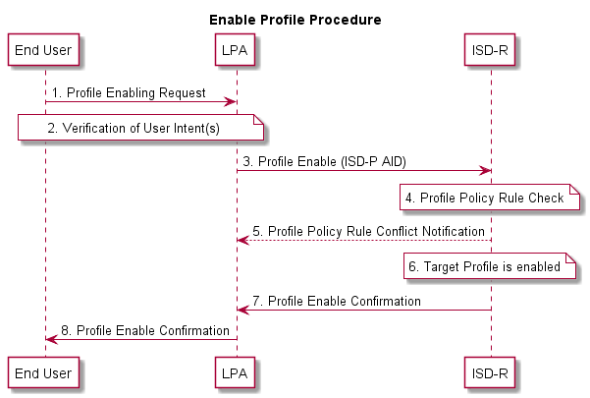
Figure 5.3.1.1.1: Enable Profile Procedure
Start conditions:
- The target Profile is disabled on the eUICC.
- The target Profile has been chosen by the End User.
- The LPA is authenticated to the eUICC as legitimate for performing Local Profile Management.
Procedure:
- The End User makes a Profile enable request on the LPA.
- User Intent is verified.
- The LPA sends a Profile enable operation for the target Profile to the ISD-R on the eUICC.
- The ISD-R checks if applied Profile Policy Rules on the target Profile permits the Profile to be enabled
- If there is a conflict with Profile Policy Rules, the ISD-R aborts the procedure and informs the End User via the LPA.
- The target Profile is enabled.
- The ISD-R informs the LPA of the enabling of the Profile.
- The End User is informed via the LPA.
End conditions:
  - The target Profile is enabled.

Disable Profile
Profile disabling can be achieved with the following procedure. The request is given by the End User on the LPA.
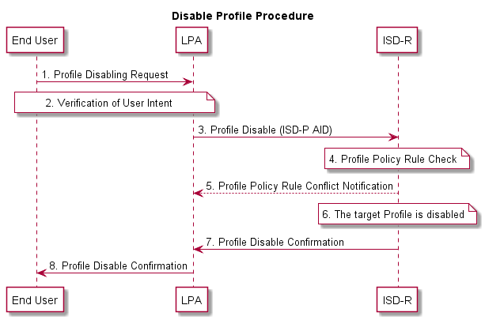
Figure 5.3.1.2.1: Disable Profile Procedure
Start conditions:
- The target Profile is enabled on the eUICC.
- The target Profile has been chosen by the End User.
- The LPA is authenticated to the eUICC as legitimate for performing Local Profile Management.
Procedure:
- The End User makes a Profile disable request on the LPA.
- User Intent is verified.
- The LPA sends a Profile disable operation to the ISD-R on the eUICC.
- The ISD-R checks if applied Profile Policy Rules on the target Profile permits the Profile to be disabled.
- If there is a conflict with Profile Policy Rules, the ISD-R aborts the procedure and informs the End User via the LPA.
- The ISD-R disables the target Profile.
- The ISD-R informs the LPA of the disabling of the Profile.
- The End User is informed via the LPA.
End conditions:
- The target Profile is disabled.

Delete Profile
Profile deletion can be achieved with the following procedure. The request is given by the End User on the LPA.
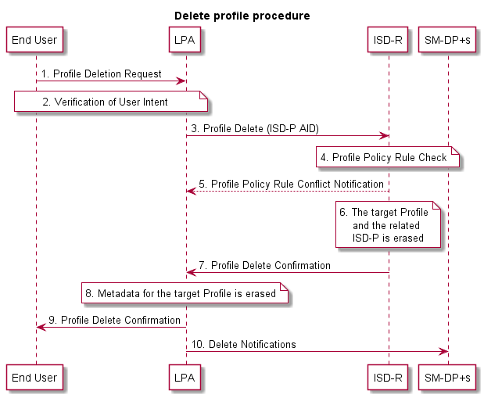
Figure 5.3.1.3.1: Delete Profile Procedure
Start conditions:
- The target Profile is disabled.
- The target Profile has been chosen by the End User
- The LPA is authenticated to the eUICC as legitimate for performing Local Profile Management.
Procedure:
- The End User makes a Profile deletion request on the LPA.
- User Intent is verified.
- The LPA sends a Profile deletion operation for the target Profile to the ISD-R on the eUICC. The request includes the ISD-P AID of the target Profile.
- The ISD-R checks if applied Profile Policy Rules permits the Profile to be deleted.
- If there is a conflict with Profile Policy Rules, the ISD-R aborts the procedure and informs the End User via the LPA.
- The ISD-R erases the target Profile and the related ISD-P.
- The ISD-R informs the LPA of the Profile deletion.
- The Profile Metadata for the target Profile is erased.
- The End User is informed via the LPA.
- The LPA sends delete Notifications to the Notification Receivers for Profile deletion in the Profile.
End conditions:
- The target Profile is deleted.

Add/Update Profile Nickname
Add/update nickname will allow the Subscriber or End User to attribute a nickname to a Profile for ease of use. Note that adding or changing a nickname SHALL NOT affect any other data or other Profile Metadata for that Profile.
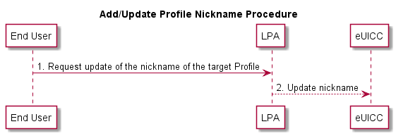
Figure 5.3.1.4.1: Add/Update Profile Nickname Procedure
Start conditions:
- User Intent has been verified.
- The target Profile has been chosen by the End User.
- The LPA is authenticated to the eUICC as legitimate for performing Local Profile Management.
Procedure:
- The End User requests the update of the nickname on the LPA.
- The LPA updates the Profile Metadata of the target Profile with the End User’s choice of nickname in the eUICC.
End conditions:
  - Profile Metadata of the target Profile has been updated with the End User’s choice of nickname.

Query Profile Metadata
This procedure will allow the End User to query the Profile Metadata of the Profiles accessible to the End User. The result SHALL display all (or parts of) the Profile Metadata for the selected Profile on the eUICC at the time of querying. No changes are made to any data on the eUICC as a result of this procedure.
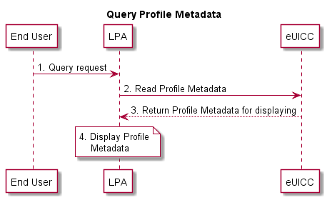
Figure 5.3.1.5.1: Query Profile Metadata Procedure
Start conditions:
- The LPA is authenticated to eUICC as legitimate for performing Local Profile Management.
- The list of Profiles accessible to the End User is displayed by the LPA (LUI).
Procedure:
- The End User selects a Profile to query.
- The LPA receives a query request from the End User.
- The LPA requests Profile Metadata from the eUICC.
- The LPA displays the Profile Metadata to the End User on the LUI.
End conditions:
  - No change to Profile Metadata.

eUICC Memory Reset
This procedure performs the eUICC Memory Reset of the eUICC including its associated Profile Metadata. The request is given by the End User to the LPA.
NOTE: A similar procedure will apply to perform the eUICC Test Memory Reset of the eUICC.
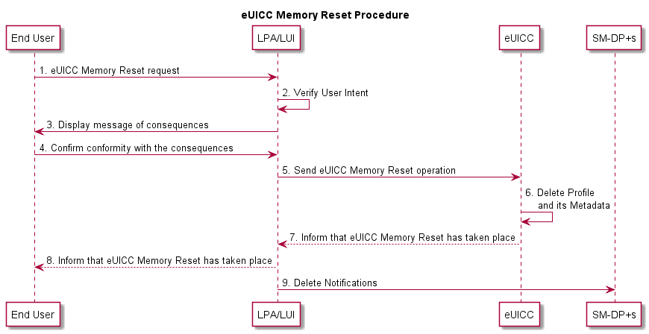
Figure 5.3.1.6.1: eUICC Memory Reset Procedure
Start conditions:
- The LPA is authenticated to the eUICC as legitimate for performing Local Profile Management.
- The eUICC Memory Reset option is displayed by the LPA (LUI).
Procedure:
- The End User makes an eUICC Memory Reset request on the LPA (LUI).
- User Intent is verified.
- The LPA (LUI) displays a message of consequences of ‘eUICC Memory Reset’ to the End User.
- The End User confirms the conformity with the consequences to the LPA.
- The LPA sends an eUICC Memory Reset operation to the eUICC.
- The eUICC deletes the Profile on the eUICC even if it is an Enabled Profile including the Profile Metadata associated with it.
- The eUICC informs the LPA of the eUICC Memory Reset of the eUICC.
- The End User is informed via the LPA (LUI).
- The LPA sends delete Notifications to all Notification Receivers for Profile deletion in the Profile.
End conditions:
- The Profile is deleted from the eUICC.

Add Profile with Activation Code
This procedure will allow the Subscriber to add a single Profile. This procedure will not enable the downloaded Profile, nor disable an Enabled Profile. Network connectivity is assumed. The download can be initiated by the input of an Activation Code.
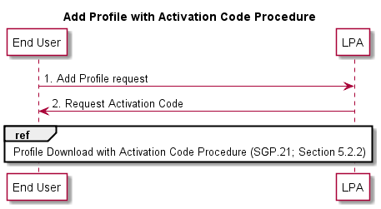
Figure 5.3.1.7.1: Add Profile with Activation Code Procedure
Start conditions:
- User Intent has been verified.
- The download of a new Profile is allowed on the eUICC.
- The LPA is authenticated to the eUICC as legitimate for performing Profile download.
Procedure:
- The End User obtains an Activation Code to add a Profile to their Device.
- The LPA requests the End User to enter the Activation Code.
- Profile Download with Activation Code Procedure as described in Section 5.2.2 starts.
End conditions:
- The Profile has been installed on the End User’s Device.
- Profile Metadata has been updated from the Profile.

Edit SM-DP+ Address
This procedure will allow the End User to edit a default SM-DP+ address on to the eUICC.
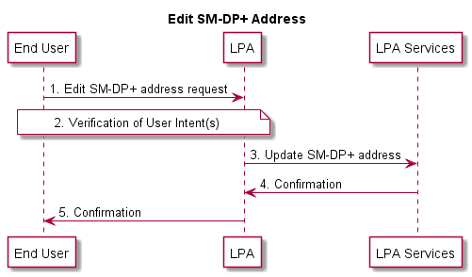
Figure 5.3.1.8.1: Edit SM-DP+ Address
Start conditions:
- There is a default SM-DP+ address in the LPA.
- The End User is willing to edit the default SM-DP+ address
Procedure:
- The End User edits the SM-DP+ Address via the LPA.
- Simple Confirmation from the End User is required.
- The LPA sends the default SM-DP+ address for storage in the LPA Service.
- The LPA Service informs the LPA of the storage of the default SM-DP+ address.
- The End User is informed via the LPA.
End conditions:
  - The target default SM-DP+ Address is edited in the LPA Services.

Retrieve Activation Code
This procedure will allow the LPA to retrieve from the SM-DP+ the Activation Code that is associated with a specific Profile currently installed on the eUICC. The End User can request for the download and installation of the Profile by using the retrieved Activation Code.
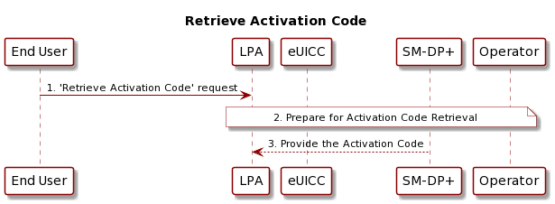
Figure 5.3.1.9.1: Retrieve Activation Code
Start conditions:
- The target Profile is installed on the eUICC
- The target Profile has been chosen by the End User.
- The LPA is authenticated to the eUICC as legitimate for performing Local Profile Management.
Procedure:
- The End User makes a 'Retrieve Activation Code' request on the LPA.
- The LPA, eUICC and the SM-DP+ perform the Activation Code Retrieval of the selected Profile that is installed on the eUICC. This step can also involve the Operator.
- If all the conditions are met, the SM-DP+ provides the Activation Code which can be used for the download and installation of the selected Profile.
End conditions:
- The LPA has stored the Activation Code provided by the SM-DP+ in its memory.

- Security Threats, Risks and Creation Process Requirements (Informative)
  - New Profile on New Primary Device (Off Device Activation)
Risk no. | Risk description
INI1 | Incomplete or corrupted Profile being pushed to the Subscriber.
INI2 | Malicious eUICC party using privileged position in order to push unsolicited Profiles to Devices.
Table A.1.1: New Profile on New Primary Device Risks
  - Profile Deletion
Risk no. | Risk description
IND1 | Long term gathering of key materials due to a long term storage of delivered Profiles after their disabling.
IND2 | Loss of sensitive data from discarded media supports (hard drives…)
IND3 | Malware launching coordinated or isolated deletion of one or several Profiles leading to a loss of connectivity to an End User.
IND4 | Accidental Profile deletion (e.g. unattended children…) leading to a loss of connectivity to an End User.
IND5 | Non-tech-savvy or malicious Subscriber repeatedly deleting Profiles and asking for them to be reloaded leading to surcharge of provisioning servers.
Table A.2.1: Profile Deletion Risks
  - Profile Switch
Risk no. | Risk description
INP1 | Malicious Profile switching originating from an internal party.
INP2 | Human error leading to the switching of alternate Profiles leading to a loss of connectivity.
INP3 | Malware launching coordinated or isolated switching of one or several Profiles leading to a loss of connectivity.
INP4 | Malware launching coordinated or isolated switching of one or several Profiles leading to major fraud scenarios.
Table A.3.1: Profile Switching Risks
  - Profile Swap
Risk no. | Risk description
INS1 | Race condition leading to the deactivation of all Profiles and a loss of connectivity.
Table A.4.1: Profile Swapping Risks
  - Cryptographic Related Risks
Risk no. | Risk description
INO1 | Loss or theft of private keys in one or several Profile Management components leading to the loss of confidentiality on the whole chain.
INO2 | Inability to revoke compromised Certificates leading to the loss of trust on the whole Certificate chain.
INO3 | Local law enforcement requests leading to the forceful disclosure of key materials.
INO4 | Local law enforcement requests leading to the forceful compromise of key components.
INO5 | Malicious or accidental revocation of Certificates leading to the denial of service on the whole provisioning Certificate chain.
INO6 | Use of temporary symmetric cryptographic or “generic” key material during the Profile creation, temporary storage, transport, or long-term storage leading to single point of failure and attack being created.
Table A.5.1: Cryptographic Related Risks
  - Quality of Service
Risk no. | Risk description
QoS1 | Profile creation burst leading to the inability for the eUICC platforms to deliver expected service level.
QoS2 | Denial of service on delivery platforms leading to the inability to deliver expected service level.
QoS3 | Inability to recover from management communication failures leading to a temporary or permanent inability to deliver a Profile.
Table A.6.1: Quality of Service Risks
  - Non-human or Unpredictable
Risk no. | Risk description
EXC1 | Catastrophic event such as floods, earthquakes, etc. leading to the destruction of a datacentre.
EXC2 | Geopolitical/Human events leading to the destruction of a datacentre.
EXC3 | Change of regulation leading to partial or total loss of trust for an actor of the provisioning delivery chain (Operator, OEM, SIM vendor…).
Table A.7.1: Non-human or Unpredictable Risks
  - New Profile during Subscriber Journey
Risk no. | Risk description
EXN1 | Malicious pairing of new Device using unattended Primary or Companion Device.
EXN2 | Use of public Wi-Fi for internet connectivity leading to the loss of confidentiality during the provisioning of Profile operations.
EXN3 | Use of public Wi-Fi for internet connectivity leading to the tampering of registration information during provisioning of Profile operations.
EXN4 | Social engineering leading to the communication of OTP materials to attackers.
EXN5 | Man-in-the-middle or eavesdropping during Profile provisioning leading to the loss of confidentiality.
EXN6 | “Implicit authentication” (e.g. HTTP MSISDN enrichment) leading to the loss of authentication or Profile material.
Table A.8.1: New Profile during Subscriber Journey Risks
  - Device Swap
Risk no. | Risk description
EXS1 | Malicious Subscriber using race condition scenarios leading to Profiles being activated on both Devices.
EXS2 | Malicious entity using weak swap procedures in order to compromise authentication vectors.
Table A.9.1: Device Swapping Risks
  - Loss of Privacy
Risk no. | Risk description
PRI1 | Improper handling, transport or disclosure of the EID or any user related data information leading to the use of the latter as a “super” user tracking identifier.
PRI2 | eUICC management commands leading to the creation of unexpected and unpredicted « remote paging » or « remote control » commands used by 3rd parties to spy or compromise Devices or the Subscriber themselves.
Table A.10.1: Loss of Privacy Risks
  - Others
Risk no. | Risk description
EXO1 | Compromising of exchanges between Profile Management actors leading to the critical loss of private keys.
EXO2 | Profile cloning due to unpredicted implementation routines for specific scenarios.
Table A.11.1: Other Risks
  - Creation Process
Req no. | Requirement description
CRE1 | Profiles failing to be created SHALL be securely deleted or at least purged of authentication vectors.
CRE2 | Communication between systems participating in the Profile creation SHALL be protected in integrity and confidentiality.
Table A.12.1: Creation Process Requirements

- Profile Production Procedure (Informative)
  - Profile Production Procedure
This section describes a generic implementation. It should be regarded as an example only; specific implementation MAY be required to address specific security concerns.
Within the eUICC, the current functionality of the UICC is represented by a Profile. Just as with current UICCs, Profiles are the responsibility of the Operator and Profile production is performed upon their request and permission (if not produced by the Operators themselves).
The same Operator procedures as in the current UICCs SHALL apply.
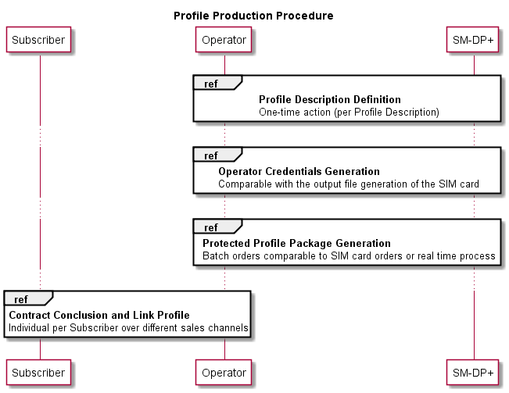
Figure B.1.1: Profile Production Procedure

Profile Production consists of three steps:
- Profile Description definition: The SM-DP+ creates and registers a Profile Description based on the Operational Profile Description.
- Operator Credentials generation: The Operator asks the SM-DP+ to generate Operator Credentials that will be used in the next step. This procedure is OPTIONAL and will not be used if the Operator wants to generate the Operator Credentials during Protected Profile Package generation.
- Protected Profile Package generation: The Profile Packages will be created, protected and stored. This step (batch type of operation or real time process) is only performed after an order with the respective Operator.
- Contract conclusion and Link Profile: At the end of the contract conclusion, an Activation Code is delivered to the End User and the Profile MAY be allocated for this contract.
NOTE: The generation of the Bound Profile Package is part of the Profile download with Activation Code procedure in Section 5.2.2.
    - Profile Description Definition
The Profile description definition MAY comprise of the following sequence:
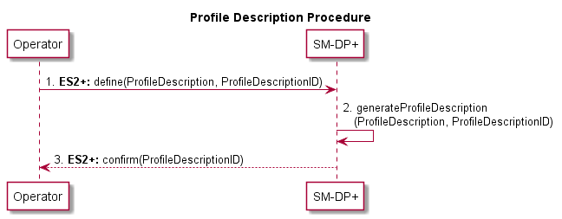
Figure B.1.1.1: Profile Description Procedure
Start Condition:
- Contractual relationship between the Operator and the SM-DP+.

Procedure:
- The Operator defines its different Profile types (identified by a [non-standardised] Profile Description ID) which contains the Network Access Application like USIM, file structure, data and applications, etc.
- The SM-DP+ creates the Profile Descriptions based on the Operators input with the corresponding Profile Description ID.
- The SM-DP+ confirms the Profile Description definition e.g. by sending the corresponding Profile Description ID.
NOTE: An Operator can define multiple Profile Descriptions with the SM-DP+

End Condition:
  - The Operator is able to order Protected Profile Packages based on Profile Description IDs.
    - Operator Credentials Generation
This procedure allows the Operator to allocate a set of Operator Credentials on the SM-DP+ without associating them to a specific ProfileDescriptionID.
Operator Credentials generation MAY comprise of the following sequence:
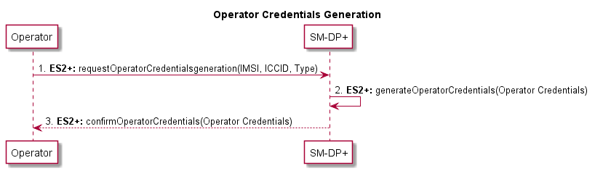
Figure B.1.2.1: Operator Credentials Generation
Start Condition:
- IMSI, ICCID and other resources have been allocated by the Operator.

Procedure:
- The Operator provides the IMSI, ICCID, type of credential to be created (e.g. Milenage [11][12], TUAK [10] etc.) and other resources that MAY already be allocated to the SM-DP+. It asks the SM-DP+ to securely generate and store a set of Operator Credentials.
- The SM-DP+ securely generates and stores a set of Operator Credentials based on the Operator’s input with the corresponding IMSI, ICCID and other resources provided.
- The SM-DP+ confirms the generation of Operator Credentials and provides them to the Operator.
    - Protected Profile Package Generation
The Protected Profile Package Generation MAY comprise of the following sequence:
This procedure MAY apply between the Profile Description definition, and the Contract conclusion and Link Profile, depending on whether the Protected Profile Package is created on demand or prepared in advance.

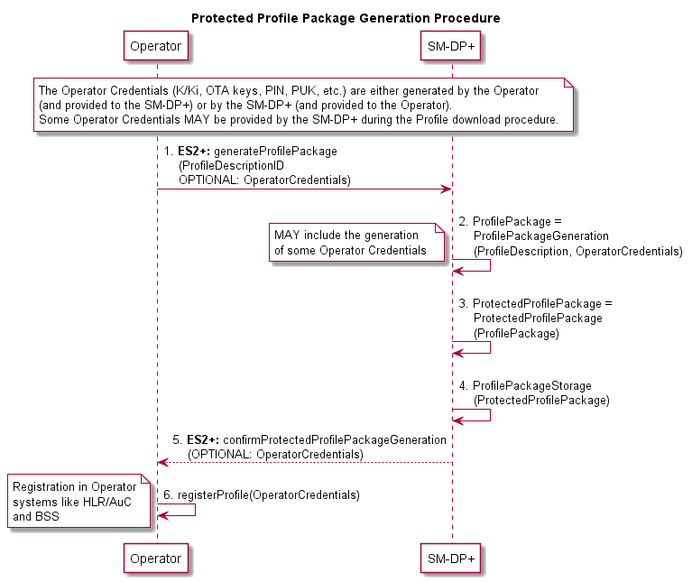
Figure B.1.3.1: Protected Profile Package Generation Procedure

Start Conditions:
- Profile Description definition
Procedure:
- The Operator orders the Protected Profile Package generation by providing the SM-DP+ with the Profile Description ID and some corresponding Operator input data (credentials e.g. ICCID, IMSI).The Operator input data required for Protected Profile Package generation (IMSI, ICCID, K/Ki, OTA Keys, PIN, PUK, etc.) is either created by the Operator (and provided to the SM-DP+) or by the SM-DP+ (and provided to the Operator).
- The SM-DP+ creates the Profile Packages.
- The SM-DP+ creates the Protected Profile Packages.
- The SM-DP+ stores the Protected Profile Packages (securely).
- The SM-DP+ confirms the Protected Profile Package generation, and eventually sends the additional Operator input data created by the SM-DP+.
- The Operator registers the Operator data in the Operator systems like HLR/AuC and BSS.

End Condition:
- The ordered Protected Profile Packages are available at the SM-DP+. The Operator is able to activate these Subscriptions and a Profile download can be triggered upon binding to an EID.
    - Contract Conclusion and Link Profile
The Activation Code has to be provided to the End User in order to achieve the Profile download procedure. The contract conclusion and Link Profile procedure describes different scenarios to link a contract with the Activation Code process. The following options are described below:
- Activation Code with known EID: The EID is given by the Subscriber to the Operator during the conclusion of the contract.
- Activation Code with unknown EID: The EID is not given by the Subscriber to the Operator during the conclusion of the contract. The EID is only provided to the SM-DP+ during the Profile download procedure and is given back from the SM-DP+ to the Operator.
- Activation Code with EID provided to the Operator: The EID is not immediately given by the Subscriber during the contract conclusion, but provided in step two to the Operator.
The contract reference MAY be, but not necessarily, any Activation Code parameter (e.g. token), ICCID or the IMSI.
In any case, the SM-DP+ SHALL be able to allocate and link a Profile to the corresponding eUICC during the Profile download procedure.
      - Activation Code with Known EID
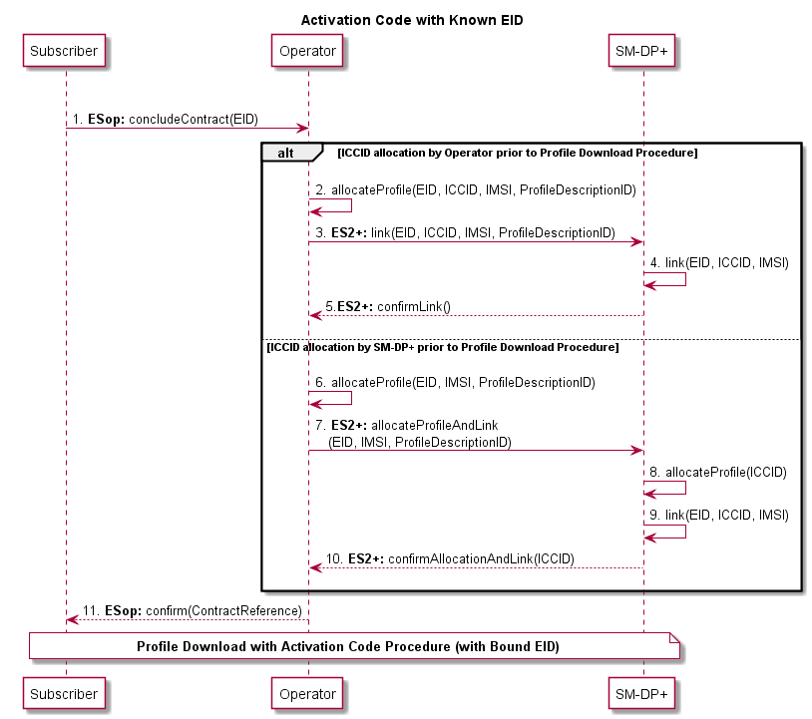
Figure B.1.4.1.1: Activation Code with Known EID Procedure
Procedure:
Steps 1-11 in Figure B.1.4.1.1: Contract conclusion with known EID
- The Subscriber concludes a contract with the Operator and provides the EID during this process.
2. to 5. Alternatively ‘ICCID allocation by Operator prior to Profile download procedure’: The Operator allocates the Profile and sends the EID, IMSI and ICCID to the SM-DP+. The SM-DP+ links the different parameters and confirms this to the Operator.
6. to 10. Alternatively ‘ICCID allocation by SM-DP+ prior to Profile download procedure’: The Operator sends the EID, the IMSI and the Profile Description ID to the SM-DP+. The SM-DP+ allocates an ICCID to a corresponding Profile, links the different parameters and confirms the allocated ICCID and the link to the Operator.
- The Operator confirms the contract conclusion to the Subscriber with the corresponding information (contract reference).
End Condition:
- The Subscriber has concluded a contract and a valid Subscription with the Operator.
- The SM-DP+ is informed about a future Profile download procedure request.

      - Activation Code with Unknown EID
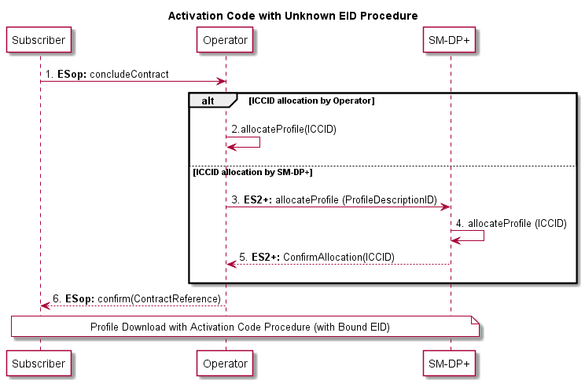
Figure B.1.4.2.1: Activation Code with Unknown EID Procedure
Procedure:
Steps 1-6 inFigure B.1.4.2.1: Contract conclusion without EID
- The Subscriber concludes a contract with the Operator without knowledge of the target eUICC (EID).
- Alternatively ‘ICCID allocation by Operator’: The Operator allocates the Profile (ICCID)
3. to 5. Alternatively ‘ICCID allocation by SM-DP+’: The Operator sends the Profile template (ID) to the SM-DP+. The SM-DP+ allocates a corresponding Profile (ICCID) and sends the allocated ICCID to the Operator.
- The Operator confirms the contract conclusion to the Subscriber with the corresponding information (contract reference).
End Condition:
- The Subscriber has concluded a contract and a valid Subscription with the Operator.
- The SM-DP+ is informed about a future Profile download procedure request.
      - Activation Code with EID Provided to the Operator
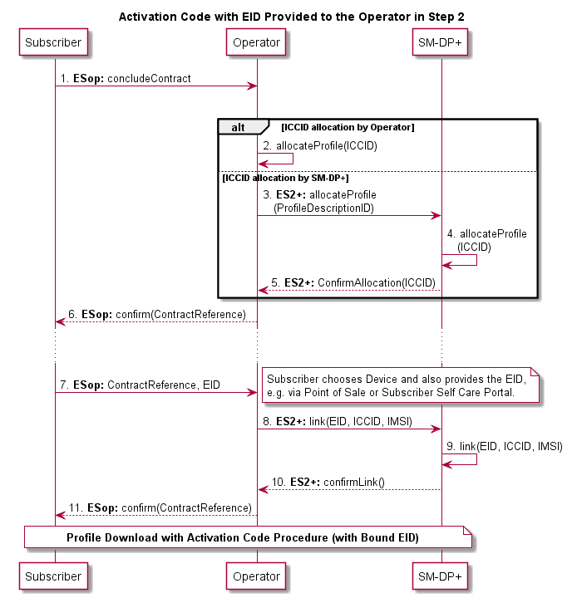
Figure B.1.4.3.1: Activation Code with EID Provided to the Operator
Procedure:
Steps 1-11 in Figure B.1.4.3.1: Activation Code with EID provided to the Operator
- The Subscriber concludes a contract with the Operator without knowledge of the target eUICC (EID).
- Alternatively ‘ICCID allocation by Operator’: The Operator allocates the Profile (ICCID)
3. to 5. Alternatively ‘ICCID allocation by SM-DP+’: The Operator sends the Profile template (ID) to the SM-DP+. The SM-DP+ allocates a corresponding Profile (ICCID) and sends the allocated ICCID to the Operator.
- The Operator confirms the contract conclusion to the Subscriber with the corresponding information (contract reference).
- After the Subscriber has chosen the Device/eUICC, the EID is provided together with the contract reference to the Operator.
8. to 10. The Operator requests the linking of the eUICC (EID) and Profile (ICCID) by the SM-DP+. The SM-DP+ links the EID and the ICCID and confirms this to the Operator.
- The Operator confirms the linking of the EID to the corresponding contract to the Subscriber.
End Condition:
- The Subscriber has concluded a contract and a valid Subscription with the Operator.
- The SM-DP+ is informed about a future Profile download procedure request.

- Local Profile Management Operations implementation (Informative)
This annex provides an example diagram for the implementation of Local Profile Management Operations and describes how the different Confirmation Levels MAY be applied.
Figure C.1: Example Flow for Device & LPA Strong Confirmation Access PIN Setup / Settings
- eUICC Categories (Normative)
The following table provides eUICCs categories defined for Remote SIM Provisioning products.

Role no. | Description
CAT1 | Basic eUICCs SHALL be compliant with at least the following features:  - Memory size available when no Profiles are installed (EEPROM) : 64kB  - ISO interface PPS 96  - BIP over HTTPS features
CAT2 | Medium eUICCs SHALL be compliant with at least the following features:  - Memory size available when no Profiles are installed (EEPROM) : 384kB  - ISO interface PPS 97  - BIP over HTTPS features  - Processor >= 25MHz  - Crypto processor >= 100MHz  - Memory Protection Unit
CAT3 | Contactless eUICCs SHALL be compliant with at least the following features:  - Memory size available when no Profiles are installed (EEPROM) : 1024kB  - ISO interface PPS 97  - BIP over HTTPS features  - Processor >= 25MHz  - Crypto processor >= 100MHz  - Memory Protection Unit
Table D.1: eUICC Categories
- LPA Settings (Informative)
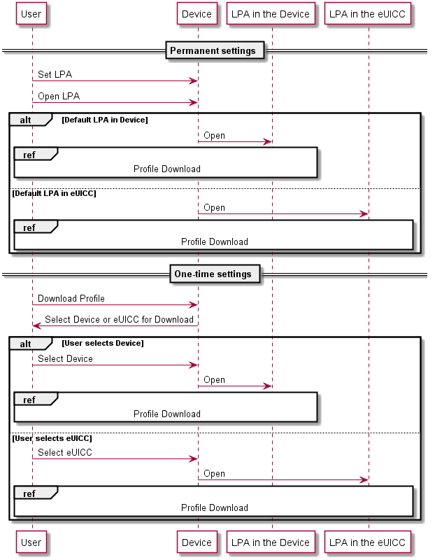
Figure E.1: LPA Settings
- Certifications Chain and Security Model (Normative)
Figure F.1: Certificate Exchange with LPA in the Device

Figure F.2: Certificate Exchange with LPA in the eUICC
  - Security Model
The Security Model defines the trust relationships between all the active components of the eUICC ecosystem with an LPA in the Device.
The figure below shows only the end-to-end logical links where cryptographic keys and sensitive data are sent. The different links define the end-to-end trust relationship between entities. We distinguish a hierarchy of seven trust links with link 1 being the most significant and link 7 being the least significant.
If trust link 1 is broken, all trust links will be broken as a result. If trust link 2 is broken, trust link 1 remains intact however all other Trusted Links are compromised or broken.
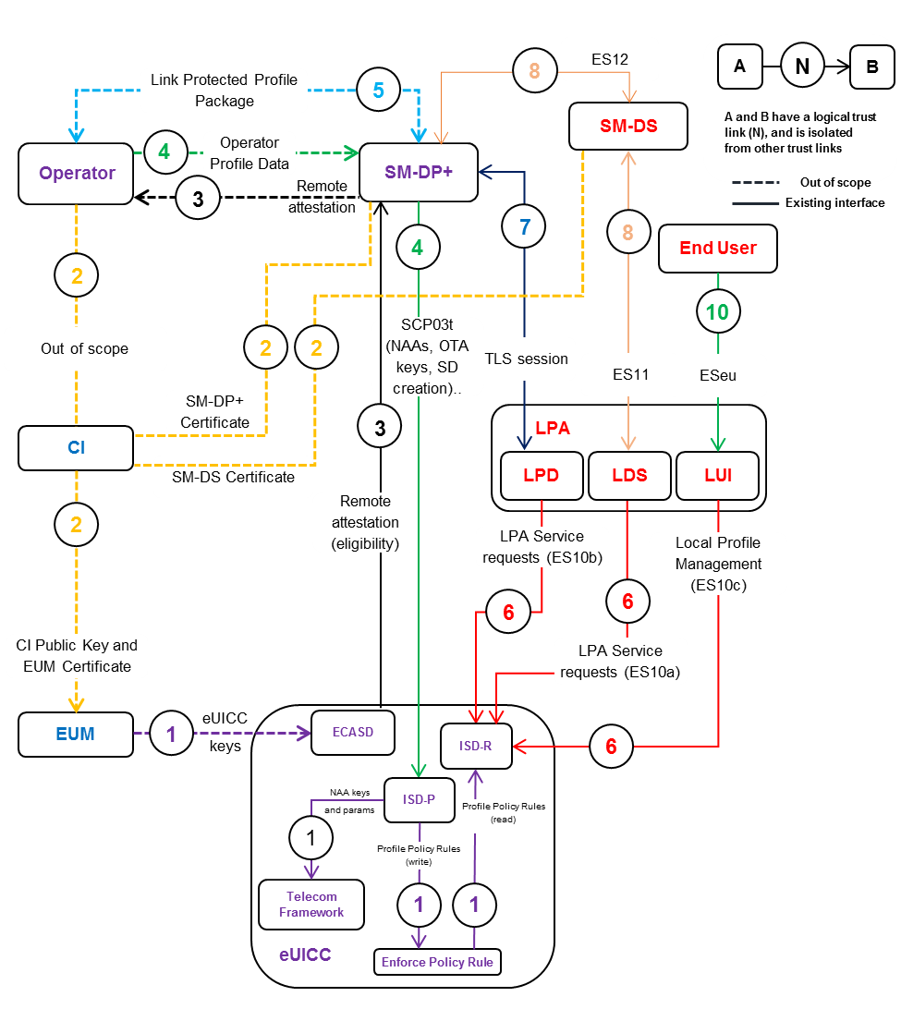
Figure F.1.1: Trusted Link with LPA in the Device
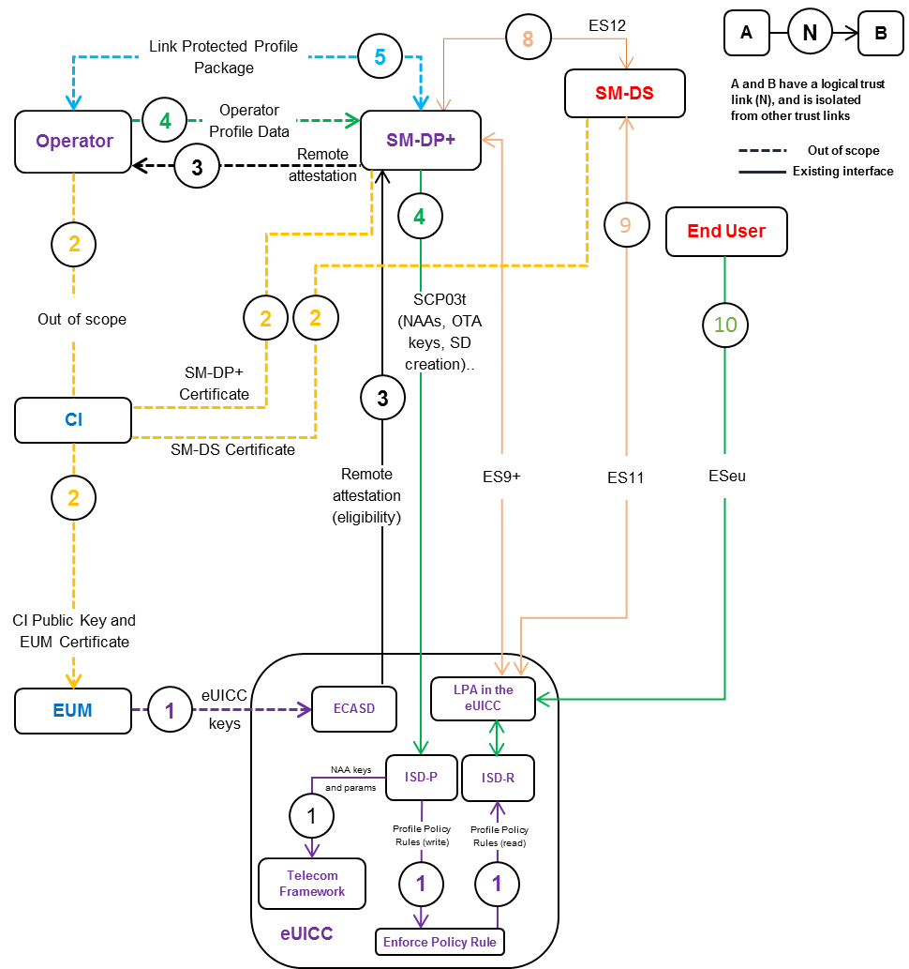
Figure F.1.2: Trusted Link with LPA in the eUICC
Trust link | Description | Interfaces involved | Possible compromises | Impact of loss of trust link
TL1 | Trust introduced onto the eUICC by the issuing EUM to enable future remote management and authorisation by the SM-DP+ and possibly the EUM: eUICC keys (EUM & CI keyset eUICC Certificates). | Out of scope | The CI public key, the EUM’s Certificate,  the EUM’s keyset,  the eUICC keys, the OS, and the Security Domains. | The trust of the entire security model is breached and all eUICCs issued under the model cannot be trusted.
TL2 | Trust placed in the CI’s verification of the EUM, SM-DP+, and the resulting Certificate issuance. | Out of scope | The EUM and SM-DP+ Certificates. | Loss of Operator trust on the EUM and SM-DP+
TL3 | Trust placed in the activities for eUICC eligibility and remote attestation from the ISD-R on the target eUICC to the Operator via the SM-DP+.  Provides eUICC Certificate, EID, reference to its certification and EUM to the Operator and SM-DP+. | ES2+  ES8+ | The eUICC Certificate or eligibility check failure. | Loss of Operator trust on the eUICC and/or SM-DP+.
TL4 | Trust placed in the activities for Profile data transfer from the Operator via the SM-DP+ to the ISD-R on the target eUICC.  Protects the Profile and associated credentials and keys (NAAs, OTA keys, ISD-R access, ISD-P SD creation …) with only the Operator, SM-DP+ and the eUICC. | ES2+  ES8+ | SM-DP+ Certificate  eUICC Certificate or eligibility check failure. | Loss of Operator trust on the SM-DP+ and/or eUICC.
TL5 | Trust placed in the information exchange between the Operator and the SM-DP+ for Link Profile requests. | ES2+ | SM-DP+ Certificate | Operator loss of trust on SM-DP+.
TL6 | Trust placed in the mechanisms provided by the LPA: Local Profile Management, Local Profile Management Operations | ESeu | LPA security | eUICC loss of trust on LPA.
TL7 | Trust placed in the TLS session | ES9+ | LPA security or SM-DP+ security. | SM-DP+ loss of trust on LPA (in the Device or the eUICC) or LPA loss of trust on the SM-DP+.
TL8 | Trust in the discovery process | ES11 | LDS security or SM-DS security. | LDS loss of trust on the SM-DS and vice versa.
TL9 | Trust in the discovery process | ES11 | eUICC security or SM-DS security. | SM-DS loss of trust on the eUICC and vice versa.
TL10 | Trust in the UI | ESeu | Device security | Loss of trust on the Device
Table F.1.1: Trusted Link Descriptions

Compromised element | Impacted Links | Description | Impact of loss of trust | Countermeasures
eUICC | TL1, TL3, TL4, TL9 | The eUICC keys and EUM’s Keyset. | The eUICC can no longer be trusted.  MNO and SM-DP+ loss of trust on eUICC. | Revoke the Certificate of the eUICC.
CI | TL2 | The EUM, SM-DS, and SM-DP+ Certificates. | Loss of Operator trust in the EUM, SM-DS and SM-DP+. | Repair/Replace CI. Generate new CI Certificate and new Certificate for the EUM, SM-DS and SM-DP+ following the SAS process.  Remote repair of already issued eUICCs: new CI public key.
EUM | TL1, TL2 | Loss of SAS accreditation. | Loss of trust from the Operator and SM-DP+ on the EUM and its eUICCs. | New SAS for the EUM. Remote repair of already issued eUICCs: new EUM Certificate, new eUICC Certificate.
SM-DP+ | TL3, TL4, TL5, TL7, TL8 | Loss of SAS accreditation. | Loss of trust from the Operator, LPA, SM-DS and eUICC on the SM-DP+. | New SAS for the SM-DP+. New SM-DP+ Certificate.
SM-DS | TL8 | Loss of SAS accreditation. | Loss of trust from the Operator, LPA, SM-DP+ and eUICC on the SM-DS. | New SAS for the SM-DS. New SM-DS Certificate.
LPA | TL6, TL7, TL8 | LPA security failure. | Loss of trust from the SM-DP+, SM-DS and eUICC on the LPA. | LPA repair by the Device Manufacturer.
Device | TL10 | Device security failure | Loss of trust in the Device UI | LUI in the eUICC self-protected with User Intent capture mechanisms (i.e. Captcha Code)
Table F.1.2: Impact of Compromising Trusted Links and Countermeasures
The signer is responsible for the revocation of the Certificates it has signed. This section describes how the new Certificates are pushed to concerned entities according to the security model.
- SM-DP+ trusts the CI
- EUM trusts the CI
- eUICC trusts the EUM and the CI
Req no. | Description
CERT1 | The new SM-DP+ Public Key Certificate(s) SHALL be issued to the SM-DP+ by a GSMA CI upon achievement of the GSMA SAS or CI repair.
CERT2 | The new SM-DS Public Key Certificate(s) SHALL be issued to the SM-DS by a GSMA CI upon achievement of the GSMA SAS or CI repair.
CERT3 | The new EUM Certificate(s) SHALL be issued to the EUM by a GSMA CI upon achievement of the GSMA SAS or CI repair.
CERT4 | The EUM Certificate(s) SHALL be loaded securely to the eUICC by the EUM  NOTE: See details in Section 4.1.1.1.
CERT5 | The CI Certificate(s) SHALL be loaded securely to the eUICC by the EUM  NOTE: See details in Section 4.1.1.1.
CERT6 | Certificates SHALL be revocable.
CERT7 | Neither the End User nor any other party SHALL be able to prevent Certificate revocation.
CERT8 | The End User SHALL not be allowed to use Remote SIM Provisioning functions with revoked Certificates.
CERT9 | The Public Key Certificate of the SM-DP+ SHALL be revoked if required (e.g. loses or subsequently fails to achieve the GSMA Remote SIM Provisioning certification requirements).
CERT10 | The Public Key Certificate of the SM-DS SHALL be revoked if required (e.g. loses or subsequently fails to achieve the GSMA Remote SIM Provisioning certification requirements).
CERT11 | The Public Key Certificate of the EUM SHALL be revoked if required (e.g. loses or subsequently fails to achieve the GSMA Remote SIM Provisioning certification requirements).
Table F.1.3: Certificate Requirements

- LPA Integrity (Normative)
The LPA SHALL be protected against misuse or being compromised by means of implementing standard procedures.
For cases where the LPA is in the Device, the LPA integrity SHALL be guided by the following Device classes:
Device class | Description | Example of Devices
Advanced | Devices with an open operating system where mechanisms such as secure boot and platform signing of applications are available and used to protect the LPA. | Smartphones, Tablets, Laptops, Advanced Wearables
Basic | Devices without possibility to install applications. The attack surface of the LPA is minimal due to the locked down nature of these Devices. Simple mechanisms to ensure that the LPA is not compromised SHALL be taken. | Connected sensors, Simple Wearables, Single use case devices
Table G.1: Device Classes

- Rules Authorisation Table (Informative)
Annex H reflects the RAT table configuration(s) that MAY be configured in an eUICC.
The RAT entries shown in Table H.1 MAY be provisioned:
PR | Operators | User consent
POL RULE1 | * | YES
POL RULE2 | * | YES
Table H.1: RAT configuration
Additional lines can be added to the RAT table to reflect agreement between some Operators and OEMs as needed. The OEM can also decide to add lines to the RAT table.
NOTE: POL RULE3 is defined for use in specific use cases that have not yet been fully defined and is not applicable for this version of the specification.

- LPA Invocation of the Provisioning Profile Example Flow (Informative)
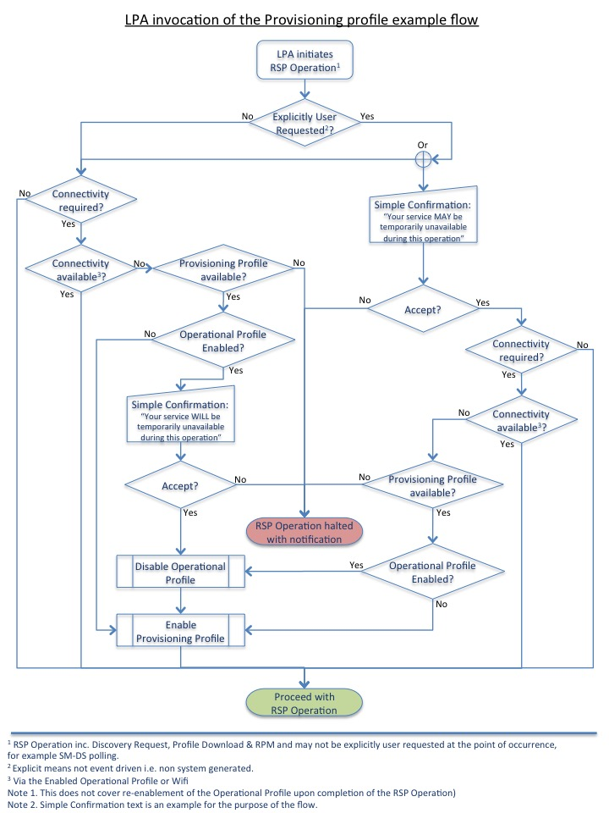
Figure I.1: LPA Invocation of the Provisioning Profile Example Flow
- [Void]
- Document Management
  - Document History
Version | Date | Brief Description of Change | Approval Authority | Editor / Company
V1.0 | 23/12/15 | First Release with amendments from Security review. | PSMC | Carmen Kwok, GSMA
V2.0 | 25/08/16 | Includes Phase 2 content | PSMC | Carmen Kwok, GSMA
V2.1 | 29/02/17 | Phase 2 maintenance release | Technology Group | Carmen Kwok, GSMA
V2.2 | 31/08/17 | Phase 2 maintenance release | RSPLEN | Carmen Kwok, GSMA
V2.3 | 24/03/21 | Phase 2 maintenance release | ISAG | Carmen Kwok, GSMA
V2.4 | 03/08/21 | Phase 2 maintenance release | ISAG | Carmen Kwok, GSMA
V2.5 | 18/11/22 | Phase 2 maintenance release | ISAG | Carmen Kwok, GSMA
V2.6 | 20/09/2024 | Introduction of Activation Code Retrieval (ACR) and Phase 2 maintenance release | ISAG | Stéphane Bandin, Orange
V2.7 | 24/04/2026 | Resolution of CVD-2025-0103 eSIM Java Card vulnerability | ISAG | Stéphane Bandin, Orange
  - Detailed Document History for V2.7
Version | Date | Additions
V2.7 Draft 00 | 14/05/2025 |  | Initial draft from SGP.21 V2.6
V2.7 Draft 01 | 14/05/2025 | CR27001R01 | Allow Test Profile Deletion by the LPA
V2.7 Draft 01 | 14/05/2025 | CR27004R01 | Definition of Test eUICC
V2.7 Draft 01 | 14/05/2025 | CR27005R01 | Clarify the download of Java Applications within Test Profile
V2.7 Draft 02 | 27/06/2025 | CR27007R02 | Prohibit Test CI coexisting with GSMA CI
V2.7 Draft 02 | 27/06/2025 | CR27008R01 | Mandate eUICC OS update support
V2.7 Draft 02 | 27/06/2025 | CR27013R01 | Adding Test CI abbreviation
V2.7 Draft 02 | 27/06/2025 | - | Renumbering of tables and figures
V2.7 Draft 03 | 17/07/2025 | CR27002R11 | Requirements on Applets in Test Profiles
V2.7 Draft 04 | 17/09/2025 | CR27010R03 | Adding MSL check of Profile against eUICC configuration
V2.7 Draft 04 | 17/09/2025 | CR27016R01 | Adding MSL definition and abbreviation
V2.7 Draft 04 | 17/09/2025 | CR27017R01 | Adding requirement on common MSL value for RSP ecosystem
V2.7 Draft 05 | 08/12/2025 | CR27009R07 | Adding eUICC-based RSP Server allowlist mechanism for test profiles
V2.7 Draft 05 | 08/12/2025 | CR27018R02 | Comment on application runtime environment for ELG9
V2.7 Draft 05 | 08/12/2025 | CR27019R01 | Make MSL support mandatory (AP #107-03)
V2.7 Draft 05 | 08/12/2025 | CR27020R12 | Make Java Application bytecode verification check mandatory to SM-DP+ processes
V2.7 Draft 05 | 08/12/2025 | CR27021R04 | Addition of Applet bytecode verification
V2.7 Draft 05 | 08/12/2025 | CR27022R06 | Safeguard allowing an eUICC to reject Applet installation into a Test Profile
V2.7 Draft 05 | 08/12/2025 | CR27026R04 | Introduce requirements on application isolation
V2.7 Draft 05 | 08/12/2025 | CR27027R01 | Editorial modifications of some requirements related to SAS
V2.7 Draft 05 | 08/12/2025 | CR27028R02 | Introduce Application Developer Role
V2.7 Draft 05 | 08/12/2025 | CR27029R04 | Introduce Requirements to Application Developers
V2.7 Draft 06 | 20/01/2026 | DQRT | Capitalize minimum security level as a definition has been added with CR27016R01

Other Information
Type | Description
Document Owner | eSIMG
Editor / Company | Stéphane Bandin, Orange

It is our intention to provide a quality product for your use. If you find any errors or omissions, please contact us with your comments. You may notify us at prd@gsma.com
Your comments or suggestions & questions are always welcome.

