

GSMA Key Management

Version 8.0

22 January 2026

Security Classification: Non-Confidential
Access to and distribution of this document is restricted to the persons permitted by the security classification. This document is subject to copyright protection. This document is to be used only for the purposes for which it has been supplied and information contained in it must not be disclosed or in any other way made available, in whole or in part, to persons other than those permitted under the security classification without the prior written approval of the Association.
Copyright Notice
Copyright © 2026 GSM Association
Disclaimer
The GSMA makes no representation, warranty or undertaking (express or implied) with respect to and does not accept any responsibility for, and hereby disclaims liability for the accuracy or completeness or timeliness of the information contained in this document. The information contained in this document may be subject to change without prior notice.
Compliance Notice
The information contain herein is in full compliance with the GSMA Antitrust Compliance Policy.
This Permanent Reference Document is classified by GSMA as an Industry Specification, as such it has been developed and is maintained by GSMA in accordance with the provisions set out GSMA AA.35 - Procedures for Industry Specifications.

Table of Contents
1 Introduction 3
1.1 Overview 3
1.2 Scope 3
1.3 Definitions 3
1.4 Abbreviations 4
1.5 References 5
1.6 Conventions 5
2 GSMA Specific Key Management Principles 6
2.1 Bilateral Trust Model 6
2.2 PKI and CA Requirements 6
2.2.1 Certificate Hierarchy 6
2.2.2 Governance 9
2.2.3 Certificate Requirements 9
2.2.4 Entry Criteria 9
2.2.5 Usage of the IPX Network and its Domain Names 10
2.2.6 Certificate Chain Verification 10
2.3 RAEX Certificate Database 10
3 Key Management Procedures 10
3.1.1 Own Root or Intermediate Certificate Generation and Publication 11
3.1.2 Peer Root or Intermediate Certificate Downloading and Configuring 11
3.1.3 Leaf Certificate Acceptance 11
3.1.4 Leaf and Intermediate Certificate Revocation 11
3.1.5 Root Certificate Revocation 11
3.1.6 Root Certificate Expiry and Replacement 11
Annex A Use case - Secure 5G N32 interconnect 12
A.1 SEPP Leaf Certificate Specific Formatting 12
A.2 PLMN-ID Based Trust Anchoring 12
A.3 FQDN-based Trust Anchoring 12
Annex B 5G User Plane 14
B.1 Naming conventions 14
Annex C Use case - DESS Phase 1 15
C.1 DESS Phase 1 Leaf Exchange Procedure 15
C.2 DESS Phase 1 Naming Scheme 15
C.2.1 MNO DESS Equipment 15
C.2.2 Non-MNO DESS Equipment, DESS Phase 1 Delegation from MNO to IPX Provider 15
C.2.3 Non-MNO DESS Equipment, Intermediate Changes 15
Annex D Document Management 16
D.1 Document History 16
D.2 Other Information 17

Introduction

Overview
This document outlines procedures for GSMA members and eligible non-members (‘Participants’) to exchange certificates and key material to facilitate use cases that rely on public key cryptographic algorithms. The procedures will be referred to as ‘key management’ in the entire document.
The key management procedures have evolved over time and can be grouped into two stages:
- Stage 1: Manual exchange of certificates (FS.34 version 6 and lower). These procedures were developed as a first approach to facilitate early adoption.
- Stage 2: Key management with enhanced scalability/automation (FS.34 version 7.x and higher). These procedures, as described in this document, are designed to enable efficient and automated key management, and are intended for widespread deployment at scale. Stage 2 makes use of the GSMA RAEX Certificate Database, which serves as a repository for all root certificates.

Scope
This document specifies key management procedures for the use cases outlined in Annex A to Annex C. Key management for additional use cases may be added to this document in the future. Other (non-documented) use cases agreed on a bilateral basis between entities are not excluded but ensuring compatibility of each use case is the responsibility of the entities involved.
This document describes key management stage 2 procedures. Stage 1 procedures, described in previous versions of this document, are available from the GSMA but are no longer maintained.

Definitions
Term | Description
Certificate Authority (CA) | An entity that verifies the identity of a Participant and issues a certificate that confirms the identity of this Participant by binding its public key to a unique identifier. Cryptographic algorithms are used by the CA to perform its tasks and to allow recipients of the certificates to verify the certificates’ validity. There is a hierarchy of CAs.
Intermediate Certificate | A certificate that is in the middle of a chain of trust. The certificate is signed by a Root CA or by an Intermediate CA.
CA Certificate | A Root CA certificate or an intermediate CA certificate.
Leaf Certificate | An individual certificate for network equipment. Examples of such certificates are individual certificates for SEPP, Diameter Edge Agent (DEA)/signalling firewall (SigFW), IPX providers’ network equipment, etc. Also known as an end-entity certificate.
Participant | A party that has uploaded a root certificate into the RAEX Certificate Database
Root CA | A CA at the topmost position of a hierarchy of CAs.
Intermediate CA | A CA at one or more levels below the Root CA in the hierarchy of CAs. Also known as a subCA. An Intermediate CA signs Leaf Certificates or other Intermediate Certificates.
Trust Anchor | A list of trusted root certificates and an associated list of PLMN-IDs configured at a SEPP PLMN-IDs and root certificates are related by virtue of belonging to the same Trust Anchor. Any given PLMN-ID can appear in at most one Trust Anchor, while any given root certificate can appear in multiple Trust Anchors.

Abbreviations
Term | Description
5GMRR | 5G Mobile Roaming Revisited (GSMA cross-working group activity)
AVP | Attribute Value Pair
CA | Certification Authority
CN | Common Name
CP | Certificate Policy
CPS | Certificate Practice Statement
CRL | Certificate Revocation List
DESS | Diameter End-to-end Security Subgroup
DEA | Diameter Edge Agent
DNS | Domain Name System
DRA | Diameter Routing Agent
FQDN | Fully Qualified Domain Name
IP | Internet Protocol
IPX | IP eXchange
MCC | Mobile Country Code
MNC | Mobile Network Code
MNO | Mobile Network Operator
NDS | Network Domain Security
OCSP | Online Certificate Status Protocol
PKI | Public Key Infrastructure
PMN / PLMN | Public Mobile Network. Note that references to 3GPP specifications or their contents may use the abbreviation “PLMN” representing “Public Land Mobile Network” (e.g. PLMNID).
PRD | Permanent Reference Document
RAEX | Roaming Agreement eXchange
SAN | Subject Alternative Name
SEG | Security Gateway
SEPP | Security Edge Protection Proxy
SigFW | Signalling Firewall
SubCA | Subordinate Certification Authority
TLS | Transport Layer Security
UPF | User Plane Function

References
Ref | Doc Number | Title
 | RFC 2119 | “Key words for use in RFCs to Indicate Requirement Levels”, S. Bradner, March 1997. Available at http://www.ietf.org/rfc/rfc2119.txt
 | RFC 8174 | Ambiguity of Uppercase vs Lowercase in RFC 2119 Key Words  https://www.rfc-editor.org/info/rfc8174
 | Handbook of Applied Cryptography | Alfred J. Menezes, Paul C. van Oorschot and Scott A. Vanstone: Handbook of Applied Cryptography, http://cacr.uwaterloo.ca/hac/
 | BSI TR 03145 | Secure Certification Authority operation
 | BSI TR-02102-1 | Cryptographic Mechanisms  https://www.bsi.bund.de/EN/Themen/Unternehmen-und-Organisationen/Standards-und-Zertifizierung/Technische-Richtlinien/TR-nach-Thema-sortiert/tr02102/tr02102_node.html
 | PRD IR.67 | DNS Guidelines for Service Providers and GRX and IPX Providers
 | RFC 3647 | Internet X.509 Public Key Infrastructure Certificate Policy and Certification Practices Framework
 | RFC 5280 | Internet X.509 Public Key Infrastructure Certificate and Certificate Revocation List (CRL) Profile
 | 3GPP TS 23.003 | Numbering, addressing and identification, https://www.3gpp.org/DynaReport/23003.htm
 | 3GPP TS 33.310 | Network Domain Security (NDS); Authentication Framework (AF) https://www.3gpp.org/DynaReport/33310.htm
 | 3GPP TS 33.501 | Security architecture and procedures for 5G System  https://www.3gpp.org/dynareport/33501.htm
 | GSMA FS.19 | Diameter Interconnect Security
 | RAEX | RAEX Certificate Database User Manual. Available via the GSMA Roaming Gateway. https://www.raextools.com/raextools/
 | GSMA NG.113 | 5GS Roaming Guidelines

Conventions
The key words “MUST”, “MUST NOT”, “REQUIRED”, “SHALL”, “SHALL NOT”, “SHOULD”, “SHOULD NOT”, “RECOMMENDED”, “MAY”, and “OPTIONAL” in this document are to be interpreted as described in RFC 2119 [1] and clarified by RFC8174 [2], when, and only when, they appear in all capitals, as shown here.

GSMA Specific Key Management Principles
Cryptographic algorithms enable confidentiality and integrity protection of data. This section provides specific details about GSMA key management. For general information about public key cryptography, the reader is referred to [3].

Bilateral Trust Model
The operating model used between parties is the ‘bilateral trust model’. It is based on an establishment of trusted relationships between Participants where each Participant has its own unique CA. Following completion of the procedures in section 3, peer Participants designate the root certificate issued by that CA as trusted. These technical procedures can be referred to and required by contractual clauses for certain use cases e.g., secure 5G N32 interconnect as specified in Annex A.
In this bilateral model, there is no centrally governed and trusted CA, and no investment towards a centralised authority to become part of the ecosystem. The bilateral model will result in a larger number of CAs to manage compared to a centralised model.

PKI and CA Requirements
The Public Key Infrastructure (PKI) CAs must comply with general requirements as part of best practices and additional specific requirements as part of the GSMA key management principles described below.

Certificate Hierarchy
In accordance with the bilateral trust model outlined in section 2.1, each Participant SHALL maintain its own CA. To be specific, if the GSMA key management community has 500 participants, at least 500 CA certificates (one per Participant) will be stored in the RAEX Certificate Database. For security reasons, two participants shall not share the same CA certificates in RAEX, and this is technically enforced by the system.
The CA certificate stored in the RAEX Certificate Database for a Participant SHALL have been issued to a CA dedicated to that Participant. The certificate SHOULD be self-signed, or it MAY have been signed by a Root CA or an Intermediate CA.
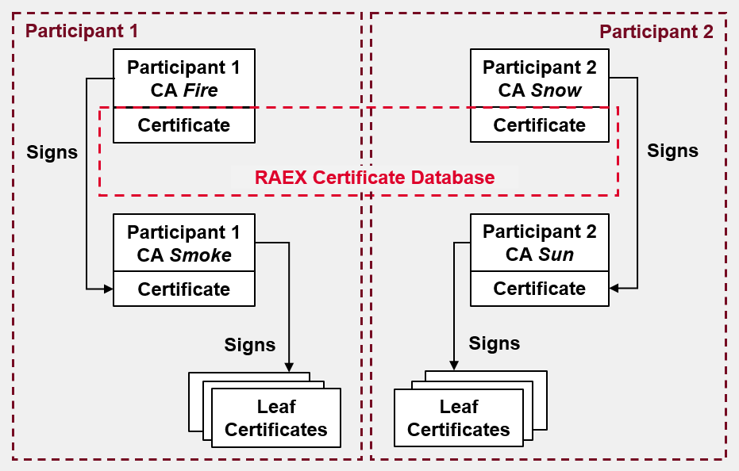
- – Recommended Approach for Certificates Stored in RAEX Certificate Database
Figure 1 shows the recommended approach: a unique CA per Participant (Fire for Participant 1, Snow for Participant 2). In this approach, the CAs Fire and Snow each have a self-signed certificate, so each is a root CA. These certificates are stored in the RAEX Certificate Database. In this approach, Intermediate CAs (Smoke for Participant 1, Sun for Participant 2) issue the leaf certificates.
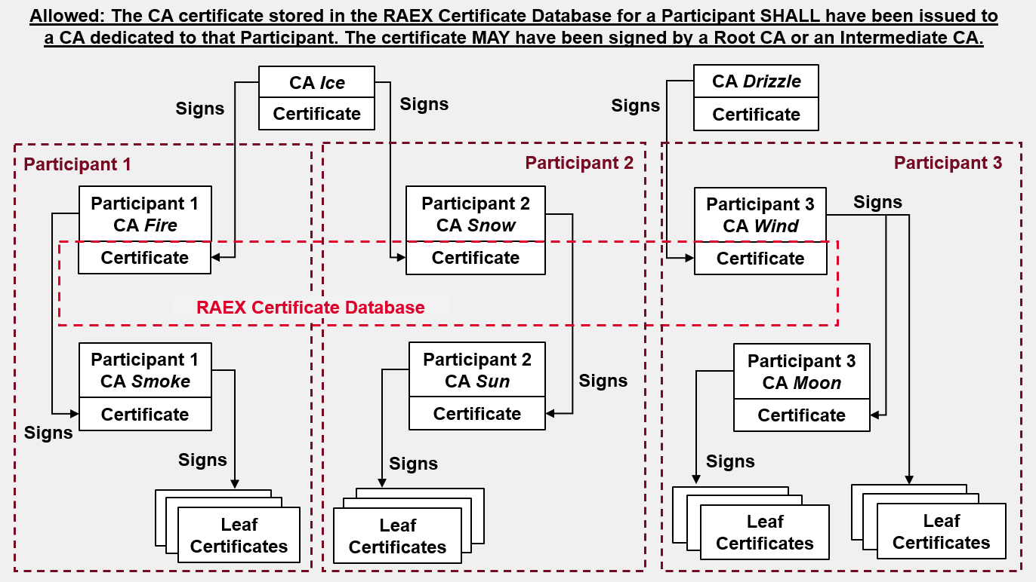
- – Allowed Approach for Certificate Stored in RAEX Certificate Database
The approach in Figure 2 is allowed. In this case, the CA certificate stored in the RAEX Certificate Database (Fire for Participant 1, Snow for Participant 2, Wind for Participant 3) is not self-signed as it has been issued by another, “higher hierarchy” CA (Ice for Participant 1 and 2, Drizzle for Participant 3). From a bilateral trust perspective, however, this “higher” CA is relevant for signing the Participant’s certificates, but plays no role in the trust establishment between participants; it may be the same for multiple participants.
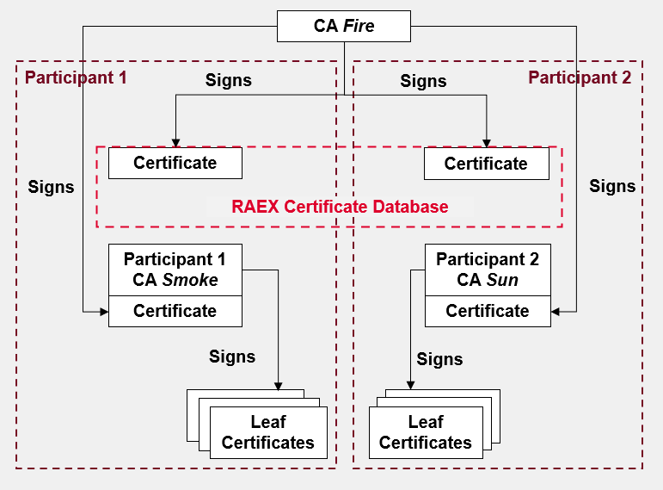
- – Disallowed Approach for Certificate Stored in RAEX Certificate Database
Figure 3 shows the situation where the same CA (Fire) issues the certificates stored in the RAEX database for both Participant 1 and Participant 2. This situation is disallowed regardless of whether Participant 1 and Participant 2 publish the same certificate or different certificates in the RAEX Certificate Database.
The CA SHOULD be uniquely created for the purpose of GSMA key management. However, it MAY be an existing CA if the CA complies with the entry criteria in section 2.2.4.
A Root CA SHALL NOT issue leaf certificates, while an Intermediate CA MAY do so.
Cross-certification between CAs of different participants (a practice that facilitates trust between separate PKIs) SHALL NOT be used, as this is not considered appropriate for the bilateral trust model.
Participants have two PKI deployment options:
- The Participant MAY use an in-house PKI for the purpose of GSMA key management. The Participant MUST use a dedicated CA for this purpose. Whether or not this CA is placed below another (Root) CA is a decision for the Participant.
- The Participant MAY use a trusted third-party CA. The CA certificate MUST be dedicated to the Participant, i.e. is not the same as for other participants. While there MAY be a trusted third-party providing PKI services for one or more Participants, this provider SHALL offer this service exclusively on the IP Exchange (IPX) network and not exposed to the Internet. However, this requirement does not preclude publishing certificate revocation lists (CRLs) or obtaining certificate revocation information via Online Certificate Status Protocol (OCSP) via the Internet in addition to their existence on the IPX network.
While it is possible to deploy both options simultaneously, this SHOULD be used only during a transition period from (1) to (2) or vice versa. Entry criteria for both deployment options can be found in section 2.2.3.

Governance
Operating a PKI in a secure manner requires a set of mechanisms and procedures to be in place, some of which are beyond the scope of this document. The guidelines in [4] SHOULD be followed by Participants. It is further recommended to consult BSI TR-02102-1 [5] to select appropriate encryption and signature algorithms as well as key lengths for operating the PKI.
Guidelines for each CA SHALL be documented and followed by at least publishing a Certificate Policy (CP) and Certification Practice Statement (CPS) for each CA in accordance with RFC 3647 [7]. Each Participant SHALL publish CP, Relying Party Agreement or other documentation, which the peer Participants can use to evaluate the trustworthiness of the Participant’s CA.
It is highly recommended that CAs are certified according to ISO/IEC 27001 or an equivalent CA audit regime (e.g., WebTrust for CAs). This is due to the importance of forthcoming trust relationships between mobile networks, external functions, suppliers and roaming/ interconnect partners. Industry best practice and future regulation is trending towards having requirements for audited CAs, with robust procedures in place that enable mutual trust. This recommendation SHOULD be applied irrespective of whether CAs are operated by internal teams or outsourced, as retrofitting such requirements could be a complex activity. Special emphasis should be added that, besides being compliant with a CA audit regime or framework, the CAs implementation SHOULD follow hardening best practices. With this, shift the paradigm from “checking boxes” to be compliant, towards a more hardened deployment.

Certificate Requirements
Root or Intermediate Certificates SHALL:
- be X.509 v.3 certificates according to RFC 5280 [8];
Leaf Certificates SHALL:
- be X.509 v.3 certificates according to RFC 5280 with the Subject Alternative Name (SAN) extension.

Entry Criteria
Providers of a PKI for GSMA key management and its Participants SHALL:
- Maintain a CA that exclusively belongs to a particular Participant
- Offer the PKI on the IPX network including downloading CRLs or obtaining certificate revocation information via OCSP (see sections 3.1.4 and 3.1.5).
- Publish Participant CA(s) in the RAEX Certificate Database
- Generate a CP and CPS for each CA based on RFC 3647, and to include a pointer towards the CPS in the Root CA certificate according to section 4.2.1.4 of RFC 5280.

Usage of the IPX Network and its Domain Names
GSMA key management is used only on the IPX network. SAN names of Leaf Certificates SHALL be of the type “dnsname” and use the following format (only suffix is shown, i.e. it is expected that the subdomain names will be added):
- mnc<MNC>.mcc<MCC>.3gppnetwork.org (strictly limited to MNOs)
- mnc<MNC>.mcc<MCC>.<UNIQUE-IPX-PROVIDER-ID>.ipxnetwork.org (for non-MNO participants acting under a mandate of a particular MNO)
- <UNIQUE-IPX-PROVIDER-ID>.ipxnetwork.org (for non-MNO participants acting outside a mandate of a particular MNO.)
Refer to PRD IR.67 [6] for the procedures around obtaining and maintaining (sub) domain names on the IPX network.
The format for 5G leaf certificates, including SEPPs, SHALL follow section 28 of TS 23.003 [9] and TS 33.310 [10]. Specifically for MNOs, this implies the SAN contains the MNC and MCC, each three digits long (zero prefix as necessary), corresponding to the MNO.
Any hosts and services including certificate status checking and certificate revocation SHALL entirely occur on the IPX network.

Certificate Chain Verification
Due to the reliance on the bilateral trust model, the GSMA key management certificate verification logic supports multiple lists of trusted CA certificates instead of a single global one. Any given certificate chain is first mapped to a particular list of CA certificates using a mapping function. This mapping function combines information from the Leaf Certificate with locally configured data. Afterwards the certificate chain is validated with respect to the selected list of CA certificates. It must be possible to allocate a separate CA certificate list to each Participant in the RAEX Certificate Database.
Depending on the use case the exact implementation may vary. Refer to the use case in the annexes for further guidelines.

RAEX Certificate Database
The RAEX Certificate Database acts as the repository of root and intermediate CA certificates. The database supports manual upload and download of certificates as well as automated certificate downloading via an API. More information on the features and use of the database can be found in the user manual [13] available to GSMA members via the RAEX application.

Key Management Procedures
This section describes the main GSMA key management procedures, where possible in chronological order.

Own Root or Intermediate Certificate Generation and Publication
Each Participant SHALL generate or reuse an existing root or intermediate certificate that shall be uploaded and published in the RAEX Certificate Database.
Among other consistency and security checks the RAEX Certificate Database will not accept certificates already published by other participants.
CRL and OCSP services for revocation SHALL be published in the certificates and SHALL have and make use of the appropriate domains as described in 3.1.4

Peer Root or Intermediate Certificate Downloading and Configuring
Each Participant SHALL download, either manually or automated, the root or intermediate certificates from the peer Participants. The Participant SHALL pre-configure the mapping of (the suffix of) the expected domain names of SANs in the leaf certificates to the corresponding certificate.

Leaf Certificate Acceptance
Upon receiving a leaf certificate of a peer participant (either in-band e.g. Transport Layer Security (TLS) or via a side channel e.g. Digital Signature Certificate) the Participant SHALL verify the SAN domain suffixes against the correct root certificate as per the procedure in 3.1.2

Leaf and Intermediate Certificate Revocation
Each CA SHALL maintain a list of certificates that are revoked and host such service on the IPX network. It is recommended that the CRL is published using the http URI scheme. This does not preclude publication of the CRL using other methods. To minimise its risk, each Participant SHOULD check such listings/ and SHOULD NOT accept revoked certificates.

Root Certificate Revocation
If a root certificate becomes compromised, it SHALL be revoked by marking it accordingly in the RAEX Certificate Database where all peer Participants will be alerted. A new root certificate shall be uploaded to the RAEX Certificate Database as soon as possible if this has not been done already.

Root Certificate Expiry and Replacement
Root and intermediate certificates are expected to have a lifetime of multiple years. If the certificate has to be replaced, the new certificate SHALL be uploaded to the RAEX Certificate Database at least 6 months before expiry of the current certificate.
- Use case - Secure 5G N32 interconnect
  - SEPP Leaf Certificate Specific Formatting
The format for 5G Leaf Certificates including a Security Edge Protection Proxy (SEPP) SHALL follow section 28 of 3GPP TS 23.003 [9] and 3GPP TS 33.310 [10]. Specifically for MNOs, and other participants that adhere to the N32 interface, this implies that it contains values for Mobile Network Code (MNC) and Mobile Country Code (MCC) in the SAN, each three digits long (zero prefix as necessary) and corresponding to the MNO.
  - PLMN-ID Based Trust Anchoring
,For the domain names containing PLMN-IDs (as defined in 2.2.5), each downloaded root CA from the RAEX Certificate Database will be associated with one or more PLMNIDs, as outlined in section 3.1.2. More precisely, each Participant generates a set of Trust Anchors, where each Trust Anchor is a combination of two items:
- A list of one or more root CA certificates downloaded from the RAEX Certificate Database, and
- A list of one or more PLMN-IDs.
Any given PLMN-ID may exist in at most one Trust Anchor.
Note: The above structure is somewhat similar but not identical to the format defined in RFC 5914.
The semantics of a Trust Anchor with PLMN-IDs are: the CA(s) represented by the certificates within this Trust Anchor are designated as the root of trust for the purposes of authenticating SEPPs claiming to belong to any of the PLMNs with the PLMN-IDs within this Trust Anchor.
While it is possible to create Trust Anchors with many root certificates, and even generate a single global list of all root certificates and associate this list with all PLMN-IDs, doing so is strongly discouraged. Instead, multiple Trust Anchors with the finest possible granularity SHOULD be created. This is to prevent impersonation attacks and to limit the attack surface represented by a compromised CA.
PLMN-ID based trust anchoring is used in certain contexts, as specified in NG.113 [14].
  - FQDN-based Trust Anchoring
For the domain names NOT containing PLMN-IDs (as defined in 2.2.5), each Trust Anchor is a structure of two items:
- A list of one or more root CA certificates downloaded from the RAEX Certificate Database, and
- A list of one or more FQDNs.
Any given FQDN may exist in at most one Trust Anchor.
The Trust Anchor is selected for the purposes of authenticating the remote certificate chain.
While it is possible to create Trust Anchors with many root certificates, and even generate a single global list of all root certificates, and associate this list with all FQDNs, doing so is strongly discouraged. Instead, multiple Trust Anchors with the finest possible granularity should be created. This is to prevent impersonation attacks and to limit the attack surface represented by a compromised CA.
The semantics of a Trust Anchor without PLMN-IDs are: the CA(s) represented by the certificates within this Trust Anchor are designated as the root of trust for the purposes of authenticating a roaming intermediary that has been configured to handle a well-defined set of roaming relations.
In a real deployment, there is likely to be a mix of different types of interconnection, some of which use PLMN-ID based trust anchoring, and some use FQDN-based trust anchoring. In order to ensure that any given roaming relation can only be handled by a particular connection, there is a need for a mechanism that ensures this. This mechanism must ensure that, both for PLMNs and for roaming intermediaries, a given roaming relation can only be served by a particular connection, and this connection is rooted in a particular trust anchor.
The details of this mechanism are described in NG.113.

- 5G User Plane
The 5G inter-PMN user plane SHALL be secured with IPsec ESP and IKEv2 certificate-based authentication unless security is provided by other means as described in section 9.9 of 3GPP TS 33.501 [11]. A Security Gateway (SEG) may be used to terminate the IPSec tunnels. Naming conventions for securing at User Plane Function (UPF) or SEG are outlined below.
  - Naming conventions
When an FQDN is used, the Subject SAN field SHALL be structured as either:
  - <UPF-id>.upf.5gc.mnc<MNC>.mcc<MCC>.3gppnetwork.org
or
  - <SEG-id>.seg.5gc.mnc<MNC>.mcc<MCC>.3gppnetwork.org
NOTE: Outsourcing or delegating N9 operator-to-operator security is to be studied in a later stage in collaboration with the GSMA 5G Mobile Roaming Revisited (5GMRR) group.

- Use case - DESS Phase 1
DESS Phase 1 entails signing and verifying Diameter messages on the interconnect and is described in more detail in PRD FS.19 [12].
  - DESS Phase 1 Leaf Exchange Procedure
As DESS Phase 1 makes use of digital signature certificates that are not exchanged in-band, the certificates have to be exchanged manually. This procedure is envisioned to be automated at a later stage by introducing a central or distributed certificate repository.
  - DESS Phase 1 Naming Scheme
DESS Phase 1 related entities such as a signalling firewall (SigFW), Diameter Routing Agent (DRA) or DEA have a different naming convention depending on whether they belong to the MNO or to the serving IPX provider. In all cases the DESS-Signing-Identity attribute value pair (AVP) shall indicate the signee in the exact format of the Subject/SAN field outlined in sections C.2.1 and C.2.2.
    - MNO DESS Equipment
The Subject SAN field SHALL be structured as:
diameteridentity.epc.mnc<MNC>.mcc<MCC>.3gppnetwork.org
where diameteridentity is the Diameter host to which the certificate is issued.
    - Non-MNO DESS Equipment, DESS Phase 1 Delegation from MNO to IPX Provider
For security delegation, not to be confused with intermediate signing as per C.2.3, as described in FS.19 [12] the Subject SAN field SHALL be structured as:
diameteridentity.epc.mnc<MNC>.mcc<MCC>.<UNIQUE-IPX-PROVIDER-ID>.ipxnetwork.org
    - Non-MNO DESS Equipment, Intermediate Changes
For intermediate signing as described in FS.19 [12] the Subject SAN field SHALL be structured as:
diameteridentity.epc.<UNIQUE-IPX-PROVIDER-ID>.ipxnetwork.org
where diameteridentity is the Diameter host to which the certificate is issued.

- Document Management
  - Document History
Version | Date | Brief Description of Change | Approval Authority | Editor / Company
1.0 | 6 Mar 2020 | First version describing key management stage 1 solution for early 5G roaming agreements and 4G LTE roaming with Diameter end-to-end security measures as described in FS.19. | TG | DESS members including Martin Kacer (P1 Security), Ewout Pronk (NetNumber), Pieter Veenstra (NetNumber), Sven Lachmund (Deutsche Telekom), Andreas Pashalidis (BSI), Anja Jerichow (Nokia), Daan Planqué (KPN)
2.0 | 30 Jun 2021 | Added requirements related to N9 operator-to-operator security. Updates to naming scheme section. Addition and application of key word conventions | ISAG | Ewout Pronk (NetNumber), Martin Kacer (Mobileum), Andreas Pashalidis (BSI), Ahmad Muhanna (Mavenir), David Maxwell (GSMA)
3.0 | 16 Dec 2021 | Added 5GMRR Phase 1 scope definitions and clarifications. Further refinements on the entire document | ISAG | Ewout Pronk (NetNumber), Roger Piqueras Jover (Google)
4.0 | 18 May 2022 | Simplification of the addressing structure for SEPPs. | ISAG | Ewout Pronk (NetNumber)
5.0 | 19 Oct 2022 | Added certificate hierarchy when 3rd party runs CA. | ISAG | Nataliya Stanetsky & Roger Piqueras Jover, (Google), Ewout Pronk (Titan.ium Platform LLC)
5.1 | 21 Apr 2023 | Updated GSMA logo. | N/A | David Maxwell (GSMA)
6.0 | 14 Nov 2023 | CR1006: Stage 1 full review and updates prior to Stage 2 development. | ISAG | Ewout Pronk (Titan.ium Platform), Andreas Pashalidis (BSI), Stefan Kiebooms (BICS).
7.0 | 19 Sep 2024 | CR1007: Rewritten to specify key management stage 2. | ISAG | DESS members
8.0 | 22 Jan 2026 | CR1008: Changes made to align the document with 5GS Roaming Guidelines (NG.113) and a recommendation has been added to use the http URI scheme to publish a certificate revocation list. | ISAG | Stefan Kiebooms (BICS), Andreas Pashalidis (BSI), Marc Balon (Orange).

  - Other Information
Type | Description
Document Owner | Fraud and Security Group (FASG) DESS
Editor / Company | GSMA

It is our intention to provide a quality product for your use. If you find any errors or omissions, please contact us with your comments. You may notify us at prd@gsma.com
Your comments or suggestions & questions are always welcome.

Eligibility criteria are described in section 2.2.4.

