

Global Title and Diameter End Point Address Leasing Code of Conduct

Version 2.0

16 December 2025

Security Classification: Non-confidential
Access to and distribution of this document is restricted to the persons permitted by the security classification. This document is subject to copyright protection. This document is to be used only for the purposes for which it has been supplied and information contained in it must not be disclosed or in any other way made available, in whole or in part, to persons other than those permitted under the security classification without the prior written approval of the Association.
Copyright Notice
Copyright © 2025 GSM Association
Disclaimer
The GSMA makes no representation, warranty or undertaking (express or implied) with respect to and does not accept any responsibility for, and hereby disclaims liability for the accuracy or completeness or timeliness of the information contained in this document. The information contained in this document may be subject to change without prior notice.
Compliance Notice
The information contain herein is in full compliance with the GSMA Antitrust Compliance Policy.
This Permanent Reference Document is classified by GSMA as an Industry Specification, as such it has been developed and is maintained by GSMA in accordance with the provisions set out GSMA AA.35 - Procedures for Industry Specifications.

Table of Contents
1 Introduction 3
1.1 Overview 3
1.2 Scope 3
1.3 Definitions 4
1.4 Abbreviations 4
1.5 References 5
1.6 Conventions 5
2 Global Title Leasing 5
2.1 Introduction to Global Titles 5
2.2 GT Leasing Parties 6
2.3 Benefits of GT Leasing 6
2.4 Issues and Concerns with GT Leasing 7
2.5 Potential impacts of GT Leasing and GT Sub-Leasing to the GT Lessor 8
3 Global Title Leasing Use Cases 9
4 GT Leasing Traffic Routing Options 9
4.1 Routing via Lessor 10
4.2 Routing via Lessee Only 11
5 Diameter End Point Address Leasing 12
5.1 Introduction to Diameter End Point Addresses 12
5.2 What is Diameter End Point Address Leasing? 12
5.3 Issues and Concerns with Diameter End Point Address Leasing 12
5.4 Conclusion on Diameter End Point Address Leasing 12
6 Global Title and Diameter End Point Address Leasing Code of Conduct 12
6.1 GT Lessors 13
6.2 Transit Carriers 15
6.3 DEPA Leasing 16
7 Global Title Best Practice Recommendations 16
7.1 GT Assignees 16
7.2 Target Operators 16
8 Threat Intelligence sharing 17
Annex A Detailed Signalling Flow Diagrams 18
A.1 Routing via Lessor 18
A.2 Routing to Lessee Only 18
Annex B Appropriate IR.21 Management 20
Annex C Document Management 21
C.1 Document History 21
C.2 Other Information 21

Introduction

Overview
This document has been produced in response to concern in the public and private domain regarding the practice of leasing access to the global mobile signalling system and the leasing of numbers and addresses to send and receive signals to both members and non-members of the GSMA.
This document addresses the various uses of leased SCCP Global Titles, or “GTs”, with a particular focus on unauthorised use cases. Unauthorised use typically exploits known vulnerabilities that are documented in GSMA PRD FS.11 [5] and elsewhere and could potentially form an attack in extreme cases. The document also considers Diameter End Point Addresses, “DEPA”, leasing. Details of known vulnerabilities in the Diameter protocol are documented in GSMA PRD FS.19 [10].
The principles of this document can apply equally to other protocols (e.g. GTP-C and HTTP2/5G). Specifically, leasing of network addressing resources used by these protocols, especially in the absence of transparency, should be avoided and other options to meeting legitimate business needs should be explored first. This document may be further developed in the future to add specific requirements for such protocols.
Section 6, "Global Title and Diameter End Point Address Leasing Code of Conduct”, has been produced as a code of conduct (CoC) to which GT Lessors and Transit Carriers may self-declare compliance. The roles of these participants are described in section 2.2. It is envisaged that all GT Lessors and Transit Carriers that support the proper policing of GT Leasing will self-declare their adherence to the CoC. Whilst this document is non-binding, any party that voluntarily commits itself to the CoC is understood to treat those requirements as binding upon itself.
It should be noted that the document has taken a prescriptive approach of defining GT Leasing and addressing it. However, the document takes a different approach to DEPA Leasing. With the exception of certain roaming enablement services, DEPA Leasing is not a well defined business model and, due to the nature of the Diameter protocol, a prescriptive approach would have many workarounds and loopholes.

Scope
This document is a reference document addressing two related issues:
- the leasing of Global Titles used within SS7 networks, motivations for this practice, how they are used; and
- the leasing of Diameter End Point Addresses, including the motivations for this practice.
This code of conduct aims to prevent abuse and the introduction of undesirable risks for mobile network operators (MNOs) and their customers. The focus of this document is on addressing the security and privacy risks associated with this practice with the goal of delivering transparency, traceability and accountability.
The following activities are considered to be out of scope:
- Hosted services, such as those offered by third parties or centrally within a MNO group. In this case it is reasonable for the host to use the GT or DEPAs of its customer, this is not considered to constitute GT or DEPA leasing. If the client’s GT od DEPA is used for any other purpose than hosted services, then that other activity is GT or DEPA leasing and must comply with the requirements of this CoC.
- Use of GTs or DEPAs to relay signalling or translation services for roaming enabling services, as defined in PRDs BA.21 [8] and BA.23 [9].
- Details regarding the vulnerabilities of mobile networks and how these vulnerabilities can be exploited are outside the scope of this document.
Additionally, consequences for those parties that lease GTs or DEPAs that have enabled unauthorised usage are outside of the scope of this document. Such activity is subject to the terms of the commercial relationship between the relevant parties.

Definitions
Term | Description
Global Title | A global title (GT) is an address used in the SCCP protocol for routing signalling messages on telecommunications networks
Diameter End Point Address (DEPA) | A host, realm or, in the context of this document, any other resource that a third party can access to have the appearance of controlling an MNO’s node
Host | A unique identifier for a Diameter node or peer within a network, used to identify the origin or destination node of Diameter messages
Realm | A realm is an administrative domain used for routing Diameter messages and identifying the origin or destination of a Diameter message

Abbreviations
Term | Description
API | Application Programming Interface
CdPA | Called Party Address
CgPA | Calling Party Address
CoC | Code of Conduct
DEPA | Diameter End Point Address
DoS | Denial of Service
FQDN | Fully Qualified Domain Name
GT | Global Title
GTT | Global Title Translation
LoA | Letter of Authority
MNO | Mobile Network Operator
MVNO | Mobile Virtual Network Operator
(S)PC | (Signalling) Point Code
RAEX | Roaming Agreement Exchange
SCCP | Signalling Connection Control Part
SS7 | Signalling System No. 7
NRA | National Regulatory Authority
PRD | Permanent Reference Document

References
Ref | Doc Number | Title
 | ITU-T E.164 | Recommendation ITU-T E.164 (2010), The international public telecommunication numbering plan.
 | RFC 2119 | “Key words for use in RFCs to Indicate Requirement Levels”, S. Bradner, March 1997. Available at http://www.ietf.org/rfc/rfc2119.txt
 | RFC 8174 | Ambiguity of Uppercase vs Lowercase in RFC 2119 Key Words  https://www.rfc-editor.org/info/rfc8174
 | GSMA PRD BA.20 | Fraud Prevention Procedures
 | GSMA PRD FS.11 | SS7 Interconnect Security Monitoring and Firewall Guidelines
 | GSMA PRD IR.21 | GSM Association Roaming Database, Structure and Updating Procedures
 | GSMA PRD IR.77 | InterOperator IP Backbone Security Req. For Service and Inter-operator IP backbone Providers
 | GSMA PRD BA.21 | Network Extension Principles
 | GSMA PRD BA.23 | Outbound Roaming Solutions Handbook
 | GSMA PRD FS.19 | Diameter Interconnect Security

Conventions
The key words “MUST”, “MUST NOT”, “REQUIRED”, “SHALL”, “SHALL NOT”, “SHOULD”, “SHOULD NOT”, “RECOMMENDED”, “MAY”, and “OPTIONAL” in this document are to be interpreted as described in RFC 2119 [2] and clarified by RFC8174 [3], when, and only when, they appear in all capitals, as shown here.

Global Title Leasing

Introduction to Global Titles
In accordance with the recommendations of the International Telecommunications Union [1], national numbering plan administrators are responsible for administering their national telecommunications numbering plans. As such, number ranges are assigned around the world in accordance with local regulation (note that there are nuances for global services and shared country codes that are beyond the scope of this document). In some markets, a strict approach to compliance with the ITU recommendations applies whilst in others there is a lighter touch regulatory regime with less oversight. In all cases, number resources are assigned to number range holders and never “given” to them. This is an important distinction.
The difference in approach to number range assignment means that in some cases only a licensed MNO may receive mobile numbering resources, whereas in other cases companies that do not offer any type of mobile network service may receive numbering resources. An example of this could be SMS aggregators that transit SMS traffic but do not operate mobile networks.
It is important to re-iterate that numbering resources are owned by a nation state and are merely assigned to the number range holder. Assignments can be withdrawn at any time, in accordance with local regulations.

GT Leasing Parties
There are different stakeholders involved in GT leasing and their roles are defined below:
      - GT Assignee – this is the party that asserts “ownership” of a GT – this is a self-declaration that the party has been assigned the number range by the appropriate national regulatory authority and has elected to use all or part of that range for Global Title addresses. Note, typically, there is no verification of the veracity of this information.
      - GT Lessor – this is a GT Assignee that has decided to lease one or more of its GTs to a third party, the GT Lessee, through a bilateral agreement.
      - GT Lessee – third party who will use a leased global title from a GT Lessor.
      - GT Sub-Lessee – this is an additional third party who has entered into an agreement with the GT Lessee to sub-lease a GT from it.
      - Transit Carrier – this is an international carrier or IPX that carries signalling traffic. In the case of Diameter and GTP traffic, there should be a maximum of two consecutive Transit Carriers. In the case of SS7 traffic, there can be multiple consecutive Transit Carriers. The Transit Carriers are responsible for delivering traffic to the Target Operator. It is possible for a Transit Carrier to additionally be a GT Lessor, separate from its role as a Transit Carrier.
      - Target Operator – this is the MNO to which the signalling traffic is destined. This may be the home network of the subscriber or a visited network in the case of roaming. The Target Operator may or may not have a roaming agreement with the GT Lessor but, with the exception of a specific commercial agreement, doesn’t have a roaming agreement with the GT Lessee (or Sub-Lessee).

Benefits of GT Leasing
The leasing of GTs to third parties can be beneficial and serve a range of purposes and stakeholders. Whilst the use of GT leasing might be helpful, there is no absolute requirement for it to support any particular service. The following claimed benefits, from the perspective of the GT Assignee, Lessor or Lessee, are provided as illustrative examples and the list is not exhaustive.
Benefits for the GT Assignee:
- Opportunity to access a new revenue stream by becoming a GT Lessor.
Benefits for the GT Lessor:
- Potential additional revenue from leasing assigned GTs
Benefits for the GT Lessee:
- Can gain access to the SS7 signalling network using leased GTs for e.g.:
  - “Thick” MVNOs that have their own core network that require such resources but may not be able to obtain them due to local regulations or they may be required to use such GTs due to local regulation; or
  - Third parties providing innovative value added services; or
  - Security companies conducting penetration testing

Issues and Concerns with GT Leasing
GT leasing has evolved through the emergence of commercial relationships that were built up over time without any industry standardisation, specifications, or recommendations. As a result, there is no agreed framework governing the relationships between GT Lessors and the networks to which they are interconnected. Not all the parties engaged in GT leasing have given consideration to the impact of GT leasing upon either the networks to which traffic generated by GT leasing is destined nor to the subscribers of those networks. There are various issues and concerns that have either never been addressed or have been addressed in a piecemeal manner. A summary of some of the key issues follows, most of which are related to the lack of transparency of the true originator and recipient of traffic from/to leased GTs.
- GT leasing hides the true source and identity of the party sending the signalling traffic.
- There is no ability for the Target Operator to independently perform due diligence on the true originator of traffic i.e. the GT Lessee. Cooperation of either the Transit Carrier or GT Lessor is required.
- There is no requirement or accountability for the GT Lessor to specify in their IR.21 document which GTs or GT ranges are being leased. The concern relates to the anonymity of the lessee of the GTs or GT ranges and the challenges this can present in fault finding and intelligence sharing.
- There is no known or explicit limitation to the GT Lessee or Sub-Lessee on their ability to continue to further sub-lease the GT to other third parties.
- The Target Operator has not given consent to be interconnected to the GT Lessee or GT Sub-Lessee.
- The Target Operator may not be aware that the signalling connection established for an intended use case may also be used for other purposes without consent.
- Commercial value may be assigned to information obtained via leased GTs for which the Target Operator is not compensated – despite them providing network resources to support these services.
- Distribution of malicious traffic across multiple coordinated leased GTs (from multiple GT Lessors) adds complexity in identifying the true originator/source of the malicious traffic.
- Fault investigation is complex. There is no verification as to the type and validity of the SS7 node using the leased GT, increasing operational complexity and increased security vulnerability for the Target Operator.
- Additional costs to the Target Operator (e.g. SS7 transit charges).
- Disruption to legitimate services. The operation of third party services by a GT Lessee or GT Sub-Lessee can impact on legitimate services offered by the Target Operator. In extreme cases, this can lead to denial of service (DoS) of the target user’s device.
- Third party services enabled via GT leasing and offered by a GT Lessee or GT Sub-Lessee cannot be guaranteed and may be disrupted if a Target Operator implements measures to block what it considers to be unauthorised use. In such cases, the third-party service provider may be open to accusations of mis-selling.
- The Target Operator (and potentially others in the signal path) may be in breach of data protection or privacy legislation through the leakage of personal identifiable information.
- Correct identification of the GT Lessor may be challenging where the Target Operator has incorrectly configured IR.21 data. Specifically, even though the GT Lessor may have provided transparent GT Lessee data in the GT Lessor’s IR.21, the Target Operator may have failed to properly invoke that data. Incorrect, incomplete or imprecise IR.21 data provided by the GT Lessor may also give an impression that no GT leasing is taking place even though this may be untrue.
- The use of leased GTs for malicious or unauthorised purposes can lead to reputational damage for the GT Lessor and its country’s national numbering resources.

Potential impacts of GT Leasing and GT Sub-Leasing to the GT Lessor
The very foundation of GT leasing is a bilateral agreement where the GT Lessee benefits from the GT Lessor’s resources. However, it is important to appreciate that those resources (e.g. roaming partner relationships, signalling connectivity, etc.) may have been accumulated over several decades of effort and investment by the GT Lessor. One reason the GT Lessor accumulated those resources was to enhance its domestic coverage, subscriber base and roaming business value. None of these are easy to accumulate and are the result of significant expenditure and investment.
When a GT Lessor leases a GT to a third party, it is placing its reputation and brand into the hands of that third party and indeed into the hands of any additional parties to which the third party may sub-lease the GT. In this case the GT Lessor would probably have limited or no commercial or technical visibility of this arrangement. If that trust is breached, the consequences may be severe. It is important that any GT Assignee considering GT Leasing is aware of the pitfalls of this business model. The additional revenues that this business may yield could be very small compared to the impact of any potential reputational damage.

Global Title Leasing Use Cases
GSMA strongly advises that GT leasing should not be used. The following is a list of use cases, historically deployed using GT leasing. In each case, solutions could have been deployed without the use of GT leasing.
- SMS aggregators aggregate traffic from multiple sources, typically enterprises but potentially also mobile operators, and route that traffic for delivery to the recipients of those messages.
- Penetration Testing: Security companies that engage in external penetration testing require access to GTs to execute their tests.
- Location tracking for fraud prevention e.g., banks may require the location of customers that have consented to share this information.
- Information about customer account status to prevent fraud e.g., “Know your customer”. This may be through confirmation of call divert status or whether a recent SIM swap has taken place.
- “Thick” MVNOs and sponsored roaming providers that have their own core networks may require GTs from their host networks for their own core network nodes.
- Mergers and acquisitions e.g. where a GT Assignee or GT Lessor has sold part of its business but continues to offer network access services to the new entity.
- Non-standardised interworking from non-3GPP networks (CDMA, WiMAX, Wi-Fi) to 3GPP networks.
Note that this list of Global Title leasing uses cases is provided for example purposes only and does not constitute an exhaustive list of approved GT Leasing use cases.
Due to potential misuse of SS7, and the obligations and liabilities imposed on GT Assignees under BA.20, the GSMA strongly advises that other options/architectures should be considered as an alternative to GT leasing. For example, where an application programming interface (API) is used to fulfil the aforementioned use cases, it should be restricted to the specific use case only, comply with data protection requirements and must be delivered with the specific consent of the Target Operator and their subscribers, where applicable.

GT Leasing Traffic Routing Options
There are two potential scenarios with respect to how signalling traffic is routed to the GT Lessee.
- Routing via Lessor - in this case, signalling traffic is routed to the GT Lessee via the GT Lessor’s network; and
- Routing via Lessee Only – in this case, signalling traffic is routed without passing through the GT Lessor’s network. This means that traffic to or from the GT Lessee is routed directly to/from them via the Transit Carrier.

Routing via Lessor
In this scenario, the Transit Carrier has visibility of the traffic received from the GT Lessor’s network. This offers significant legal, commercial and technical advantages to the GT Lessor. By ensuring that all signalling traffic passes through the GT Lessor’s network it has full visibility of the traffic and can implement appropriate technical controls. Additionally, the GT Lessor can monitor the traffic to ensure compliance with the relevant contractual, regulatory and legal obligations. However, for the GT Lessee, these advantages are the inverse - traffic routing and management becomes more complex, especially where The GT Lessee is aggregating traffic from multiple different GT Lessors.
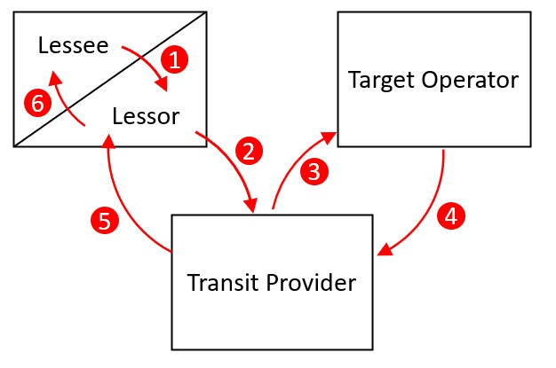
- – Routing via Lessor
Figure 1 above illustrates the high-level signalling flow as follows:
- Traffic originates from the GT Sub-Lessee/GT Lessee. For simplicity, the Sub-Lessee has not been included in the diagram.
- Traffic is sent using the GT Lessor network.
- The Target Operator receives the traffic. Here, the Target Operator may be the subscriber’s home network or roaming partner in case the subscriber is roaming.
- The Target Operator responds to the message
- The Transit Carrier delivers the response back to the GT Sub-lessee/Lessee via the GT Lessor’s Network.
A more complete diagram is included in Annex A illustrating the signalling flow together with illustrative calling and called addresses and point codes.

Routing via Lessee Only
In this scenario, the Transit Carrier will have visibility of the traffic originating from the GT Lessee’s network, albeit the calling GT indicates to all subsequent recipients of the traffic that the traffic originated from the GT Lessor network even though this is not the case.
This approach offers the GT Lessee significant advantages, as it can avoid any kind of scrutiny by the GT Lessor of the traffic it is sending and receiving, and it has the benefit of more direct access to the signalling traffic. This allows the GT Lessee the flexibility to select its own Transit Carriers and set its own commercial rates, which could disadvantage the GT Lessor. Typically, the Transit Carrier (and other Transit Carriers in the signalling path) will require the GT Lessee to provide a “Letter of Authority” from the GT Lessor confirming that the GT Lessee has authorisation to use the GT and therefore to receive the traffic directly.
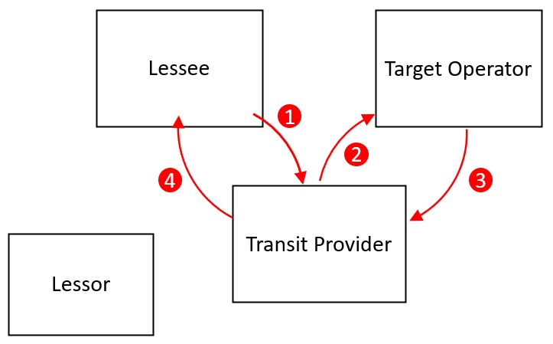
- – Routing via Lessee Only
Figure 2 above illustrates the high-level signalling flow as follows:
- Traffic originates from the GT Sub-Lessee/ Lessee
- Target Operator receives the traffic
- Target Operator responds to the message
- Transit Carrier routes the response back to the GT Lessee.
A more complete diagram is included in Annex A illustrating the signalling flow together with illustrative calling and called addresses and point codes.
Note that in this scenario the GT Lessor plays a significantly diminished role and has no visibility of traffic originating from or terminating to the GT Lessee’s network. As the GT Lessor is responsible and liable for all Global Titles assigned to it, and is responsible for ensuring the security of Global Title use to protect both the GT Lessor and the Target Operators, Routing via Lessee Only should be discontinued because of the security and privacy risks the practice poses for mobile users.

Diameter End Point Address Leasing

Introduction to Diameter End Point Addresses
The Diameter protocol is used to support 4G services, including roaming. Diameter Hosts and Realms are unique addresses, used for the transmission and reception of Diameter messages.
Diameter signalling is routed to realms that are assigned to MNOs. Within an MNO, individual network elements related to Diameter traffic have a Diameter host address. Those resources are either used by the MNO to support its own services or to support services provided by its MVNO customers or its roaming partners.

What is Diameter End Point Address Leasing?
For the purposes of this document, DEPA Leasing is considered to be exclusively the provision of DEPAs to a third party, subject to a contractual relationship, whereby a Lessee is assigned permission to use a DEPA by the Lessor.

Issues and Concerns with Diameter End Point Address Leasing
With the exception of roaming enablement services, as defined in PRDs BA.21 [8] and BA.23 [9], there are no known legitimate use cases of DEPA Leasing. Attacks using Diameter are widely documented and logically, these can only be conducted by either the MNO that originates the traffic or by a party that has access to that MNO’s DEPAs.
It is accepted that a proportion of Diameter attacks may originate from the MNO that owns the DEPAs. However, given evidence of attacks that are coordinated across multiple MNO DEPAs, it is clear that attacks are also originated by parties that have third party access to MNO DEPAs.

Conclusion on Diameter End Point Address Leasing
In the absence of any justifiable use case for DEPA Leasing, other than those outside the scope of this document, this activity should not be undertaken. The Global Title and Diameter End Point Address Leasing Code of Conduct in section 6 below prohibits DEPA Leasing.

Global Title and Diameter End Point Address Leasing Code of Conduct
This CoC is aimed at all DEPA Lessors, GT Lessors and/or Transit Carriers.
All mandatory requirements are included in this section 6 only. GT Lessors, by their very nature, provide the critical numbering resources to access the SS7 networks whilst Transit Carriers typically enable the connectivity. As such, it is critical that these ecosystem participants adhere to this CoC and all such players are strongly encouraged to fully adopt the recommendations set out below.
Any party wishing to comply with this CoC should be aware that partial compliance with the requirements (i.e. statements using “SHALL”, “MUST” and/or “MUST NOT”, but not statements using “SHOULD” and/or “MAY”) is non-compliance and none of the requirements can be varied for any individual party.
Whilst DEPA Assignees, GT Assignees and Target Operators are not directly involved in the act of GT Leasing, and are not eligible to formally declare compliance with the CoC to the GSMA, they are nonetheless encouraged to otherwise declare their support for this CoC to further encourage the adoption of best practice across the ecosystem.

GT Lessors
GT Lessors are required to adhere to the following requirements to comply with this CoC. A GT Lessor is, by definition, a GT Assignee that has decided to monetise its GT resources. The decision to monetise resources has consequences and this CoC imposes appropriate requirements on all GT Lessors.
Once a decision has been taken to become a GT Lessor, the GT Lessor should be aware that it is legally liable for any harm caused to the Target Operator, irrespective of whether it or the GT Lessee generated malicious traffic that may result in harm. PRD BA.20 [4] is unambiguous on this matter. GT leasing is not a preferred method of gaining access to a roaming operator’s network. Although previously tolerated to support some use cases, it can obfuscate the true source of signalling making fault finding and network and user protection more difficult and is discouraged.
- GT Lessors MUST take responsibility for their Global Titles and the consequences (predictable or otherwise) of their decisions in relation to GT Leasing. They SHALL acknowledge that they are always responsible for the signalling generated by their GT Lessees and SHALL have appropriate measures in place to ensure compliance.
- GT Lessors MUST ensure that they are familiar with the details of BA.20 [4] related to the liability resulting from GT Leasing.
- GT Lessors SHALL commit to conduct due diligence on any potential GT Lessees before providing them with access to any GTs. This SHOULD include both a review of the company and the declared use cases that they plan to support using the leased GTs. Additionally, upon adopting this CoC, GT Lessors SHALL conduct a retrospective and periodic due diligence of all existing GT Lessees.
- GT Lessor SHALL require the GT Lessee to use a Transit Carrier that has signed up to this Code of Conduct.
- GT Lessors, who are Full Members of the GSMA, MUST provide clear and current information within their IR.21 using the appropriate RAEX format, or free text fields prior to RAEX being updated, to clearly declare which of their GTs are subject to GT Leasing. This information MUST be provided with complete transparency and be available to all GSMA members.
- The GT Lessor’s IR.21 MUST detail the business name of the GT Lessee and the type of signalling node that is using the leased GT.
- GT Lessors MUST implement real-time technical controls on the use of leased GTs to ensure they are compliant with the recommendations of FS.11 and to ensure their use is limited to the specific declared use cases defined in the agreement(s) between GT Lessor, GT Lessee and roaming partner. For the avoidance of doubt, contractual controls only are not considered adequate and outsourcing real time technical controls, such as an outbound firewall, is not recommended due to the sensitive nature of traffic and the risks involved. In the specific case of authorised penetration testing only, a GT Lessor may remove real-time technical controls that could impair the authorised penetration testing traffic destined for a Target Operator upon receipt of a written request and “Authorisation to Test” from that Target Operator.
- GT Lessors SHALL not allow use of the Routing via Lessee Only method,
- GT Lessors MUST disclose full details of their GT Lessees upon request from Target Operators where evidence is supplied to confirm that traffic received by the Target Operators using GT Lessor’s leased GTs was in breach of the relevant PRDs. This will assist the investigations by the Target Operators (where multiple GTs may have been used) and will facilitate threat intelligence sharing.
- GT Lessors MUST NOT object to being named in threat intelligence sharing reports as a party that originated traffic that was in breach of the relevant PRDs. This does not negate the right to reply if named in such reports.
- GT Lessors MUST consent to the Transit Carrier providing signalling traces related to traffic originating from their GTs to the Target Operators upon request.
- GT Lessors MUST retain summary signalling data (i.e. aggregated data which includes Originating Point Codes, Calling and Called GTs, MTP3 information, SCCP information and MAP information) for GTs leased to GT Lessees for 4 months minimum.
- GT Lessors MUST store full signalling trace data for at least 10 calendar days.
- Threat intelligence sharing is considered “best practice” and, as such, GT Lessors SHOULD support and participate in threat intelligence sharing.
- As a principle, sub-leasing of GTs is not recommended and SHOULD be avoided. However, there are circumstances e.g. business restructuring where such a relationship is created. Where GT sub-leasing takes place, the following clauses MUST be adhered to:
  - GT Lessors MUST contractually oblige any GT Lessees to declare any instances where the GT Lessees have allocated addresses to GT Sub-Lessees. In such scenarios, the GT Lessors MUST engage the GT Sub-Lessees in the same manner as GT Lessees per 6.1, (notably clauses 3,4,5 and 6).
  - GT Lessors MUST NOT allow GT Sub-Lessees to further sublet addresses to other parties.
- Where GT Lessees or GT Sub-Lessees are identified by the GT Lessors as falsifying information in a declaration of use case, or in declarations of Sub-leasing, the GT Lessors MUST terminate the GT Lessees’ or Sub-Lessees’ traffic with immediate effect and SHOULD inform other carriers through threat intelligence sharing.
- GT Lessors that declare compliance with this CoC MUST comply in good faith with the CoC Complaints process.

Transit Carriers
Transit Carriers are required to adhere to the following requirements to comply with this CoC. Any Transit Carrier that signs up to this CoC SHALL adhere to the relevant PRDs. Traffic is typically cascaded through a chain of Transit Carriers and the rules in this CoC apply equally to all of those Transit Carriers that also declare compliance with the CoC.
It is acknowledged that satisfying these requirements will require effort and investment by Transit Carriers. This could lead to additional commercial charges from Transit Carriers to their customers.
- Transit Carriers MUST assure that the next hop, for diameter request messages destined to a DEPA, is either the relevant DEPA Assignee or the IPX diameter provider of the DEPA assignee as stated in IR.21.
- Transit Carriers SHALL not use or facilitate use of the Routing via Lessee Only method.
- Transit Carriers MUST ensure that they comply with the binding requirements of PRD IR.77.
- Upon request from a Target Operator, Transit Carriers MUST provide details of whether traffic received by the Target Operator using leased GTs was subject to the Routing via Lessor or the Routing via Lessee Only method.
- Transit Carriers MUST support Target Operators by providing details of traffic that transited their network that is the subject of Target Operator investigations. This applies whether the Transit Carrier has a commercial relationship with the Target Operator or not, within the constraints permitted by data privacy regulations.
- Upon request from a Target Operator, including a copy of a relevant signalling trace for traffic that transited towards or terminated in the Target Operator’s network, a Transit Carrier MUST provide an unmodified signalling trace for ingress traffic using leased GTs transiting its network towards the Target Operator.
- Transit Carriers MUST retain summary signalling data (i.e. aggregated data which includes Originating Point Codes, Calling and Called GTs, MTP3 information, SCCP information and MAP information) for leased GTs for 1 month minimum.
- Transit Carriers MUST store full signalling trace data for at least 7 calendar days.
- Transit Carriers MUST identify the source of the traffic that was delivered to the Target Operators. In the case that multiple Transit Carriers are involved in the delivery of this traffic, Transit Carriers that have declared compliance with this CoC SHALL identify the party from which they received the traffic.
- Where Target Operators are unable to block traffic from GT Lessees, the Transit Carriers SHOULD block that traffic to those Target Operators upon request from the Target Operators.
- Transit Carriers that lease GTs MUST comply with all the requirements of section 6.1.
- Threat intelligence sharing is considered “best practice” and, as such, Transit Carriers SHOULD support and participate in threat intelligence sharing.
- Transit Carriers MUST NOT object to being named in threat intelligence sharing reports as a party that transited traffic that was in breach of the relevant PRDs. This does not negate the right to reply if named in such reports.
- Transit Carriers MAY block any traffic deemed fraudulent as a proactive measure without a prior request from Target Operators. Transit Carriers SHOULD inform Target Operators and GT Lessors that such blocks have been implemented.
- Transit Carriers that declare compliance with this CoC MUST comply in good faith with the CoC Complaints process.

DEPA Leasing
      - All forms of DEPA Leasing are prohibited.
      - DEPA Lessors MUST cease any DEPA leasing and seek alternative indirect arrangements.

Global Title Best Practice Recommendations
The following recommendations are included as best practice for GT Assignees and Target Operators and do not form part of the CoC.

GT Assignees
GT Assignees are advised to proceed with caution when considering the matter of GT leasing. All other options/architectures (e.g. use of APIs) should be explored first before using GT leasing. Where there are legitimate uses of GT leasing, any arrangement enabling such services should ensure both contractual and technological means to enforce such legitimate usage and to block any unauthorised usage (as outlined in 6.1).
GT Assignees should commit to reviewing the requirements placed upon GT Lessors in this code of conduct and should agree to comply with all of them should they become GT Lessors.

Target Operators
- Target Operators should consider implementing the recommendations outlined in FS.11, where applicable.
- Target Operators that are recipients of signalling traffic that is in breach of the relevant GSMA PRDs should share threat intelligence since threat intelligence sharing is considered “best practice”. This is detailed in section 8 below.
- Target Operators should identify the networks from where attacks originated, and should attempt to attribute attacks to their true source. This is critical for any investigation into any breach and is also important for correlation of distributed attacks (as well as for threat intelligence sharing).
- Target Operators should review and, where appropriate, update their commercial contracts with GT Lessors and Transit Carriers to ensure all parties are compliant with this CoC.
- Target Operators should not accept signalling traffic originating from any party with whom they do not have an agreement to terminate such traffic. They SHOULD consider blocking calling party GTs that are not assigned to a GSMA operator member with which they have a roaming or interworking contract or otherwise a bilateral agreement. This is considered best practice.
- Target Operators should not accept signalling messages from GTs assigned to non-members of the GSMA. Where they do so, they do so at their own risk.

Threat Intelligence sharing
To increase awareness of the problems associated with GT Leasing, MNOs should consider using services that share threat intelligence. Various commercial solutions are available as well as the GSMA’s T-ISAC MISP instance (misp.gsma.com). This applies equally to Target Operators, as well as GT Lessors, and also applies to other parties such as signalling firewall or other signalling security providers, where they have the appropriate authorisation from their customers (typically a Target Operator).

- Detailed Signalling Flow Diagrams
  - Routing via Lessor
Figure 3 illustrates the complete signalling flow for Routing via Lessor, complete with illustrative calling and called party addresses as well as point codes and Global Title Translation (GTT).
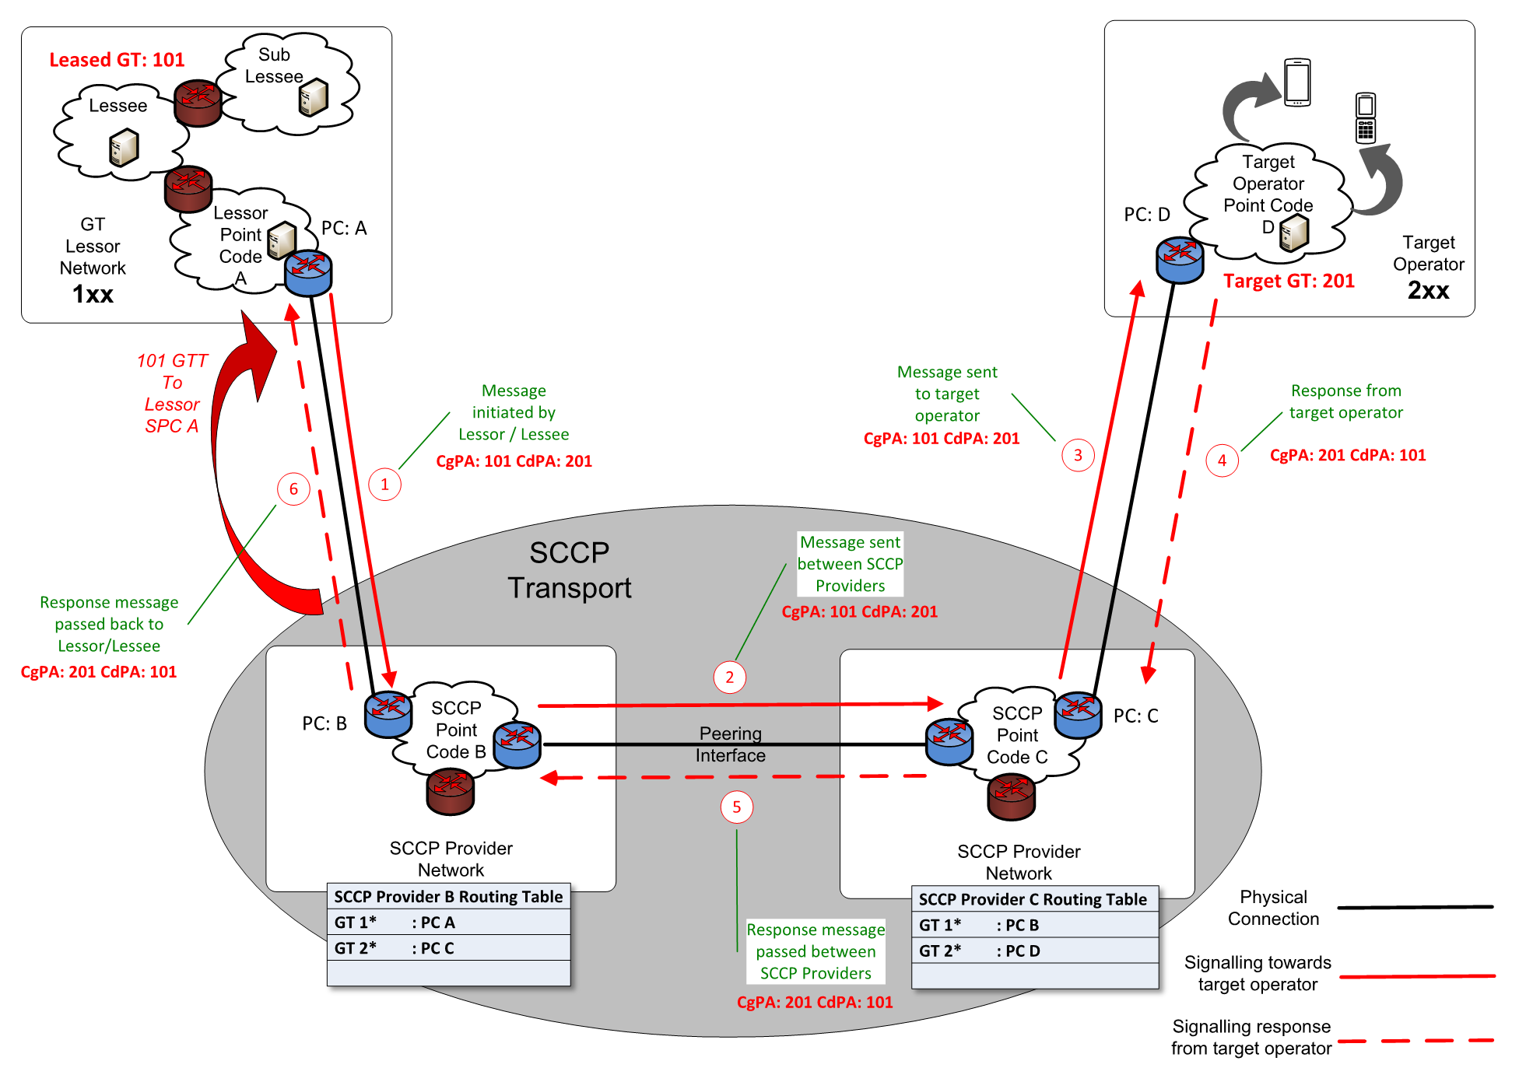
- – Routing via Lessor Signalling Flow
  - Routing to Lessee Only
Figure 4 illustrates the complete signalling flow for Routing via Lessee Only, complete with illustrative calling and called party addresses as well as point codes and Global Title Translation (GTT).
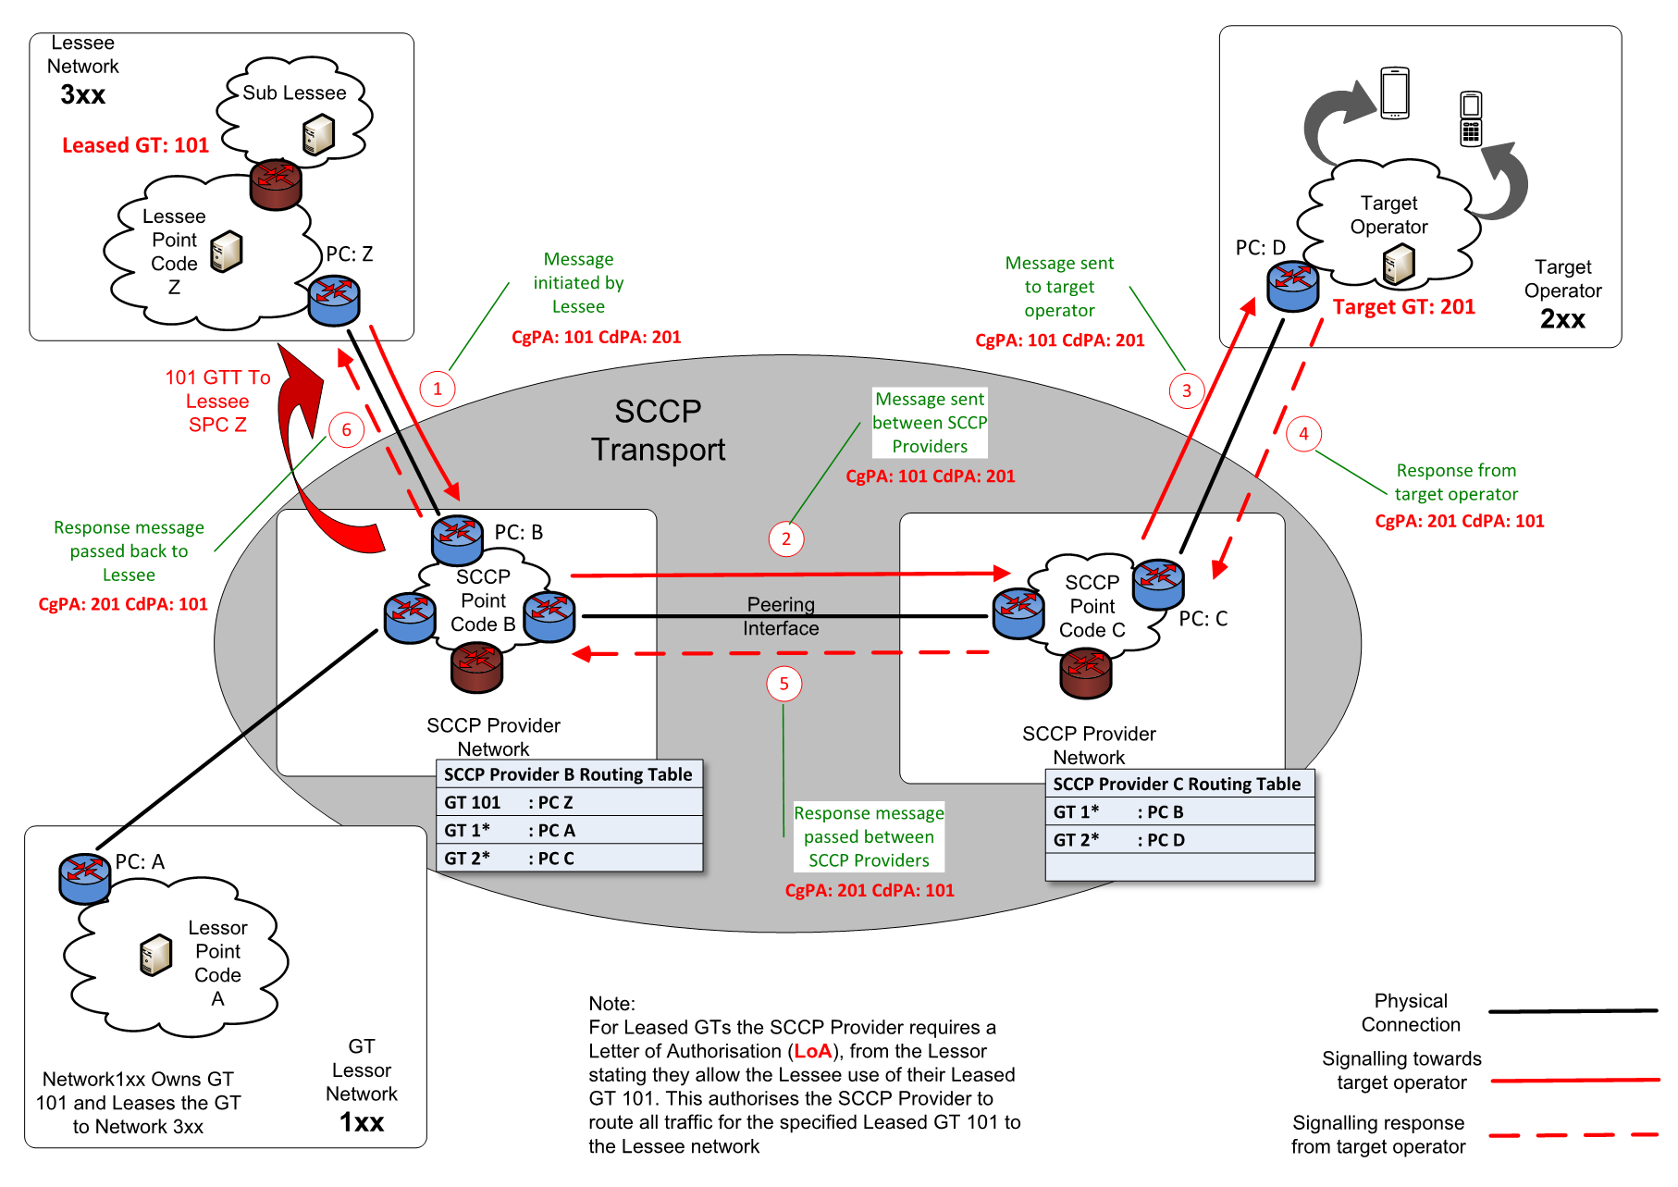
- – Routing via Lessee Only Signalling Flow

- Appropriate IR.21 Management
It is important that MNOs fully break out number ranges down to the individual ranges assigned to all individual operators. An example of this is contained in Table 1 below:
Range | GT
100 | Operator A
101 | Operator A
102 | Operator A
103 | Operator A
104 | Operator B
105 | Operator A
106 | Operator A
107 | Operator A
108 | Operator A
109 | Operator A
110 | Operator A
- – Example of Number Range Break-Out
In Table 1 GT 104 is assigned to Operator B, whereas all other GTs beginning with 10 belong to Operator A. It is therefore important that MNOs configure each GT separately to ensure that Operator B is correctly identified. If MNOs assume that all GTs commencing with 10 belong to Operator A, then any traffic originating from Operator B will not be correctly attributed.
When configuring their systems, it is important for MNOs to break out IR.21 defined GT ranges to a level of detail necessary to unambiguously identify the appropriate operator and exclude ranges that are not within the IR.21 data. There should not be a scenario where a GT range is allocated to multiple operators.
- Document Management
  - Document History
Version | Date | Brief Description of Change | Approval Authority | Editor / Company
1.0 | 28 Mar 2023 | First version. | ISAG | Stephen Ornadel, Mobileum.
1.1 | 15 Nov 2024 | CR1002: Update the requirement on GT Lessors in relation to authorised penetration testing. Update requirements referring to past deadline relating to use of Routing via Lessee only. | FASG | Domonkos Tomcsányi, Umlaut Communications GmbH  David Maxwell, GSMA
2.0 | 16 Dec 2025 | Diameter brought into scope by including DEPA Leasing in the Code of Conduct. Minor editorial changes also made. | ISAG | Stephen Ornadel, Telenor Linx  James Moran, GSMA
  - Other Information
Type | Description
Document Owner | FASG
Editor / Company | Stephen Ornadel, Telenor Linx

It is our intention to provide a quality product for your use. If you find any errors or omissions, please contact us with your comments. You may notify us at prd@gsma.com
Your comments or suggestions & questions are always welcome.

